HARARE INSTITUTE OF TECHNOLOGY

DEPARTMENT OF INFORMATION TECHNOLOGY
BTECH (HONS) INFORMATION TECHNOLOGY
AI-Powered Proactive IT Asset Optimisation System
BY
CURTIS L.Y KASUKUSA
H220042V
HIT 400
SUPERVISOR: MR GOTORA

This project report was submitted to Harare Institute of Technology in partial fulfilment of the Bachelor of Technology (Hons) Degree in Information Technology.

DECLARATION

DEDICATION

ACKNOWLEDGEMENTS

ABSTRACT

Table of Contents

Table of Figures

Table of Tables

List of Acronyms

CHAPTER 1: INTRODUCTION

1.1 Introduction
Managing IT assets has become one of the more demanding responsibilities facing organisations today. As infrastructure grows and diversifies, keeping accurate records of every device, software licence, and piece of hardware is no longer feasible through manual spreadsheets or periodic audits. When assets are not properly monitored, organisations face unexpected failures, compliance gaps, and expenditure on equipment that could have been maintained or repurposed. Unplanned downtime carries a significant operational cost — Beyer et al. (2016) note that reactive incident management consistently consumes more engineering effort and financial resource than proactive monitoring and prevention.
This project proposes an AI-driven IT Asset Management (ITAM) system to address these shortcomings. Zonta et al. (2020) demonstrate that predictive maintenance approaches, when applied to hardware environments, consistently reduce both the frequency and cost of unplanned failures. Building on that principle, the proposed system continuously collects real-time hardware health data from devices across the network and applies a machine learning model to detect early signs of impending failure. It also automates routine monitoring, issues alerts to relevant staff, and presents the state of the IT estate through a centralised dashboard, giving organisations the tools to manage assets intelligently and reduce both downtime and maintenance costs.

1.2 Motivation
During my industrial attachment I worked within an IT support team that tracked the organisation's hardware assets almost entirely through Microsoft Excel spreadsheets. On the surface it seemed manageable, but very quickly I saw how much effort went into simply keeping the records current. Every time a device was moved, repaired, or decommissioned, someone had to remember to update the file, and that did not always happen promptly. Cross-referencing entries to verify licence status or warranty expiry was slow and frequently produced conflicting results.
What struck me most was how reactive everything was. Hardware failures were discovered only after a user reported that their machine had stopped working. Sommerville (2016) notes that reactive systems of this kind place the full burden of issue detection on end users, which delays response times and amplifies the impact of failures. That experience directly motivated this project — I wanted to build something that would give IT teams visibility into device health before problems escalated, replacing reactive firefighting with informed, scheduled maintenance.

1.3 Problem Statement
Across many organisations, IT assets are managed through manual processes that cannot keep pace with the demands of a dynamic IT environment. ISO/IEC 19770-1 (2017) identifies real-time visibility and lifecycle accuracy as foundational requirements of an effective ITAM system, yet most organisations still rely on spreadsheet-based approaches updated only intermittently. Asset locations go unverified, hardware degradation goes undetected, and maintenance only happens after something breaks. The consequences include increased repair costs, unnecessary replacements, licence waste, and reduced staff productivity. Without a proactive system, organisations continually absorb costs that could reasonably have been avoided.

1.4 Related Work

Freshservice
Freshservice, developed by Freshworks, provides both agent-based and agentless hardware discovery across Windows and macOS environments. It maps CMDB relationships and supports real-time dependency visualisation, making it useful for tracking asset lifecycles from procurement through to disposal (Freshworks, 2023). However, as Hussain et al. (2022) note, Freshservice faces limitations in automation depth and third-party integration breadth compared to enterprise-grade platforms, making it less suitable for large and complex infrastructure environments.

Lansweeper
Lansweeper performs agentless network scanning through WMI, SNMP, SSH, and HTTP protocols to catalogue hardware across Windows, Linux, macOS, and IoT environments. Its SQL-backed reporting engine makes it a practical foundation for feeding asset data into SIEM or CMDB tools, and it supports compliance frameworks including GDPR and HIPAA (Lansweeper, 2023). Its primary limitation is the absence of AI-driven analytics; as Zonta et al. (2020) observe, discovery-focused tools that lack predictive capability can identify what assets exist but cannot anticipate when those assets are likely to fail.

Device42
Device42 was built for hybrid infrastructure environments, offering detailed hardware discovery, dependency mapping, and power consumption tracking alongside agentless scanning. It integrates well with ITSM and DCIM platforms and is strong in data centre visibility and audit readiness (Hussain et al., 2022). The platform has a steep learning curve and requires substantial configuration before full deployment, which can extend the time to value for organisations with limited IT staff.

1.5 Hypothesis
Null Hypothesis (H0): There is no significant difference in operational downtime, maintenance costs, or asset utilisation efficiency between the proposed AI-powered ITAM system and traditional manual tracking approaches.
Alternative Hypothesis (H1): Implementing an AI-driven, predictive IT Asset Management system will lead to a measurable reduction in operational downtime and maintenance costs, alongside a notable improvement in asset utilisation efficiency, compared with conventional manual record-keeping methods.

1.6 Technical Objectives
- To collect and display real-time hardware health metrics — CPU load, memory usage, disk space, and temperature — from heterogeneous IT assets on a centralised monitoring console.
- To predict hardware failures and generate forward-looking health insights using a Random Forest machine learning model trained on historical telemetry data, following the approach established by Breiman (2001).
- To send automated email alerts to IT administrators when anomalies or unresolved issues are detected.

Expected Results:
- Financial Optimisation and Cost Reduction: By continuously analysing asset usage patterns and predicting end-of-life timelines, the system will support a shift from reactive purchasing to strategic budget allocation. Turner et al. (2003) highlight that automated service management tools consistently reduce both operational expenditure and the administrative overhead of manual asset oversight.
- Reduction in Operational Downtime: Using SNMP agents and machine learning to detect anomalies early, the system is expected to significantly reduce unplanned equipment failures. This aligns with the findings of Zonta et al. (2020), who demonstrate that predictive maintenance models can reduce equipment failure rates substantially when applied consistently.
- Automated Efficiency and Productivity: Replacing manual inventory audits with automated asset discovery removes a significant administrative burden. As Beyer et al. (2016) argue, automating routine operational tasks directly frees engineering capacity for higher-value work.
- Strategic Decision Making: Centralising asset data and surfacing it through visualisation tools gives management a clear picture of total cost of ownership and resource utilisation, enabling IT infrastructure planning to be aligned with longer-term business objectives (Storey and Song, 2017).

1.7 Ethics Considerations
- Employee Privacy and Surveillance: Continuous endpoint monitoring carries a real risk of crossing the boundary between device health tracking and employee surveillance. Mather et al. (2009) warn that without clearly defined data governance policies, security monitoring systems can inadvertently enable the collection of personal behavioural data. Clear boundaries must be established and staff must be informed of exactly what data is collected and why.
- Transparency in Automated Recommendations: When the system recommends a hardware replacement or raises an alert, the data points driving that decision must be visible to the IT team. Wieringa (2014) stresses that the trustworthiness of decision-support systems depends on their ability to surface reasoning in a form that practitioners can evaluate and, if necessary, override.
- Algorithmic Bias and Fairness: Anomaly detection models trained on historical data may flag legitimate but uncommon work patterns as suspicious, producing false positives. Zhang et al. (2023) note that this risk is best mitigated through regular model audits and by ensuring that anomaly thresholds are calibrated against objective device metrics rather than assumed behavioural norms.
- Data Centralisation and Security Responsibility: Aggregating sensitive information about device vulnerabilities, user activity, and asset locations into a single database creates a high-value target. Mell and Grance (2011) emphasise that centralised data architectures require rigorous access controls and encryption policies to ensure that the concentration of data does not introduce unacceptable security risk.

1.8 Conclusion
This chapter has established the core problem motivating this project and outlined the proposed approach to addressing it. The limitations of manual IT asset management are supported both by direct observation during the industrial attachment and by the broader literature on proactive versus reactive system management. The proposed system introduces real-time monitoring, machine learning-based failure prediction, and automated alerting within a platform designed to give IT teams genuine visibility and time to act ahead of failures. The ethical considerations raised here will be carried forward into the system design.

CHAPTER 2: LITERATURE REVIEW

2.1 Introduction
IT Asset Management platforms have evolved substantially over the past decade. What began as simple database-driven inventory tools have developed into integrated service management ecosystems capable of handling procurement, lifecycle tracking, compliance, and support within a single interface. Janssen and Joha (2011) observe that as organisations adopt hybrid cloud models and distributed working arrangements, the demand for scalable, intelligent ITAM solutions has accelerated considerably. This chapter reviews five platforms — Freshservice, SolarWinds Service Desk, SysAid, Anakage, and Lansweeper — evaluating each against the requirements this project seeks to address.

2.2 Related Works

SysAid
SysAid is a comprehensive ITSM platform that embeds asset management within its service desk environment, allowing IT teams to manage hardware and software inventory alongside incident and change management in one system (SysAid, 2023). Its Service Automation features reduce the volume of manual tasks administrators need to perform, and the platform supports remote control of endpoints directly from ticket records. For medium-sized organisations requiring an integrated solution, SysAid performs well. However, its interface is generally regarded as less intuitive than those of newer competitors, and advanced features require considerable configuration. As Hussain et al. (2022) note, the platform functions best as part of a broader ITSM workflow rather than as a standalone enterprise-grade ITAM repository.

SolarWinds Service Desk
SolarWinds Service Desk is a cloud-hosted ITSM platform with a strong emphasis on asset lifecycle governance, providing automated asset discovery, risk detection, and software licence compliance monitoring that feed into a consolidated view of the IT estate (SolarWinds, 2023). The platform aligns closely with ITIL practices and is commonly chosen where audit readiness and compliance are priorities (Axelos, 2019). However, Gartner (2023) identifies limitations in advanced features such as predictive maintenance and non-IT asset tracking, characterising SolarWinds as a reliable compliance platform that remains largely reactive in its approach to asset health monitoring.

Anakage
Anakage takes a different approach, positioning itself as a next-generation automation platform that extends traditional ITAM through proactive monitoring and self-healing capabilities (Anakage, 2023). Its agent-based architecture provides deep visibility into device health, compliance status, and usage patterns, and its Collaborative Automation Agents (Cobots) can perform automated remediation actions before users are affected (Zhang et al., 2023). However, Hussain et al. (2022) note that Anakage offers limited support for financial asset management and lifecycle governance, positioning it as a complementary operational layer rather than a comprehensive ITAM solution.

Lansweeper
Lansweeper is widely regarded as one of the strongest asset discovery tools available, valued for its agentless scanning capability. Its DeepScan engine identifies and catalogues traditional IT hardware, IoT devices, operational technology, and cloud resources without requiring software installation on endpoints (Lansweeper, 2023). Gartner (2023) consistently positions it as a best-in-class discovery tool. However, as Zonta et al. (2020) observe, its native capabilities for proactive remediation and predictive analytics remain limited — it tells you what assets you have but cannot anticipate which are about to fail.

Freshservice
Freshservice is a cloud-native ITSM platform distinguished primarily by its usability and speed of deployment (Freshworks, 2023). Its intuitive interface lowers adoption barriers and enables non-technical stakeholders to engage with asset management processes (Gartner, 2023). The platform covers the full asset lifecycle and automates common workflow tasks such as staff onboarding and offboarding, reducing manual workload (Axelos, 2019). While well-suited to small and medium enterprises, Hussain et al. (2022) note that large organisations with complex legacy infrastructure may find its predictive analytics capabilities insufficient.

2.3 Conclusion
Looking across the five platforms reviewed, a consistent pattern emerges: each excels in a specific functional area but does not offer a fully integrated solution for proactive, intelligent asset management. Lansweeper leads in discovery but is passive in health monitoring. SysAid and SolarWinds are strong on governance but remain reactive (Hussain et al., 2022). Anakage introduces self-healing automation but is not a complete ITAM platform (Anakage, 2023). Freshservice is accessible and strong on lifecycle management but limited in predictive depth (Gartner, 2023).
Collectively, the literature reveals a fragmented ITAM ecosystem in which discovery, monitoring, automation, and lifecycle governance operate as loosely coupled components rather than as an integrated intelligent system (Zhang et al., 2023). None of the reviewed platforms fully combines real-time telemetry, predictive analytics, and unified lifecycle management within a single coherent architecture, justifying the need for the AI-powered system proposed in this project.

CHAPTER 3: REQUIREMENTS ANALYSIS

3.1 Introduction
Requirements engineering is the process of identifying, documenting, and validating what a system must do before development begins. Sommerville (2016) describes it as the most critical phase of any software project, arguing that errors introduced at the requirements stage are significantly more expensive to correct once development is underway. For this project, requirements were gathered through direct observation, interviews, questionnaires, and document analysis, all conducted within the context of the organisation's existing IT operations.

3.1.1 Evaluate Alternatives
Two main alternatives were considered before committing to a custom-built system. The first was to deploy an off-the-shelf reactive ITAM tool such as Snipe-IT or ManageEngine. These platforms centralise asset records and support incident logging, but as Hussain et al. (2022) observe, they are fundamentally reactive — they record what has already occurred rather than anticipating what is about to happen.
The second alternative was to develop a predictive module or API plugin layered on top of an existing platform such as ServiceNow or SolarWinds. While this would leverage existing infrastructure, Lwakatare et al. (2019) caution that integrating new intelligence layers into legacy platforms introduces architectural dependencies that are difficult to maintain and extend over time. Building from the ground up allows the architecture to be designed specifically around the project's requirements with no inherited constraints.

3.1.2 Outsourcing
Outsourcing the development was considered but ultimately rejected. Raza et al. (2012) note that outsourced technology projects frequently experience scope misalignment and communication overhead, particularly when functional requirements are closely tied to operational context that is difficult to convey to an external team. In a research and development setting where requirements evolve through building and testing, maintaining close control of the codebase is essential.

3.1.3 Improvement Over the Current System
The proposed system improves on the existing manual approach in several concrete ways. Data integrity is strengthened through role-based access control. Real-time alerting replaces the passive, periodic checks of the current system. The user interface is designed to be practical and navigable rather than requiring users to work across multiple spreadsheet files. Pfleeger and Atlee (2010) argue that usability improvements of this kind directly affect the accuracy and timeliness of the decisions the system is intended to support — they are not merely cosmetic.

3.1.4 Development Approach
The system will be developed using a modular architecture. Monitoring agents deployed on endpoints collect hardware telemetry via SNMP scripts and push data to a centralised Python backend. The backend stores and processes incoming data and runs the Random Forest model to generate failure predictions (Breiman, 2001). A React-based web frontend provides the user interface, and the database retains both live metrics and historical records used to retrain the model as data accumulates. Security, scalability, and extensibility are treated as first-class design requirements throughout.

3.2 User Requirements
Administrator Requirements:
- The system shall allow administrators to manage user accounts, including creating, updating, and deactivating users.
- The system shall enable administrators to assign and manage user roles and access permissions.
- The system shall allow administrators to configure system settings, alert thresholds, and notification preferences.
- The system shall provide administrators with system usage logs and audit trails for monitoring and compliance.
- The system shall ensure secure authentication and authorisation for all administrative functions.

IT Manager Requirements:
- The system shall provide IT managers with a centralised dashboard displaying the overall health and performance of IT assets.
- The system shall notify IT managers in advance of predicted asset failures and performance risks.
- The system shall provide AI-generated optimisation and maintenance recommendations.
- The system shall allow IT managers to access historical reports and analytics for planning and decision making.
- The system shall support exporting reports for management and documentation purposes.

IT Technician Requirements:
- The system shall allow technicians to view assigned assets and their current health status.
- The system shall notify technicians of maintenance tasks and failure alerts requiring action.
- The system shall provide technicians with diagnostic information to assist in troubleshooting.
- The system shall allow technicians to update maintenance status and record actions taken on assets.
- The system shall be accessible and easy to use in field and on-site settings.

3.2.1 Data Collection Phase
The following methods were used to gather information about the existing system and define requirements for the new one, following the structured elicitation approach recommended by Sommerville (2016):
Questionnaires: A structured questionnaire was distributed to IT support staff and team members. The survey measured how frequently asset records contained errors, how much time was spent on manual corrections each week, and how hardware failures were typically detected. The results provided quantitative evidence of the scale of the problem.
Interviews: Discussions with IT managers and system administrators explored the specific pain points of the current process in depth — particularly the operational impact of unexpected hardware downtime and the burden of manual data entry.
Direct Observation: Time spent shadowing IT administrators during the industrial attachment provided first-hand insight into the current system's use. The most significant observation was the time lag between an asset failure occurring and it being recorded, as well as the difficulty staff faced in locating device details quickly during an active incident.
Document Analysis: Existing Excel asset registers, historical maintenance logs, and purchase records were reviewed to understand what data was already captured and in what format. This analysis informed the data model, identifying which fields were essential for generating meaningful machine learning predictions (Breiman, 2001).

Sample Questionnaire: IT Asset Management Assessment
Purpose: This questionnaire collects information on current IT asset management practices and challenges, in support of the development of an AI-Powered Proactive IT Asset Optimisation System. All responses are used for academic and system development purposes only.
Section A: Respondent Information
1. What is your role in the organisation?
☐ IT Administrator ☐ IT Manager ☐ IT Technician ☐ Other: __________
2. How many years of experience do you have in IT support or asset management?
☐ Less than 1 year ☐ 1–3 years ☐ 4–6 years ☐ More than 6 years
Section B: Current IT Asset Management Practices
3. How are IT assets currently recorded and tracked?
☐ Spreadsheets (Excel) ☐ Manual paper records ☐ Dedicated ITAM software ☐ Combination of methods
4. How often do you find inaccuracies in asset records?
☐ Very often ☐ Often ☐ Sometimes ☐ Rarely ☐ Never
5. How much time do you spend correcting asset record errors per week?
☐ Less than 1 hour ☐ 1–3 hours ☐ 4–6 hours ☐ More than 6 hours
Section C: Asset Monitoring and Maintenance
6. How are hardware failures usually detected?
☐ After users report issues ☐ During scheduled manual checks ☐ Through automated alerts ☐ Not systematically detected
7. How frequently do unexpected hardware failures occur?
☐ Very frequently ☐ Frequently ☐ Occasionally ☐ Rarely ☐ Never
8. How effective is the current system in preventing asset failures?
☐ Very effective ☐ Effective ☐ Neutral ☐ Ineffective ☐ Very ineffective
Section D: Impact on Operations
9. How would you rate the impact of asset downtime on daily operations?
☐ Very high ☐ High ☐ Moderate ☐ Low ☐ Very low
10. How confident are you in the accuracy of current asset data for decision-making?
☐ Very confident ☐ Confident ☐ Neutral ☐ Not confident ☐ Not confident at all
Section E: Automation and AI Readiness
11. Would automated monitoring and predictive alerts improve your work efficiency?
☐ Strongly agree ☐ Agree ☐ Neutral ☐ Disagree ☐ Strongly disagree
12. How valuable would AI-based failure prediction be to your role?
☐ Very valuable ☐ Valuable ☐ Moderately valuable ☐ Slightly valuable ☐ Not valuable
13. Are you willing to adopt an AI-driven IT asset management system?
☐ Yes ☐ No ☐ Not sure
Section F: Overall Assessment
14. Overall, how satisfied are you with the current IT asset management approach?
☐ Very satisfied ☐ Satisfied ☐ Neutral ☐ Dissatisfied ☐ Very dissatisfied
15. What is the biggest challenge with the current system?
☐ Inaccurate data ☐ Slow issue detection ☐ High manual workload ☐ Lack of reporting and insights ☐ Other: __________________
Thank you for participating. Your input directly informs the development of a more effective IT asset management solution.

3.2.2 Technical Feasibility
The proposed system relies on widely used, well-documented technologies. Perera et al. (2015) highlight that SNMP-based telemetry collection, on which the system depends for hardware monitoring, is a mature and broadly supported protocol across the range of device types the system will cover. All chosen technologies are within the development team's existing skill set, and there are no significant technical risks that would prevent delivery within the agreed timeframe.

3.2.3 Hardware Requirements
- Development laptop: 256 GB SSD or higher, Core i-series processor, 16 GB RAM minimum

3.2.4 Software Requirements
- Operating System: Windows 11
- Programming Languages: Python, JavaScript (React)
- Development Environment: Visual Studio Code
- Database: MySQL
- Web Technologies: HTML, CSS, JavaScript, React
- Version Control: Git with GitHub

3.2.5 Technical Expertise
Development requires proficiency in Python backend development, React frontend development, MySQL database administration, and REST API design. Familiarity with SNMP-based monitoring and supervised machine learning model training is also required. A working knowledge of version control, software testing, and basic security practices rounds out the technical requirements.

3.3 Economic Feasibility
The project is economically justified. Most of the required software tools are open-source, which significantly reduces licensing costs. Turner et al. (2003) argue that systems that automate routine operational tasks typically recover their development costs within one to two years through reductions in labour and downtime-related expenditure. The cost-benefit analysis below provides a two-year projection.

3.3.1 Cost-Benefit Analysis
The table below compares projected development and operational costs against expected operational savings across 2025 and 2026:

YEAR | 2025 | 2026
Benefits | $ | $
Reduced downtime costs | 1,200 | 1,500
Lower maintenance & replacement costs | 900 | 1,100
Reduced manual monitoring labour | 700 | 900
Improved asset utilisation & planning | 500 | 700
Total Benefits | 3,300 | 4,200
Development Costs
System development & AI model training | 600 | 150
Hardware for development & testing | 800 | 100
Software & development tools | 200 | 150
Total Development Costs | 1,600 | 400
Operational Costs
Hosting & infrastructure | 300 | 300
Maintenance & system updates | 200 | 300
Total Operational Costs | 500 | 600
Total Costs (development + operational) | (2,100) | (1,000)
Total Benefits | 3,300 | 4,200
Profit / (Loss) | 1,200 | 3,200

Net Profit = Total Benefits - Total Costs = (1,200 + 3,200) - (2,100 + 1,000) = $4,400

3.3.2 Tangible Benefits
- Reduced IT Asset Downtime: Early detection of hardware degradation reduces unexpected outages and improves system availability (Zonta et al., 2020).
- Reduced Operational Labour Costs: Automated monitoring removes the need for routine manual checks, freeing time for higher-value tasks (Beyer et al., 2016).
- Improved Asset Utilisation: Accurate, real-time data allows the organisation to identify underused resources and reallocate them effectively.
- Cost Savings from Preventive Maintenance: Addressing issues before they escalate into failures is consistently cheaper than emergency repair or unplanned replacement.

3.3.3 Intangible Benefits
- Improved Decision Making: Real-time dashboards and predictive analytics support better-informed IT management decisions (Storey and Song, 2017).
- Enhanced System Reliability: Proactive monitoring increases confidence in the stability of the IT environment.
- Improved Organisational Efficiency: Automating routine tasks allows IT teams to focus on strategic work rather than administration.
- Reduced Operational Risk: Early warning of potential failures reduces the likelihood of critical service outages.

3.4 Operational Feasibility
The system is designed to complement rather than replace existing IT workflows. IT administrators and asset managers will use it for monitoring, maintenance scheduling, and decision support — tasks they already perform, with better tooling. Since primary users already possess basic IT management skills, training requirements are minimal. Wieringa (2014) recommends that operational feasibility assessments consider not only whether a system can technically be used, but whether it will be accepted and sustained within the organisation's existing culture and processes. Risks such as over-reliance on automated recommendations will be mitigated through human-in-the-loop validation requirements for critical actions.

3.4.1 Schedule Feasibility
The project is planned across a twelve-month period with clearly defined phases and measurable deliverables. Historical asset data will be used to accelerate the machine learning model training phase. Stakeholder reviews are built into the schedule at key decision points to catch any requirements or design issues before they affect subsequent phases.

3.5 Work Plan

3.5.1 Work Schedule

Task | Duration (Days) | Start Period | End Period
Project Initiation | 7 | August 2025 | August 2025
Requirements Gathering | 8 | August 2025 | August 2025
System Design | 12 | September 2025 | September 2025
Database Design | 7 | September 2025 | September 2025
Front-end Development | 21 | October 2025 | October 2025
Back-end Development | 21 | November 2025 | November 2025
Integration and Testing | 20 | December 2025 | January 2026
User Acceptance Testing | 8 | February 2026 | February 2026
Deployment | 7 | March 2026 | March 2026
Maintenance and Support | Ongoing | April 2026

3.5.2 Gantt Chart
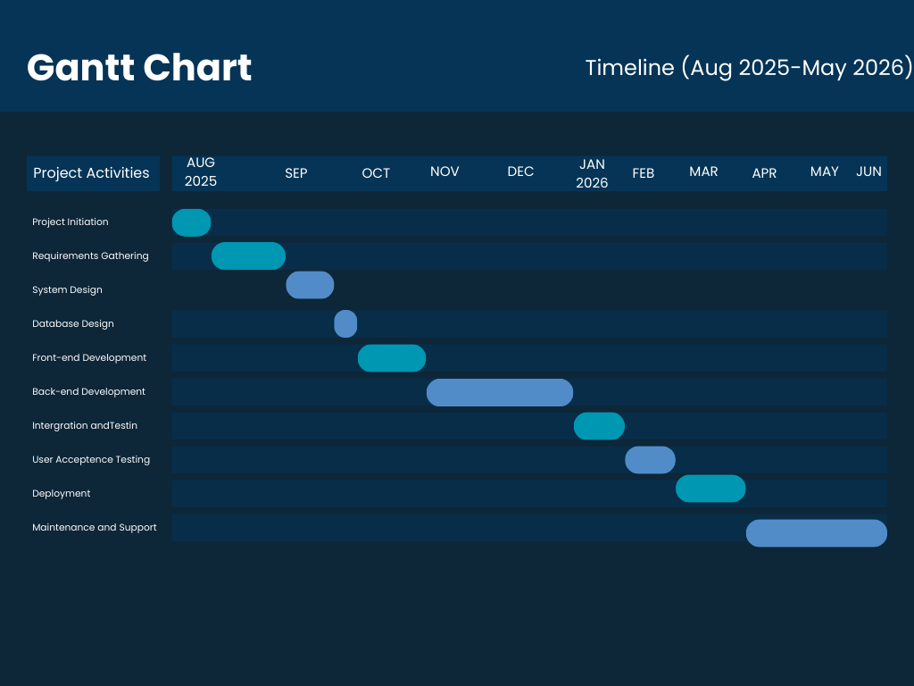

3.6 Conclusion
This chapter has established the requirements baseline for the AI-Powered Proactive IT Asset Optimisation System. Alternative development approaches were considered and rejected before concluding that a custom-built system was the most appropriate path. User requirements were defined for three distinct roles, and four data collection methods were used to ground those requirements in the real operational context. Technical, economic, operational, and schedule feasibility assessments confirm that the project is viable within the available resources and timeframe.

CHAPTER 4: SYSTEM ANALYSIS

4.1 Introduction
This chapter examines the existing IT asset management system in detail — how it operates, where it falls short, and what those weaknesses mean in practice. Wieringa (2014) argues that a thorough analysis of the current system is an essential precondition for designing an effective replacement, since it establishes the baseline against which the proposed system's improvements can be evaluated. System models including context diagrams, data flow diagrams, use case diagrams, and UML diagrams are used to describe both the current and proposed architectures.

4.2 Description of the Current System
The organisation currently manages its IT assets primarily through Microsoft Excel spreadsheets. Records covering hardware specifications, purchase dates, warranty periods, and maintenance history are entered and updated manually by IT personnel. These updates tend to happen reactively — after an incident or during a scheduled audit — which means the data is frequently out of date. Pfleeger and Atlee (2010) identify episodic data entry as a primary source of inaccuracy in manual management systems, noting that the longer the gap between an event and its recording, the greater the likelihood of error.
There is no automated mechanism for monitoring hardware health in real time. CPU usage, memory consumption, disk performance, and temperature are not tracked. As Etzion and Niblett (2010) observe, systems that rely on user-reported events as the primary trigger for maintenance action are structurally incapable of preventing failures — they can only respond to them after disruption has already occurred.

4.3 Analysis of the Existing System
The fundamental problem with the current system is that it records what has already happened rather than monitoring what is currently happening. ISO/IEC 19770-1 (2017) specifies that an effective ITAM system must maintain continuous, accurate visibility of asset status — a requirement the spreadsheet-based approach cannot meet.
From a technical standpoint, the system does not support integration with other tools, cannot scale efficiently as the asset base grows, and provides no analytics beyond manual spreadsheet interpretation. Storey and Song (2017) highlight that the absence of automated data aggregation and trend analysis prevents organisations from identifying patterns in asset utilisation and failure rates, limiting the quality of infrastructure planning decisions.

4.3.1 Context Diagram of the Existing System
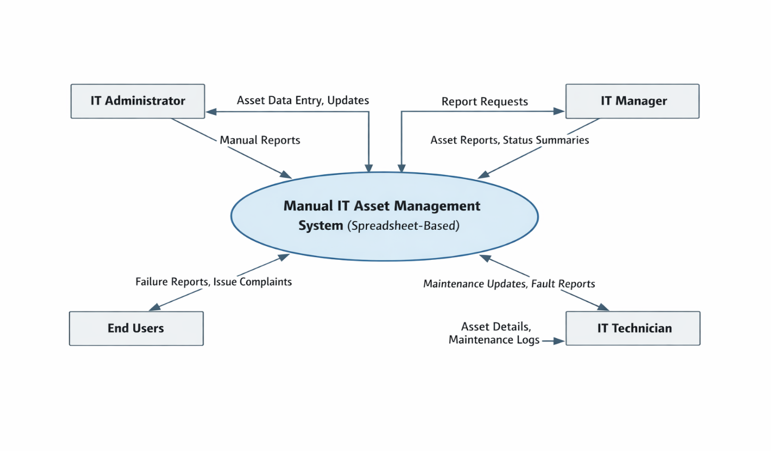

4.3.2 Weaknesses of the Current System
- Manual and error-prone asset tracking leads to records that are frequently inaccurate or out of date.
- Reactive failure management means problems are discovered only after they have already caused disruption.
- The absence of automated monitoring and predictive analytics makes consistent preventive maintenance practically impossible.
- Poor scalability and manual reporting create increasing inefficiency as the number of managed assets grows.

4.4 Description of the Proposed Solution

4.4.1 Context Diagram and Data Flow Diagrams
Context Diagram:
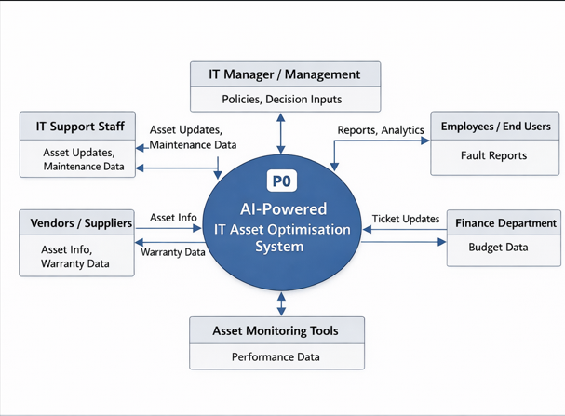

Level 1 DFD:
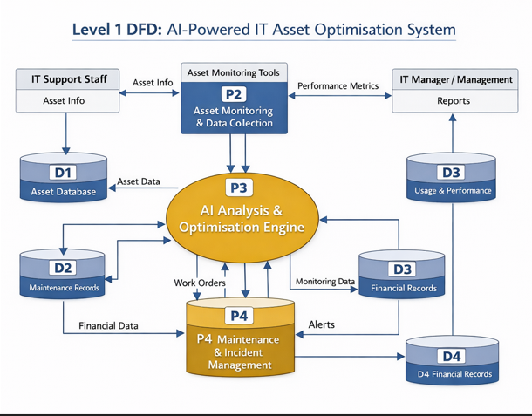

4.5 Requirements Analysis

4.5.1 Functional Requirements (Use Case Diagram)
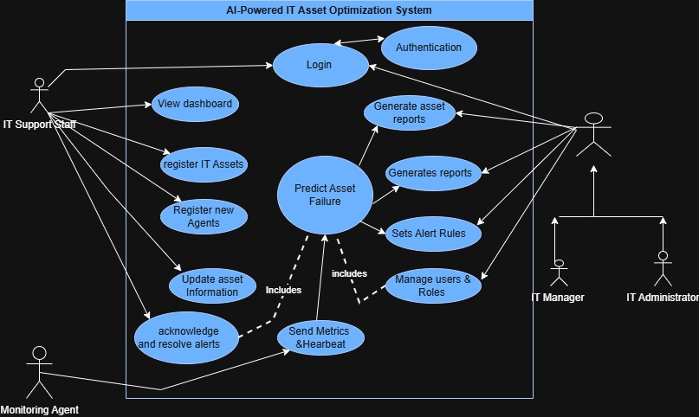

4.5.2 Non-Functional Requirements
- Performance: The system must analyse asset data and deliver optimisation recommendations without noticeable delay, supporting concurrent users and delivering AI-generated insights in near real time.
- Security: All sensitive asset and organisational data must be protected through secure authentication, role-based access control, encryption, and audit logging to prevent unauthorised access (Mather et al., 2009).
- Reliability: The system must remain available throughout working hours, perform automated backups on a regular schedule, and recover gracefully from failures without data loss (Beyer et al., 2016).
- Usability: The interface must be intuitive enough for IT staff to use with minimal training, providing clear messaging, contextual alerts, and accessible AI-generated guidance.
- Scalability: The system must handle a growing number of assets and users without requiring major architectural changes, and the machine learning models must scale to accommodate increasing data volumes.
- Compatibility: The system must function correctly on standard web browsers, integrate with existing IT infrastructure, and support the operating systems in common use within the organisation.

4.6 System Models

4.6.1 UML Activity Diagram
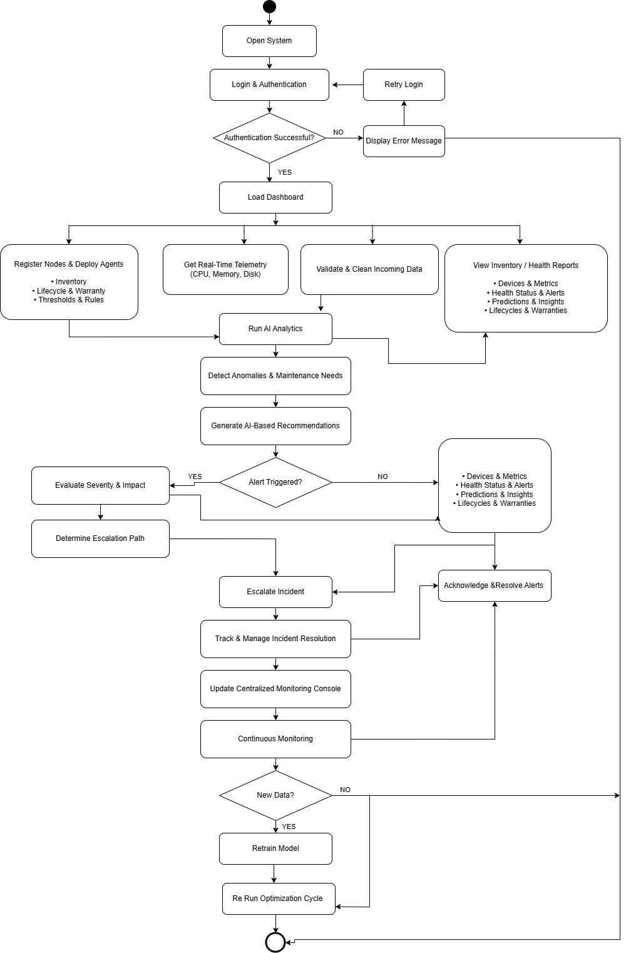

4.6.2 UML Class Diagram
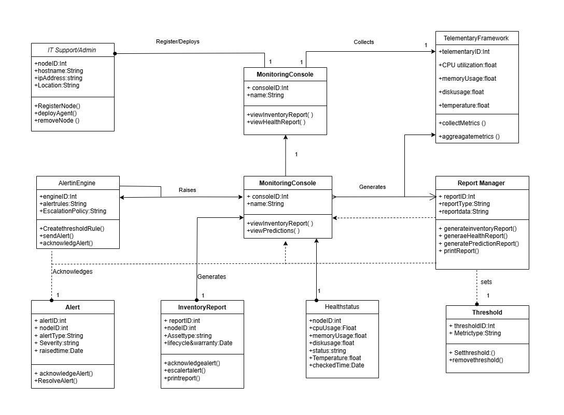

4.6.3 UML Sequence Diagram
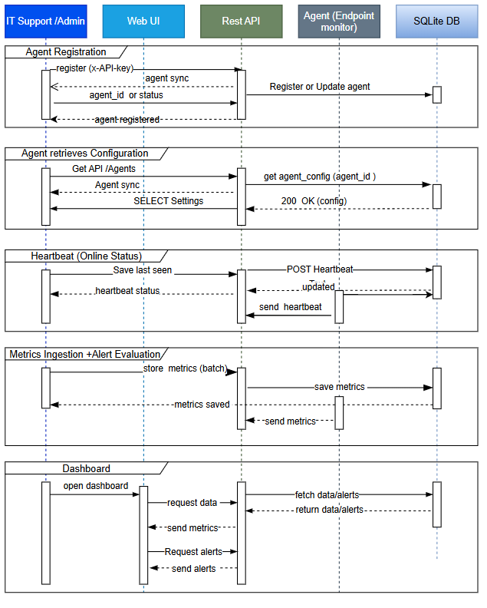

REFERENCES

Anakage (2023) Anakage endpoint automation platform overview. Available at: https://www.anakage.com (Accessed: 10 January 2025).
Axelos (2019) ITIL Foundation: ITIL 4 Edition. London: TSO (The Stationery Office).
Beyer, B., Jones, C., Petoff, J. and Murphy, N.R. (2016) Site Reliability Engineering: How Google Runs Production Systems. Sebastopol, CA: O'Reilly Media.
Breiman, L. (2001) 'Random forests', Machine Learning, 45(1), pp. 5-32.
Etzion, O. and Niblett, P. (2010) Event Processing in Action. Greenwich, CT: Manning Publications.
Freshworks (2023) Freshservice IT asset management. Available at: https://freshservice.com/itam (Accessed: 15 January 2025).
Gartner (2023) Magic Quadrant for IT Service Management Platforms. Stamford, CT: Gartner Research.
Hussain, A., Khan, M.A. and Iqbal, Z. (2022) 'Comparative analysis of IT asset management platforms in enterprise environments', International Journal of Computer Science and Network Security, 22(4), pp. 112-121.
ISO/IEC 19770-1 (2017) Information Technology - IT Asset Management - Part 1: IT Asset Management Systems. Geneva: International Organisation for Standardisation.
Janssen, M. and Joha, A. (2011) 'Challenges for adopting cloud-based software as a service (SaaS) in the public sector', in Proceedings of the 19th European Conference on Information Systems (ECIS), Helsinki, Finland, pp. 1-12.
Lansweeper (2023) Lansweeper IT asset discovery: product documentation. Available at: https://www.lansweeper.com/docs (Accessed: 20 January 2025).
Lwakatare, L.E., Kilamo, T., Karvonen, T., Sauvola, T., Heikkila, V., Itkonen, J., Kuvaja, P., Mikkonen, T., Oivo, M. and Lassenius, C. (2019) 'DevOps in practice: a multiple case study of five companies', Information and Software Technology, 114, pp. 217-230.
Mather, T., Kumaraswamy, S. and Latif, S. (2009) Cloud Security and Privacy: An Enterprise Perspective on Risks and Compliance. Sebastopol, CA: O'Reilly Media.
Mell, P. and Grance, T. (2011) The NIST Definition of Cloud Computing. NIST Special Publication 800-145. Gaithersburg, MD: National Institute of Standards and Technology.
Perera, C., Liu, C.H. and Jayawardena, S. (2015) 'The emerging Internet of Things marketplace from an industrial perspective: a survey', IEEE Transactions on Emerging Topics in Computing, 3(4), pp. 585-598.
Pfleeger, S.L. and Atlee, J.M. (2010) Software Engineering: Theory and Practice. 4th edn. Upper Saddle River, NJ: Pearson.
Raza, M., Adenola, A.F., Nafis, T. and Yusuf, S. (2012) 'The slow adoption of cloud computing and IT workforce', in Proceedings of the 2012 International Conference on Cloud Computing Technologies, Applications and Management, Dubai, UAE, pp. 88-94.
SolarWinds (2023) SolarWinds Service Desk: asset management features. Available at: https://www.solarwinds.com/service-desk (Accessed: 12 January 2025).
Sommerville, I. (2016) Software Engineering. 10th edn. Harlow: Pearson Education.
Storey, V.C. and Song, I.Y. (2017) 'Big data technologies and management: What conceptual modelling can do', Data and Knowledge Engineering, 108, pp. 50-67.
SysAid (2023) SysAid ITSM platform: AI-driven service automation. Available at: https://www.sysaid.com (Accessed: 18 January 2025).
Turner, M., Budgen, D. and Brereton, P. (2003) 'Turning software into a service', IEEE Computer, 36(10), pp. 38-44.
Wieringa, R.J. (2014) Design Science Methodology for Information Systems and Software Engineering. Berlin: Springer.
Zhang, Y., Chen, X. and Liu, J. (2023) 'Proactive endpoint monitoring using collaborative automation agents in enterprise IT environments', Journal of Systems and Software, 196, article 111537.
Zonta, T., da Costa, C.A., da Rosa Righi, R., de Lima, M.J., da Trindade, E.S. and Li, G.P. (2020) 'Predictive maintenance in the Industry 4.0: a systematic literature review', Computers and Industrial Engineering, 150, article 106889.

