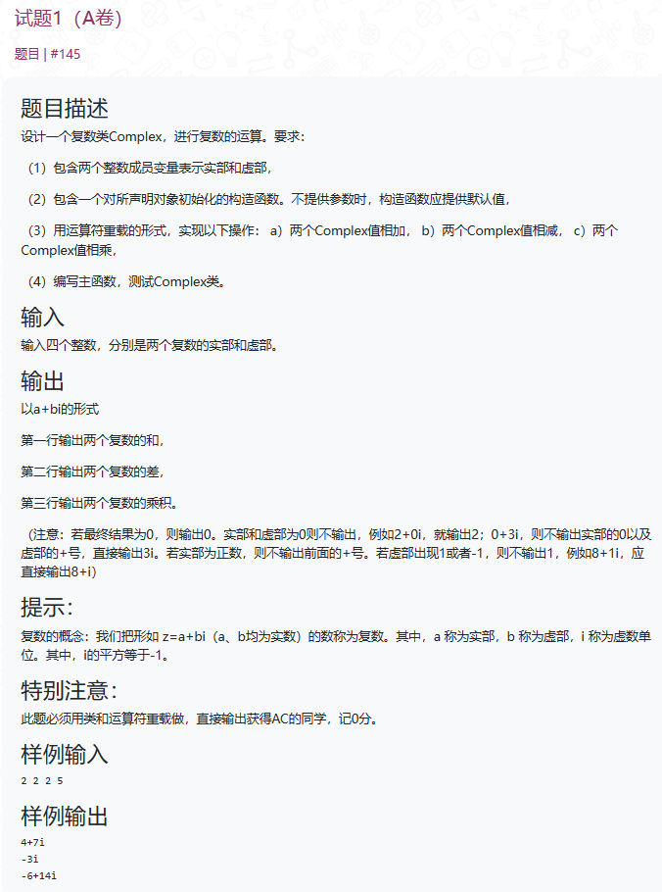
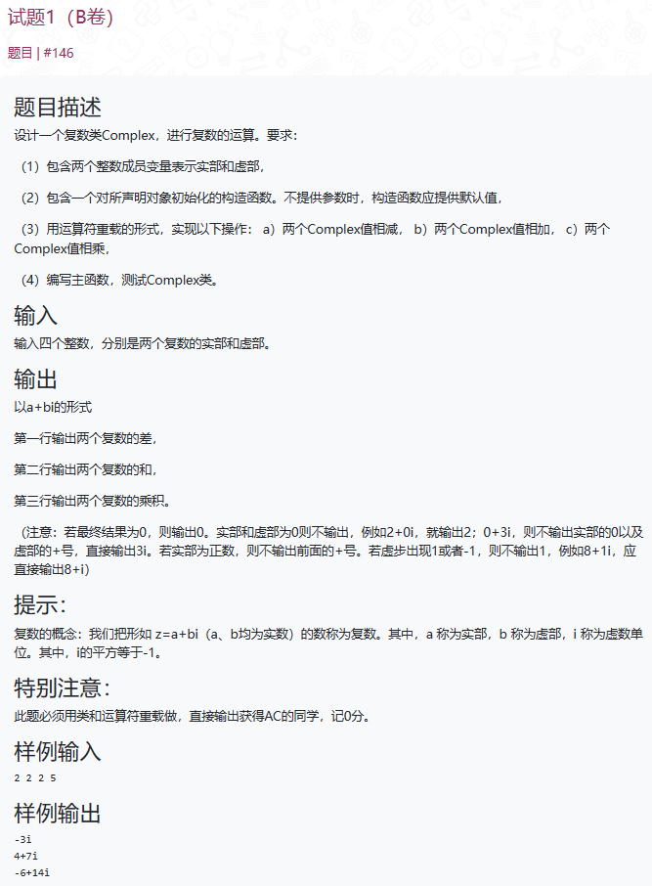
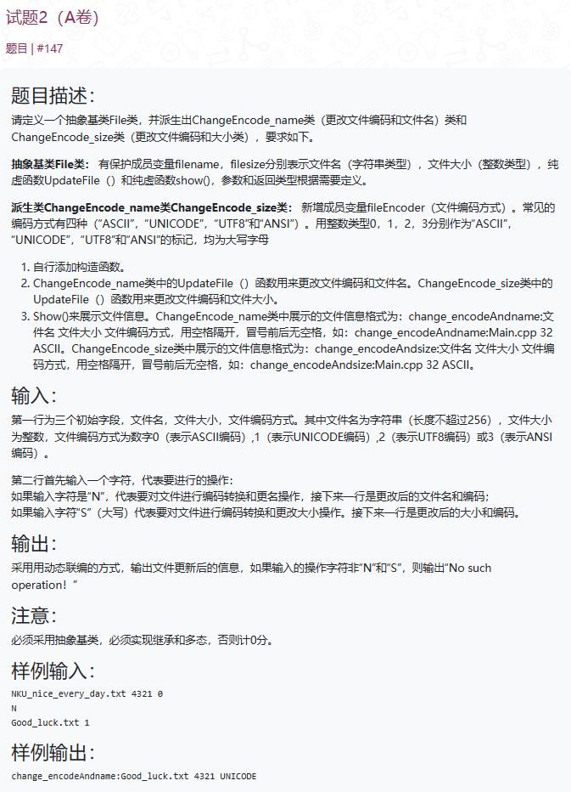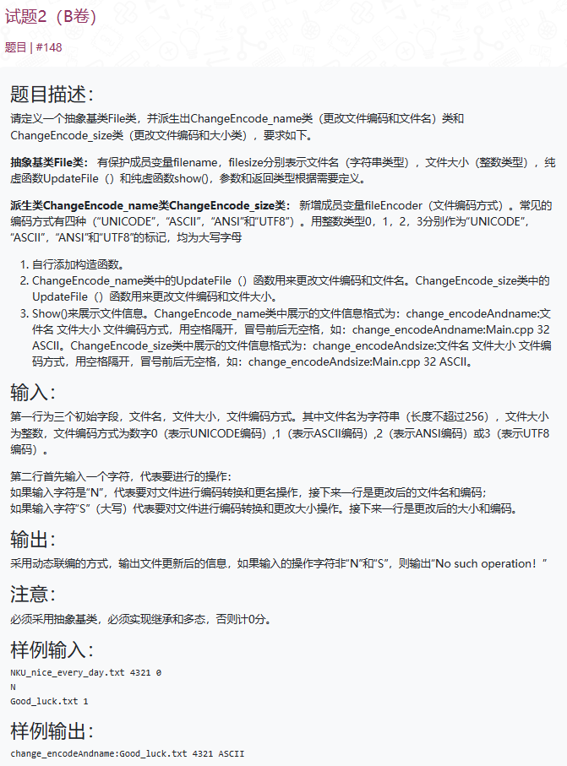
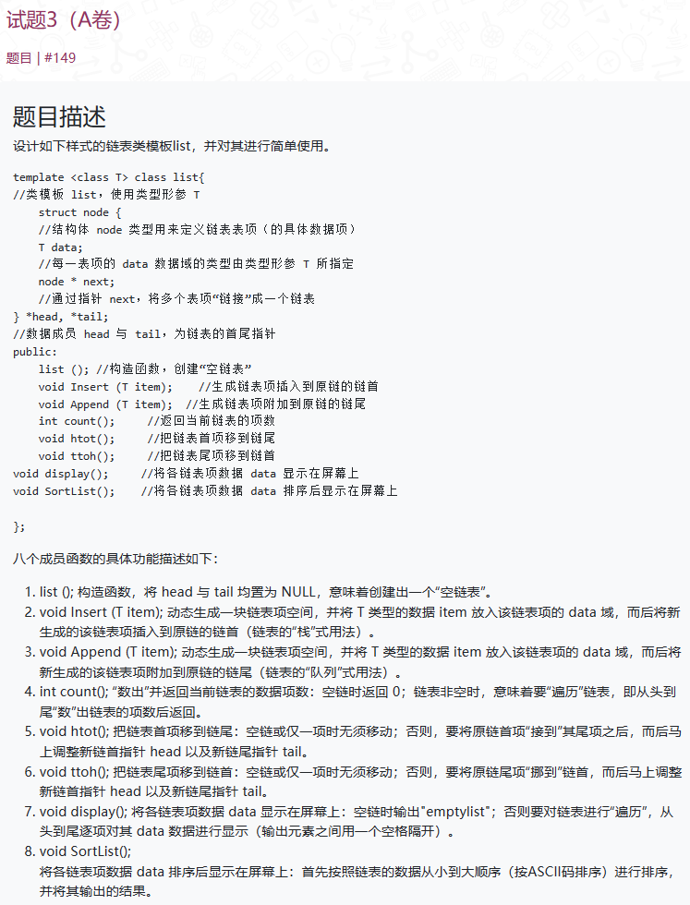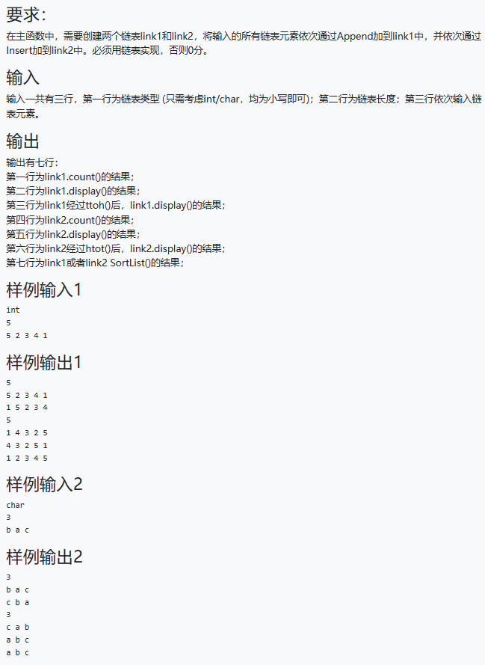

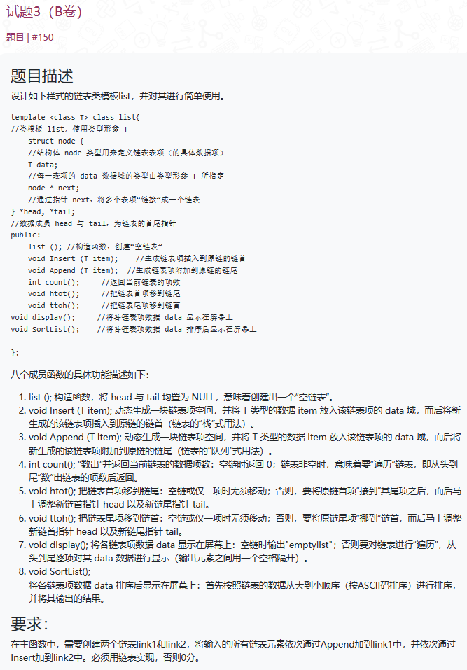
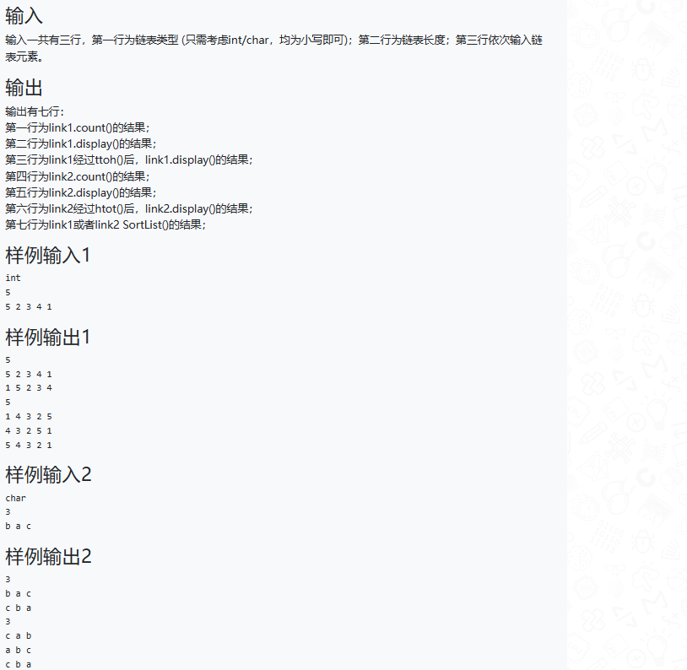

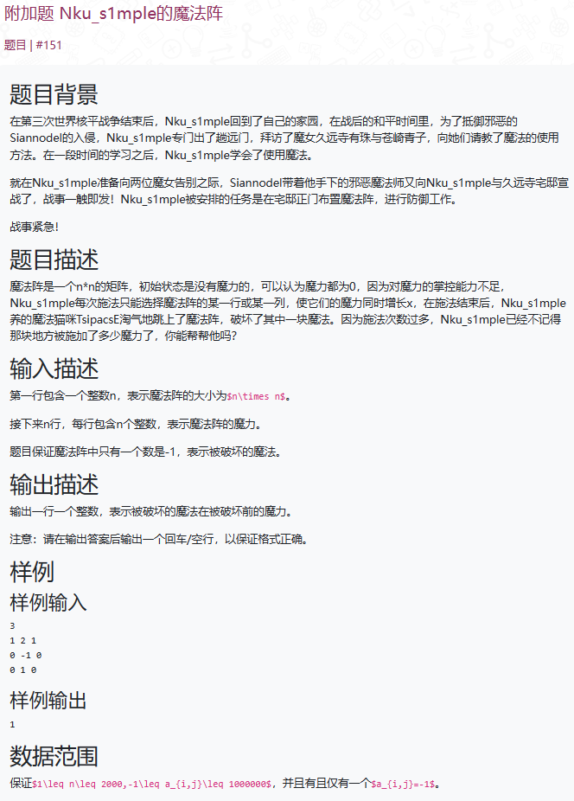

A卷第一题（BY LuHaozhe）
#include <iostream>
using namespace std;
class Complex {
int shi;
int xu;
public:
Complex() {
shi = 0;
xu = 0;
}
void input(int a,int b) {
shi = a;
xu = b;
}
friend Complex operator+(Complex& a, Complex& b) {
Complex temp;
temp.shi = a.shi + b.shi;
temp.xu = a.xu + b.xu;
return temp;
}
friend Complex operator-(Complex& a, Complex& b) {
Complex temp;
temp.shi = a.shi - b.shi;
temp.xu = a.xu - b.xu;
return temp;
}
friend Complex operator*(Complex& a, Complex& b) {
Complex temp;
temp.shi = a.shi * b.shi - a.xu * b.xu;
temp.xu = a.shi * b.xu + b.shi * a.xu;
return temp;
}
void output() {
if (shi == 0) {
if (xu == 0) {
cout << "0" << endl;
}
else {
cout << xu << "i" << endl;
}
}
else {
if (xu == 0) {
cout << shi << endl;
}
else {
if (xu > 0) {
cout << shi << "+" << xu << "i" << endl;
}
else {
cout << shi << xu <<"i" <<endl;
}
}
}
}
};

int main() {
int a1, a2, b1, b2;
cin >> a1 >> a2 >> b1 >> b2;
Complex com1;
Complex com2;
Complex com3;
Complex com4;
Complex com5;
com1.input(a1, a2);
com2.input(b1, b2);
com3 = com1 + com2;
com3.output();
com4 = com1 - com2;
com4.output();
com5 = com1 * com2;
com5.output();
return 0;
}

A卷第二题（BY JiangFengyi）
#include<iostream>
#include<string>
using namespace std;

class File
{
protected:
string filnname;
int filesize;
public:
File(string name, int size) :filnname(name), filesize(size) {};
virtual ~File() {};
virtual void UpdateFile(int encoder, string newname) = 0;
virtual void UpdataFile(int encoder, int newsize) = 0;
virtual void show() = 0;
};

class ChangeEncode_name : public File
{
int fileEncoder;
public:
ChangeEncode_name(string name, int size, int encoder) :File(name, size), fileEncoder(encoder) {};
void UpdateFile(int encoder, string newname)
{
fileEncoder = encoder;
filnname = newname;
}
void UpdataFile(int encoder, int newsize)
{
fileEncoder = encoder;
filesize = newsize;
}
void show()
{
cout << "change_encodeAndsize:" << filnname << " " << filesize << " ";
switch (fileEncoder)
{
case 0:
cout << "ASCII";
break;
case 1:
cout << "UNICODE";
break;
case 2:
cout << "UTF8";
break;
case 3:
cout << "ANSI";
break;
}
cout << endl;
}
};

class ChangeEncode_size :public File
{
int fileEncoder;
public:
ChangeEncode_size(string name, int size, int encoder) :File(name, size), fileEncoder(encoder) {};
void UpdataFile(int encoder, int newsize)
{
fileEncoder = encoder;
filesize = newsize;
}
void UpdateFile(int encoder, string newname)
{
fileEncoder = encoder;
filnname = newname;
}
void show()
{
cout << "change_encodeAndsize:" << filnname << " " << filesize << " ";
switch (fileEncoder)
{
case 0:
cout << "ASCII";
break;
case 1:
cout << "UNICODE";
break;
case 2:
cout << "UTF8";
break;
case 3:
cout << "ANSI";
break;
}
cout << endl;
}
};

int main()
{
string filename;
int filesize;
int encoder;
cin >> filename >> filesize >> encoder;
char ch;
cin >> ch;
if (ch == 'N')
{
ChangeEncode_name file(filename, filesize, encoder);
cin >> filename >> encoder;
file.UpdateFile(encoder, filename);
file.show();
}
if (ch == 'S')
{
ChangeEncode_size file(filename, filesize, encoder);
cin >> filesize >> encoder;
file.UpdataFile(encoder, filesize);
file.show();
}
}

A卷第三题（BY Luhaozhe）
#include<iostream>
#include<string>
using namespace std;

template <class T>
class list {
struct node {
T data;
node* next;
};

node* head;
node* tail;

public:
list() : head(nullptr), tail(nullptr) {}

void Insert(T item) {
node* newNode = new node;
newNode->data = item;
newNode->next = head;
head = newNode;
if (tail == nullptr) {
tail = head;
}
}

void Append(T item) {
node* newNode = new node;
newNode->data = item;
newNode->next = nullptr;
if (tail == nullptr) {
head = tail = newNode;
} else {
tail->next = newNode;
tail = newNode;
}
}

int count() {
int count = 0;
node* current = head;
while (current != nullptr) {
count++;
current = current->next;
}
return count;
}

void htot() {
if (head != nullptr && head != tail) {
node* firstNode = head;
head = head->next;
tail->next = firstNode;
firstNode->next = nullptr;
tail = firstNode;
}
}

void ttoh() {
if (head != nullptr && head != tail) {
node* lastNode = tail;
node* current = head;
while (current->next != tail) {
current = current->next;
}
current->next = nullptr;
tail = current;
lastNode->next = head;
head = lastNode;
}
}

void display() {
if (head == nullptr) {
std::cout << "emptylist";
} else {
node* current = head;
while (current != nullptr) {
std::cout << current->data << " ";
current = current->next;
}
}
std::cout << std::endl;
}

void SortList() {
if (head != nullptr && head != tail) {
node* current = head;
node* index = nullptr;
T temp;

while (current != nullptr) {
index = current->next;
while (index != nullptr) {
if (current->data > index->data) {
temp = current->data;
current->data = index->data;
index->data = temp;
}
index = index->next;
}
current = current->next;
}
display();
}
}
};
int main() {

string listType;
cin >> listType;

int length;
cin >> length;

if (listType == "int") {
list<int> link1;
list<int> link2;
for (int i = 0; i < length; i++) {

int item;
cin >> item;
link1.Append(item);
link2.Insert(item);
}
cout << link1.count() << endl;
link1.display();

link1.ttoh();
link1.display();

cout << link2.count() << endl;
link2.display();

link2.htot();
link2.display();

cout << "Sorted List: ";

link1.SortList();
} else if (listType == "char")
{ list<int> link1;
list<int> link2;
for (int i = 0; i < length; i++) {

char item;
cin >> item;
link1.Append(item);
link2.Insert(item);
}
cout << link1.count() << endl;
link1.display();

link1.ttoh();
link1.display();

cout << link2.count() << endl;
link2.display();

link2.htot();
link2.display();

cout << "Sorted List: ";

link1.SortList();

}

return 0;
}

