Main features:

1. Login screen(with validation, where username: ‘admin’ and password: ‘1234’):

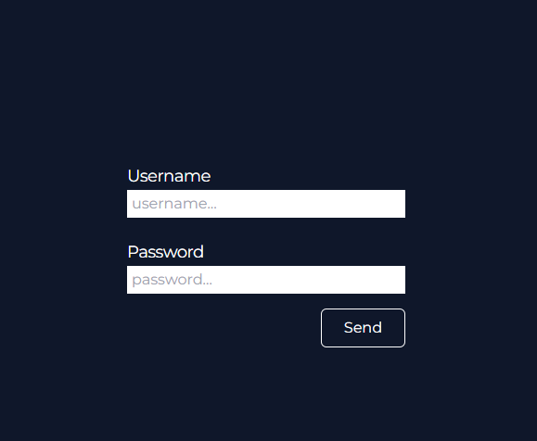

1. Logout



1. News Feeds  
   
2. Article. You can tap on it and will open an article details.  
   
3. On the end of “All Feeds” there is a button “Add”. You can add new article  
   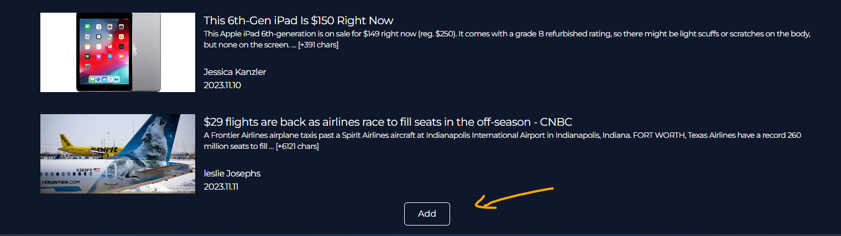
4. When you adding a new news, you can choose a category of article. After it, article will be showed on the correct category, which you can open in header. Unfortunately, due to my problems, I didn't have time to do it with the " section > option", so you have to enter an existing category in the field, which can be seen in the header. Of course there is validation on this form.  
   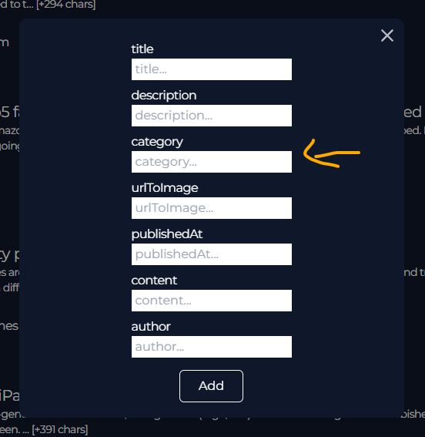
5. If you tap on article and open an article details, you can remove this article from client and backend side. For it, I wrote a logic with Express.js on Node.js. Also you can come back to your feed if you tap on the arrow  
   