太原师范学院计算机系

课 程 设 计

（数据结构与算法）

设计题目: 航班信息排序和检索
专业班级： 计算机科学与技术202001班
学生姓名： 李满祥 （组长）
彭士云、张蕾、王俊强、王博凡 （组员）
指导教师： 亓慧

2021年 12 月 28 日

课程设计任务书及成绩评定

课题名称 | 航班信息排序和检索

一、题目的目的和要求：
1、设计目的
巩固和加深对数据结构的理解，通过上机实验、调试程序，加深对课本知识的理解，最终使学生能够熟练应用数据结构的知识写程序。
（1）通过本课程的学习，能熟练掌握几种基本数据结构的基本操作。
（2）能针对给定题目，选择相应的数据结构，分析并设计算法，进而给出问题的正确求解过程并编写代码实现。
2、设计题目要求：
设计一个航空客运订票系统，以使上述业务可以借助计算机来完成。
(1）每条航线所涉及的信息有:终点站名，航班号，飞机号，飞行周日（星期几)，乘员定额，余票量。乘客信息有:乘客名，预订票数，航班号。
(2）系统的主要功能是:
1)查询航线，根据旅客提出的终点站名输出下列信息:航班号，飞机号，星期几飞行;最近一天航班的日期和余票量。
2)承办订票业务，根据客户提出的要求（航班号，订票量）查询该航班的票余量，如果尚有余票，则为客户办理手续，若已经满员或者余票少于订票额，则需要重新询问客户要求，若需要，则为客户登记排队候补。
3)承办退票业务，根据客户提供的情况（航班，姓名），为客户办理退票手续，然后查询该航班是否有人排队候补，首先询问排在第一的客户，如果退票额能满足他的需求，则为其办理订票，否则依次询问其他候补客户是否订票。

二、设计进度及完成情况

日 期 | 内 容
12月5日 | 选取参考书，查阅有关文献资料，完成资料搜集和系统分析工作。
12月12日 | 任务分工，成员完成各自任务。
12月25-  12月27 | 项目实现
12月28日 | 总结归纳，撰写课程设计报告并进行课程设计答辩，要求每个同学针对自己的设计回答指导教师的提问。  考核结束后将课程设计报告电子版交班长统一刻光盘上交。

指导教师评语
指导教师：
年 月 日
成绩评定
学 号 | 姓 名 | 任务分工 | 成绩
2020151112 | 李满祥 | 项目负责人，整体框架和文件操作，代码整合运行测试修改，实验报告的撰写
2020151121 | 彭士云 | 显示全部航线信息，显示所有订票人员信息，查看候补名单，ppt的设计制作
2020151139 | 张蕾 | 改签功能的实现，创建候补链表和删除候补人员，ppt的设计制作
2020151128 | 王俊强 | 订票功能和退票功能的实现，实验报告的撰写
2020151127 | 王博凡 | 乘客的查询航线和显示订票信息

目 录
第一章 系统分析与总体设计 1
第二章 详细设计 2
第三章 运行与测试 3
第四章 总结与心得 4
参考文献: 5

第一章 系统分析与总体设计
- 数据结构的设计
项目中共有两类数据，一是乘客类，二是航班类。乘客的存储信息采取链表的方式，航班的信息采取数组的方式。原因如下：乘客在订票，退票等等操作时，都需要对进行插入，删除，修改的操作，适合使用链表。而航班的信息不需要经常的变动，所以采用数组的方式存储。
- 算法设计
- 订票功能的实现
根据用户输入的终点站和订购票数，对航班信息进行检索，判断其余票量是否满足乘客的订票需求，若满足则订票成功，否则，询问乘客是否需要候补票。
void booktiket(Pananger*& pananger, AriportRoutes*& airportrouts, string name, Pananger*& backpananger) {
string endden;
int number,choice;//航班票的票数
Pananger* head;
head = pananger->next;

while (head)
{
if (head->getNnme()==name)
{
cout << "请输入您的终点站" << endl;
cin >> endden;
cout << "请输入订购的票数";
cin >> number;
for (int i = 0; i < SIZE; i++)
{
if (airportrouts[i].getendden() == endden)
{
if (airportrouts[i].getremain() < number)
{
cout << "剩余票数不足,是否开始候补票\n1------是 2-----否" << endl;
cin >> choice;
switch (choice)
{
case 1://加入候补票序列
init(backpananger, name, airportrouts[i].getflight(), number);
return;
break;
case 2:
break;
default:
break;
}
}
else {
airportrouts[i].setremain(airportrouts[i].getremain() - number);
head->setFlight(airportrouts[i].getflight());
head->setTitlenumber(number);
cout << "恭喜你订票成功" << endl;
return;

}
}

}
cout << "无此航线" << endl;

return;
}
head = head->next;

}
cout << "查无此人" << endl;
}
- 查询功能
通过用户输入终点站的信息，遍历航班数组，如果存在该航班，显示在终端界面上，反之输出无此航线。
void serchairport(AriportRoutes*& airportrouts) {
string endden;
cout << "请输入终点站" << endl;
cin >> endden;
for (int i = 0; i < SIZE;i++) {
if (airportrouts[i].getendden()==endden)
{
cout << "终点站：" << airportrouts[i].getendden()<<endl;
cout << "航班号：" << airportrouts[i].getflight() << endl;
cout << "飞机号" << airportrouts[i].getplane() << endl;
cout << "飞行周日：" << airportrouts[i].getplanetime() << endl;
cout << "乘客定额：" << airportrouts[i].getpangernumber() << endl;
cout << "剩余票数:" << airportrouts[i].getremain() << endl;
cout << endl;
return;
}

}
cout << "无此航线" << endl;

}
- 退票
由用户输入退票的数量，检索航班数组，将退票的数量加入到余票量中，并检测候补票链表中是否有订购该航班信息的乘客，若有，则判断余票量是否满足乘客的订票额，满足，则订购成功，并从候补票链表中删除该乘客。
void refund(Pananger*& pananger, AriportRoutes*& airportrouts, string name,Pananger *&backpananger) {
Pananger* head,*low;
int number;
head = pananger->next;
low = backpananger;
cout << "请输入要退票的张数" << endl;
cin >> number;
while (head)
{
if (head->getNnme() == name)
{
for (int i = 0; i < SIZE; i++)
{
if (airportrouts[i].getflight() == head->getFlight())
{
if (head->getTitlenumber()>=number)
{
head->setTitlenumber(head->getTitlenumber() - number);
if(head->getTitlenumber()==0) head->setFlight("");

airportrouts[i].setremain(airportrouts[i].getremain() + number);
houbu(pananger, backpananger, airportrouts[i]);
cout << "退票成功";
break;
}
}

}
return;
}

head = head->next;

}
cout << "查无此人" << endl;

}
- 改签功能
①首先将用户订购的票会系统中，该航班余票量增加，
②由系统询问用户需要改签的站点以及订票额。
③根据用户的输入检索航班，改签成功
void changeticket(Pananger*& pananger, AriportRoutes*& airportrouts, string name) {
string endden;
int number;
Pananger* head;
head = pananger->next;
while (head)
{
if (head->getNnme()==name)
{
for (int i = 0; i < SIZE; i++)
{
if (airportrouts[i].getflight() == head->getFlight())
{
airportrouts[i].setremain(airportrouts[i].getremain() + head->getTitlenumber());

}
}

head->setFlight("");
head->setTitlenumber(0);
cout << "请输入终点站" << endl;
cin >> endden;
cout << "请输入订购票数" << endl;
cin >> number;
for (int i = 0; i < SIZE; i++)
{
if (airportrouts[i].getendden()==endden)
{
head->setFlight(airportrouts[i].getflight());
if (airportrouts[i].getremain() < number)
{
cout << "查无此人" << endl;
}
else
{
head->setTitlenumber(number);
}
return;
}

}

}
head = head->next;

}

}
- 显示订票信息
根据用户姓名显示个人信息
void showperson(Pananger*& pananger, string name) {
Pananger* head;
head = pananger->next;
while (head)
{
if (head->getNnme() == name) {
cout << "用户名："<< head->getNnme() << endl;
cout << "订购票数：" << head->getTitlenumber() << endl;
cout << "航班号:" << head->getFlight() << endl;
cout << endl;
return;
}
head = head->next;
}
cout << "查无此人" << endl;

}
三、抽象数据类型的设计
显示全部航班信息
void showairport(AriportRoutes *&airportrouts)
{
for (int i = 0; i < SIZE; i++)
{
cout << "终点站：" << airportrouts[i].getendden()<< endl;
cout << "航班号：" << airportrouts[i].getflight() << endl;
cout << "飞机号" << airportrouts[i].getplane() << endl;
cout << "飞行周日：" << airportrouts[i].getplanetime() << endl;
cout << "乘客定额：" << airportrouts[i].getpangernumber() << endl;
cout << "剩余票数:" << airportrouts[i].getremain() << endl;
cout << endl;
}
}
显示所有订票乘客的信息
void showallpananger(Pananger*& pananger)
{
Pananger* head;
head = pananger->next;
int number=0;
while (head)
{
if (head->getFlight()!="")
{
cout << "乘客姓名：" << head->getNnme() << endl;
cout << "订购票数" << head->getTitlenumber() << endl;
cout << "航班号" << head->getFlight() << endl;
cout << endl;
number++;
}
head = head->next;
}
if (number==0)
{
cout << "无人订票" << endl;
}
}
显示所有候补乘客的信息
void showall(Pananger*& backpananger)
{
Pananger* head;
head = backpananger;

if (!head->next)
{
cout << "无候补乘客" << endl;
}
else
{
while (head)
{
if (head->getNnme()!="")
{
cout << "乘客姓名：" << head->getNnme() << endl;
cout << "候补票数" << head->getTitlenumber() << endl;
cout << "候补航班号" << head->getFlight() << endl;
cout << endl;

}

head = head->next;

}
}
}

第二章 详细设计
- 设计抽象数据类型对应的类定义。
航班信息
class AriportRoutes
{
public:
AriportRoutes();
AriportRoutes(string endden, string flight, string plane, string planetime, int pangernumber,int remain);
//设置航班的信息
void setData(string endden, string flight, string plane, string planetime, int pangernumber, int remain);
string getendden();
string getflight();
string getplane();
string getplanetime();
int getpangernumber();
void setremain(int remain);
int getremain();

private:
string endden;//终点站名
string flight;//航班号
string plane;//飞机号
string planetime;//飞行周日
int pangernumber;//乘员定额
int remain;//余票量
};
乘客类
class Pananger {
public:
Pananger* next;
Pananger();
Pananger(string name, int titlenumber,string flight);
string getNnme();
string getFlight();
int getTitlenumber();
void setName(string name);
void setFlight(string flight);
void setTitlenumber(int titlenumber);
//string getName();
//string getFlight();
//AriportRoutes getAriportRoutes();

private:
string name;
int titlenumber;//订票额
string flight;//航班号

};
- 设计每个成员函数；
//航天信息
void airpote_show();
//乘客菜单
void pannager_show();
//读取文件创建航班信息
void creatairport(AriportRoutes *&airportrouts);
//读取文件创建候补乘客信息
void ceratbackpananger(Pananger*& backpananger);
//根据终点站查询航班信息
void serchairport(AriportRoutes*& airportrouts);
//订票信息
void booktiket(Pananger*& pananger, AriportRoutes*& airportrouts,string name, Pananger*& backpananger);
//退票
void refund(Pananger*& pananger, AriportRoutes*& airportrouts, string name, Pananger*& backpananger);
//3.改 签
void changeticket(Pananger*& pananger, AriportRoutes*& airportrouts, string name);
//显示个人信息
void showperson(Pananger*& pananger, string name);
//初始化乘客类
void creatpananger(Pananger *&pananger);
//传递航班号和用户名姓名创建链表
void init(Pananger *&backpananger,string name,string flight,int ticketnumber);
//根据用户名删除候补票链表
void delatebackpananger(Pananger*& backpananger, string name);
//当检测到有人退票时，遍历候补票链表
void houbu(Pananger*& pananger, Pananger*& backpananger, AriportRoutes& airportrouts);
//将内容写入文件
void write(Pananger* pananger, AriportRoutes airportrouts[], Pananger* backpananger);
//5.查看候补名单
void showall(Pananger*& backpananger);
//显示订票名单
void showallpananger(Pananger*& pananger);
//查看航线信息
void showairport(AriportRoutes *&airportrouts);
- 设计主函数
int main()
{
AriportRoutes *airportrouts = new AriportRoutes[SIZE];//航线信息
Pananger *pananger,*backpananger;//backpananger是候补票序列
pananger = new Pananger();
backpananger = new Pananger();
ceratbackpananger(backpananger);//链表
creatairport(airportrouts);//构建航班信息，数组，不动
creatpananger(pananger);//链表

int choice;//用户选择的变量
string name;
printf("欢迎使用航天管理系统,请选择你的身份\n");
printf("1-----机场管理人员 2------乘客\n");

while (1)
{
cin>>choice;
if (choice == 2)
{
pannager_show();
cout << "请输入姓名："<<endl;
cin >> name;

while (1)
{
cout<<"请输入操作序号："<<endl;
cin >> choice;
switch (choice)
{
case 0://退出系统
write(pananger, airportrouts,backpananger);
cout<<"欢迎下次使用"<<endl;
exit(0);
case 1://1.订 票
booktiket(pananger, airportrouts,name, backpananger);
break;
case 2://2.查询航线
serchairport(airportrouts);
break;
case 3://3.改 签
changeticket(pananger, airportrouts,name);
break;
case 4://4.退 票
refund(pananger, airportrouts,name,backpananger);
break;
case 5://5.显示订票信息
showperson(pananger,name);
break;
case 6:
cout << "请输入姓名：" << endl;
cin >> name;
break;

default:
cout << "输入错误请重新输入" << endl;
break;
}
}

}
else if (choice == 1) {

while (1)
{
airpote_show();
cout << "请输入操作序号：" << endl;
cin >> choice;
switch (choice)
{
case 0://退出系统
cout << "欢迎下次使用" << endl;
exit(0);
case 1://3.查看航天信息
showairport(airportrouts);
break;
case 2://4.查看订票信息
showallpananger(pananger);
break;
case 3://5.查看候补名单
showall(backpananger);
break;

default:
cout<<"输入错误，请重新输入"<<endl;
break;
}
}
}
else
{
printf("输入错误请重新输入");
}
}
system("pause");
return 0;
}
- 所有代码
AriportRoutes.h
#pragma once
#include<iostream>
#include<string>
#include<fstream>
using namespace std;
class AriportRoutes
{
public:
AriportRoutes();
AriportRoutes(string endden, string flight, string plane, string planetime, int pangernumber,int remain);
//设置航班的信息
void setData(string endden, string flight, string plane, string planetime, int pangernumber, int remain);
string getendden();
string getflight();
string getplane();
string getplanetime();
int getpangernumber();
void setremain(int remain);
int getremain();

private:
string endden;//终点站名
string flight;//航班号
string plane;//飞机号
string planetime;//飞行周日
int pangernumber;//乘员定额
int remain;//余票量
};
Pananger.h
#pragma once
#include<iostream>
#include<string>
#include"AriportRoutes.h"
using namespace std;
class Pananger {
public:
Pananger* next;
Pananger();
Pananger(string name, int titlenumber,string flight);
string getNnme();
string getFlight();
int getTitlenumber();
void setName(string name);
void setFlight(string flight);
void setTitlenumber(int titlenumber);
//string getName();
//string getFlight();
//AriportRoutes getAriportRoutes();

private:
string name;
int titlenumber;//订票额
string flight;//航班号

};
tool.h
#pragma once
#include"AriportRoutes.h"
#include"Pananger.h"
static int SIZE=11;
//航天信息
void airpote_show();
//乘客菜单
void pannager_show();
//读取文件创建航班信息
void creatairport(AriportRoutes *&airportrouts);
//读取文件创建候补乘客信息
void ceratbackpananger(Pananger*& backpananger);
//根据终点站查询航班信息
void serchairport(AriportRoutes*& airportrouts);
//订票信息
void booktiket(Pananger*& pananger, AriportRoutes*& airportrouts,string name, Pananger*& backpananger);
//退票
void refund(Pananger*& pananger, AriportRoutes*& airportrouts, string name, Pananger*& backpananger);
//3.改 签
void changeticket(Pananger*& pananger, AriportRoutes*& airportrouts, string name);
//显示个人信息
void showperson(Pananger*& pananger, string name);
//初始化乘客类
void creatpananger(Pananger *&pananger);
//传递航班号和用户名姓名创建链表
void init(Pananger *&backpananger,string name,string flight,int ticketnumber);
//根据用户名删除候补票链表
void delatebackpananger(Pananger*& backpananger, string name);
//当检测到有人退票时，遍历候补票链表
void houbu(Pananger*& pananger, Pananger*& backpananger, AriportRoutes& airportrouts);
//将内容写入文件
void write(Pananger* pananger, AriportRoutes airportrouts[], Pananger* backpananger);
//5.查看候补名单
void showall(Pananger*& backpananger);
//显示订票名单
void showallpananger(Pananger*& pananger);
//查看航线信息
void showairport(AriportRoutes *&airportrouts);
AriportRoutes.cpp
#include"AriportRoutes.h"
AriportRoutes::AriportRoutes() {

}
AriportRoutes::AriportRoutes(string endden, string flight, string plane, string planetime, int pangernumber,int remain)
{

this->endden = endden;
this->flight = flight;
this->plane = plane;
this->planetime = planetime;
this->pangernumber = pangernumber;
this->remain = remain;
}

void AriportRoutes::setData(string endden, string flight, string plane, string planetime, int pangernumber,int remain)
{
this->endden = endden;
this->flight = flight;
this->plane = plane;//""
this->planetime = planetime;
this->pangernumber = pangernumber;
this->remain = remain;

}
string AriportRoutes::getendden() {
return this->endden;
}
string AriportRoutes::getflight() {
return this->flight;
}
string AriportRoutes::getplane() {
return this->plane;
}
string AriportRoutes::getplanetime() {
return this->planetime;
}
int AriportRoutes::getpangernumber() {
return this->pangernumber;
}
int AriportRoutes::getremain() {
return this->remain;
}
void AriportRoutes::setremain(int remain) {
this->remain = remain;
}
Pananger.cpp
#include"Pananger.h"
Pananger::Pananger() {

}
Pananger::Pananger(string name,int titlenumber,string flight) {
this->name = name;
this->flight = flight;
this->titlenumber = titlenumber;
}
string Pananger::getNnme() {
return this->name;
}
string Pananger::getFlight() {
return this->flight;
}
void Pananger::setName(string name) {
this->name = name;

}
void Pananger::setFlight(string flight) {
this->flight = flight;
}
int Pananger::getTitlenumber() {
return this->titlenumber;
}
void Pananger::setTitlenumber(int titlenumber) {
this->titlenumber = titlenumber;
}
tool.cpp
#include"tool.h"
#include"AriportRoutes.h"
#include"Pananger.h"
//航天信息
void airpote_show() {
cout<<"-------------欢迎使用航天管理系统-----------"<<endl;
cout << "-------------1.查看航线信息-----------------" << endl;
cout << "-------------2.查看订票信息----------------- "<< endl;
cout << "-------------3.查看候补名单----------------- "<< endl;
cout << "-------------0.退出系统--------------------- "<< endl;
}
//乘客菜单
void pannager_show() {
cout << "-------------欢迎使用航天管理系统-----------" << endl;
cout << "-------------1.订 票---------------------" << endl;
cout << "-------------2.查询航线---------------------" << endl;
cout << "-------------3.改 签----------------------" << endl;
cout << "-------------4.退 票----------------------" << endl;
cout << "-------------5.显示订票信息------------------" << endl;
cout << "-------------6.切换用户------------------" << endl;
cout << "-------------0.退出系统----------------------" << endl;
}
//读取文件创建航班信息
void creatairport(AriportRoutes *&airportrouts) {
ifstream file;
string endden, flight, plane, planetime, pangernumber,remain;
int i=0, pangernumber1,remain1;
file.open("domo.txt", ios::in);
if (!file.is_open()) {
cout << "打开文件失败" << endl;
}
else
{
while (!file.eof())
{
getline(file, endden);
getline(file, flight);
getline(file, plane);
getline(file, planetime);
getline(file, pangernumber);
getline(file, remain);
pangernumber1 = atoi(pangernumber.c_str());
remain1 = atoi(remain.c_str());
airportrouts[i].setData(endden, flight, plane, planetime, pangernumber1,remain1);
i++;
}

}
SIZE = i;
//cout << SIZE << endl;
}
//根据终点站查询航班信息
void serchairport(AriportRoutes*& airportrouts) {
string endden;
cout << "请输入终点站" << endl;
cin >> endden;
for (int i = 0; i < SIZE;i++) {
if (airportrouts[i].getendden()==endden)
{
cout << "终点站：" << airportrouts[i].getendden()<<endl;
cout << "航班号：" << airportrouts[i].getflight() << endl;
cout << "飞机号" << airportrouts[i].getplane() << endl;
cout << "飞行周日：" << airportrouts[i].getplanetime() << endl;
cout << "乘客定额：" << airportrouts[i].getpangernumber() << endl;
cout << "剩余票数:" << airportrouts[i].getremain() << endl;
cout << endl;
return;
}

}
cout << "无此航线" << endl;

}
//读取文件创建候补乘客信息
void ceratbackpananger(Pananger*& backpananger)
{
Pananger* head, * temp;
int titlenumber1;
head = backpananger;
string name, flight, titlenumber;
ifstream file;
file.open("backpananger.txt", ios::in);
if (head)
{
if (!file.is_open())
{
cout << "打开文件失败" << endl;
}

else {
while (!file.eof())
{
getline(file, name);
getline(file, titlenumber);
getline(file, flight);
titlenumber1 = atoi(titlenumber.c_str());
if (name!="")
{
temp = new Pananger(name, titlenumber1, flight);
temp->next = NULL;
head->next = temp;
head = temp;
//cout << "姓名：" << head->getNnme();
}

}

}

}

}

//订票功能的实现,创建候补票链表
void booktiket(Pananger*& pananger, AriportRoutes*& airportrouts, string name, Pananger*& backpananger) {
string endden;
int number,choice;//航班票的票数
Pananger* head;
head = pananger->next;

while (head)
{
if (head->getNnme()==name)
{

cout << "请输入您的终点站" << endl;
cin >> endden;
cout << "请输入订购的票数";
cin >> number;
for (int i = 0; i < SIZE; i++)
{
if (airportrouts[i].getendden() == endden)
{
if (airportrouts[i].getremain() < number)
{
cout << "剩余票数不足,是否开始候补票\n1------是 2-----否" << endl;
cin >> choice;
switch (choice)
{
case 1://加入候补票序列
init(backpananger, name, airportrouts[i].getflight(), number);
return;
break;
case 2:
break;
default:
break;
}
}
else {
airportrouts[i].setremain(airportrouts[i].getremain() - number);
head->setFlight(airportrouts[i].getflight());
head->setTitlenumber(number);
cout << "恭喜你订票成功" << endl;
return;

}

}

}
cout << "无此航线" << endl;

return;
}
head = head->next;

}
cout << "查无此人" << endl;
}
//退票,//检索候补票链表，给了第一个
void refund(Pananger*& pananger, AriportRoutes*& airportrouts, string name,Pananger *&backpananger) {
Pananger* head,*low;
int number;
head = pananger->next;
low = backpananger;
cout << "请输入要退票的张数" << endl;
cin >> number;
while (head)
{
if (head->getNnme() == name)
{
for (int i = 0; i < SIZE; i++)
{
if (airportrouts[i].getflight() == head->getFlight())
{
if (head->getTitlenumber()>=number)
{
head->setTitlenumber(head->getTitlenumber() - number);
if(head->getTitlenumber()==0) head->setFlight("");

airportrouts[i].setremain(airportrouts[i].getremain() + number);
houbu(pananger, backpananger, airportrouts[i]);
cout << "退票成功";
break;
}
}

}
return;
}

head = head->next;

}
cout << "查无此人" << endl;

}
//3.改 签
void changeticket(Pananger*& pananger, AriportRoutes*& airportrouts, string name) {
string endden;
int number;
Pananger* head;
head = pananger->next;
while (head)
{
if (head->getNnme()==name)
{
for (int i = 0; i < SIZE; i++)
{
if (airportrouts[i].getflight() == head->getFlight())
{
airportrouts[i].setremain(airportrouts[i].getremain() + head->getTitlenumber());

}
}

head->setFlight("");
head->setTitlenumber(0);
cout << "请输入终点站" << endl;
cin >> endden;
cout << "请输入订购票数" << endl;
cin >> number;
for (int i = 0; i < SIZE; i++)
{
if (airportrouts[i].getendden()==endden)
{
head->setFlight(airportrouts[i].getflight());
if (airportrouts[i].getremain() < number)
{
cout << "查无此人" << endl;
}
else
{
head->setTitlenumber(number);
}
return;
}

}

}
head = head->next;

}

}
//显示个人信息
void showperson(Pananger*& pananger, string name) {
Pananger* head;
head = pananger->next;
while (head)
{
if (head->getNnme() == name) {
cout << "用户名："<< head->getNnme() << endl;
cout << "订购票数：" << head->getTitlenumber() << endl;
cout << "航班号:" << head->getFlight() << endl;
cout << endl;
return;
}
head = head->next;
}
cout << "查无此人" << endl;

}
//创建乘客类
void creatpananger(Pananger*& pananger) {
Pananger *head ,*temp;
int titlenumber1;
head = pananger;
string name, flight, titlenumber;
ifstream file;
file.open("pananger.txt", ios::in);
if (!file.is_open())
{
cout << "打开文件失败" << endl;
}

else {
while (!file.eof())
{
getline(file, name);
getline(file, titlenumber);
getline(file, flight);
titlenumber1 = atoi(titlenumber.c_str());
temp = new Pananger(name, titlenumber1, flight);
temp->next = NULL;
head->next = temp;
head = temp;

}

}

}
//传递航班号和用户名姓名创建链表
void init(Pananger*& backpananger, string name, string flight, int ticketnumber)
{
Pananger* head, * temp;

head = backpananger;
while (head->next)
{

head = head->next;

}
temp = new Pananger(name,ticketnumber,flight);
temp->next = NULL;
head->next = temp;
cout <<"航班号为" << temp->getFlight() << "候补票添加成功" << endl;
}
//根据用户名删除候补票链表
void delatebackpananger(Pananger*& backpananger, string name)
{
Pananger* head, * temp;
head = backpananger;
temp = NULL;
if (head->next->getNnme()==name)
{
temp = head->next;
head->next = head->next->next;
delete temp;

}
else
{
while (head)
{
if (head->next->getNnme() == name)
{
temp = head->next;
head->next = temp->next;
delete temp;
cout << "删除成功" << endl;

}
head = head->next;
}
}
/*while (head)
{
if (head->next->getNnme() == name)
{
temp = head;
head->next->next = temp->next;
temp->next = NULL;
delete temp;
cout << "删除成功" << endl;
return;
}
head = head->next;
}*/
}
//当检测到有人退票时，遍历候补票链表
void houbu(Pananger*& pananger, Pananger*& backpananger, AriportRoutes& airportrouts)
{
Pananger* backhead, * head;
backhead = backpananger->next;
head = pananger;
while (backhead)
{
if (airportrouts.getflight() == backhead->getFlight())
{
while (head)
{
if (airportrouts.getremain() >= backhead->getTitlenumber())
{
if (head->getNnme() == backhead->getNnme())
{
head->setTitlenumber(backhead->getTitlenumber());
head->setFlight(backhead->getFlight());
airportrouts.setremain(airportrouts.getremain() - head->getTitlenumber());
cout << head->getNnme() << "的" << head->getTitlenumber() << "候补票订购成功" << endl;
delatebackpananger(backpananger, head->getNnme());
return;
}
}
else
{
if (head->getNnme() == backhead->getNnme())
{
head->setTitlenumber(airportrouts.getremain());
head->setFlight(backhead->getFlight());
cout << head->getNnme() << "的" << head->getTitlenumber() << "候补票订购成功" << endl;
delatebackpananger(backpananger, head->getNnme());
return;
}
}
head = head->next;
}

}
backhead = backhead->next;
}
}
//将内容写入文件
void write(Pananger* pananger, AriportRoutes airportrouts[],Pananger *backpananger)
{
int error=0;
Pananger* head;
head = pananger->next;
ofstream file;
file.open("pananger.txt",ios::out);
while (head)
{
file << head->getNnme() << endl;
file << head->getTitlenumber() << endl;
file << head->getFlight();
if (head->next)
{
file << endl;
}
head = head->next;
}
file.close();

ofstream filea;
filea.open("domo.txt", ios::out);
for (int i = 0; i < SIZE; i++)
{
filea << airportrouts[i].getendden() << endl;
filea << airportrouts[i].getflight() << endl;
filea << airportrouts[i].getplane() << endl;
filea << airportrouts[i].getplanetime() << endl;
filea << airportrouts[i].getpangernumber() << endl;
filea << airportrouts[i].getremain();
if (i != SIZE - 1)
{
filea << endl;

}
}
filea.close();
//将backpananger写入文件
Pananger* headb,*head1,*temp;
headb = backpananger->next;

ofstream fileb;
fileb.open("backpananger.txt", ios::out);
/*if (error<2)
{
cout << "没有数据" << endl;
}
else
{*/
while (headb)
{
cout << headb->getNnme() << endl;
if (headb->getNnme()!="")
{

fileb << headb->getNnme() << endl;
fileb << headb->getTitlenumber() << endl;
fileb << headb->getFlight() << endl;

}

headb = headb->next;

}

fileb.close();

}
//5.查看候补名单
void showall(Pananger*& backpananger)
{
Pananger* head;
head = backpananger;

if (!head->next)
{
cout << "无候补乘客" << endl;
}
else
{
while (head)
{
if (head->getNnme()!="")
{
cout << "乘客姓名：" << head->getNnme() << endl;
cout << "候补票数" << head->getTitlenumber() << endl;
cout << "候补航班号" << head->getFlight() << endl;
cout << endl;

}

head = head->next;

}
}
}
//显示订票名单
void showallpananger(Pananger*& pananger)
{
Pananger* head;
head = pananger->next;
int number=0;
while (head)
{
if (head->getFlight()!="")
{
cout << "乘客姓名：" << head->getNnme() << endl;
cout << "订购票数" << head->getTitlenumber() << endl;
cout << "航班号" << head->getFlight() << endl;
cout << endl;
number++;
}
head = head->next;
}
if (number==0)
{
cout << "无人订票" << endl;
}
}
//查看航线信息
void showairport(AriportRoutes *&airportrouts)
{
for (int i = 0; i < SIZE; i++)
{
cout << "终点站：" << airportrouts[i].getendden()<< endl;
cout << "航班号：" << airportrouts[i].getflight() << endl;
cout << "飞机号" << airportrouts[i].getplane() << endl;
cout << "飞行周日：" << airportrouts[i].getplanetime() << endl;
cout << "乘客定额：" << airportrouts[i].getpangernumber() << endl;
cout << "剩余票数:" << airportrouts[i].getremain() << endl;
cout << endl;
}
}
main.h

#include"tool.h"

using namespace std;

int main()
{
AriportRoutes *airportrouts = new AriportRoutes[SIZE];//航线信息
Pananger *pananger,*backpananger;//backpananger是候补票序列
pananger = new Pananger();
backpananger = new Pananger();
ceratbackpananger(backpananger);//链表
creatairport(airportrouts);//构建航班信息，数组，不动
creatpananger(pananger);//链表

int choice;//用户选择的变量
string name;
printf("欢迎使用航天管理系统,请选择你的身份\n");
printf("1-----机场管理人员 2------乘客\n");

while (1)
{
cin>>choice;
if (choice == 2)
{
pannager_show();
cout << "请输入姓名："<<endl;
cin >> name;

while (1)
{
cout<<"请输入操作序号："<<endl;
cin >> choice;
switch (choice)
{
case 0://退出系统
write(pananger, airportrouts,backpananger);
cout<<"欢迎下次使用"<<endl;
exit(0);
case 1://1.订 票
booktiket(pananger, airportrouts,name, backpananger);
break;
case 2://2.查询航线
serchairport(airportrouts);
break;
case 3://3.改 签
changeticket(pananger, airportrouts,name);
break;
case 4://4.退 票
refund(pananger, airportrouts,name,backpananger);
break;
case 5://5.显示订票信息
showperson(pananger,name);
break;
case 6:
cout << "请输入姓名：" << endl;
cin >> name;
break;

default:
cout << "输入错误请重新输入" << endl;
break;
}
}

}
else if (choice == 1) {

while (1)
{
airpote_show();
cout << "请输入操作序号：" << endl;
cin >> choice;
switch (choice)
{
case 0://退出系统
cout << "欢迎下次使用" << endl;
exit(0);
case 1://3.查看航天信息
showairport(airportrouts);
break;
case 2://4.查看订票信息
showallpananger(pananger);
break;
case 3://5.查看候补名单
showall(backpananger);
break;

default:
cout<<"输入错误，请重新输入"<<endl;
break;
}
}
}
else
{
printf("输入错误请重新输入");
}
}
system("pause");
return 0;
}

第三章 运行与测试

- 在调试过程中，从TXT文件中读取到的数据类型都是string类型，无法将string类型转为int类型，通过查阅资料，最后使用了atoi函数
- 候补链表的的数据无法写入文件当中，通过询问老师解决。
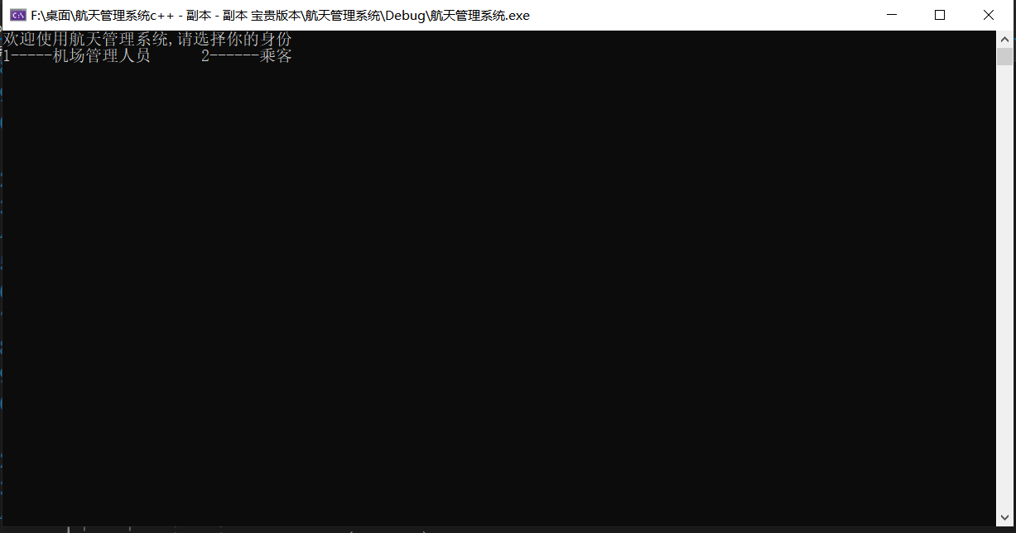
订票功能
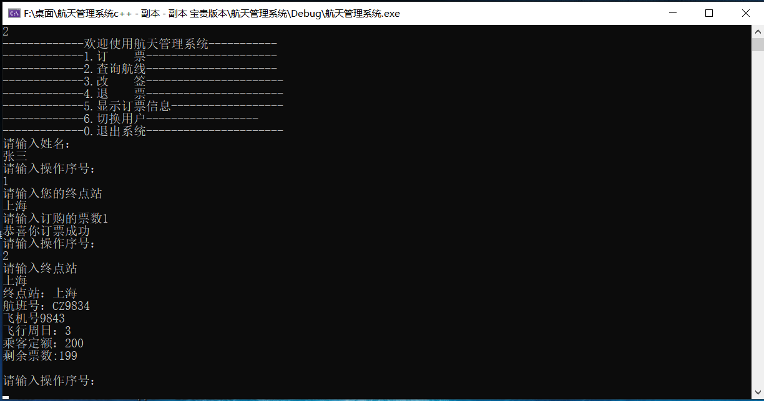
退票功能
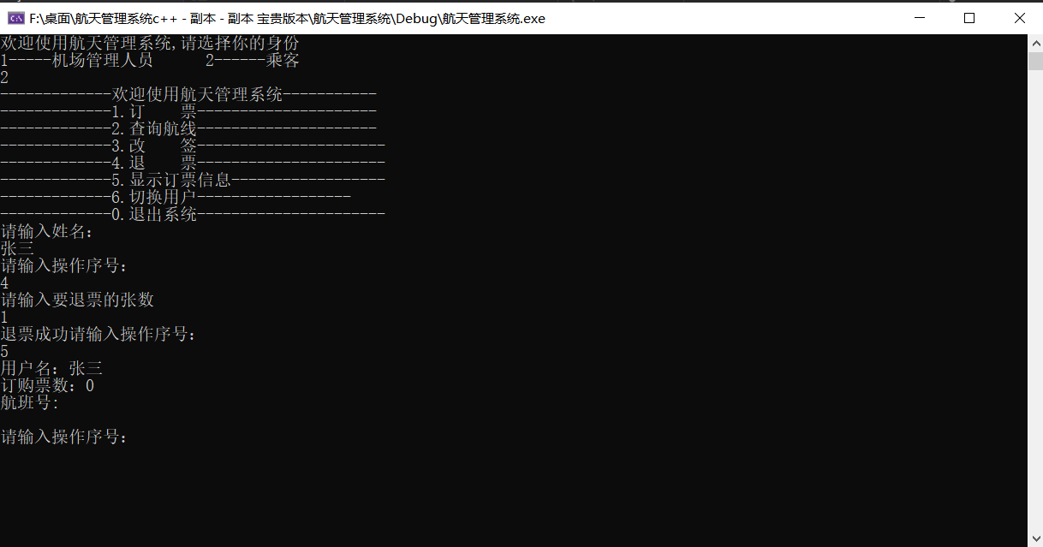
查询航线信息
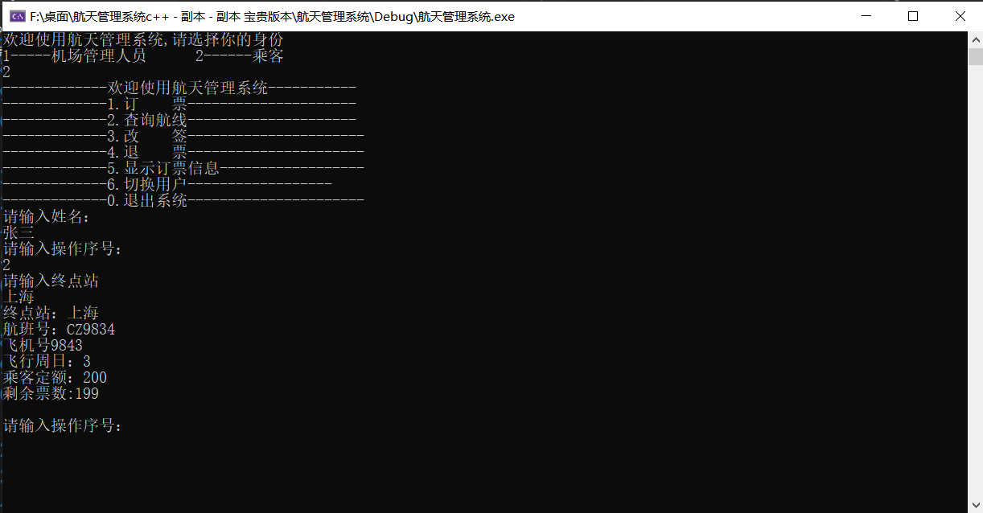
将乘客添加至候补票与候补票订购成功

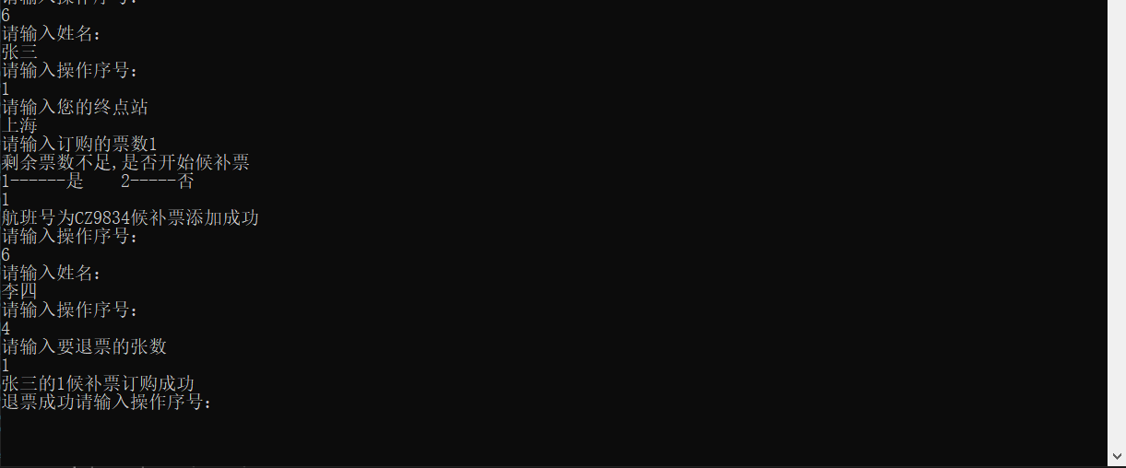

改签的功能
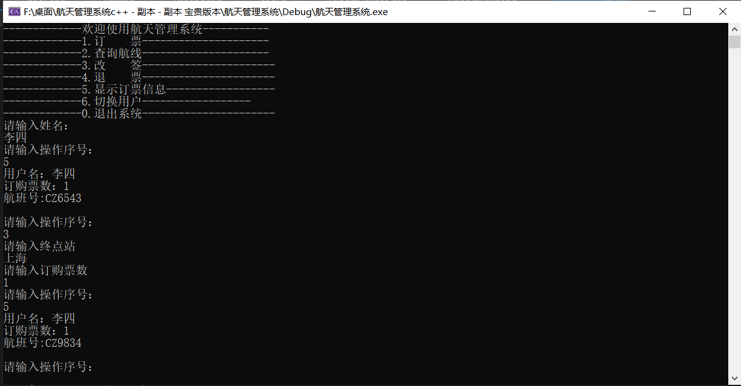
显示全部航班信息

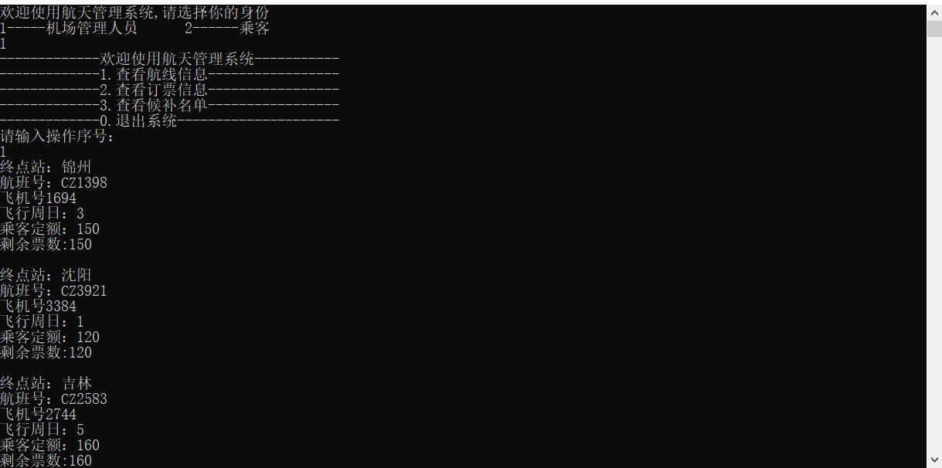
显示全部订票乘客信息
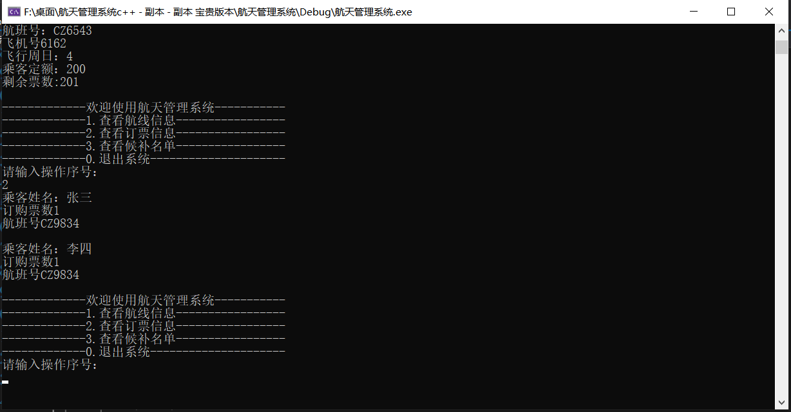

显示全部候补乘客信息
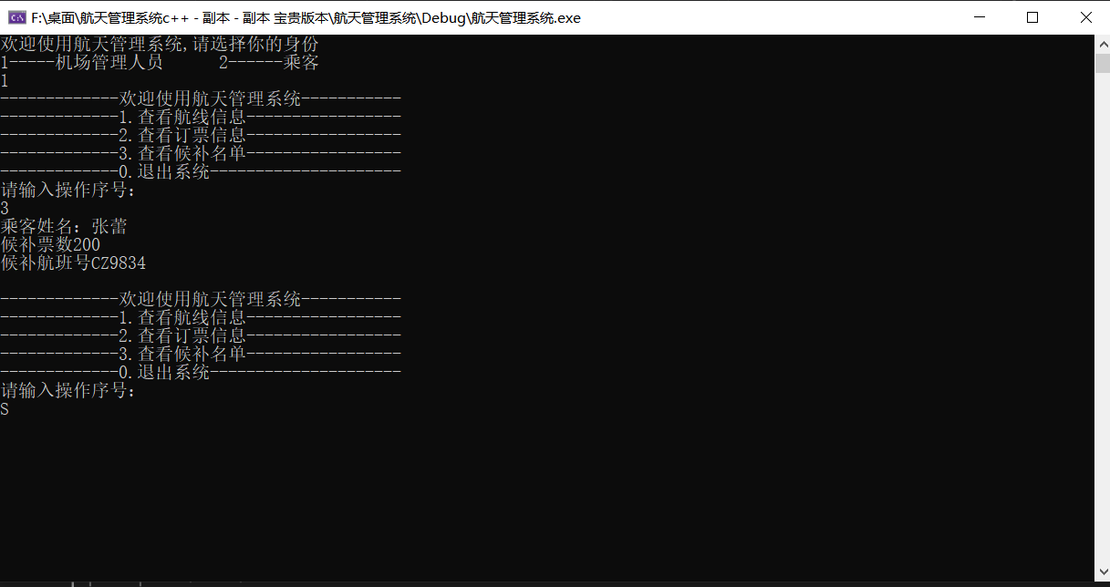

第四章 总结与心得
在课程设计的过程中，我们组首先将这个课题进行了分析，将航班信息系统分为订票，退票，改签，查询，添加候补乘客，界面的设计等几个部分，进行了明确的分工，每位成员都对这次课程设计高度重视，
在对本次课程设计之后，经过小组分工的合作，在代码编写过程中，我们发现对c++的一些知识有了遗忘，通过查询资料，将这次课程设计中c++的知识回顾了一遍。在课程设计中遇到的问题，我们小组成员之间相互配合，共同研究，最后解决了问题。在这短短几天的日子里，巩固了以前所学过的知识，而且学到了很多在书本上所没有学到过的知识。
这次的课程设计中对链表的基本操作得到了很好的练习，其中的代码逻辑我们也理解的更加清晰。在代码编写的过程中对于c++的基本知识还不太理解。今后应多尝试编写代码，在实践中更好的理解编程。不断积累经验，为以后的工作学习研究打基础。

参考文献:
[1] 严蔚敏,李冬梅,吴伟民.数据结构(C语言版)（第2版）,北京:人民邮电出版社,2015
[2] 谭浩强，C++语言程序设计（第五版），北京:清华大学出版社2014

