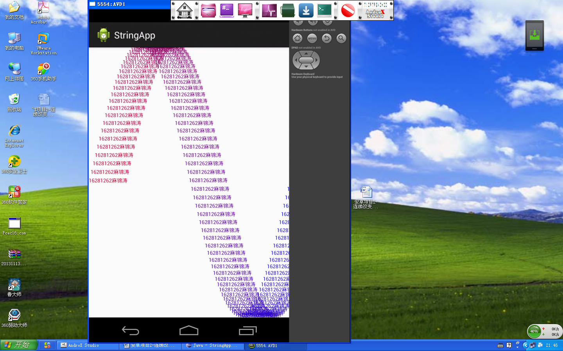

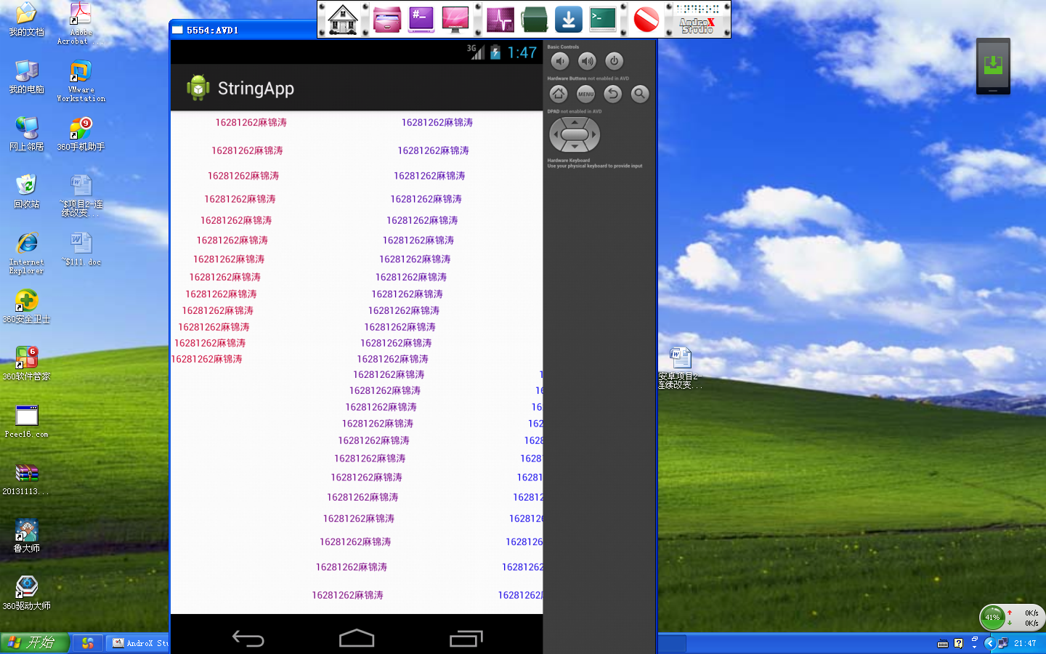
修改部分的源代码及代码注释：
private void calcPos() {
for(int i = 0; i != NUM; ++i) {
point[i] = new Point();
point[i].x = i * cxView / NUM;
point[i].y = (int) (cyView / 2 * ( 1 - Math.sin(TWOPI * i / NUM)));
}
}
将此处的sin改成tan：private void calcPos() {
for(int i = 0; i != NUM; ++i) {
point[i] = new Point();
point[i].x = i * cxView / NUM;
point[i].y = (int) (cyView / 2 * ( 1 - Math.tan(TWOPI * i / NUM)));
}
}
即可从图一到图二。

