|  |  |  |  |  |  |  |  |  |  |  |  |  |  |  |  |  |  |  |  |  |  |  |  |  |  |
| --- | --- | --- | --- | --- | --- | --- | --- | --- | --- | --- | --- | --- | --- | --- | --- | --- | --- | --- | --- | --- | --- | --- | --- | --- | --- |
| |  |  | | --- | --- | | For office use only | | | T1 | ________________ | | T2 | ________________ | | T3 | ________________ | | T4 | ________________ | | |  | | --- | | Team Control Number  **00000** | |  | | Problem Chosen  **A** | | |  |  | | --- | --- | | For office use only | | | F1 | ________________ | | F2 | ________________ | | F3 | ________________ | | F4 | ________________ | |

**2018 Mathematical Contest in Modeling (MCM) Summary Sheet**

**Title**（此处应写论文标题）

**Summary**

美赛论文的摘要的英文一般用Summary，摘要最好在本页完成。

**标题**为16号Times New Roman字体加粗并居中

**摘要**为14号Times New Roman字体加粗并居中

**关键词**为12号Times New Roman字体加粗并居左

**行间距一般为1倍行距，为控制在一页可适当调整。**

首页不需要页眉和页码。

“00000”修改为自己的控制编号（Team Control Number），“A”改为自己的选题题号（A/B/C/D/E/F）

**Key words:** 三到五个关键词

注：红色字为解释说明部分，使用时应全部删除或换成黑色字。

**Contents**

I. Introduction 4

1.1 Background 4

1.2 Our works 4

II. The Description of the Problem 5

2.1 Problem statement 5

2.2 Analysis of Specific Issues 5

2.2.1 Analysis of Problem 1 5

2.2.2 Analysis of Problem 2 5

2.2.3 Analysis of Problem 3 5

2.2.4 Analysis of Problem 4 6

III. Basic assumption 6

IV. Glossary & Symbols 6

4.1 Glossary 6

4.2 Symbols 7

V. Models 7

5.1 Analysis and Solving of Question One 7

5.1.1 Model Preparation 7

5.1.2 Model Establishment 8

5.1.3 Model solving 8

5.1.4 Analysis of the Result 9

5.2 Analysis and Solving of Question Two 9

5.2.1 Model Preparation 9

5.2.2 Model Establishment and Solving 10

5.2.3 Analysis of the Result 11

5.3 Analysis and Solving of Question Three 11

5.3.1 Model Preparation 11

5.3.2 Model Establishment 12

5.3.3 Model solving 13

5.3.4 Analysis of the Result 13

5.4 Analysis and Solving of Question Four 13

5.4.1 Model Preparation 13

5.4.2 Model Establishment 14

5.4.3 Model soving 15

5.4.4 Analysis of the Result 15

VI. Error Analysis and Sensitivity Analysis 15

6.1 Error Analysis 15

6.1.1 Error Analysis of Model One 15

6.1.2 Error Analysis of Model Two 15

6.1.3 Error Analysis of Model Three 16

6.2 Sensitivity Analysis 16

6.2.1 Sensitivity Analysis of Model One 16

6.2.2 Sensitivity Analysis of Model Two 16

6.2.2 Sensitivity Analysis of Model Three 16

VII. Evaluation and Promotion of Model 16

7.1 Strength and Weakness 16

7.1.1 Strength 16

7.1.2 Weakness: 17

7.2 Promotion 17

Ⅷ. Conclusions 17

8.1 Conclusions of the problem 17

8.2 Methods used in our models 17

I X. References 18

X. Appendix 18

10.1 Appendix One 18

10.2 Appendix Two 18

从目录开始有页眉和页码，把“00000”改为自己的控制编号，页码会自动调整可以不用编辑。

# I. Introduction

## 1.1 Background

在此开始正文，

正文的一级标题为16号Times New Roman字体加粗并居中

正文的二级标题为14号Times New Roman字体加粗并居左

正文的三级标题为12号Times New Roman字体加粗并居左

一般不设四级标题，若有的话请用（1）或1）或①等代替为11号Times New Roman字体加粗并居左

正文部分为11号Times New Roman字体不加粗

英文文章的段落开头一般是居左并无缩进的，即段首顶格书写。

从目录开始有页眉和页码，把“00000”改为自己的控制编号，页码会自动调整可以不用编辑。

## 1.2 Our works

* Task 1
* Task 2
* Task 3
* Task 4

# II. The Description of the Problem

## 2.1 Problem statement

Fig1. thinking research paper figure

## 2.2 Analysis of Specific Issues

2.2.1 Analysis of Problem 1

2.2.2 Analysis of Problem 2

2.2.3 Analysis of Problem 3

2.2.4 Analysis of Problem 4

# III. Basic assumption

* The convection of water inside the bath tub does not affect the current water temperature. The reason is that heat exchange caused by convective occurs only between the parts of the water in the bathtub, this process does not get heat exchange from the outside of the system, in other words, only water temperature distribution changed.

# IV. Glossary & Symbols

## 4.1 Glossary

* Load degree: V / C is maximum traffic service divided by basic capacity under ideal conditions,. The basic capacity is the maximum amount of traffic on the four-hour service level half.

## 4.2 Symbols

|  |  |  |
| --- | --- | --- |
| **Symbols** | **Definition** | **Units** |
| **Z** | The index of development | J |
| **CI** | Coordinated index of development | J |
| **DI** | Sustainability index of development | J |
| **A** | Economic index of development | J |
| **B** | Social index of development | K |
| **C** | Environment index of development | K |
| **F** | Impact index value | km3 |
| **S** | Reality index value | m |
| $β$ | Influence coefficient | m2 |

# V. Models

## 5.1 Analysis and Solving of Question One

5.1.1 Model Preparation

假设在阿卡类药物传播期内所考查地区的总人数不变，既不考虑出生率和死亡率，也不考虑人口迁移，人群分为未服用阿卡类药物和已服用阿卡类药物两类，以下简称健康者和病人。并记t时刻这两类人群在总人数N中所占的比例分别为s(t)和i(t).每个病人每天有效接触并使健康者服用阿卡类药物的平均人数是常数λ，λ称为日接触传染率，表示当病人与健康者有效接触时，使健康者受感染变为病人。每天被治愈的病人数的比例为常数μ，称为日治愈率，可表示为每天戒毒成功的人数比例。特别说明病人治愈后仍可以反复服用阿卡类药物成为病人，显然1/μ是这种药物传播期内的平均传染期。这样，我们就可以建立起来了一个类似于传染病传播模型的阿卡类药物传播的微分方程模型。

5.1.2 Model Establishment

**Step1:** 根据阿卡类药物的传播特点建立起微分方程

$\left\{\begin{aligned} N\frac{di}{dt }=λN_{s}\left(t\right)i\left(t\right)-μNi(t) \\ s\left(t\right)+i\left(t\right)=1 \\ i\left(0\right)=0 \end{aligned}\right.$（1）

**Step2:** 进一步化简

$\left\{\begin{aligned}\frac{di}{dt}=λi\left(t\right)\left[1-i\left(t\right)\right]-μi(t) \\ i\left(0\right)=i_{0}\end{aligned}\right.$（2）

}

**Step3:** 结果分析知

$i\left(t\right)$ = $\left\{\begin{aligned}{[\frac{λ}{λ-μ}+{\left(\frac{1}{i_{0}}-\frac{λ}{λ-μ}\right)e}^{-\left(λ-μ\right)t}]}^{-1} λ≠μ \\ {(λt+\frac{1}{i_{0}})}^{-1} λ=μ \end{aligned}\right.$（3）

**Step4:** 定义σ=λ / μ，注意到λ和1/μ的含义，可知σ是整个传播期内日传染率与日治愈率的比例，称为接触数。利用σ，模型可以改写为：

$\frac{di}{dt}=-λi(t)[i\left(t\right)-(1-\frac{1}{σ}$) ] （4）

**Step5:** 分离变量，进一步化简

$\frac{di}{i(t)[i\left(t\right)-(1-\frac{1}{σ})]}$ = $-λ dt$（5）

**Step6:** 两边积分，求解得

$i\left(t\right)=\frac{1-1/σ}{e^{-}λt(1-\frac{1}{σ})+c}$**（其中c为参数） （6）**

5.1.3 Model soving

（1）图一为五个洲的病人总数随着时间的变化曲线，图二为五个洲之间的地理位置关系，从图中可以看出Ohia中的病人总数在一直增加，Pennsylvania的病人总数在减少，其他三个州的病人总数的随时间变化趋势不是很明显。

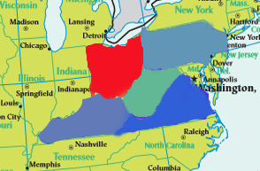fig1.The total number of patients in five states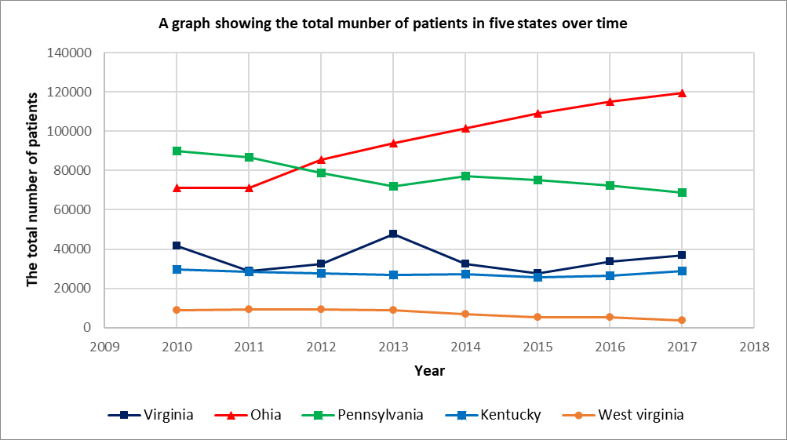 over time fig2 .The geography of the five continents （2）分析可知，阿卡类药物传播过程在不同州之间的规律是相同的，为了使描述的规律更为显著，故以Ohia的数据为例对公式（6）进行拟合求解，利用Matlab软件求解，使得残差平方和最小，即min {SSE= $\sum{{(i\left(t\right)-y_{i})}^{2}}$}.

求得：

$λ=0.7,μ=0.556,σ=1.259,c=1.5$，SSE=0.000014.

Ohia州的阿卡类药物感染率随时间的变化函数为

$i\left(t\right)=\frac{0.0206}{e^{-}0.01442t+1.5}$（7）

5.1.4 Analysis of the Result

**（1）**由 $σ=1.259，$ λ >μ可知类阿片药品的日接触传播率大于日治愈率，和Ohia州2010到2017年阿片药物感染率的逐年上升趋势相吻合，同时残差平方和SSE=0.000014极小，说明模型的拟合度很好。

（2）分析可知接触数σ=1是一个阀值。当σ>1时， $i$（t）的增减性取决于 $i_{0}$ 的大小，但其极限值 $\lim_{i→∞}{i=1-\frac{1}{σ}}$ 随着σ的增加而增加；当σ≤1时病人比例 $i$（t）越来越小，最终趋于0，这是由于传播期内健康者变成病人的人数不超过原来病人人数的原因。

（3）这样美国政府就需要特别关注临界值σ，当σ>1时病人数增加,社会治安情况可能就可能会恶化,同时考虑到各类阿卡类药物服用数与阿卡类药物服用总数的比例在短期内稳定的,同时治愈率即强制戒毒率在一定政府政策(如社会治安打压力度)下是基本不变的,所有我们可以根据特定阿卡类药物的使用率来推测总传染率λ,再与治愈率μ进行比较,例如当λ>μ时,病人数将会增加,此时政府就需要制定措施如加强社会治安等.以Ohia州为例,从表2可以看出Heroin的病人数占总人数的30.5%,这样就可以根据Heroin的病人数较为准确的估计出总病人数和传染率,再和临界值进行分析,这样问题1就得到了很好地解决.

**Table1.The percentage of all drug sick in 2010 Ohia**

|  |  |  |  |  |  |  |  |
| --- | --- | --- | --- | --- | --- | --- | --- |
| **Name** | **Heroin** |  | **Methadone** | **Morphine** | **…** | **Oxycodone** | **Buprenorphine** |
| **Percentage** | **0.305** |  | **0.0246** | **0.0209** | **…** | **0.122** | **0.377** |

## 5.2 Analysis and Solving of Question Two

5.2.1 Model Preparation

According to the analysis of the socio-economic data provided by the US population, there are too many analytical indicators. There are 149 effective analysis index categories after pre-processing, and there is a strong correlation between each index. This systematically analyzes and studies the society. The relationship between economic data and the spread of Aka drugs has caused great difficulties. Therefore, we first conduct R-type cluster analysis on 149 social and economic indicators, and divide the highly relevant economic indicators into several categories. Identify the main factors that influence the spread of opioids. In this way, we can select representative indicators from various analysis indicators, and then analyze the selected social economic indicators and the spread of Aka drugs. Among them, $x_{1}$, $x_{2}$,…, $x_{149}$ respectively represent 149 people's census social economy index

5.2.2 Model Establishment And Solving

(1) R-type cluster analysis

**Step1:** The correlation coefficient is used to measure the correlation of the variables. Record the value of the variable $x_{j}$ ${（x_{j},x_{j},…,x_{j}）}^{T}∈R^{n}$ (j=1,2,...,m), then you can use the sample correlation coefficient of the two variables $x_{j}$ and $x_{k}$ as Their measure of similarity, ie

$r_{jk}$ = $\frac{\sum_{i=1}^{n}{(x_{ij}-\overline{x_{j}})(x_{ik}-\overline{x_{k}}})}{{[\sum_{i=1}^{n}{{\left(x_{ij}-\overline{x_{j}}\right)}^{2}{\sum_{i=1}^{n}{ }(x_{ik}-\overline{x_{k}})}^{2}})]}^{\frac{1}{2}}}$

**Step2:** The shortest distance method is used to cluster the variables, and the distance between the two types of variables is defined as

R（$G_{1},G_{2}$）=min||

Where: $d_{jk}=1-|R_{ij}|$ or ${d_{jk}}^{2}$ =1- ${r_{jk}}^{2}$, at this time, R（$G_{1}, G_{2}$）is similar to the two variables with the greatest similarity between the two classes Sex metrics are related.

**Step3:** Correlation analysis of 149 people's census social economic data indicators in Ohia is conducted, and the correlation coefficient between various factors is obtained.

**Table1.** **Table of correlation of 149 analytical indicators**

|  |  |  |  |  |  |  |  |
| --- | --- | --- | --- | --- | --- | --- | --- |
|  | $$x_{1}$$ | $$x_{2}$$ | $$x_{3}$$ | … | $$x_{147}$$ | $$x_{148}$$ | $$x_{149}$$ |
| $$x_{1}$$ | 1 | 0.9945 | 0.9888 | … | 0.8368 | 0.8117 | 0.6925 |
| $$x_{2}$$ | 0.9945 | 1 | 0.9967 | … | 0.8297 | 0.8282 | 0.6598 |
| $$x_{3}$$ | 0.9888 | 0.9967 | 1 | … | 0.8087 | 0.8179 | 0.6654 |
| … | … | … | … | … | … | … | … |
| $$x_{147}$$ | 0.8368 | 0.8297 | 0.8087 | … | 1 | 0.7261 | 0.6413 |
| $$x_{148}$$ | 0.8117 | 0.8282 | 0.8179 | … | 0.7261 | 1 | 0.3962 |
| $$x_{149}$$ | 0.6925 | 0.6598 | 0.6654 | … | 0.6413 | 0.3962 | 1 |

**Step4:** The 149 variables were systematically clustered by the maximum coefficient method. The classification results are shown in Fig. 3.

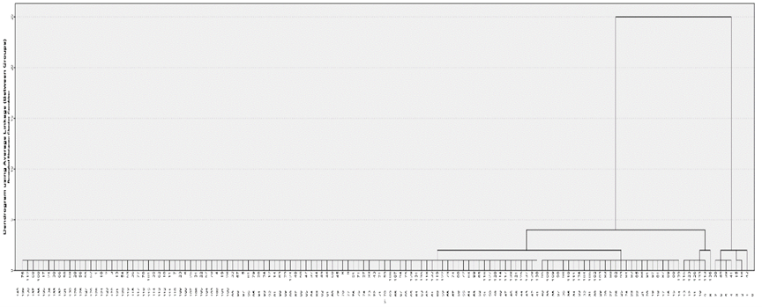

fig3. Clustering figure

5.2.3 Analysis of the Result

（1）Use $w_{1}$, $w_{2}$,… $w_{149}$ to represent each node on the cluster map, and record Ω={w_1, w_2,...,w_149}. )

When the distance value ƒ=2, it is divided into five categories, namely

$G_{1}$ ={${w_{38},w_{39,}w_{40},w_{41},w}_{42}$}, $G_{2}$ ={$w_{15},w_{16}$}

$G_{3}$ ={$w_{113},w_{115,}w_{123},w_{126},w_{133}，w_{136}$},

$G_{4}$ ={$w_{95},w_{108,}w_{109},w_{98},w_{110},w_{111},w_{134,}w_{104},w_{105},w_{102},w_{103},w_{83},$

$w_{90},w_{82},w_{93},w_{85},w_{86},w_{91},w_{97},w_{87}$, $w_{89},w_{88},w_{139}$}

$G_{5}$ ={$w_{76},w_{58,}w_{130,}…$} ，其中 $G_{5}$ = $Ω$-（$G_{1}$ + $G_{2}$ + $G_{3}$ + $G_{4}$）.

（2）The analysis shows that the first category reflects fertility information, the second category mainly reflects Average household size and Average family size information, the third category mainly reflects the information about the birthplace and the mother tongue, and the fourth category mainly reflects the year of entry. The fifth category mainly reflects information about the Year of entry and the level of education. So we select 5 analytical indicators from 149 indicators, which are $x_{42}$, $x_{15}$, $x_{113}$, $x_{88}$, $x_{64}$.

## 5.3 Analysis and Solving of Question Three

5.3.1 Model Preparation

Based on the above two time series models, the grey RBF neural network combined interstate space prediction model is established. The number of cases in a certain state is predicted by the number of cases in other states at the same time section, and the time series model is cross-tested. The gray system mines valuable internal laws by generating and developing some known information. Set the system characteristic data sequence:

$x^{(0)}=(x^{(0)}(1)$, $x^{\left(0\right)}\left(2\right),$… ${,x}^{(0)}(n))$ $(1)$

Is the original sequence, where $x^{(0)}(1)$, $x^{\left(0\right)}\left(2\right),$… ${,x}^{(0)}(n)$ represents the n variables of the decision attribute Observed value

（1－AGO）： $x^{(1)}=(x^{(1)}(1)$, $x^{\left(1\right)}\left(2\right),$… ${,x}^{(1)}(n))$ $(2)$

Where $x^{\left(1\right)}k$ = $\sum_{i=1}^{k}{{(x}^{(0)}(i)})$， $k=1,2…n$ pairs to generate sequence $x^{(1)}$ Establish differential equations:

$$\frac{dx^{(1)}}{dt}+ax^{(1)}=b (3)$$

The parameter column c of the equation is ${(a,b)}^{T}$, and the approximate value can be obtained by the least squares method.

$c$ = ${{(B}^{T}B)}^{-1}B^{T}Y_{n} (4)$

Where B, $Y_{n}$ is

$B=\left[\begin{matrix} \\ \begin{matrix}{-\frac{1}{2}(x}^{\left(1\right)}\left(1\right)+x^{\left(1\right)}\left(2\right)) & 1 \\ { -\frac{1}{2}(x}^{\left(1\right)}\left(2\right)+x^{\left(1\right)}\left(3\right)) & 1 \\ \begin{matrix}… \\ {-\frac{1}{2}(x}^{\left(1\right)}\left(n-1\right)+x^{\left(1\right)}\left(n\right))\end{matrix} & \begin{matrix}… \\ 1\end{matrix}\end{matrix}\end{matrix}\right]$, $Y_{n}={\left[\begin{matrix} \\ \begin{matrix}x^{\left(0\right)}\left(2\right) \\ \begin{matrix}x^{\left(0\right)}\left(3\right) \\ …\end{matrix} \\ x^{\left(0\right)}\left(n\right)\end{matrix}\end{matrix}\right]}^{T} (5)$

The solution to this equation is: $x^{\left(1\right)}(t+1$)= $\left(x^{\left(1\right)}\left(1\right)-\frac{b}{a}\right)e^{-at}+\frac{b}{a} (6)$

Where $x^{\left(1\right)}(t+1$) is the predicted value of the accumulated value, and it is reduced to the original data by one reduction:

$x^{\left(0\right)}(t+1$) = $x^{\left(1\right)}(t+1$)- $x^{\left(1\right)}(t$) = $-a\left(x^{\left(0\right)}\left(1\right)-\frac{b}{a}\right)e^{-at}$ $\left(t=1,2,3…n\right) (7)$

The RBF neural network is a three-layer forward neural network with a radial basis function as a hidden layer activation (nuclear) function, including input layer, hidden layer and output layer. It has strong approximation, classification and learning speed, and topology. The structure is shown below

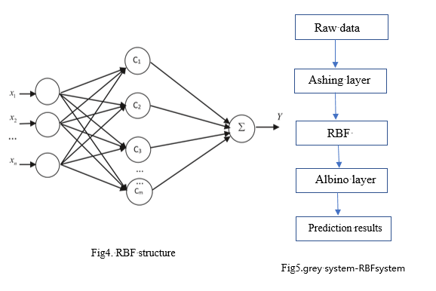

Where $X$ =($x_{1}$, $x_{2},…x_{n}$) is the input vector, $C$ =($C_{1}$, $C_{2},…C_{M}$) is the hidden layer, passing the Gaussian function $c_{i}\left(x\right)=exp\left(\frac{\left\|x-c_{i}\right\|}{2δ_{i}}\right)$ Implementing a nonlinear mapping of the input layer to the hidden layer, where $c_{i }$ is the center of the i-th basis function, $\left\|x-c_{i}\right\|$ is the norm of the vector $x-c_{i}$, ie the distance between x and $c_{i}$, $δ_{i}$ is the first i perceptual variables, Y is the output vector, is the linear mapping of the hidden layer c, Y = $\sum_{j=1}^{m}{w_{j}}c_{j,}w_{j}$ ($j=1,2…m$) is the jth The weight of the node to the output layer.

5.3.2 Model Establishment

* + **Step1:** Ash the input data to eliminate the randomness of the data.
  + **Step2:** Input RBF neural network
  + **Step3:** Add a whitening layer after the output layer to restore the output data.

5.3.3 Train Results

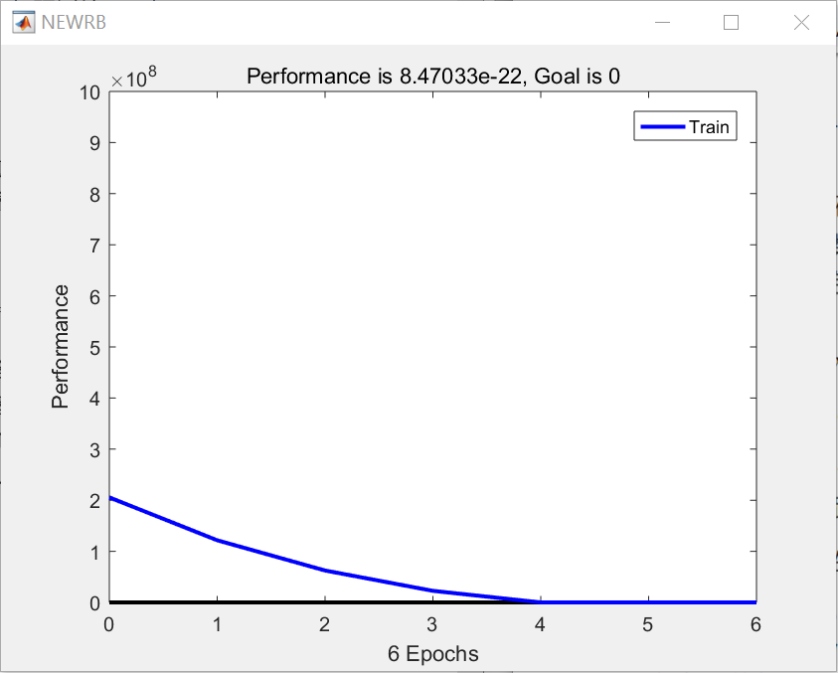

Fig6. Training result

5.3.4 Analysis of the Result

Combining the above three models, we propose the following four strategies to combat the opioid crisis, and illustrate the effectiveness of the strategy in combination with the model:

1. Increase the management and supervision of opioids through state legislation or national legislation, and reduce the chances of people getting in contact with or obtaining opioid addictive drugs. Combined with the first model, it was verified that the case incidence decreased as λ decreased.

2. Increase employment opportunities for low-income people and reduce the gap between the rich and the poor.

3. Communities and schools promote publicity on the harm of opioid abuse.

4. Open office-run schools to increase the proportion of educated residents in poor communities. Combined with the second model, when the proportion of education and education of residents rises, the rate of case-discovery within the state has a downward trend.

We conducted correlation analysis on the characteristic parameters corresponding to several strategies, and extracted the “law on the management and supervision of opioids” with the strongest correlation with the case incidence rate, corresponding to the σ parameter in model one.

Assuming that the propagation rate λ is consistent, when σ>λ, the strategy achieves the expected effect of inhibiting drug transmission, and when σ<λ, the strategy cannot achieve the desired effect.