|  |  |  |  |  |  |  |  |  |  |  |  |  |  |  |  |  |  |  |  |  |  |  |  |  |  |
| --- | --- | --- | --- | --- | --- | --- | --- | --- | --- | --- | --- | --- | --- | --- | --- | --- | --- | --- | --- | --- | --- | --- | --- | --- | --- |
| |  |  | | --- | --- | | For office use only | | | T1 | ________________ | | T2 | ________________ | | T3 | ________________ | | T4 | ________________ | | |  | | --- | | Team Control Number  **1911245** | |  | | Problem Chosen  **C** | | |  |  | | --- | --- | | For office use only | | | F1 | ________________ | | F2 | ________________ | | F3 | ________________ | | F4 | ________________ | |

**2018 Mathematical Contest in Modeling (MCM) Summary Sheet**

**Title**（此处应写论文标题）

**Summary**

美赛论文的摘要的英文一般用Summary，摘要最好在本页完成。

**标题**为16号Times New Roman字体加粗并居中

**摘要**为14号Times New Roman字体加粗并居中

**关键词**为12号Times New Roman字体加粗并居左

**行间距一般为1倍行距，为控制在一页可适当调整。**

首页不需要页眉和页码。

“00000”修改为自己的控制编号（Team Control Number），“A”改为自己的选题题号（A/B/C/D/E/F）

Task 1:We

建立了基于传染病模型的阿卡类药物传播的微分方程模型。

Task 2: We

对经济社会指标后，进行聚类分析以后减少我们的工作难度

Task 3: We

我们建立了嵌入型灰色－RBF神经网络组合模型：在RBF 神经网络的输入层之前加入灰化层对输入数据做了灰化处理，而在输出层后加入白化层对输出数据做还原处理，根据2010-2017年四个州（VA/PA/PY/WV）毒品总量的数据作为训练样本构建模型，并选取 2016和2017 年同期数据作为测试样本以对预测模型进行检验，最后利用该模型预测2016和2017年OH的毒品总量。结果表明,所建立的灰色 RBF 神经网络组合模型相对模拟误差小，预测结果更为可靠，可以用于毒品总量预测。

In the end, we make sensitivity analysis and discuss the strengths as well as weaknesses of our model. Moreover, a policy memo is presented to the decision maker on the utility, results and recommendations based on our PIPE policy model.

**Key words: Differential equation model;** **R-type cluster analysis;** **Related analysis;** **Grey-RBF neural network model**

**Contents**

1. Problem statement 4

2. Problem analysis 5

3. Basic assumption 6

4. Glossary & Symbols 6

5. Models 7

5.1 Analysis and Solving of Question One 7

5.1.1 Model Preparation 7

5.1.2 Model Establishment 8

5.1.3 Model solving 8

5.1.4 Analysis of the Result 9

5.2 Analysis and Solving of Question Two 9

5.2.1 Model Preparation 9

5.2.2 Model Establishment and Solving 10

5.2.3 Analysis of the Result 11

5.3 Analysis and Solving of Question Three 11

5.3.1 Model Preparation 11

5.3.2 Model Establishment 12

5.3.3 Model solving 13

5.3.4 Analysis of the Result 13

6. Error Analysis and Sensitivity Analysis 15

6.1 Error Analysis 15

6.1.1 Error Analysis of Model One 15

6.1.2 Error Analysis of Model Two 15

6.1.3 Error Analysis of Model Three 16

6.2 Sensitivity Analysis 16

6.2.1 Sensitivity Analysis of Model One 16

6.2.2 Sensitivity Analysis of Model Two 16

6.2.2 Sensitivity Analysis of Model Three 16

7. Evaluation and Promotion of Model 16

7.1 Strength and Weakness 16

7.1.1 Strength 16

7.1.2 Weakness: 17

7.2 Promotion 17

8. Conclusions 17

8.1 Conclusions of the problem 17

8.2 Methods used in our models 17

9. References 18

10. Appendix 18

10.1 Appendix One 18

10.2 Appendix Two 18

# 1. Problem statement

National crises about the use of synthetic and non-synthetic opioids are coming to the United States, so federal organizations such as the US Centers for Disease Control (CDC) are working to save lives and prevent the negative impact of the epidemic on health and the national economy. As part of the DEA Transfer Control Office, the DEA/National Forensic Laboratory Information System (NFLIS) has published a data-intensive annual report. "The database within NFLIS includes data from crime laboratories that process approximately 88% of state and local drug cases in the country each year.

This issue focuses on individual counties located in five US states: Ohio, Kentucky, West Virginia, Virginia, and Pennsylvania. Several data sets of drug identification count data sets for anesthesia analgesics (synthetic opioids) and heroin from five states were presented. Drug identification occurs when a law enforcement agency submits evidence to a crime laboratory as part of a criminal investigation and the forensic scientist in the laboratory tests the evidence. Typically, when law enforcement agencies submit these samples, they provide location data (counties) and their incident reports. When the evidence is submitted to the crime laboratory and the location data is not available, the crime laboratory uses the location of the city/county/state investigation law enforcement organization that submitted the case.

* Question 1

Using the provided NFLIS data, a mathematical model was created to describe the spread and characteristics of synthetic opioids and heroin events (cases) between the five states and their counties. Also identify any possible locations where specific opioids may have begun to be used in five states. The problems that the US government will have when envisioning patterns and features that continue to exist. And predict that when these conditions occur at these drug recognition threshold levels, the model will need to be able to predict when and where they will occur in the future?

* Question 2

Use the provided socio-economic data creation model to address the following questions: Explain the development of opioids, what contributed to the use of opioids and the growth of addiction, and why the use of opioids still exists. Is the use or use trend related to any US Census socioeconomic data provided? If so, please modify the mathematical model in question one.

* Question 3

Combine the results of Questions 1 and 2 to identify possible strategies for combating the opioid crisis. Use this model to test the effectiveness of the strategy; identify any important parameter boundaries on which success (or failure) depends.

# 2. Problem analysis

## 2.1 Problem statement

## 2.2 Analysis of Specific Issues

2.2.1 Analysis of Problem 1

2.2.2 Analysis of Problem 2

2.2.3 Analysis of Problem 3

2.2.4 Analysis of Problem 4

# III. Basic assumption

* The convection of water inside the bath tub does not affect the current water temperature. The reason is that heat exchange caused by convective occurs only between the parts of the water in the bathtub, this process does not get heat exchange from the outside of the system, in other words, only water temperature distribution changed.

# IV. Glossary & Symbols

# V. Models

## 5.1 Analysis and Solving of Question One

5.1.1 Model Preparation

Assume that the total number of people in the area examined during the period of Aka drug transmission remains unchanged, regardless of birth rate and mortality, or population migration. The population is divided into two categories: no taking Aka and taking Aka. , hereinafter referred to as healthy people and patients. And at the time t, the proportion of these two groups of people in the total number N is s(t) and i(t). The average number of people who can effectively contact each patient every day and make healthy people take Aka drugs is constant λ. λ is called the daily contact infection rate, which means that when the patient is in effective contact with the healthy person, the healthy person is infected and becomes a patient. The proportion of patients who are cured every day is a constant μ, called the daily cure rate, which can be expressed as the proportion of successful people who are detoxified every day. In particular, patients can still take Aka drugs repeatedly after the patient is cured. It is obvious that 1/μ is the average infection period during the drug's transmission period. In this way, we can establish a differential equation model for the spread of Aka drugs similar to the model of infectious disease transmission.

5.1.2 Model Establishment

**Step1:** Establish differential equations based on the characteristics of Aka drugs

$\left\{\begin{aligned} N\frac{di}{dt }=λNS\left(t\right)i\left(t\right)-μNi(t) \\ s\left(t\right)+i\left(t\right)=1 \\ \end{aligned}\right.$（1）

**Step2:** Further simplification

$\left\{\begin{aligned}\frac{di}{dt}=λi\left(t\right)\left[1-i\left(t\right)\right]-μi(t) \\ i\left(0\right)=i_{0}\end{aligned}\right.$（2）

}

**Step3:** Know the results

$i\left(t\right)$ = $\left\{\begin{aligned}{[\frac{λ}{λ-μ}+{\left(\frac{1}{i_{0}}-\frac{λ}{λ-μ}\right)e}^{-\left(λ-μ\right)t}]}^{-1} λ≠μ \\ {(λt+\frac{1}{i_{0}})}^{-1} λ=μ \end{aligned}\right.$（3）

**Step4:** Defining σ=λ / μ, noting the meaning of λ and 1/μ, we can see that σ is the ratio of the daily infection rate to the daily cure rate during the whole propagation period, called the number of contacts. With σ, the model can be rewritten as:

$\frac{di}{dt}=-λi(t)[i\left(t\right)-(1-\frac{1}{σ}$) ] （4）

**Step5:** Separate variables and further simplify

$\frac{di}{i(t)[i\left(t\right)-(1-\frac{1}{σ})]}$ = $-λ dt$（5）

**Step6:** Find the points on both sides and solve them.

$i\left(t\right)=\frac{1-1/σ}{e^{-}λt(1-\frac{1}{σ})+c}$**（c is the parameter） （6）**

5.1.3 Model soving

（1）Figure 1 shows the relationship between the total number of patients in five continents over time, and Figure 2 shows the geographical relationship between the five continents. It can be seen from the figure that the total number of patients in Ohia has been increasing, and the total number of patients in Pennsylvania is decreasing. The trend of the total number of patients in the other three states over time is not very obvious.

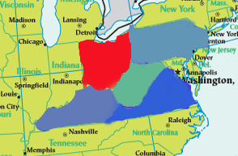fig1.The total number of patients in five states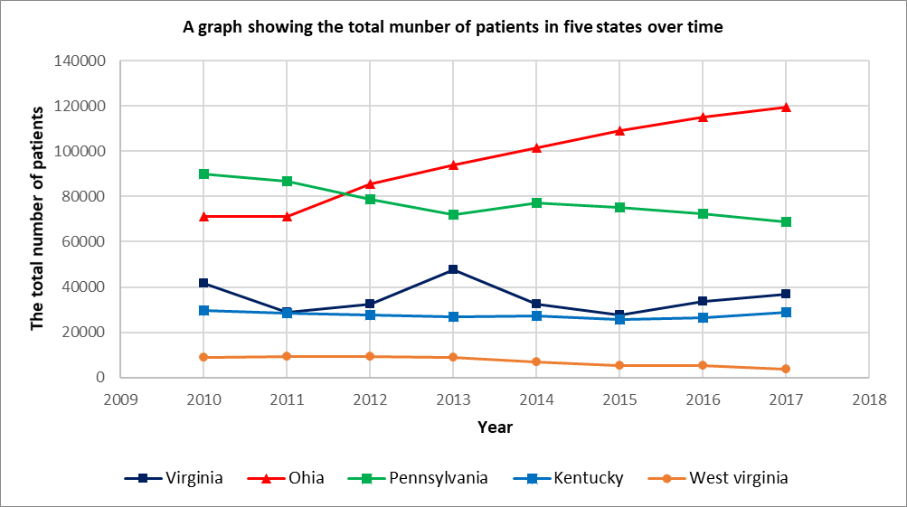 over time fig2 .The geography of the five continents （2）The analysis shows that the rule of Aka drug propagation process is the same between different states. In order to make the description law more significant, the formula (6) is solved by using Ohia data as an example, and solved by Matlab software. , so that the sum of squared residuals is the smallest, that is to say.

Obtain：

$λ=0.7,μ=0.556,σ=1.259,c=1.5$，SSE=0.000014.

The function of the Aka drug infection rate in Ohia over time is

$i\left(t\right)=\frac{0.0206}{e^{-}0.01442t+1.5}$（7）

5.1.4 Analysis of the Result

（1）From σ=1.259, λ >μ, the daily contact transmission rate of the opioid-like drugs is greater than the daily cure rate, which is consistent with the increasing trend of the opioid drug infection rate in Ohia Prefecture from 2010 to 2017, and the residual square sum SSE=0.000014 is extremely small. , indicating that the model has a good fit

（2）The analysis shows that the contact number σ=1 is a threshold. When σ>1, the increase and decrease of i(t) depends on the size of i_0, but its limit value $\lim_{i→∞}{i=1-\frac{1}{σ}}$ increases with the increase of σ; When σ ≤ 1, the proportion of patients i(t) is getting smaller and smaller, and eventually tends to 0. This is because the number of healthy people who become patients during the transmission period does not exceed the original number of patients.

（3）In this way, the US government needs to pay special attention to the critical value σ. When the number of patients increases with σ>1, the social security situation may be worsened, taking into account the ratio of the number of Aca drugs taken to the total number of Aka drugs. Stable in the short term, and the cure rate, that is, the compulsory detoxification rate, is basically unchanged under certain government policies (such as social security). All of us can estimate the total infection rate λ according to the usage rate of specific Aka drugs. Compared with the cure rate μ, for example, when λ>μ, the number of patients will increase, and the government needs to develop measures such as strengthening social security. Taking Ohia as an example, it can be seen from Table 2 that the number of patients in Heroin accounts for The total number of people is 30.5%, so that the total number of patients and the infection rate can be estimated accurately based on the number of patients in Heroin, and then analyzed with the critical value, so that the problem is well solved.

**Table1.The percentage of all drug sick in 2010 Ohia**

|  |  |  |  |  |  |  |  |
| --- | --- | --- | --- | --- | --- | --- | --- |
| **Name** | **Heroin** |  | **Methadone** | **Morphine** | **…** | **Oxycodone** | **Buprenorphine** |
| **Percentage** | **0.305** |  | **0.0246** | **0.0209** | **…** | **0.122** | **0.377** |

## 5.2 Analysis and Solving of Question Two

5.2.1 Model Preparation

According to the analysis of the socio-economic data provided by the US population, there are too many analytical indicators. There are 149 effective analysis index categories after pre-processing, and there is a strong correlation between each index. This systematically analyzes and studies the society. The relationship between economic data and the spread of Aka drugs has caused great difficulties. Therefore, we first conduct R-type cluster analysis on 149 social and economic indicators, and classify highly relevant economic indicators into several categories to identify the main factors affecting the spread of opioids. In this way, we can select representative indicators from various analysis indicators, and then analyze the selected social and economic indicators and the spread of Aka drugs. Among them, $x_{1}$, $x_{2}$,…, $x_{149}$ respectively represent 149 people's census social and economic indicators

5.2.2 Model Establishment And Solving

(1) Establishment and Solution of R-Type Cluster Analysis

**Step1:** The correlation coefficient is used to measure the correlation of the variables $Record$ $the value of the variable {x_{j}（x_{1},x_{2},…,x_{j}）}^{T}∈R^{n}$ (j=1,2,...,m), then the sample correlation coefficients of the two variables $x_{j}$ and $x_{k}$ can be used as their similarity measure,

$r_{jk}$ = $\frac{\sum_{i=1}^{n}{(x_{ij}-\overline{x_{j}})(x_{ik}-\overline{x_{k}}})}{{[\sum_{i=1}^{n}{{\left(x_{ij}-\overline{x_{j}}\right)}^{2}{\sum_{i=1}^{n}{ }(x_{ik}-\overline{x_{k}})}^{2}})]}^{\frac{1}{2}}}$（8）

**Step2:** The shortest distance method is used to cluster the variables, and the distance between the two types of variables is defined as,

R（$G_{1},G_{2}$）=min||

among them： $d_{jk}=1-\left|R_{ij}\right|$ or ${d_{jk}}^{2}$ =1- ${r_{jk}}^{2}$, at this time，R（$G_{1}, G_{2}$）correlation with the similarity measure between the two most similar variables in the two categories.

**Step3:** Correlation analysis of Ohia's 149 people's census social economic data indicators is conducted, and a correlation coefficient table between various factors is obtained.

**Table1.** **Table of correlation of 149 analytical indicators**

|  |  |  |  |  |  |  |  |
| --- | --- | --- | --- | --- | --- | --- | --- |
|  | $$x_{1}$$ | $$x_{2}$$ | $$x_{3}$$ | … | $$x_{147}$$ | $$x_{148}$$ | $$x_{149}$$ |
| $$x_{1}$$ | 1 | 0.9945 | 0.9888 | … | 0.8368 | 0.8117 | 0.6925 |
| $$x_{2}$$ | 0.9945 | 1 | 0.9967 | … | 0.8297 | 0.8282 | 0.6598 |
| $$x_{3}$$ | 0.9888 | 0.9967 | 1 | … | 0.8087 | 0.8179 | 0.6654 |
| … | … | … | … | … | … | … | … |
| $$x_{147}$$ | 0.8368 | 0.8297 | 0.8087 | … | 1 | 0.7261 | 0.6413 |
| $$x_{148}$$ | 0.8117 | 0.8282 | 0.8179 | … | 0.7261 | 1 | 0.3962 |
| $$x_{149}$$ | 0.6925 | 0.6598 | 0.6654 | … | 0.6413 | 0.3962 | 1 |

**Step4:** The 149 variables were systematically clustered by the maximum coefficient method.The classification results are shown in Fig. 3.

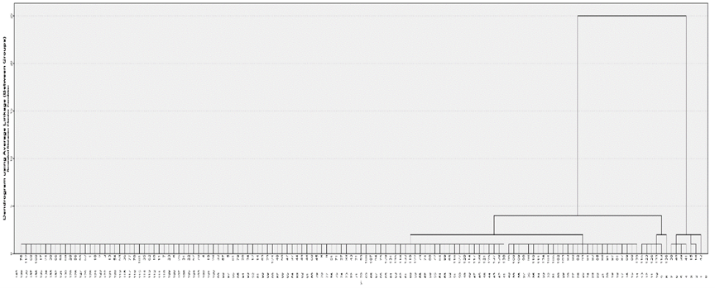

fig3. Clustering figure

Use $w_{1}$, $w_{2}$,… $w_{149}to represent each node on the cluster map, and recordΩ$ ={$w_{1}$, $w_{2}$,… $,w_{149}$}.

When the distance value ƒ=2, it is divided into five categories, namely

$G_{1}$ ={${w_{38},w_{39,}w_{40},w_{41},w}_{42}$}, $G_{2}$ ={$w_{15},w_{16}$}

$G_{3}$ ={$w_{113},w_{115,}w_{123},w_{126},w_{133}，w_{136}$},

$G_{4}$ ={$w_{95},w_{108,}w_{109},w_{98},w_{110},w_{111},w_{134,}w_{104},w_{105},w_{102},w_{103},w_{83},$

$w_{90},w_{82},w_{93},w_{85},w_{86},w_{91},w_{97},w_{87}$, $w_{89},w_{88},w_{139}$}

$G_{5}$ ={$w_{76},w_{58,}w_{130,}…$} ，among this $G_{5}$ = $Ω$-（$G_{1}$ + $G_{2}$ + $G_{3}$ + $G_{4}$）.

The analysis shows that the first category reflects fertility information, the second category mainly reflects Average household size and Average family size information, the third category mainly reflects the information about the birthplace and the mother tongue, and the fourth category mainly reflects the year of entry. The fifth category mainly reflects information about the Year of entry and the level of education. So we select 5 analytical indicators from 149 indicators, which are $x_{42}$, $x_{15}$, $x_{113}$, $x_{88}$, $x_{64}$.

（2）Related analysis

Now we have a correlation analysis between the relationship between the analysis indicators ( $x_{15},x_{42}$, $x_{64}, x_{88}$, $x_{113}$) and the number of Aka drug transmissions (y).

Table2. Ohia's five evaluation indicators and the total number of patients

|  |  |  |  |  |  |  |  |
| --- | --- | --- | --- | --- | --- | --- | --- |
|  | 2010 | 2011 | 2012 | 2013 | 2014 | 2015 | 2016 |
| $$x_{15}$$ | 221.3 | 218.81 | 221.37 | 222.57 | 221.32 | 220.85 | 220.63 |
| $$x_{42}$$ | 130349 | 129855 | 153278 | 125586 | 145998 | 139586 | 1435739 |
| $x_{64}$, | 153782 | 150359 | 130349 | 126298 | 123940 | 122551 | 121848 |
| $$x_{88}$$ | 78425 | 79963 | 84566 | 81626 | 92519 | 86580 | 90673 |
| $$x_{113}$$ | 915914 | 939454 | 949903 | 968771 | 979239 | 975437 | 912807 |
| y | 70999 | 71282 | 85415 | 93747 | 101423 | 109150 | 115276 |

**Step1:** Calculate the average of five analytical indicators and the number of Aka drug transmissions

$\overline{x_{42}}$, $\overline{x_{15}}$, $\overline{x_{113}}$, $\overline{x_{88}}$, $\overline{{ x}_{64}}$, $\overline{y}$

**Step2:** Calculate the Person correlation coefficient using the formula

$rx_{i}y_{1}=\frac{\sum_{j=1}^{n}{(x_{ij}-\overline{x_{i}}})(y_{1i}-\overline{y})}{\sqrt{\sum_{j=1}^{n}{{(x_{ij}-\overline{X_{i}})}^{2}\sum_{i=1}^{n}{{(y_{i}-\overline{y})}^{2}} }}}$ (9) Correlation coefficient table

Table3. Correlation coefficient table

|  |  |  |  |  |  |  |
| --- | --- | --- | --- | --- | --- | --- |
|  | $$x_{15}$$ | $$x_{42}$$ | $$x_{64}$$ | $$x_{88}$$ | $$x_{113}$$ | y |
| $$x_{15}$$ | 1 |  |  |  |  |  |
| $$x_{42}$$ | -0.13401 | 1 |  |  |  |  |
| $$x_{64}$$ | -0.43901 | -0.36292 | 1 |  |  |  |
| $$x_{88}$$ | 0.100381 | 0.48748 | -0.8024 | 1 |  |  |
| $$x_{113}$$ | 0.328978 | -0.57424 | -0.51013 | 0.298602 | 1 |  |
| y | 0.262012 | 0.579961 | -0.92325 | 0.732652 | 0.284207 | 1 |

5.2.3 Analysis of the Result

1）It can be seen from the correlation coefficient table $r_{\overline{x_{64}}}y$ = -0.92325, ||>0.8,so there is a high correlation and a negative correlation between $x_{64}$ and y. According to the analysis, the number of patients in Ohia increases as people's education level decreases.

2)进一步分析其原因,病人总数随着人群受教育程度的变化而变化,可能是因为随着人们认知水平的提高会有意识地拒绝阿卡类药物,此时,传染率λ也将会减小.这样的话,第一问中微分方程模型中传染率λ为常数的假设就是不正确的.所以,我们就需要对模型一进行修正.

3)模型一的修正.

①由前面的分析可知,传染率λ并不是一个常数,所以我们可以令λ=h(t),表示为传染率是一个随时间而变化的函数,此时公式(1)应该修改为

$\left\{\begin{aligned} N\frac{di}{dt }=h(t)Ns\left(t\right)i\left(t\right)-μNi(t) \\ s\left(t\right)+i\left(t\right)=1 \\ \end{aligned}\right.$（10）

②我们可以类比于Logistic模型,对h(t)进行大胆的假设,令λ=a+bt(a,b为参数).此时,微分方程应该为,

$\left\{\begin{aligned} N\frac{di}{dt }=(a+bt)Ns\left(t\right)i\left(t\right)-μNi(t) \\ s\left(t\right)+i\left(t\right)=1 \\ \end{aligned}\right.$（11）

化简为

$\frac{di}{dt }$ = $(a+bt)$ [1- $i\left(t\right)$]- $μi(t)$ (12)

## 5.3 Analysis and Solving of Question Three

5.3.1 Model Preparation

Fig4. thinking research paper figure

5.3.2 Model Establishment

* + **Step1:**
  + **Step2:**
  + **Step3:**

* + **Step4:**
  + **Step5:**
  + **Step6:**
  + **Step7:**
  + **Step8:**
  + **Step9:**

5.3.3 Results

**Table 3 The results of the model parameter value table**

|  |  |  |  |  |
| --- | --- | --- | --- | --- |
|  |  |  |  |  |
|  |  |  |  |  |
|  |  |  |  |  |
|  |  |  |  |  |
|  |  |  |  |  |

5.3.4 Analysis of the Result



Fig5. Basketball Coaches

## 5.4 Analysis and Solving of Question Four

5.4.1 Model Preparation

**(1) Data Processing**



**(2) Assumptions**

**(3) The Foundation of Model**

5.4.2 Model Establishment

* + **Step1:**
  + **Step2:**
  + **Step3:**

* + **Step4:**
  + **Step5:**
  + **Step6:**
  + **Step7:**
  + **Step8:**
  + **Step9:**



Fig6. Traffic flow changes with the rate of large truck

5.4.3 Results

**Table 4 The results of the model parameter value table**

|  |  |  |  |  |
| --- | --- | --- | --- | --- |
|  |  |  |  |  |
|  |  |  |  |  |
|  |  |  |  |  |
|  |  |  |  |  |
|  |  |  |  |  |

5.4.4 Analysis of the Result

# VI. Error Analysis and Sensitivity Analysis

## 6.1 Error Analysis

6.1.1 Error Analysis of Model One

6.1.2 Error Analysis of Model Two

6.1.3 Error Analysis of Model Three

## 6.2 Sensitivity Analysis

6.2.1 Sensitivity Analysis of Model One

6.2.2 Sensitivity Analysis of Model Two

6.2.2 Sensitivity Analysis of Model Three

# VII. Evaluation and Promotion of Model

## 7.1 Strength and Weakness

7.1.1 Strength

7.1.2 Weakness:

## 7.2 Promotion

# Ⅷ. Conclusions

## 8.1 Conclusions of the problem

## 8.2 Methods used in our models

# I X. References

[1] Xu Lun Hui,Luo Qiang,Fu Hui.Car following safe distance model based on braking process of leading vehicle f [J].Journal of Guangxi Normal University(Natural Science Edition),2010,28(1):1-5.

[2]

[3]

[4]

# X. Appendix

## 10.1 Appendix One

美赛中可以有附录也可以没有附录，即此部分可以省略

## 10.2 Appendix Two