|  |  |  |  |  |  |  |  |  |  |  |  |  |  |  |  |  |  |  |  |  |  |  |  |  |  |
| --- | --- | --- | --- | --- | --- | --- | --- | --- | --- | --- | --- | --- | --- | --- | --- | --- | --- | --- | --- | --- | --- | --- | --- | --- | --- |
| |  |  | | --- | --- | | For office use only | | | T1 | ________________ | | T2 | ________________ | | T3 | ________________ | | T4 | ________________ | | |  | | --- | | Team Control Number  **00000** | |  | | Problem Chosen  **A** | | |  |  | | --- | --- | | For office use only | | | F1 | ________________ | | F2 | ________________ | | F3 | ________________ | | F4 | ________________ | |

**2018 Mathematical Contest in Modeling (MCM) Summary Sheet**

**Title**（此处应写论文标题）

**Summary**

美赛论文的摘要的英文一般用Summary，摘要最好在本页完成。

**标题**为16号Times New Roman字体加粗并居中

**摘要**为14号Times New Roman字体加粗并居中

**关键词**为12号Times New Roman字体加粗并居左

**行间距一般为1倍行距，为控制在一页可适当调整。**

首页不需要页眉和页码。

“00000”修改为自己的控制编号（Team Control Number），“A”改为自己的选题题号（A/B/C/D/E/F）

**Key words:** 三到五个关键词

注：红色字为解释说明部分，使用时应全部删除或换成黑色字。

**Contents**

I. Introduction 4

1.1 Background 4

1.2 Our works 4

II. The Description of the Problem 5

2.1 Problem statement 5

2.2 Analysis of Specific Issues 5

2.2.1 Analysis of Problem 1 5

2.2.2 Analysis of Problem 2 5

2.2.3 Analysis of Problem 3 5

2.2.4 Analysis of Problem 4 6

III. Basic assumption 6

IV. Glossary & Symbols 6

4.1 Glossary 6

4.2 Symbols 7

V. Models 7

5.1 Analysis and Solving of Question One 7

5.1.1 Model Preparation 7

5.1.2 Model Establishment 8

5.1.3 Results 8

5.1.4 Analysis of the Result 9

5.2 Analysis and Solving of Question Two 9

5.2.1 Model Preparation 9

5.2.2 Model Establishment 10

5.2.3 Results 10

5.2.4 Analysis of the Result 11

5.3 Analysis and Solving of Question Three 11

5.3.1 Model Preparation 11

5.3.2 Model Establishment 12

5.3.3 Results 13

5.3.4 Analysis of the Result 13

5.4 Analysis and Solving of Question Four 13

5.4.1 Model Preparation 13

5.4.2 Model Establishment 14

5.4.3 Results 15

5.4.4 Analysis of the Result 15

VI. Error Analysis and Sensitivity Analysis 15

6.1 Error Analysis 15

6.1.1 Error Analysis of Model One 15

6.1.2 Error Analysis of Model Two 15

6.1.3 Error Analysis of Model Three 16

6.2 Sensitivity Analysis 16

6.2.1 Sensitivity Analysis of Model One 16

6.2.2 Sensitivity Analysis of Model Two 16

6.2.2 Sensitivity Analysis of Model Three 16

VII. Evaluation and Promotion of Model 16

7.1 Strength and Weakness 16

7.1.1 Strength 16

7.1.2 Weakness: 17

7.2 Promotion 17

Ⅷ. Conclusions 17

8.1 Conclusions of the problem 17

8.2 Methods used in our models 17

I X. References 18

X. Appendix 18

10.1 Appendix One 18

10.2 Appendix Two 18

从目录开始有页眉和页码，把“00000”改为自己的控制编号，页码会自动调整可以不用编辑。

# I. Introduction

## 1.1 Background

在此开始正文，

正文的一级标题为16号Times New Roman字体加粗并居中

正文的二级标题为14号Times New Roman字体加粗并居左

正文的三级标题为12号Times New Roman字体加粗并居左

一般不设四级标题，若有的话请用（1）或1）或①等代替为11号Times New Roman字体加粗并居左

正文部分为11号Times New Roman字体不加粗

英文文章的段落开头一般是居左并无缩进的，即段首顶格书写。

从目录开始有页眉和页码，把“00000”改为自己的控制编号，页码会自动调整可以不用编辑。

## 1.2 Our works

* Task 1
* Task 2
* Task 3
* Task 4

# II. The Description of the Problem

## 2.1 Problem statement

Fig1. thinking research paper figure

## 2.2 Analysis of Specific Issues

2.2.1 Analysis of Problem 1

2.2.2 Analysis of Problem 2

2.2.3 Analysis of Problem 3

2.2.4 Analysis of Problem 4

# III. Basic assumption

* The convection of water inside the bath tub does not affect the current water temperature. The reason is that heat exchange caused by convective occurs only between the parts of the water in the bathtub, this process does not get heat exchange from the outside of the system, in other words, only water temperature distribution changed.

# IV. Glossary & Symbols

## 4.1 Glossary

* Load degree: V / C is maximum traffic service divided by basic capacity under ideal conditions,. The basic capacity is the maximum amount of traffic on the four-hour service level half.

## 4.2 Symbols

|  |  |  |
| --- | --- | --- |
| **Symbols** | **Definition** | **Units** |
| **Z** | The index of development | J |
| **CI** | Coordinated index of development | J |
| **DI** | Sustainability index of development | J |
| **A** | Economic index of development | J |
| **B** | Social index of development | K |
| **C** | Environment index of development | K |
| **F** | Impact index value | km3 |
| **S** | Reality index value | m |
| $β$ | Influence coefficient | m2 |

# V. Models

## 5.1 Analysis and Solving of Question One

5.1.1 Model Preparation

假设在阿卡类药物传播期内所考查地区的总人数不变，既不考虑出生率和死亡率，也不考虑人口迁移，人群分为未服用阿卡类药物和已服用阿卡类药物两类，以下简称健康者和病人。并记t时刻这两类人群在总人数N中所占的比例分别为s(t)和i(t).每个病人每天有效接触并使健康者服用阿卡类药物的平均人数是常数λ，λ称为日接触传染率，表示当病人与健康者有效接触时，使健康者受感染变为病人。每天被治愈的病人数的比例为常数μ，称为日治愈率，可表示为每天戒毒成功的人数比例。特别说明病人治愈后仍可以反复服用阿卡类药物成为病人，显然1/μ是这种药物传播期内的平均传染期。这样，我们就可以建立起来了一个类似于传染病传播模型的阿卡类药物传播的微分方程模型。

5.1.2 Model Establishment

**Step1:** 根据阿卡类药物的传播特点建立起微分方程

$\left\{\begin{aligned} N\frac{di}{dt }=λN_{s}\left(t\right)i\left(t\right)-μNi(t) \\ s\left(t\right)+i\left(t\right)=1 \\ i\left(0\right)=0 \end{aligned}\right.$（1）

**Step2:** 进一步化简

$\left\{\begin{aligned}\frac{di}{dt}=λi\left(t\right)\left[1-i\left(t\right)\right]-μi(t) \\ i\left(0\right)=i_{0}\end{aligned}\right.$（2）

}

**Step3:** 结果分析知

$i\left(t\right)$ = $\left\{\begin{aligned}{[\frac{λ}{λ-μ}+{\left(\frac{1}{i_{0}}-\frac{λ}{λ-μ}\right)e}^{-\left(λ-μ\right)t}]}^{-1} λ≠μ \\ {(λt+\frac{1}{i_{0}})}^{-1} λ=μ \end{aligned}\right.$（3）

**Step4:** 定义σ=λ / μ，注意到λ和1/μ的含义，可知σ是整个传播期内每个病人有效接触的平均人数，称为接触数。利用σ，模型可以改写为：

$\frac{di}{dt}=-λi(t)[i\left(t\right)-(1-\frac{1}{σ}$) ] （4）

**Step5:** 分离变量，进一步化简

$\frac{di}{i(t)[i\left(t\right)-(1-\frac{1}{σ})]}$ = $-λ dt$（5）

**Step6:** 两边积分，求解得

$i\left(t\right)=\frac{1-1/σ}{e^{-}λt(1-\frac{1}{σ})+c}$**（其中c为参数） （6）**

5.1.3 Results

图一为五个洲的病人总数随着时间的变化曲线，图二为五个洲之间的地理位置关系，从图中可以看出Ohia中的病人总数在一直增加，Pennsylvania的病人总数在减少，其他三个州的病人总数的随时间变化趋势不是很明显。

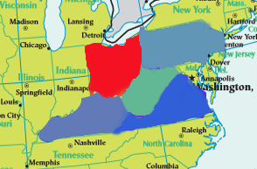fig1.The total number of patients in five states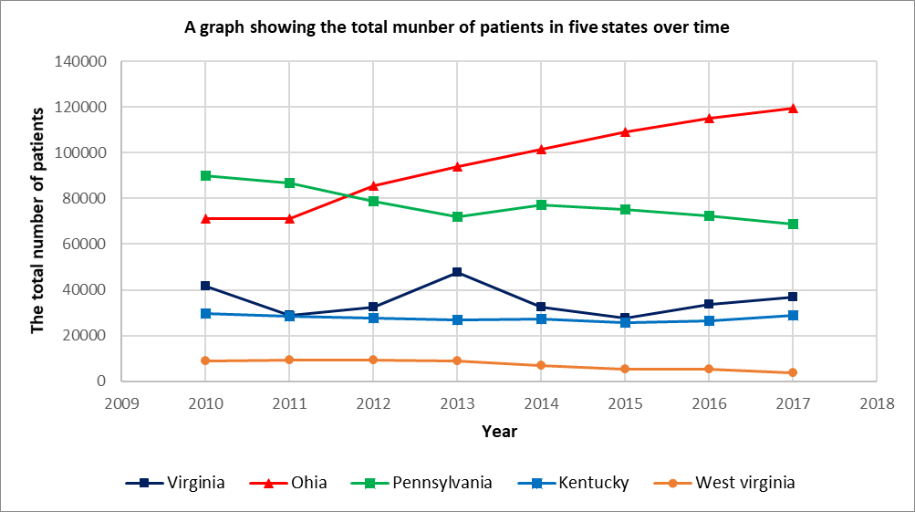 over time fig.2 The geography of the five continents

分析可知，阿卡类药物传播过程在不同州之间的规律是相似，为了使描述的规律更为显著，故采用Ohia的数据对公式（6）进行拟合求解，利用Matlab软件求解，使得残差平方和最小，即min {SSE= $\sum{{(i\left(t\right)-y_{i})}^{2}}$}.

求得

$λ=0.7,c=1.5$，SSE=0.000014.

Ohia州的阿卡类药物感染率随时间的变化

**Table 2 The results of the model parameter value table**

|  |  |  |  |  |
| --- | --- | --- | --- | --- |
|  |  |  |  |  |
|  |  |  |  |  |
|  |  |  |  |  |
|  |  |  |  |  |
|  |  |  |  |  |

5.1.4 Analysis of the Result

## 5.2 Analysis and Solving of Question Two

5.2.1 Model Preparation

**(1) Data Processing**



**(2) Assumptions**

**(3) The Foundation of Model**

Fig3. thinking research paper figure

5.2.2 Model Establishment

* + **Step1:**
  + **Step2:**
  + **Step3:**

* + **Step4:**
  + **Step5:**
  + **Step6:**
  + **Step7:**
  + **Step8:**
  + **Step9:**

5.2.3 Results

5.2.4 Analysis of the Result

## 5.3 Analysis and Solving of Question Three

5.3.1 Model Preparation

**(1) Data Processing**



**(2) Assumptions**

**(3) The Foundation of Model**

Fig4. thinking research paper figure

5.3.2 Model Establishment

* + **Step1:**
  + **Step2:**
  + **Step3:**

* + **Step4:**
  + **Step5:**
  + **Step6:**
  + **Step7:**
  + **Step8:**
  + **Step9:**

5.3.3 Results

**Table 3 The results of the model parameter value table**

|  |  |  |  |  |
| --- | --- | --- | --- | --- |
|  |  |  |  |  |
|  |  |  |  |  |
|  |  |  |  |  |
|  |  |  |  |  |
|  |  |  |  |  |

5.3.4 Analysis of the Result



Fig5. Basketball Coaches

## 5.4 Analysis and Solving of Question Four

5.4.1 Model Preparation

**(1) Data Processing**



**(2) Assumptions**

**(3) The Foundation of Model**

5.4.2 Model Establishment

* + **Step1:**
  + **Step2:**
  + **Step3:**

* + **Step4:**
  + **Step5:**
  + **Step6:**
  + **Step7:**
  + **Step8:**
  + **Step9:**



Fig6. Traffic flow changes with the rate of large truck

5.4.3 Results

**Table 4 The results of the model parameter value table**

|  |  |  |  |  |
| --- | --- | --- | --- | --- |
|  |  |  |  |  |
|  |  |  |  |  |
|  |  |  |  |  |
|  |  |  |  |  |
|  |  |  |  |  |

5.4.4 Analysis of the Result

# VI. Error Analysis and Sensitivity Analysis

## 6.1 Error Analysis

6.1.1 Error Analysis of Model One

6.1.2 Error Analysis of Model Two

6.1.3 Error Analysis of Model Three

## 6.2 Sensitivity Analysis

6.2.1 Sensitivity Analysis of Model One

6.2.2 Sensitivity Analysis of Model Two

6.2.2 Sensitivity Analysis of Model Three

# VII. Evaluation and Promotion of Model

## 7.1 Strength and Weakness

7.1.1 Strength

7.1.2 Weakness:

## 7.2 Promotion

# Ⅷ. Conclusions

## 8.1 Conclusions of the problem

## 8.2 Methods used in our models

# I X. References

[1] Xu Lun Hui,Luo Qiang,Fu Hui.Car following safe distance model based on braking process of leading vehicle f [J].Journal of Guangxi Normal University(Natural Science Edition),2010,28(1):1-5.

[2]

[3]

[4]

# X. Appendix

## 10.1 Appendix One

美赛中可以有附录也可以没有附录，即此部分可以省略

## 10.2 Appendix Two