Ross Cameron Momentum Trading Strategy - Development Summary
Strategy Overview
The Ross Cameron momentum trading strategy is designed to capture intraday momentum moves on high-volatility stocks. It follows a systematic approach:
Core Philosophy:
- Trade pullbacks after initial surges (buy the bounce, not the breakout)
- Use multiple confirmation filters to reduce false signals
- Employ structural stops (pattern-based) rather than arbitrary percentages
- Size positions for a simulated $500 account ($100 per trade, 5 trades max per day)
Entry Requirements (ALL must be met):
- Pullback Pattern: Surge → pullback → first candle making new high after dip
- MACD Positive: MACD line above signal line (12/26/9 settings)
- Volume Confirmation: No volume topping patterns, max 4/5 red candles in pullback
- VWAP Filter: Price above VWAP (long trades only)
Exit Logic:
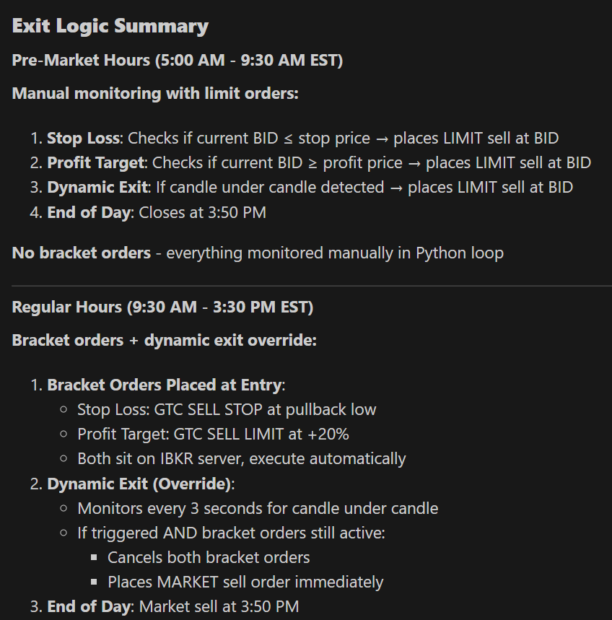
Problem-Solving Development History

Problem: No way to validate strategy performance without waiting weeks for live trading results.
Solution: Created RossCameron-Backtest.py - a historical simulation engine that fetches IBKR data and tests the strategy bar-by-bar. This allows rapid iteration on strategy parameters using real market data from past high-momentum stocks.

Problem: Strategy logic duplicated between live trading script and backtest script, causing version drift when making changes to one but not the other.
Solution: Created RossCameron-Strategy.py as a shared module containing ALL strategy logic. Both live trading and backtesting scripts now import from this single source of truth. Changes to entry/exit conditions automatically apply to both scripts, eliminating ~425 lines of duplicate code.

Problem: Backtest results didn't account for trading costs, making profit estimates unrealistic.
Solution: Implemented IBKR Fixed Pricing commission structure in the strategy module:
- $0.005 per share base commission
- $1.00 minimum per order
- SEC fee (~$0.0278 per $1000) on sell orders
Both buy and sell commissions are tracked separately and deducted from P&L calculations.

Problem: Scanning for past 60 10s bars is not comprehensive enough, which results in a lot of false breakouts and noisy entries.
Solution: Increased number of bars to 180, spans past 30 minutes. Breakouts are now more meaningful.

Problem: Breakouts are now more meaningful, but less relevant. Low win rate (0-30%) with excessive overtrading - strategy generated 25+ trades per day on single stocks, many hitting stop loss immediately during mid-surge entries.
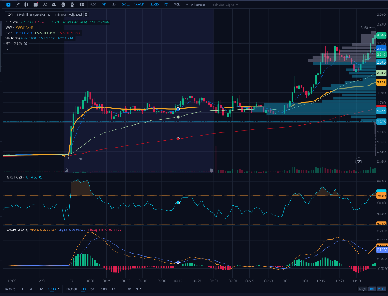
Solution: Switched pattern detection from 10-second bars to 1-minute bars. Changed PATTERN_LOOKBACK_BARS from 90 (15 min on 10-sec) to 30 bars (30 min on 1-min timeframe). Increased minimum pullback requirement from 2% to 3%. This filters out micro-patterns and noise during parabolic moves, reducing trade frequency to 3-5 quality trades per day while avoiding entries during vertical surges.

Problem: Structural stop losses based on pullback lows could sometimes be excessively wide (15-20% risk), creating unacceptable risk on a $500 account.
Solution: Added a 10% maximum stop loss cap. The system now uses whichever is tighter: the structural pullback low OR 10% below entry. This respects pattern structure when possible while enforcing a hard risk limit.

Problem: Stop loss placed exactly at pullback low caused premature exits from minor wicks below support, even when overall structure remained intact. Additionally, some setups had stop loss too close to entry (<2%), creating poor risk/reward ratios.
Solution: Added 1% buffer below pullback low (multiplies by 0.99) and enforced minimum 2% stop distance validation. Setups with stops closer than 2% are now rejected. This gives trades room to breathe through normal volatility while maintaining structural support-based stops. Formula: stop_price = round(pullback_low * 0.99, 2) with validation if stop_distance_pct < 0.02: reject trade.

Problem: Strategy only traded regular market hours (9:30 AM - 4:00 PM), missing significant pre-market momentum moves where many gappers make their biggest moves.
Solution:
- Changed IBKR data request from RTH=1 (regular hours only) to RTH=0 (all hours)
- Removed time filter that skipped pre-market hours in backtest logic
- Strategy now captures moves from 4:00 AM onwards when pre-market data is available

Problem: VWAP calculation included 6.5 hours of historical data (390 bars), causing stale values in afternoon trades. Price could be clearly below current conditions but still "above VWAP" due to morning data weight. Additionally, VWAP jumped dramatically at 9:30 AM market open due to sudden volume influx overwhelming thin pre-market data.
Solution: Implemented session VWAP that resets at 9:30 AM market open. Pre-market hours use local pre-market VWAP, but from 9:30 AM onwards, VWAP calculates only from 9:30 AM bars forward (ignoring pre-market). This matches standard trading platform behavior and eliminates afternoon entries when price is below current session VWAP but above all-day average.

Problem: Single-symbol backtesting required running the script multiple times to test portfolio performance across different stocks, making it tedious to analyze strategy effectiveness on diverse market conditions.
Solution: Implemented multi-symbol backtesting capability allowing up to 3 symbols in a single run (e.g., "AAPL, TSLA, NVDA"). System runs independent backtests for each symbol with separate $500 capital, then aggregates results showing combined P&L, overall win rate, profit factor, and per-symbol breakdown table. Displays all trades in unified view with symbol column for easy analysis.

Problem: Pre-market trading was disabled, missing significant momentum moves on gapper stocks that make their biggest moves between 4:00-9:30 AM before regular market open.
Solution: Enabled pre-market trading by changing IBKR data request parameter from RTH=1 (regular hours only) to RTH=0 (extended hours), and removed time filters blocking pre-market hours. Strategy now trades from 4:00 AM to 4:00 PM EST. Pre-market uses local VWAP, regular hours use session VWAP from 9:30 AM onwards, preventing data mixing issues between sessions.

