Classification of Drug Consumption Using Personality and Demographic Data

Project Number: Project 3-Drug consumption dataset

Course: STATS5099-Data Mining and Machine Learning

Group Number：Group 20

Group Members:
Yuning Jia
Yunji Zhang
Xinyi Hu
Erxuan Zhuo

Date:
30 March 2026

1 Introduction
1.1 Background
Drug use is a significant public health issue, and its relationship with psychological and behavioral factors has receiving increasing attention. Previous studies show that personality traits (such as impulsivity and sensation seeking) may influence an individual's likelihood of engaging in substance use behaviors. Accurate classification and attribution analysis of drug use behavior based on individual characteristics are essential for optimizing healthcare resource allocation and developing personalized health intervention plans.
1.2 Dataset Description
This project analyzed a dataset of 1885 individuals (group_20.xlsx) from Moodle, including demographic variables, personality traits. Drug use patterns vary across individuals and can lead to different health outcomes, making accurate classification essential. The response variable was amyl nitrite use (drug use category). There were originally seven categories. To improve model performance and avoid small-sample issues, we merged these categories into three groups: Never Used, used a Decade Ago, and Used in the Past Decade. Based on this dataset, we developed multi-class classification models to predict drug use categories and identified the best-performing model.
1.3 Research Objectives
This study aims to explore the relationship between respondent characteristics and drug categories. Six classification models (including Random Forest, Decision Tree, Neural Network, KNN, SVM, and Logistic Regression) are built and compared. The goal is to evaluate their performance and select the best model with high accuracy, good generalization ability, and strong adaptability for drug category classification.

2 Exploratory Data Analysis (EDA）
2.1 Data Structure and Descriptive Statistics
The dataset was loaded, containing a total of 1885 rows and 14 columns. The columns include ID, demographic characteristics (Age, Sex, Education, Country, Ethnicity), personality measurements (Nscore, Escore, Oscore, Ascore, Cscore, Impulsive, SS), a fictitious drug variable for bias detection, and the target variable Amyl (Amyl nitrite consumption).
Preliminary inspection revealed no missing values in the dataset, and all input features had been quantified as real-valued variables. The target variable Amyl was originally categorical, representing seven levels of drug use frequency.
2.2 Preprocessing of Categorical Variables
2.2.1 Gender Variable
The Gender variable was binarised: values greater than 0 were mapped to 1 (Male), and the rest to 0 (Female) (Table 1). The distribution of gender was nearly balanced after processing.
Table 1. Gender Frequency Table
Group | N | Percentage（%）
Female (0) | 943 | 50.03
Male (1) | 942 | 49.97
Total | 1885 | 100.0
2.2.2 Country and Ethnicity Variables
The categorical variables Country and Ethnicity were converted into integer labels. The distributions after encoding are shown in Table 2 and Table 3.
Table 2. Country Frequency Table
Country | N | Percentage（%）
UK | 1044 | 55.39
USA | 557 | 29.55
Other | 284 | 15.06
Total | 1885 | 100.00
As shown in Table 2, the UK had the largest sample size (1044), followed by the USA (557), while other countries had very few samples.
Table 3. Ethnicity Frequency Table
Ethnicity | N | Percentage（%）
White | 1720 | 91.25
Other | 165 | 8.75
Total | 1885 | 100.00
As shown in Table 3, White respondents accounted for an absolute majority (1720 samples), and other ethnic groups were severely underrepresented.
2.3 Target Variable Class Merging
To alleviate class sparsity and align with practical public health applications, the original 7-level Amyl variable was merged into 3 classes using the custom function change_classes:
· Never Used: No history of Amyl nitrite use
· Decade Ago: used over a decade ago
· Recent Use: used in last decade
The class distribution after merging is presented in Table 4
Table 4. Target Variable Class Distribution
Class | N | Percentage（%）
Never Used | 1305 | 69.2
Decade Ago | 210 | 11.1
Recent Use | 370 | 19.6
Total | 1885 | 100.00
The results indicated a significant class imbalance: the ‘Never Used’ class dominated, and the ‘Decade Ago’ class had the smallest sample size.
2.4 Feature Standardisation
To eliminate scale differences across features, StandardScaler was applied to all numerical input features, transforming them into standardised data with a mean of 0 and a standard deviation of 1. The original versions of Country and Ethnicity (Country_raw, Ethnicity_raw) were retained for subsequent analysis. Note that standardisation was fitted on the full dataset prior to train-test splitting; the resulting impact on evaluation is expected to be minimal.
2.5 Visualisation of Target Variable Distribution
A bar chart was plotted to display the distribution of the merged classes (Figure1).
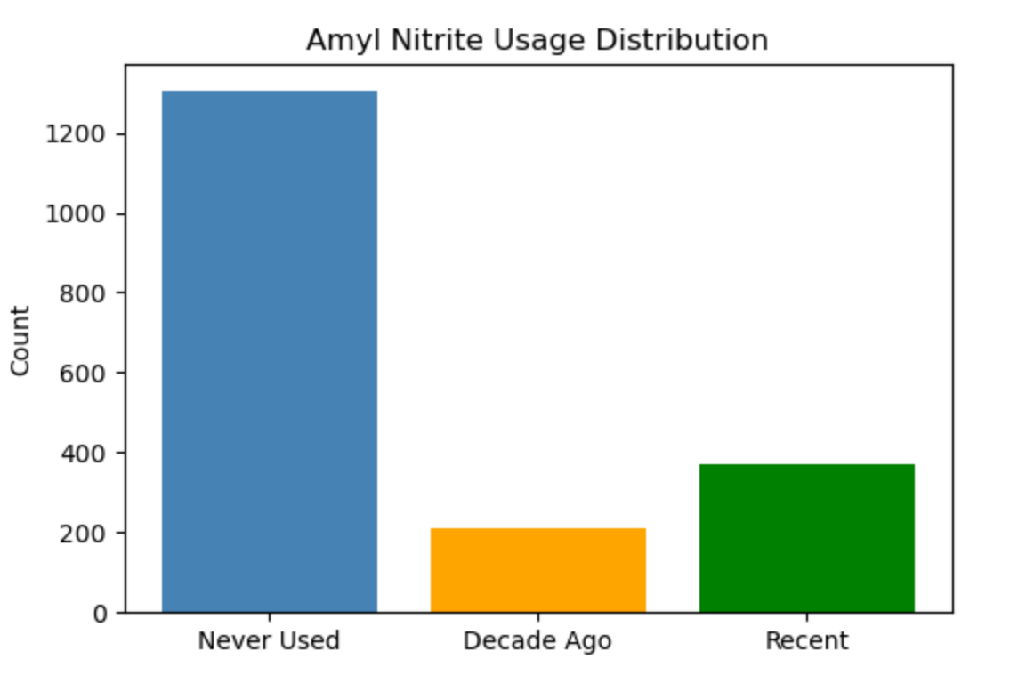
Figure 1. Distribution of Amyl Nitrite Consumption Categories
Figure 1 clearly illustrates severe class imbalance: the sample size of ‘Never Used’ was far larger than the other two classes, ‘Recent Use’ was the second-largest class, and ‘Decade Ago’ had the fewest samples. This issue will be mitigated using methods such as class weighting and resampling in subsequent modelling.
2.6 Relationship Between personality measurements and Drug Use
Boxplots were generated for the seven personality measurements, grouped by the merged Amyl classes to identify distributional differences (Figure 2).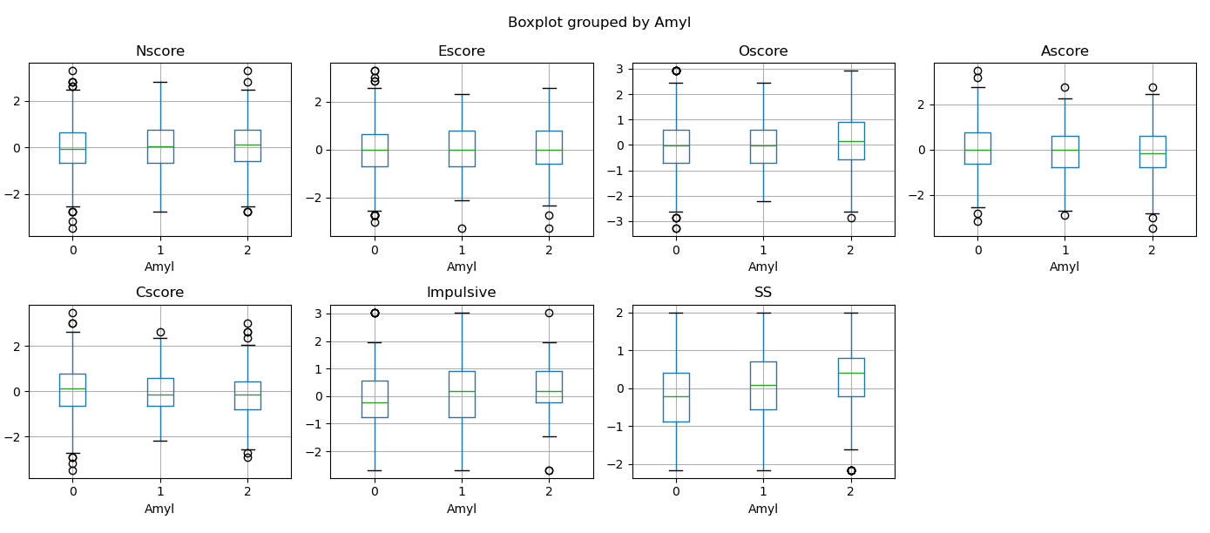
Figure 2. Boxplots of Personality Measurements Grouped by Drug Use Category
·Figure 2 shows that Nscore, Escore, and Ascore exhibited minimal distributional differences across the three classes, indicating relatively weak predictive power.
·Oscore: The median score of the ‘Recent Use’ group was significantly higher than that of the ‘Never Used’ group, suggesting a positive correlation between openness and recent drug use.
·SS: The median and upper quartile of the ‘Recent Use’ group were notably higher, indicating a strong association between sensation seeking and recent Amyl nitrite consumption.
·Cscore: The median score of the ‘Recent Use’ group was slightly lower, implying that lower conscientiousness was associated with a higher probability of recent drug use.
·Impulsive: The 'Recent Use' group showed a slightly higher median compared to 'Never Used', suggesting a moderate positive association between impulsivity and recent drug use.
2.7 Correlation Analysis of Personality Measurements
Pearson correlation coefficients for the seven personality Measurements were calculated and visualised in a heatmap (Figure 3).
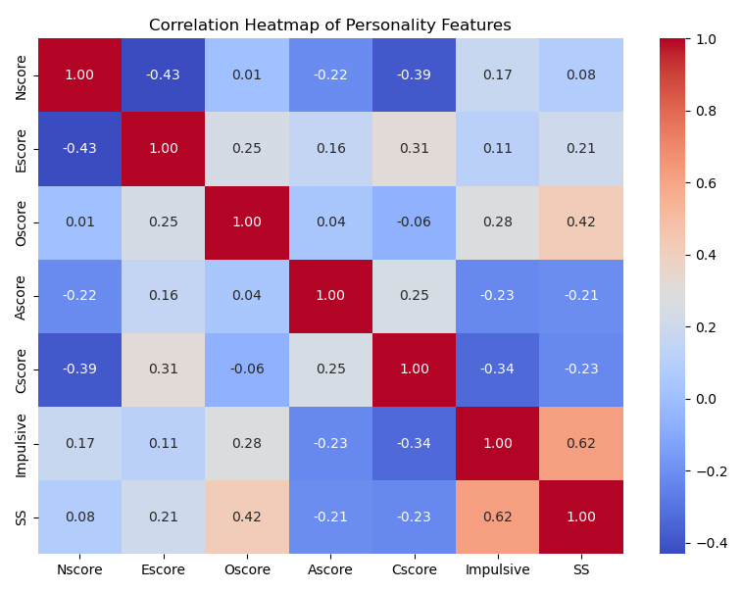
Figure 3. Correlation Heatmap of Personality Measurements
Figure 3 shows that Impulsive and SS had the highest correlation (0.62), both related to risk-taking behaviour, which is consistent with expectations. Nscore was negatively correlated with Escore (-0.43), indicating that individuals with higher neuroticism had lower extraversion.Nscore was negatively correlated with Cscore (-0.39), indicating that individuals with higher neuroticism had lower self-discipline.All correlations were weak to moderate (|r| < 0.7), confirming no severe multicollinearity. Thus, all Measurements could be included in modelling.
2.8 EDA Summary
This exploratory analysis shows that the dataset contains no missing values and is suitable for modelling after standardisation. The target variable exhibits significant class imbalance, with the ‘Never Used’ class being the most frequent. Among personality Measurements, SS and Impulsive are most strongly correlated and closely associated with drug use behaviour; neuroticism is negatively correlated with extraversion and conscientiousness, with no severe multicollinearity overall. Country and ethnicity distributions are unbalanced, and the small sample from New Zealand leads to unstable results. In summary, SS and Impulsive are the most critical predictive features, and class imbalance should be addressed in subsequent modelling.
3 Method and Result
3.1 Performance Evaluation Measures
Two metrics are used to evaluate model performance. Accuracy measures the proportion of correctly classified samples overall. However, given the significant class imbalance in this dataset (Never Used: 69.2%), accuracy alone can be misleading — a model predicting all samples as "Never Used" would achieve 69% accuracy while failing entirely on minority classes. Therefore, Macro F1-score is adopted as the primary evaluation criterion, as it computes the F1-score for each class independently and takes the unweighted average, giving equal importance to all classes regardless of sample size.Macro F1-score is also the standard evaluation metric for multi-class imbalanced classification in scikit-learn (average='macro'), and is used as the primary criterion for hyperparameter tuning via GridSearchCV in this study.
$$Macro F1=\frac{1}{K}\sum_{k=1}^{K}{\frac{2⋅P_{k}⋅R_{k}}{P_{k}+R_{k}}}$$
Where K is the number of classes, Pk and Rk are the precision and recall of class k respectively.
3.2 Random Forest and Decision Tree
3.2.1 Data Preprocessing
The input features X include 12 variables (Age, Gender, Education, Country, Ethnicity, Nscore, Escore, Oscore, Ascore, Cscore, Impulsive, SS), and the target variable y is merged into 3 categories of drug use (0=Never Used, 1=Decade Ago, 2=Recent). Stratified sampling with an 8:2 ratio (stratify=y) was adopted to split the data into training set (1508 samples) and test set (377 samples), with the class distribution of 69.2% for Never Used, 11.1% for Decade Ago, and 19.6% for Recent.
3.2.2 Model Design
1.Random Forest
For the Random Forest model, GridSearchCV combined with 5-fold stratified cross-validation (StratifiedKFold) was used for hyperparameter search, with f1_macro as the evaluation metric to adapt to the problem of class imbalance; the optimal parameters determined through the search are n_estimators=100, max_depth=10, min_samples_leaf=5, and max_features='sqrt', and class_weight='balanced' was set to further mitigate the impact of class imbalance on model performance.
2.Decision Tree
Similar to the Random Forest model, the Decision Tree model also used 5-fold stratified cross-validation for hyperparameter tuning, and its optimal parameters were determined as criterion='gini', max_depth=5, and min_samples_leaf=10; to handle the class imbalance problem, class_weight='balanced' was also set for the Decision Tree model to avoid bias towards the majority class.
3.2.3 Results and Evaluation
1.Random Forest Results
The Random Forest model achieved a best Macro F1 of 0.5307 in cross-validation, with test set accuracy of 0.68 and Macro F1 of 0.5467.
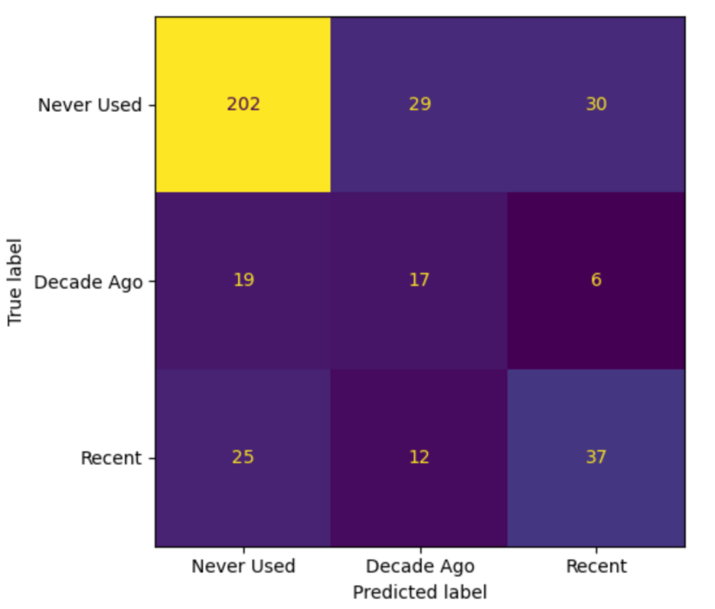
Figure 5. Confusion Matrix of the Random Forest Model
In the confusion matrix, 202 Never Used samples were correctly classified, 17 Decade Ago samples were correctly classified, and 37 Recent samples were correctly classified, showing good performance on majority class and moderate performance on minority classes.
The model performs best on the "Never Used" class, while the "Decade Ago" class has the lowest classification accuracy due to class imbalance, which is consistent with the results of the model evaluation and reflects the impact of sample size differences on classification performance.

2.Decision Tree Results
The Decision Tree model had a best Macro F1 of 0.4630 in cross-validation, and its overall performance on the test set was lower than that of the Random Forest model, with an accuracy of 0.48 and a Macro F1 of 0.4424.
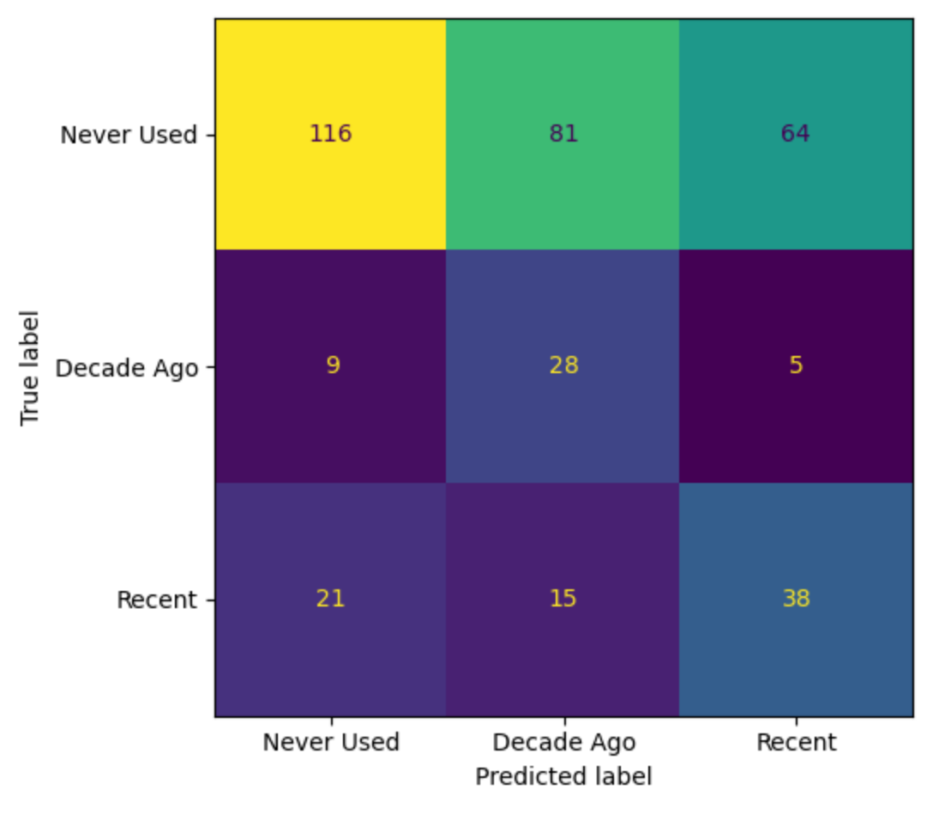
Figure 6. Confusion Matrix of the Decision Tree Model
According to the confusion matrix,116 Never Used samples, 28 Decade Ago samples (recall 0.67) and 38 Recent samples were correctly classified, indicating that the model had a certain advantage in identifying the Decade Ago class but suffered from obvious overfitting, resulting in low overall accuracy.
3.2.4 Results Comparison and Analysis
Table 5. Performance Comparison of Random Forest and Decision Tree Models
Model | Accuracy | Macro F1
Random Forest | 0.68 | 0.5467
Decision Tree | 0.48 | 0.4424
A comprehensive comparison of the two models shows that the Random Forest model has better overall performance than the Decision Tree model, with an accuracy of 0.68 and a Macro F1 of 0.5467, which is significantly higher than the Decision Tree's accuracy of 0.48 and Macro F1 of 0.4424; the Random Forest model has more stable classification performance on the Never Used and Recent classes, while the Decision Tree model has a higher recall on the Decade Ago class but lower overall accuracy.
Overall, the Random Forest model demonstrates superior overall performance and is more suitable for this multi-class classification task. Further analysis reveals that both models perform worst on the ‘Decade Ago’ class with the smallest sample size, achieving an F1-score of only 0.34, which fully reflects the negative impact of class imbalance; meanwhile, the Random Forest most accurately identifies the ‘Never Used’ class with the highest sample proportion (precision=0.82, recall=0.77), while it achieves an F1-score of 0.50 on the ‘Recent’ class, indicating moderate performance with room for improvement.
3.3 Neural Network and K-Nearest Neighbors
3.3.1 Data Preprocessing
To address class imbalance in the dataset and improve prediction performance, we used targeted optimization strategies in two types of models: the two-stage neural network model and the KNN model. In the neural network, the ratio of majority-class samples to minority-class samples is used as weights to give the model greater attention to minority class samples during training, thus reducing prediction bias. For the K-Nearest Neighbor model, hyperparameter tuning was applied to balances the prediction performance between majority and minority classes, and preventing the model from becoming overly biased towards the majority class.
3.3.2 Model Design
1. Two-Stage Neural Network
To address the 3-class classification problem, a two-stage (cascaded) binary classification strategy was applied.
Stage 1:A binary neural network (BinaryNet) was trained on all samples to distinguish between “Never Used” (CL0) and “Used” (CL1 & CL2). The model used 12 input features (demographic and personality variables) and a 3-layer fully connected structure (64 → 32 → 1 neurons) with ReLU activation and Dropout (0.5, 0.3) to reduce overfitting. Binary Cross-Entropy with class weights was used as the loss function.
Stage 2: Samples predicted as “Used” were further classified into “Decade Ago” (CL1) and “Recent” (CL2) using the same network structure.
The final 3-class prediction was obtained by combining results from both stages. Although each stage is binary classification, the final output satisfies the multi-class requirement.
2 K-Nearest Neighbors (KNN) Model
KNN is a non-parametric and instance-based method that can directly handle multi-class classification. It was used as a baseline model to compare with the neural network.
The model directly predicted three classes (Never Used, Decade Ago, Recent). Different values of k (3, 5, 7, 9, 10, 11) were tested, and k=10 was selected as the optimal parameter.
Model performance was evaluated using accuracy, precision, recall, F1-score, and confusion matrix on the test set.
3.3.3 Results and Evaluation
1. Neural Networks
Stage 1: The model achieved a test accuracy of 0.75. It showed strong performance in identifying the “Never Used” class (recall = 0.90) but had limited ability to detect the minority class (“Previously Used”, recall = 0.41).
Stage 2: The test accuracy was 0.68. The model showed relatively balanced performance, with F1 scores of 0.71 for “Decade Ago” and 0.64 for “Recent”.
Final Three-Class Prediction: After combining both stages, the overall accuracy reached 0.71, with a Macro F1 score of 0.51, indicating more balanced performance across classes. It showed better balanced performance across classes, although it still struggled with minority class recall.
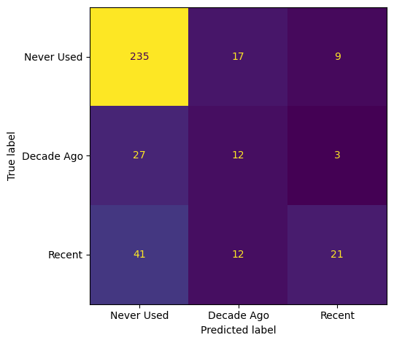
Figure 7. Confusion Matrix of the NN
According to the confusion matrix, 235 Never Used samples, 12 Decade Ago samples (recall 0.29), and 21 Recent samples were correctly classified. The model can effectively identify non-users, but it is difficult to distinguish between past and recent users because the sample size is small and the feature differences are not significant.
2. K-Nearest Neighbors
As the value of k increases, the overall accuracy of the KNN model first rises and then falls, reaching its highest accuracy of 0.72 at k=10. Larger k improves performance on the majority class but reduces that on minority classes, so k=10 is chosen as the optimal parameter.
The K-Nearest Neighbors (KNN) model achieved its best performance with k=10, reaching an overall test set accuracy of 0.72 and a Macro F1 score of 0.43. While the model performed well for the majority class (“Never Used”), its recall for the minority class (“Decade Ago”) was very low (0.07), indicating limited recognition of small classes.

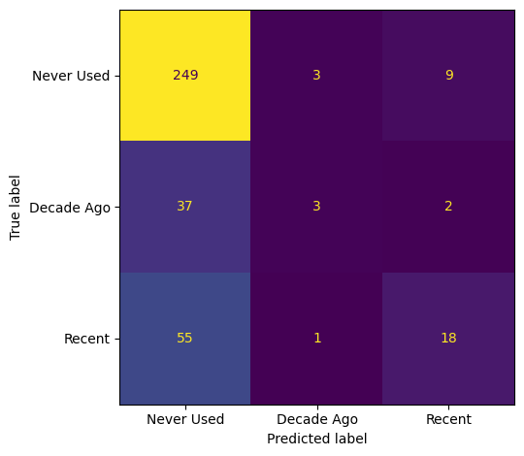
Figure 8. Confusion Matrix of the KNN
According to the confusion matrix, 248 never-used samples, 3 samples from ten years ago (with a recall of 0.07), and 12 recent samples were correctly classified, indicating that the model performs well in identifying never-used categories. The core limitation of the KNN model is that the "used before" category is mistakenly identified as "never used".
3.3.4 Results Comparison and Analysis
Table 6. Performance Comparison of Neural Network and KNN Models
Model | Accuracy | Macro F1
NN | 0.71 | 0.51
KNN | 0.72 | 0.43
This study compared the performance of the two-stage neural network and the KNN model in the three-class classification task of drug use. Both models achieved an overall accuracy above 70% and performed well in identifying the majority class “Never Used” (F1 ≈ 0.83). However, relying only on accuracy can be misleading. The two-stage neural network achieved a notably higher macro F1 (0.51) than KNN (0.43), indicating more balanced performance across all classes.
KNN showed poor ability in identifying the minority class “Decade Ago” (recall as low as 0.07), mainly due to the small sample size and overlapping features between classes, which caused the model to be biased toward the majority class.In comparison, the two-stage neural network alleviated the class imbalance to some extent by decomposing the multi-class task into two binary classification tasks and applying class weights. However, it was limited by the fact that misclassifications in the first stage could not be corrected in later stages.
3.4 Support Vector Machine (SVM)
3.4.1 Data Preparation and Preprocessing
The dataset was loaded, with input features x (12 demographic and personality variables) and target y (3-class amyl nitrite use: Never Used, Decade Ago, Recent). Stratified sampling split the data into 70% training and 30% test sets. Numerical features were standardised to mean=0 and std=1.
3.4.2 Support Vector Machine (SVM)
1. Model Configuration
A Support Vector Machine (SVM) classifier was implemented with the following settings:
·Kernel: rbf (radial basis function)
·Regularisation parameter: C=8.0, controlling the trade-off between maximising margin and minimising classification error
·Kernel coefficient: gamma=0.1, defining the influence of a single training sample
·Class imbalance handling: class_weight='balanced' to adjust weights inversely proportional to class frequencies, mitigating bias towards the majority class (Never Used)
2. Model Training and Evaluation
The SVM model was trained on the standardised training set, and predictions were generated for the test set. Model performance was evaluated using accuracy and a confusion matrix.
Test accuracy: 0.6 (60.0%), Macro F1: 0.50
Confusion matrix:
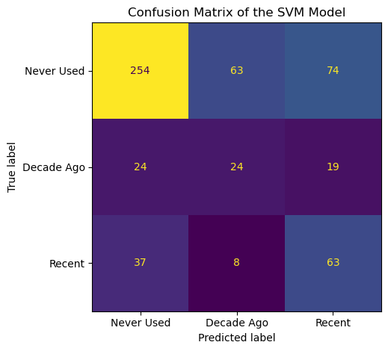
Figure 9. Confusion Matrix of the SVM
· Never Used: 254 correct classifications, with misclassifications to Decade Ago (63) and Recent (74)
· Decade Ago: 24 correct classifications, with misclassifications to Never Used (24) and Recent (19)
· Recent: 63 correct classifications, with misclassifications to Never Used (37) and Decade Ago (8)
3.Performance Analysis
The SVM model leverages non-linear kernel functions to capture complex relationships between features, providing a performance improvement over the linear Logistic Regression baseline. The class_weight='balanced' setting helps mitigate bias towards the majority class, ensuring the model does not completely ignore minority classes.
3.5 Logistic Regression Model
3.5.1 Model Configuration
A multi-class Logistic Regression classifier was constructed with the following key settings:
a. Solver: lbfgs (default), which is suitable for small datasets and multi-class classification tasks;
b. Regularisation parameter: C=1.0 (default value) to control model overfitting and complexity;
c. Class imbalance handling: class_weight=balanced to reduce bias towards the majority class;
d. Max iterations: max iter=500 to ensure the model converges successfully.
3.5.2 Model Training and Evaluation
The Logistic Regression model was trained on the standardised training set, and prediction results were obtained on the test set.
The model’s performance was evaluated using test accuracy and confusion matrix.
Test accuracy: 0.509(50.9%), Macro F1: 0.46, indicating that 50.9% of test samples were correctly classified
Confusion matrix:
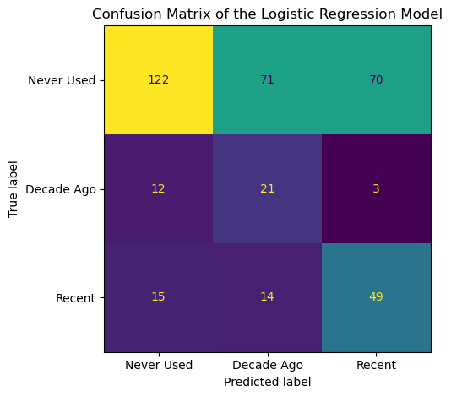
Figure 10. Confusion Matrix of the LR
·Never Used: 122 samples were correctly classified, 71 were misclassified as Decade Ago, and 70 were misclassified as Recent;
·Decade Ago: 21 samples were correctly classified, 12 were misclassified as Never Used, and 3 were misclassified as Recent;
·Recent: 49 samples were correctly classified, 15 were misclassified as Never Used, and 14 were misclassified as Decade Ago.
3.5.3 Performance Analysis
The Logistic Regression model achieved a test accuracy of 50.9%, serving as a simple and reliable linear baseline for this multi-class classification task. It performed relatively well on the majority ‘Never Used’ class but poorly on the ‘Decade Ago’ class with the smallest sample size (only 21 correct classifications), which fully reflects the impact of class imbalance. Its overall performance was slightly lower than the SVM model (60.0%) and significantly inferior to ensemble models (e.g. Random Forest) and neural networks.
3.5.4 Model Comparison
Table 7. Performance Comparison of Logistic Regression and SVM Models
Model | Accuracy | Macro F1
Logistic Regression | 0.509 | 0.46
SVM | 0.60 | 0.50
In terms of model performance, the Logistic Regression model achieved a test accuracy of 0.509 and a test Macro F1 of 0.46, while the SVM model achieved a test accuracy of 0.60 and a test Macro F1 of 0.50. Overall, the SVM model performs slightly better than the Logistic Regression model in terms of overall classification effect, both models perform well on the majority ‘Never Used’ class, but poorly on the ‘Decade Ago’ class due to class imbalance, and both are significantly inferior to ensemble models and neural networks.
3.6 Model Comparison
Table 8. Performance Comparison Table of Six Classification Models
Model | Test Accuracy | Test Macro F1
Two-stage Neural Network | 0.71 | 0.51
KNN (K=10) | 0.72 | 0.43
Random Forest | 0.68 | 0.55
SVM | 0.60 | 0.50
Logistic Regression | 0.509 | 0.46
Decision Tree | 0.48 | 0.44
As Macro F1 is the primary evaluation criterion, Random Forest is identified as the best-performing model with the highest Macro F1 of 0.55.
4.conclusion
This report developed six classification models based on demographic and personality Measurements and compared their performance in classifying categories of drug use. The two-stage neural network achieved the most balanced performance across all categories (accuracy = 0.71, Macro F1 = 0.51), while the Random Forest model attained the highest Macro F1 score of 0.55. As Macro F1 is adopted as the primary evaluation criterion in this study, Random Forest is identified as the best-performing model, demonstrating the most balanced classification performance across all three classes.
Nevertheless, this study has several limitations. For instance, the small sample size of minority classes and weak feature distinctions between some categories have contributed to reduced prediction accuracy. Future research could improve model robustness and minority-class recognition by applying oversampling techniques for minority classes, incorporating additional predictive features, and implementing model ensemble methods.

