- Use the command : git clone https://github.com/woshizhpy/Android-Calculator
To clone the project to your local machine.
- Open folder ”app” in it with Android Studio (Download Android Studio here: )
- Click Build -> Rebuild project
If any error due to version mismatch, please update the version following the error message guide.
- Click here to run the application 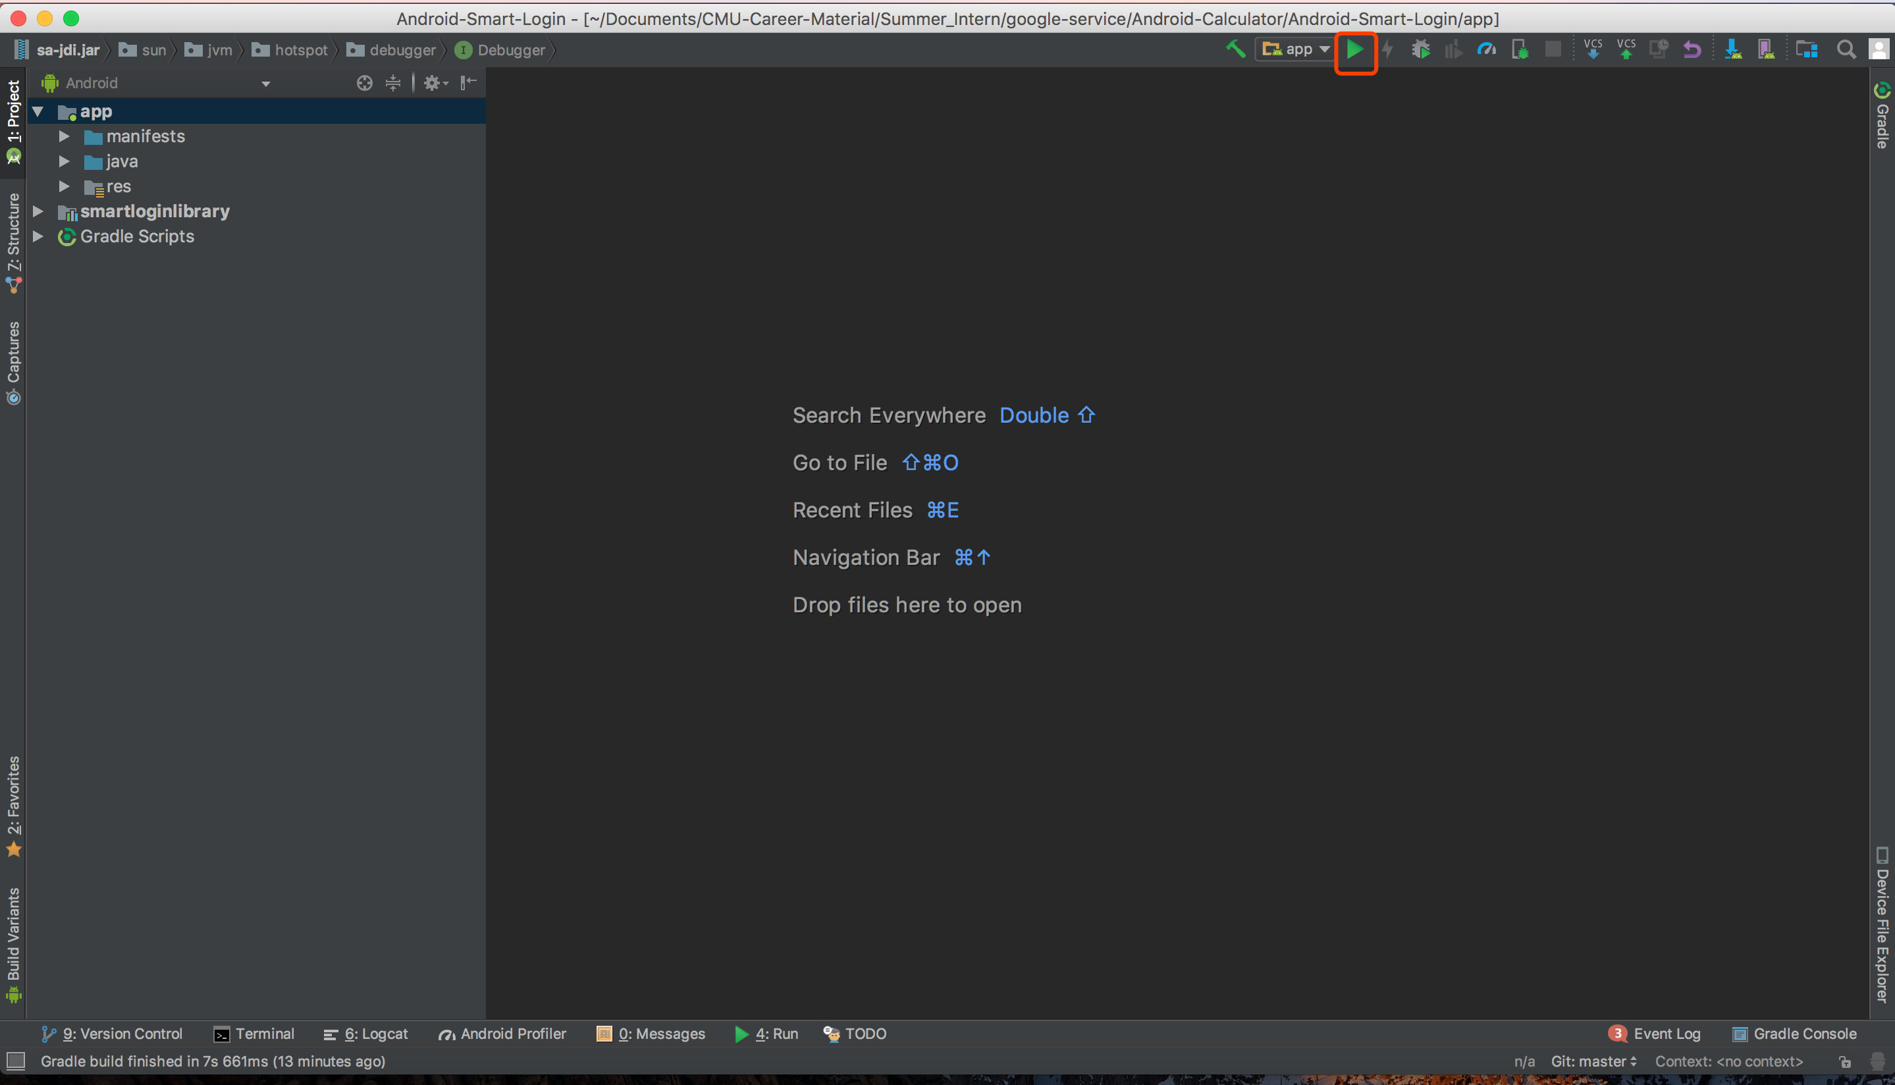
- You will see the login window like this:

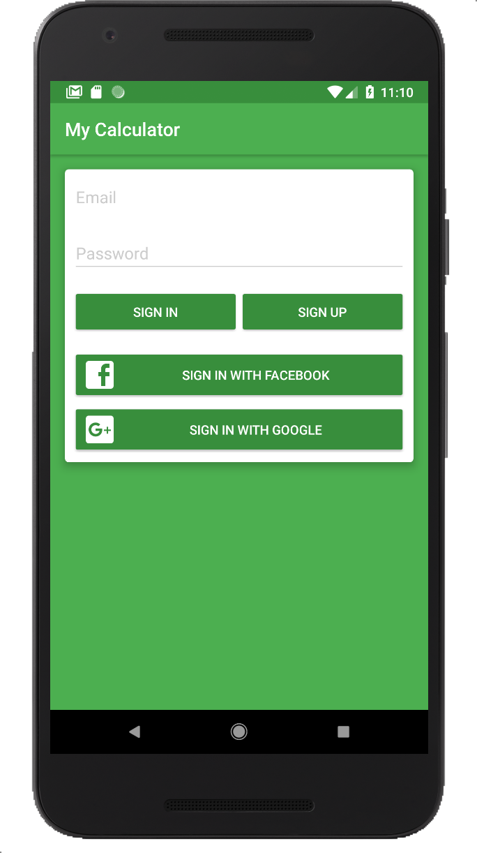

- When you logged in, you will see the calculator like this:

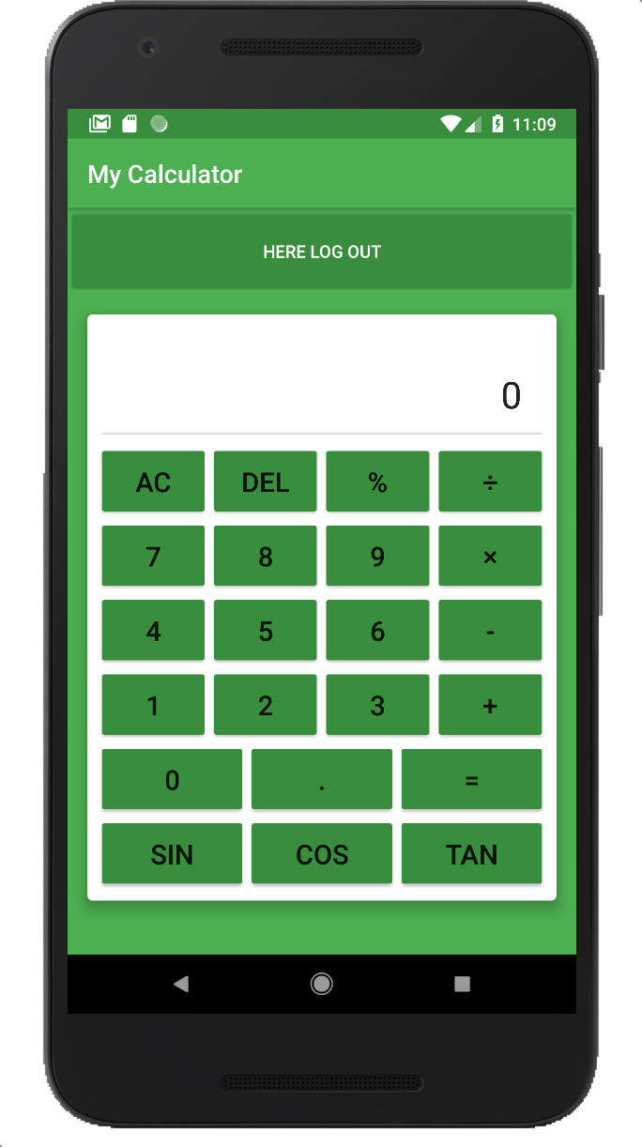

- The sin, cos, tan operation works like this: if you want to calculate sin(30), press 30 then press sin, you will see the result.

