Jonathan Lin

INFX 589 E Winter 2015

Assignment 3

This visualization takes current data about over 350 members from the Japanese pop group AKB48 Group. The group consists of four core sister groups each based out of a different region in Japan. While the expectation is that most members of each sister group would be hometown performers, this visualization would look at the distribution of member’s hometowns across Japan. The visualization would take the form of choropleth map using colorbrewer color scales to differentiate counts among prefectures. I think maps makes the most sense when looking at a geographical distribution of data. Other considerations included bar and scatter plots, but since prefecture is the base axis, using geographic shape files to represent seems like a good idea. However, this would mean that the numerical values of count and mean would likely be represented by color or size rather than length or position.

For interactions, hovering over a prefecture will give exact values. Clicking on a prefecture should give some sort of interaction, currently thinking of zoom. User controls will allow the user to filter data based on sister group affiliation or age.

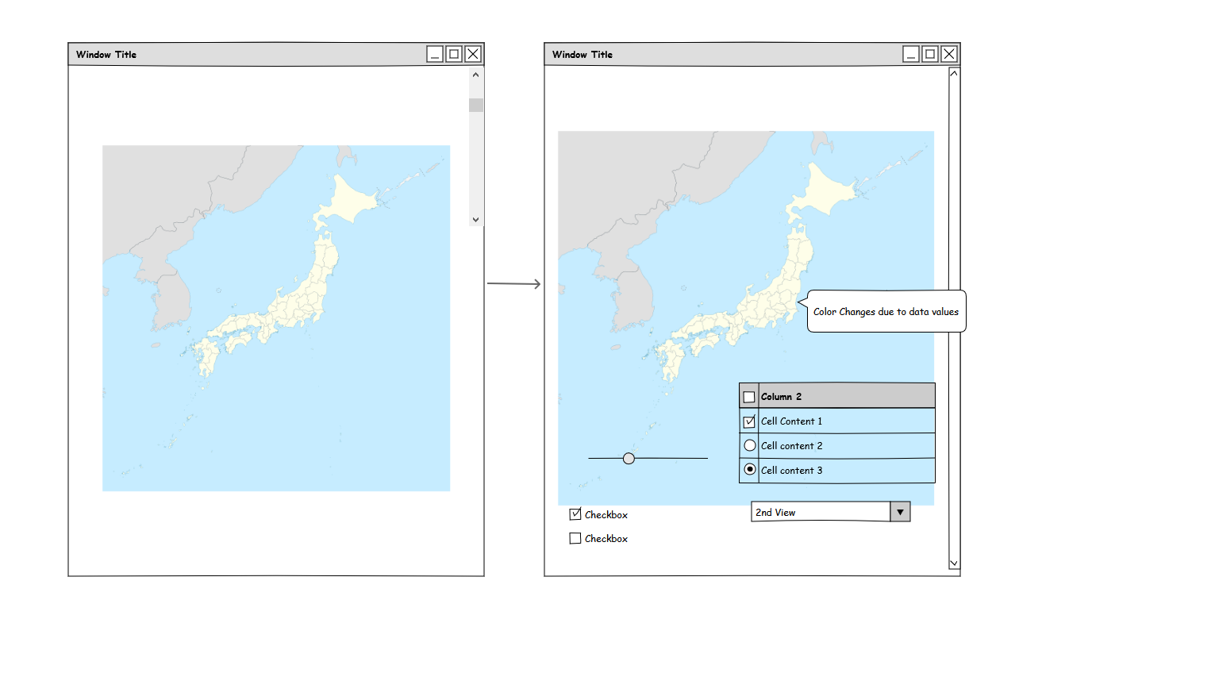

After implementation, many of the interactions I had planned were dropped. The user filters had to be dropped due to time constraints. I think I might have spent too much time trying to get the data to load. I needed to spend time working on merging geojson, topojson, and delimitated text data together. I ended going between a click-to-zoom and a mouse wheel-zoom as a primary interaction. Because Japan is tall and narrow, it has trouble fitting on landscape display without being zoomed out, at least using the projection I used. Click-to-zoom seemed to be less adjustable than using the mouse wheel to let users zoom in on the map to be able to hover over the tinier prefectures. Also, I ended up using Mercator, mostly because I could not find Japan using the coordinates with other projections.

Hovering over a prefecture brings up a tool-tip that shows the the prefecture name and the exact value of the number of 48 Group members from that prefecture. Clicking a prefecture will attempt to center the map at that point.

The static legend shows the five bins used in the map to color the data values. Used colorbrewer’s PuRd for its cute color pallet. The colors are log-scaled to try and represent the predominance of small values compared to the larger numbers in the range from 0 to 45.

I would have liked to have had more time to work on these maps, which I have been wanting to learn how to create for a while. I’ll probably keep working on these in the future, although I find d3 a bit difficult to use for dynamic data. I probably should have tried one of the many mapping libraries like leaflet.js but it seemed to cause conflicts with the base d3 code I was working in.

References

Original D3.js choropleth map code and Japanese topojson geographic data from <https://github.com/dataofjapan/land>

AKB48 data scraped from AKPedia, http://48pedia.org/

Legend from Mapbox, <https://www.mapbox.com/tilemill/docs/guides/advanced-legends/>

Mousewheel-zoom + click-to-center from http://bl.ocks.org/mbostock/2206340

Hover tips from https://github.com/Caged/d3-tip

Responsive map from <http://eyeseast.github.io/visible-data/2013/08/26/responsive-d3/>

Responsive layout from Bootstrap <http://getbootstrap.com/>