To check that this program will give me corrected sentence, I made a training data file with the lyrics of song, which is “I was born to love you”.

After that, I insert the sentence “I wasd borna top you”.

At first, for “I”, this program show me the list of candidate.

See the picture below.

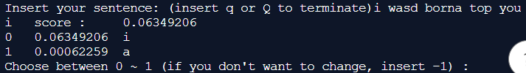

The value before the word is the product of unigram probability of the word times probability of miss-type.

And the list of candidate consists of three sets. (substitution up to 2, insertion, deletion).

After that, for the “wasd”, see the picture below.

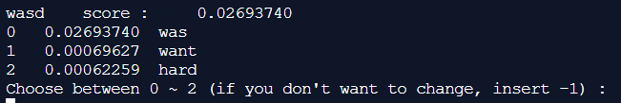

This program recommended “was” as best option.

And let’s jump into “top”.

Since I implemented substitution up to 2 letters, this program showed me “you”.

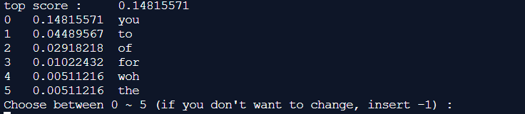

After choosing the word for “you”, it printed out the corrected sentence

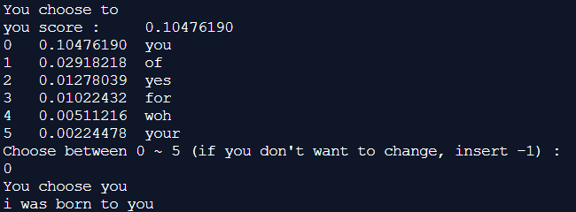

And let me try another sentence “I loved uou”



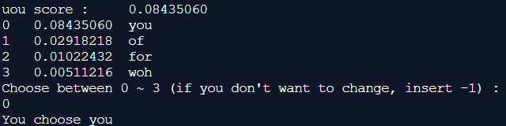

Though that was very tiny training data, but this program suggested some reasonable list of candidates.

After that, I insert ‘q’ to terminate the program.

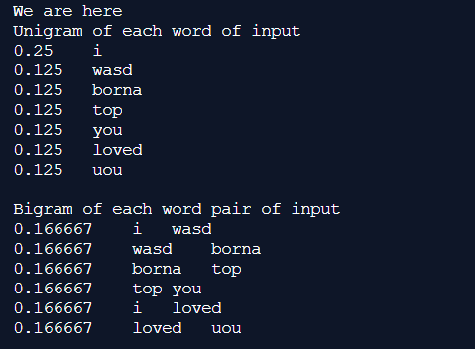

This is the end of program.