Problem 4.1

JAESANG PARK

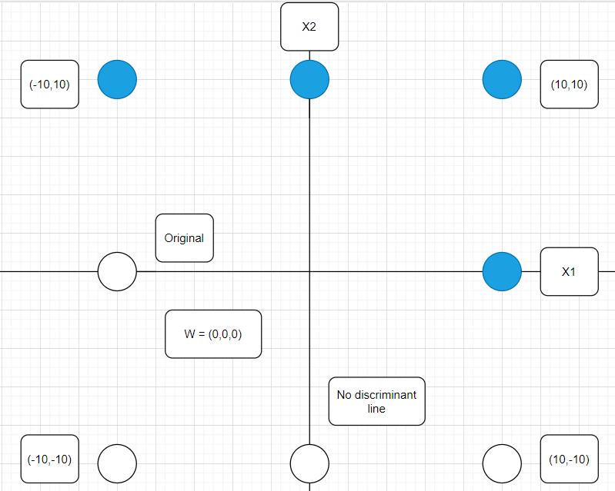 Picture above shows the state before the learning, the diagram with weight vector W with X1 and X2 axis.

The blue circles mean that the target output is 1.

And the white circles mean that the target output is 0.

It looks like the circle covers some area, but it points at some point.

The left upper corner circle points the (-10,10).

Since W = (0,0,0), there is no disciminant line

Epoch 1

|  |  |  |  |  |  |  |  |  |  |  |  |
| --- | --- | --- | --- | --- | --- | --- | --- | --- | --- | --- | --- |
| $$x_{1}$$ | $$x_{2}$$ | $$x_{3}$$ | $$w_{1}$$ | $$w_{2}$$ | $$w_{3}$$ | $$x∙w$$ | $$y$$ | $$t$$ | $w_{1}$ | $w_{2}$ | $w_{3}$ |
| 0 | 10 | -1 | 0 | 0 | 0 | 0 | 1 | 1 | 0 | 0 | 0 |
| 10 | -10 | -1 | 0 | 0 | 0 | 0 | 1 | 0 | -5 | 5 | 0.5 |
| -10 | 10 | -1 | -5 | 5 | 0.5 | 99.5 | 1 | 1 | 0 | 0 | 0 |
| 0 | -10 | -1 | -5 | 5 | 0.5 | -50.5 | 0 | 0 | 0 | 0 | 0 |
| 10 | 0 | -1 | -5 | 5 | 0.5 | -50.5 | 0 | 1 | 5 | 0 | -0.5 |
| -10 | 0 | -1 | 0 | 5 | 0 | 0 | 1 | 0 | 5 | 0 | 0.5 |
| 10 | 10 | -1 | 5 | 5 | 0.5 | 99.5 | 1 | 1 | 0 | 0 | 0 |
| -10 | -10 | -1 | 5 | 5 | 0.5 | -100.5 | 0 | 0 | 0 | 0 | 0 |

W = (5,5,0.5)

So, discriminant line is $x_{2}={-x}_{1}+0.1$.

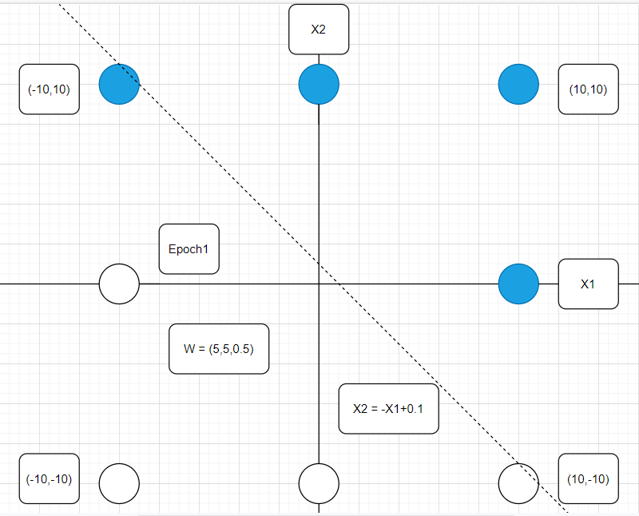

In this case, (-10,10) is misclassified.

Epoch 2

|  |  |  |  |  |  |  |  |  |  |  |  |
| --- | --- | --- | --- | --- | --- | --- | --- | --- | --- | --- | --- |
| $$x_{1}$$ | $$x_{2}$$ | $$x_{3}$$ | $$w_{1}$$ | $$w_{2}$$ | $$w_{3}$$ | $$x∙w$$ | $$y$$ | $$t$$ | $w_{1}$ | $w_{2}$ | $w_{3}$ |
| 0 | 10 | -1 | 5 | 5 | 0.5 | 49.5 | 1 | 1 | 0 | 0 | 0 |
| 10 | -10 | -1 | 5 | 5 | 0.5 | -0.5 | 0 | 0 | 0 | 0 | 0 |
| -10 | 10 | -1 | 5 | 5 | 0.5 | -0.5 | 0 | 1 | -5 | 5 | -0.5 |
| 0 | -10 | -1 | 0 | 10 | 0 | -100 | 0 | 0 | 0 | 0 | 0 |
| 10 | 0 | -1 | 0 | 10 | 0 | 0 | 1 | 1 | 0 | 0 | 0 |
| -10 | 0 | -1 | 0 | 10 | 0 | 0 | 1 | 0 | 5 | 0 | 0.5 |
| 10 | 10 | -1 | 5 | 10 | 0.5 | 149.5 | 1 | 1 | 0 | 0 | 0 |
| -10 | -10 | -1 | 5 | 10 | 0.5 | -150.5 | 0 | 0 | 0 | 0 | 0 |

W = (5,10,0.5)

So, discriminant line is $x_{2}={-0.5x}_{1}+0.05$.

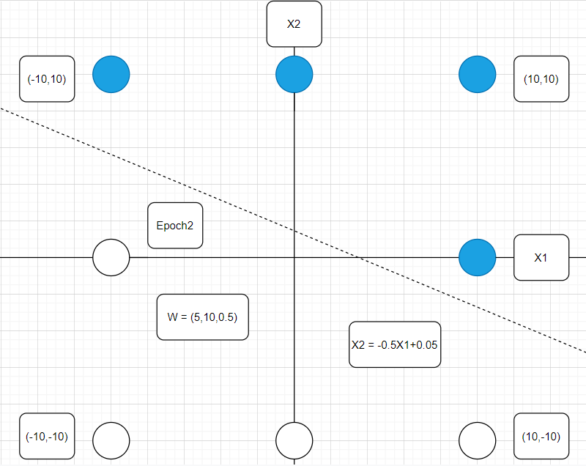

The discriminant line absolutely classifies the class.

But I don’t think I can conclude the W vector is converged.

Because there are too few evidence. (only two rows)

Epoch 3

|  |  |  |  |  |  |  |  |  |  |  |  |
| --- | --- | --- | --- | --- | --- | --- | --- | --- | --- | --- | --- |
| $$x_{1}$$ | $$x_{2}$$ | $$x_{3}$$ | $$w_{1}$$ | $$w_{2}$$ | $$w_{3}$$ | $$x∙w$$ | $$y$$ | $$t$$ | $w_{1}$ | $w_{2}$ | $w_{3}$ |
| 0 | 10 | -1 | 5 | 10 | 0.5 | 99.5 | 1 | 1 | 0 | 0 | 0 |
| 10 | -10 | -1 | 5 | 10 | 0.5 | -50.5 | 0 | 0 | 0 | 0 | 0 |
| -10 | 10 | -1 | 5 | 10 | 0.5 | 49.5 | 1 | 1 | 0 | 0 | 0 |
| 0 | -10 | -1 | 5 | 10 | 0.5 | -100.5 | 0 | 0 | 0 | 0 | 0 |
| 10 | 0 | -1 | 5 | 10 | 0.5 | 49.5 | 1 | 1 | 0 | 0 | 0 |
| -10 | 0 | -1 | 5 | 10 | 0.5 | -50.5 | 0 | 0 | 0 | 0 | 0 |
| 10 | 10 | -1 | 5 | 10 | 0.5 | 149.5 | 1 | 1 | 0 | 0 | 0 |
| -10 | -10 | -1 | 5 | 10 | 0.5 | -150.5 | 0 | 0 | 0 | 0 | 0 |

W = (5,10,0.5)

So, discriminant line is $x_{2}={-0.5x}_{1}+0.05$.

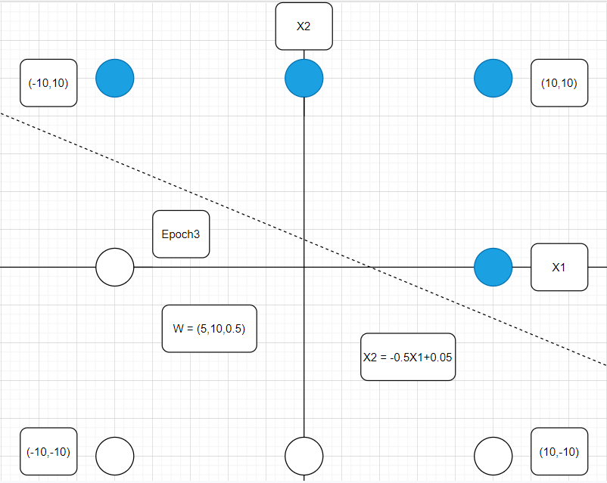

I can conclude that the weight vector W is converged to (5,10,0.5).

Because through the epoch, the W was not changed at all.

Epoch 4

|  |  |  |  |  |  |  |  |  |  |  |  |
| --- | --- | --- | --- | --- | --- | --- | --- | --- | --- | --- | --- |
| $$x_{1}$$ | $$x_{2}$$ | $$x_{3}$$ | $$w_{1}$$ | $$w_{2}$$ | $$w_{3}$$ | $$x∙w$$ | $$y$$ | $$t$$ | $w_{1}$ | $w_{2}$ | $w_{3}$ |
| 0 | 10 | -1 | 5 | 10 | 0.5 | 99.5 | 1 | 1 | 0 | 0 | 0 |
| 10 | -10 | -1 | 5 | 10 | 0.5 | -50.5 | 0 | 0 | 0 | 0 | 0 |
| -10 | 10 | -1 | 5 | 10 | 0.5 | 49.5 | 1 | 1 | 0 | 0 | 0 |
| 0 | -10 | -1 | 5 | 10 | 0.5 | -100.5 | 0 | 0 | 0 | 0 | 0 |
| 10 | 0 | -1 | 5 | 10 | 0.5 | 49.5 | 1 | 1 | 0 | 0 | 0 |
| -10 | 0 | -1 | 5 | 10 | 0.5 | -50.5 | 0 | 0 | 0 | 0 | 0 |
| 10 | 10 | -1 | 5 | 10 | 0.5 | 149.5 | 1 | 1 | 0 | 0 | 0 |
| -10 | -10 | -1 | 5 | 10 | 0.5 | -150.5 | 0 | 0 | 0 | 0 | 0 |

W = (5,10,0.5)

So, discriminant line is .

