2.13

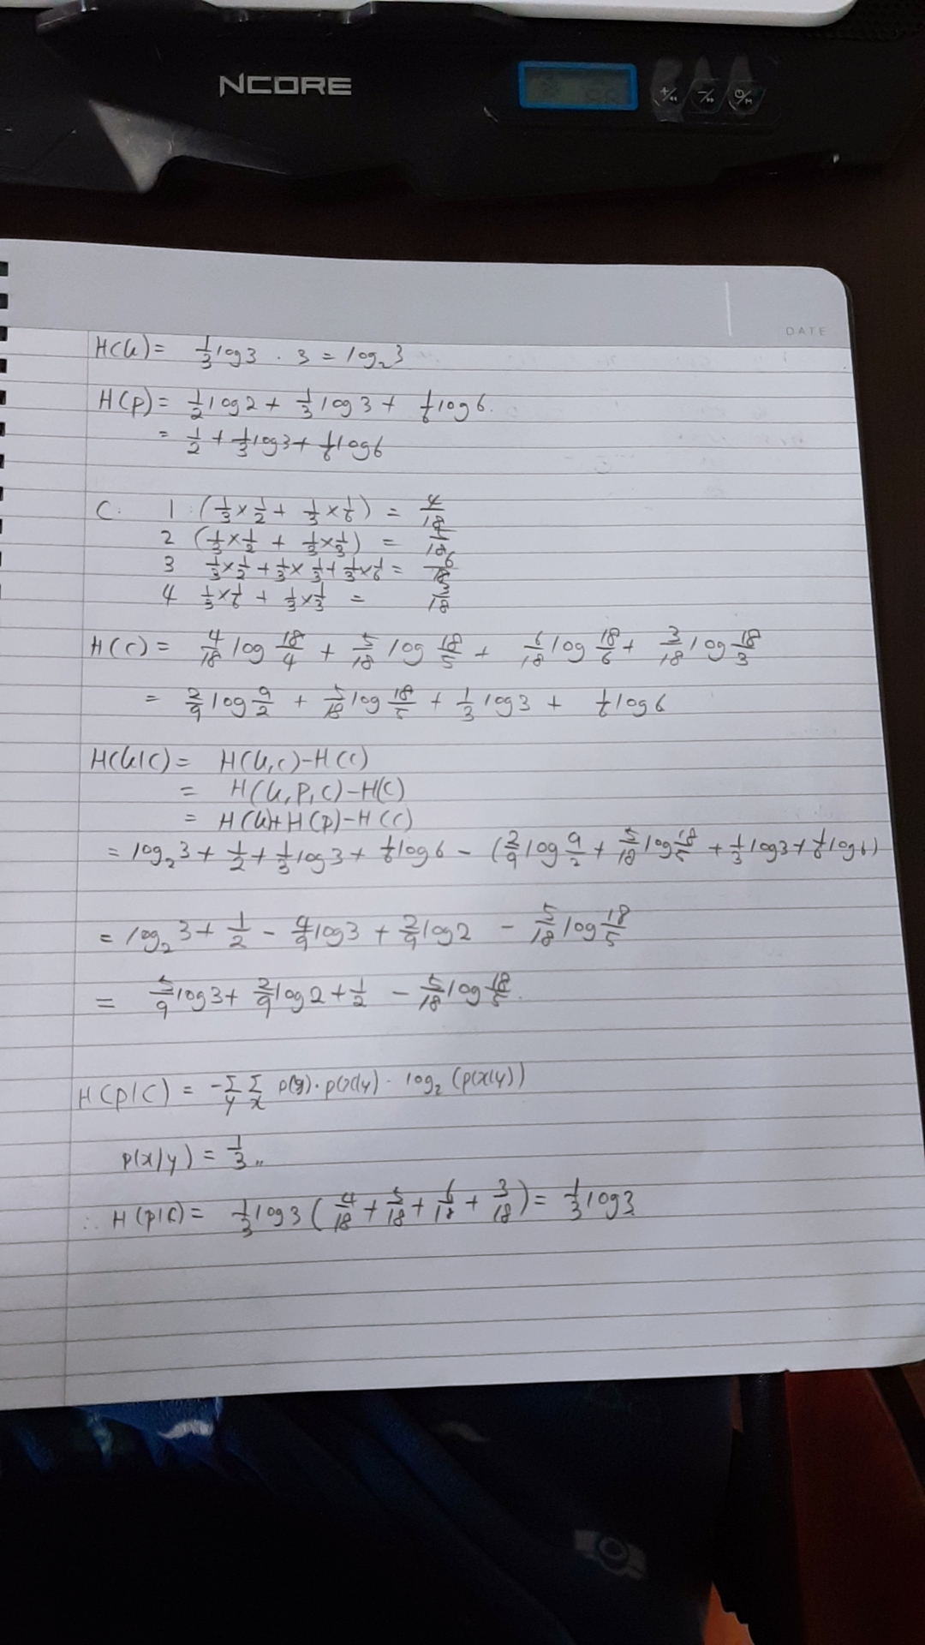

3.1

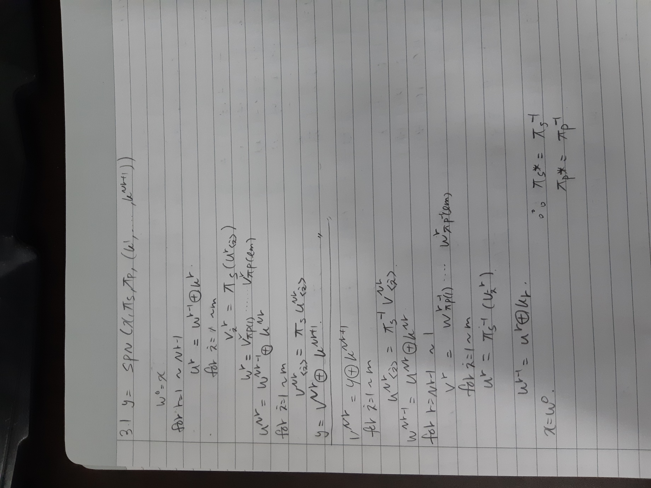

3.5

key0

2b28ab09

7eaef7cf

15d2154f

16a6883c

key1

a0fafe17

88542cb1

23a33939

2a6c7605

key2

f2c295f2

7a96b943

5935807a

7359f67f

key3

3d80477d

4716fe3e

1e237e44

6d7a883b

key4

ef44a541

a8525b7f

b671253b

db0bad00

key5

d4d1c6f8

7c839d87

caf2b8bc

11f915bc

key6

6d88a37a

110b3efd

dbf98641

ca0093fd

key7

4e54f70e

5f5fc9f3

84a64fb2

4ea6dc4f

key8

ead27321

b58dbad2

312bf560

7f8d292f

key9

ac7766f3

19fadc21

28d12941

575c006e

key10

d014f9a8

c9ee2589

e13f0cc8

b6630ca6

3.6

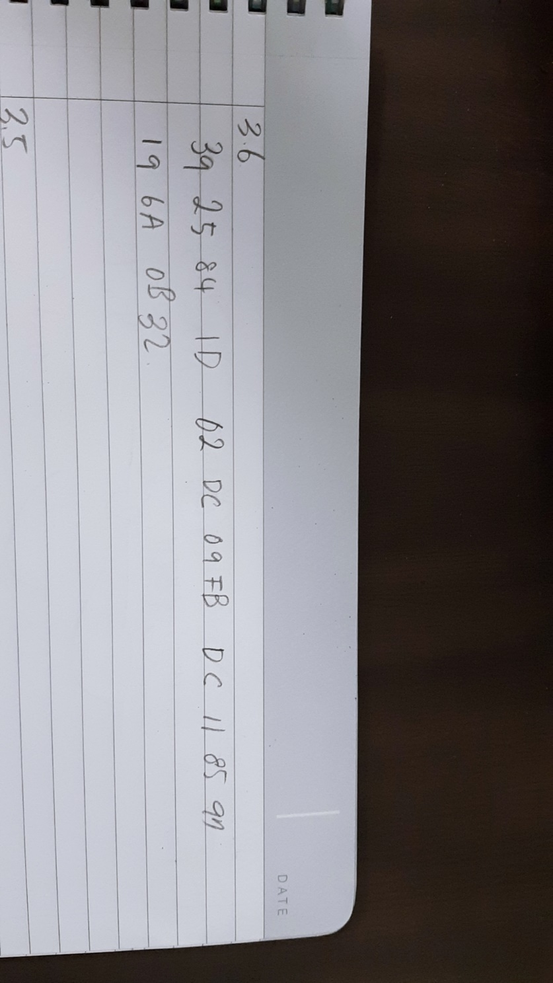

And I also submitted the code.

just g++ homework.cpp

Then ./a.out 2B7E151628AED2A6ABF7158809CF4F3C 3243F6A8885A308D313198A2E0370734

The output could omit 0 if 0 is the first letter.

02DB09FB would be written 2DB09FB.

3.10

