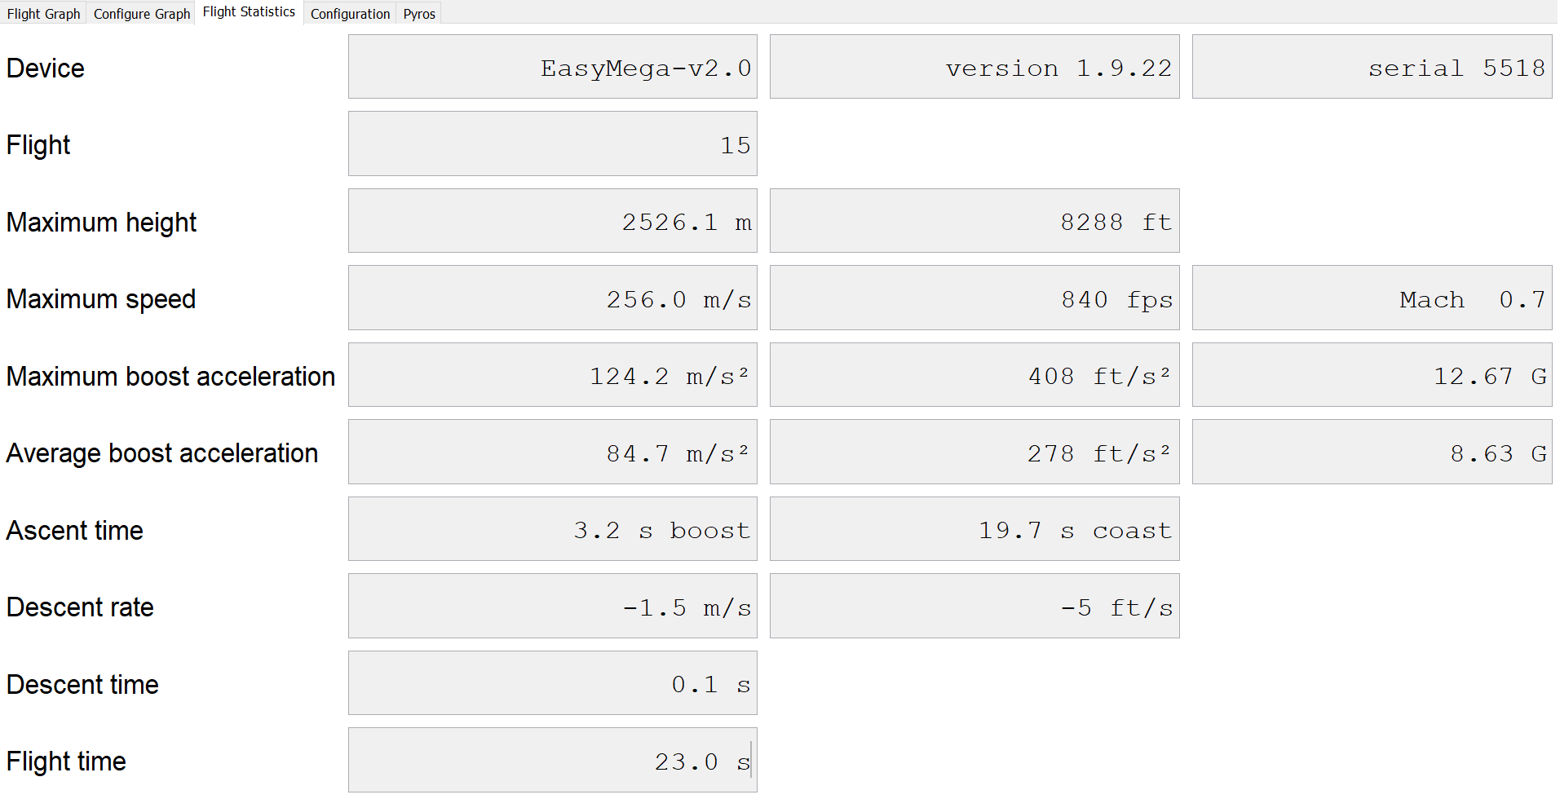
Figure 1: Summarised data over the course of the flight.

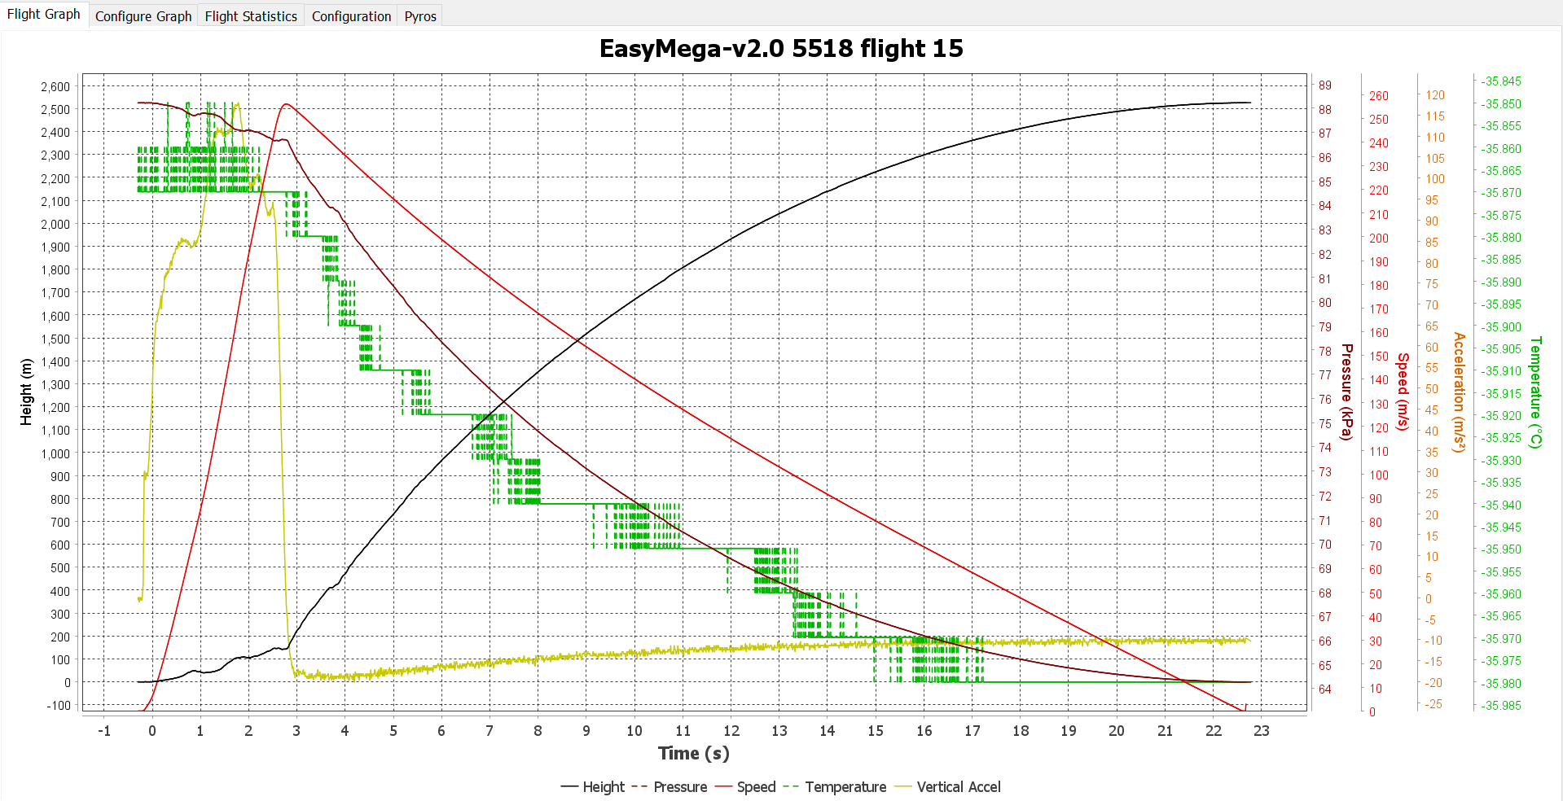
Figure 2: Pressure (kPa), and temperature variation (°C) over time (seconds)
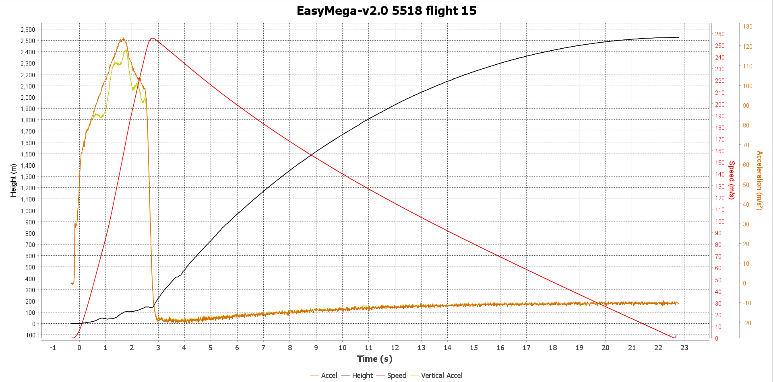
Figure 3: Speed (m/s) and acceleration (m/s²) over time (seconds)

