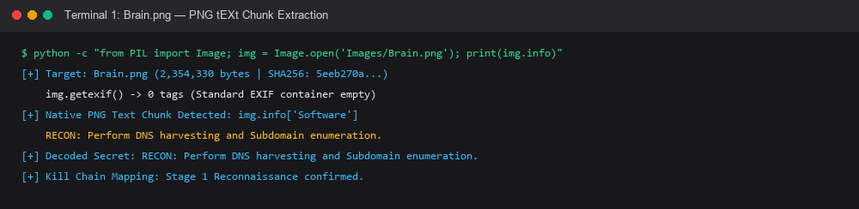
Figure 1: Forensic terminal output extracting Stage 1 Reconnaissance payload from Brain.png tEXt chunk.
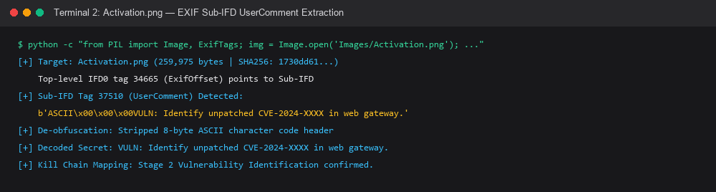
Figure 2: Forensic terminal output extracting and de-obfuscating Stage 2 payload from Activation.png Sub-IFD.
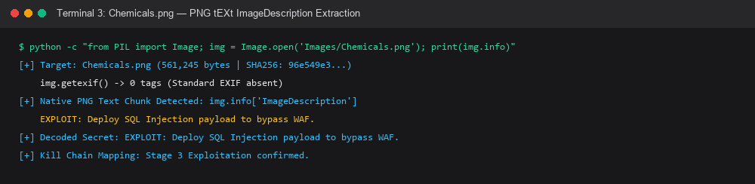
Figure 3: Forensic terminal output extracting Stage 3 Exploitation payload from Chemicals.png tEXt chunk.
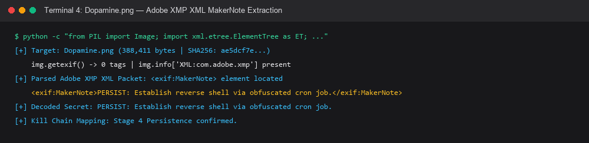
Figure 4: Forensic terminal output parsing Adobe XMP XML packet from Dopamine.png to uncover Stage 4 payload.
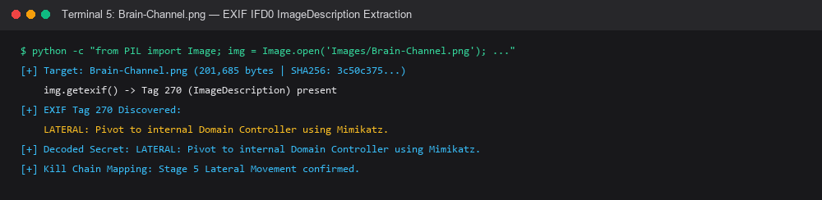
Figure 5: Forensic terminal output extracting Stage 5 Lateral Movement payload from Brain-Channel.png EXIF IFD0.
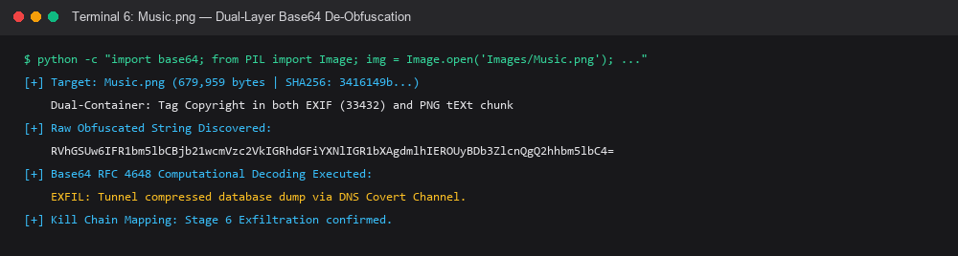
Figure 6: Forensic terminal output demonstrating Base64 decoding of Stage 6 Exfiltration payload from Music.png.

