Terminal Evidence Verification

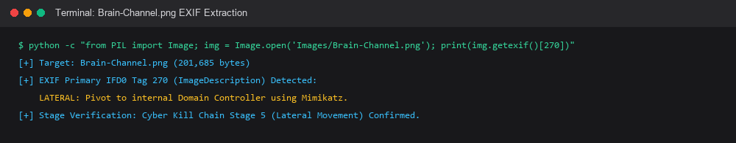
Figure 1: Forensic CLI extraction terminal verifying Stage 5 covert channel.

