**Lstm_95.h5 :**

lstm one to one

standard scaler

early stopping 34 epoch

LSTM(units=64, input_shape=(1,14), return_sequences=True),

BatchNormalization(),

Dropout(0.2),

LSTM(units=32, return_sequences=True),

BatchNormalization(),

Dense(units=1, activation='sigmoid')

model.compile(optimizer='adam', loss='binary_crossentropy', metrics=['accuracy'])

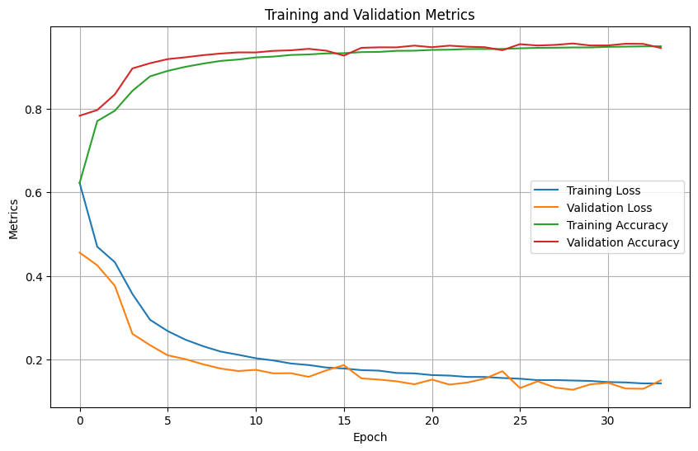

Epoch 1/100

1237/1237 [==============================] - 14s 10ms/step - loss: 0.6225 - accuracy: 0.6222 - val_loss: 0.4557 - val_accuracy: 0.7830

Epoch 2/100

1237/1237 [==============================] - 11s 9ms/step - loss: 0.4697 - accuracy: 0.7702 - val_loss: 0.4253 - val_accuracy: 0.7966

Epoch 3/100

1237/1237 [==============================] - 11s 9ms/step - loss: 0.4326 - accuracy: 0.7950 - val_loss: 0.3762 - val_accuracy: 0.8341

Epoch 4/100

1237/1237 [==============================] - 11s 9ms/step - loss: 0.3565 - accuracy: 0.8427 - val_loss: 0.2612 - val_accuracy: 0.8962

Epoch 5/100

1237/1237 [==============================] - 11s 9ms/step - loss: 0.2949 - accuracy: 0.8773 - val_loss: 0.2342 - val_accuracy: 0.9087

Epoch 6/100

1237/1237 [==============================] - 11s 9ms/step - loss: 0.2679 - accuracy: 0.8903 - val_loss: 0.2099 - val_accuracy: 0.9184

Epoch 7/100

1237/1237 [==============================] - 11s 9ms/step - loss: 0.2474 - accuracy: 0.9000 - val_loss: 0.2008 - val_accuracy: 0.9228

Epoch 8/100

1237/1237 [==============================] - 12s 10ms/step - loss: 0.2319 - accuracy: 0.9076 - val_loss: 0.1886 - val_accuracy: 0.9279

Epoch 9/100

1237/1237 [==============================] - 12s 9ms/step - loss: 0.2189 - accuracy: 0.9141 - val_loss: 0.1783 - val_accuracy: 0.9318

Epoch 10/100

1237/1237 [==============================] - 11s 9ms/step - loss: 0.2113 - accuracy: 0.9174 - val_loss: 0.1724 - val_accuracy: 0.9346

Epoch 11/100

1237/1237 [==============================] - 11s 9ms/step - loss: 0.2029 - accuracy: 0.9225 - val_loss: 0.1752 - val_accuracy: 0.9344

Epoch 12/100

1237/1237 [==============================] - 11s 9ms/step - loss: 0.1976 - accuracy: 0.9246 - val_loss: 0.1668 - val_accuracy: 0.9382

Epoch 13/100

1237/1237 [==============================] - 11s 9ms/step - loss: 0.1903 - accuracy: 0.9284 - val_loss: 0.1672 - val_accuracy: 0.9395

Epoch 14/100

1237/1237 [==============================] - 12s 10ms/step - loss: 0.1867 - accuracy: 0.9297 - val_loss: 0.1584 - val_accuracy: 0.9430

Epoch 15/100

1237/1237 [==============================] - 12s 9ms/step - loss: 0.1808 - accuracy: 0.9321 - val_loss: 0.1740 - val_accuracy: 0.9386

Epoch 16/100

1237/1237 [==============================] - 12s 10ms/step - loss: 0.1785 - accuracy: 0.9326 - val_loss: 0.1864 - val_accuracy: 0.9268

Epoch 17/100

1237/1237 [==============================] - 12s 10ms/step - loss: 0.1745 - accuracy: 0.9352 - val_loss: 0.1547 - val_accuracy: 0.9455

Epoch 18/100

1237/1237 [==============================] - 12s 10ms/step - loss: 0.1733 - accuracy: 0.9357 - val_loss: 0.1519 - val_accuracy: 0.9467

Epoch 19/100

1237/1237 [==============================] - 11s 9ms/step - loss: 0.1677 - accuracy: 0.9383 - val_loss: 0.1477 - val_accuracy: 0.9466

Epoch 20/100

1237/1237 [==============================] - 11s 9ms/step - loss: 0.1667 - accuracy: 0.9386 - val_loss: 0.1407 - val_accuracy: 0.9507

Epoch 21/100

1237/1237 [==============================] - 11s 9ms/step - loss: 0.1627 - accuracy: 0.9404 - val_loss: 0.1518 - val_accuracy: 0.9469

Epoch 22/100

1237/1237 [==============================] - 11s 9ms/step - loss: 0.1615 - accuracy: 0.9411 - val_loss: 0.1399 - val_accuracy: 0.9507

Epoch 23/100

1237/1237 [==============================] - 12s 10ms/step - loss: 0.1582 - accuracy: 0.9425 - val_loss: 0.1448 - val_accuracy: 0.9481

Epoch 24/100

1237/1237 [==============================] - 12s 10ms/step - loss: 0.1581 - accuracy: 0.9427 - val_loss: 0.1541 - val_accuracy: 0.9470

Epoch 25/100

1237/1237 [==============================] - 12s 10ms/step - loss: 0.1557 - accuracy: 0.9427 - val_loss: 0.1719 - val_accuracy: 0.9398

Epoch 26/100

1237/1237 [==============================] - 12s 10ms/step - loss: 0.1539 - accuracy: 0.9443 - val_loss: 0.1317 - val_accuracy: 0.9542

Epoch 27/100

1237/1237 [==============================] - 11s 9ms/step - loss: 0.1505 - accuracy: 0.9454 - val_loss: 0.1477 - val_accuracy: 0.9509

Epoch 28/100

1237/1237 [==============================] - 11s 9ms/step - loss: 0.1508 - accuracy: 0.9458 - val_loss: 0.1328 - val_accuracy: 0.9525

Epoch 29/100

1237/1237 [==============================] - 12s 10ms/step - loss: 0.1497 - accuracy: 0.9464 - val_loss: 0.1276 - val_accuracy: 0.9559

Epoch 30/100

1237/1237 [==============================] - 13s 10ms/step - loss: 0.1486 - accuracy: 0.9464 - val_loss: 0.1406 - val_accuracy: 0.9510

Epoch 31/100

1237/1237 [==============================] - 13s 10ms/step - loss: 0.1460 - accuracy: 0.9478 - val_loss: 0.1442 - val_accuracy: 0.9512

Epoch 32/100

1237/1237 [==============================] - 13s 10ms/step - loss: 0.1451 - accuracy: 0.9483 - val_loss: 0.1305 - val_accuracy: 0.9553

Epoch 33/100

1237/1237 [==============================] - 13s 10ms/step - loss: 0.1427 - accuracy: 0.9489 - val_loss: 0.1299 - val_accuracy: 0.9549

Epoch 34/100

1237/1237 [==============================] - 14s 11ms/step - loss: 0.1427 - accuracy: 0.9491 - val_loss: 0.1503 - val_accuracy: 0.9451

1546/1546 [==============================] - 7s 4ms/step - loss: 0.1256 - accuracy: 0.9559

Training time : 402.3834400177002