***Absley***

John Absley

Born - 1827, Halifax, England

Died – 30th April, 1881, Merchant marine, at sea, Great Britian

Aged – 51 years

Cause of death - Drowning

Sailed on the City of Adelaide as a crew member (Able Seaman)

* 28th June, 1875, from London, England, arriving in Port Adelaide, 26th September, 1875
* 11th November, 1875 from Port Adelaide to London arriving 24th February, 1876

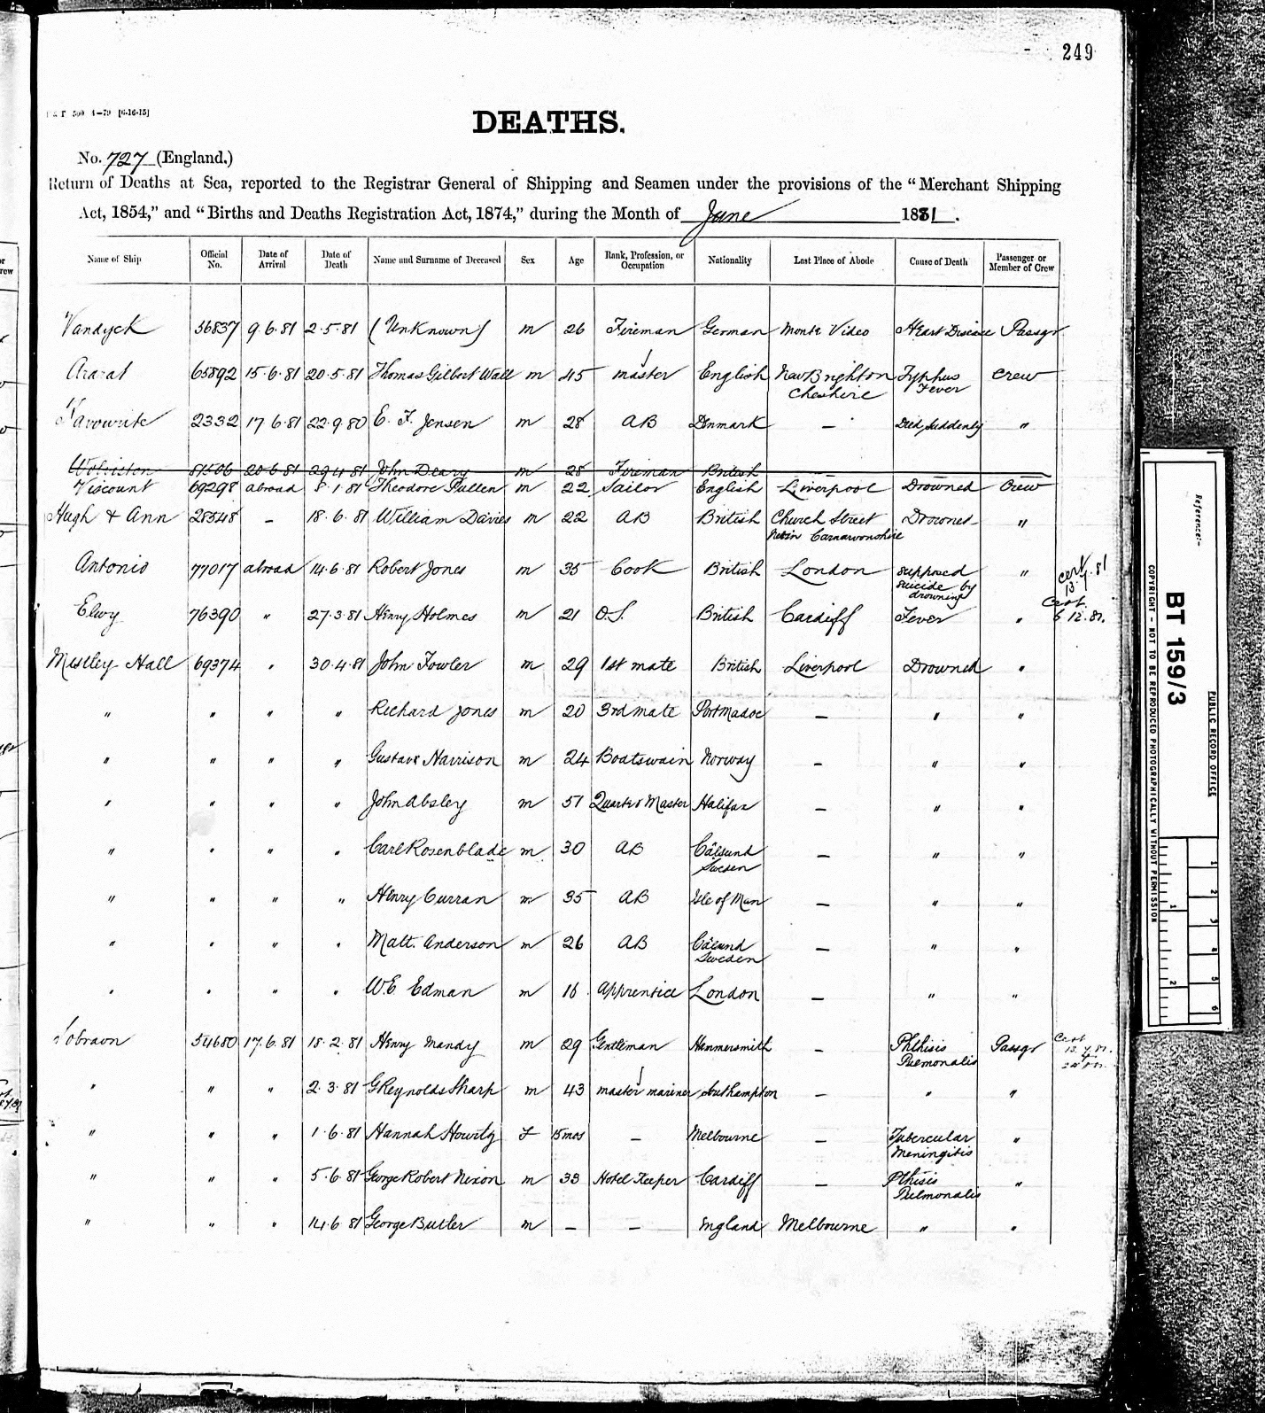

*Reads:*

*Deaths*

*No. 727*

*Return of Deaths at sea, reported to the Registrar General of Shipping and Seamen under the provisions of the “Merchant Shipping Act 1854,” and “Births and Death Registration Act 1874” during the month of June*

*Name of Ship – Mistley Hall*

*Official No. 69374*

*Date of arrival – abroad*

*Date of death – 30th April, 1881*

*Name and Surname of deceased – John Absley*

*Sex – Male*

*Age – 51 years*

*Rank, profession or occupation – Quarter Master*

*Nationality – Halifax*

*Cause of death – Drowned*

*Passenger or crew – crew*

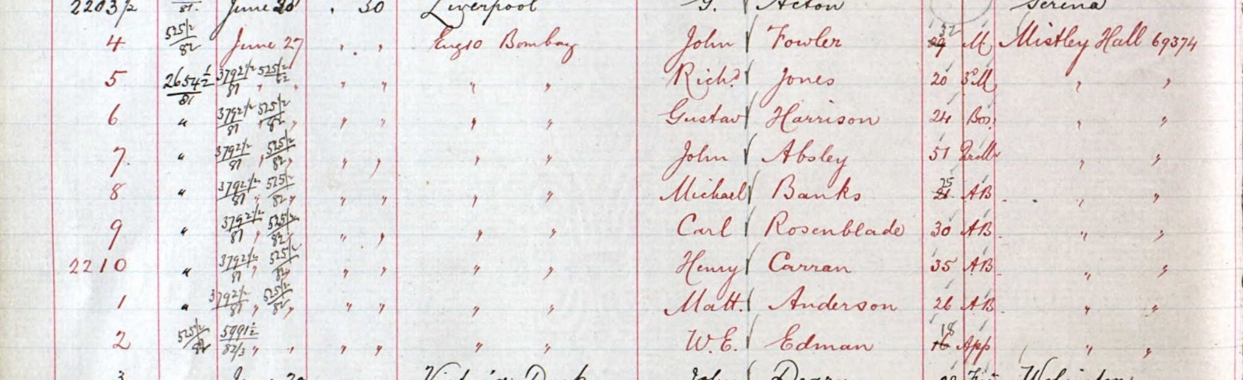

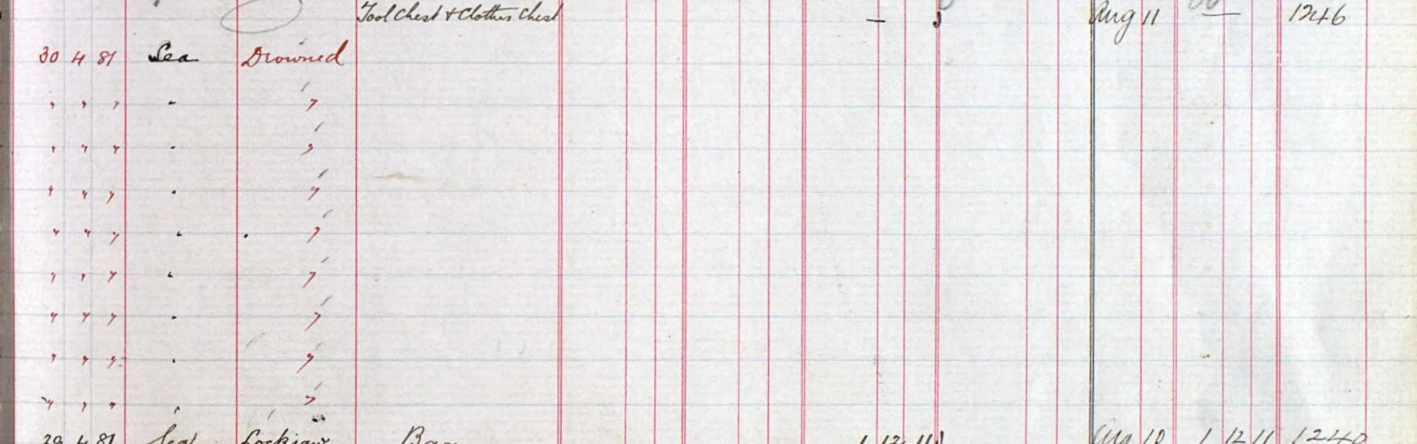

UK, Register of Deaths at Seam

BT153: Registers of Wages and Effects of Deceased Seamen