***Ahun***

John Ahun

Born – 1833, Ireland

Sailed on City of Adelaide as a crew member, Able Seaman,

* Voyage from Port Adelaide 27th December, 1866 and arrived in London, 10th April, 1867
* Voyage from London, 24th May 1870 and Port Adelaide, 18th August, 1870

***English Census***

***1871 – Farnborough, Hampshire (Fusiliers 10 and Depot 104***

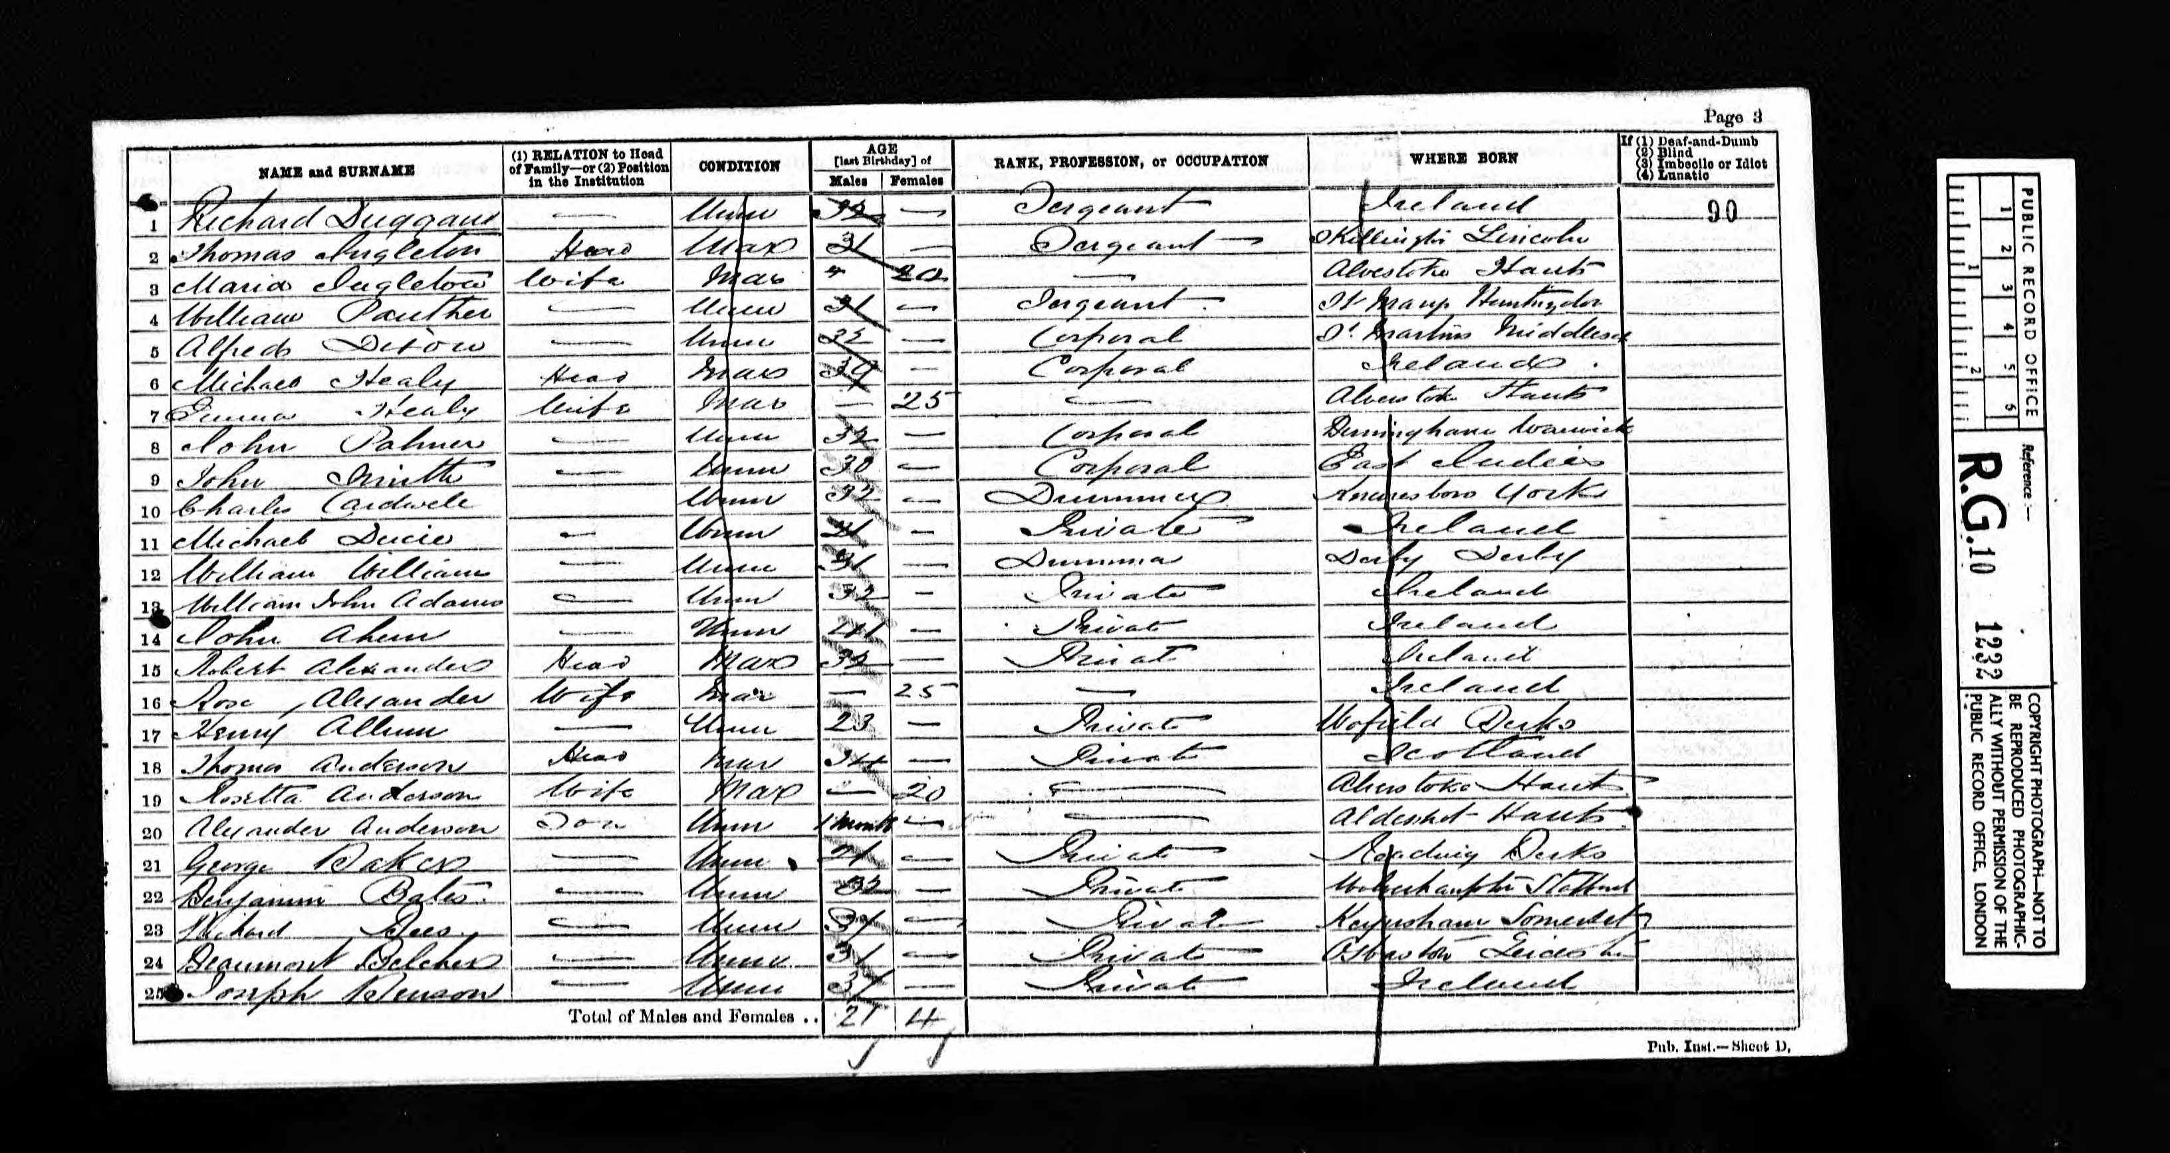

Reads:

John Ahun, unmarried, 41 years, occupation – Private, born - Ireland