***Baker***

Bridget Baker

Born – 1855

Died –

Aged –

Abode – Salisbury, 1912

Married - 25th June, 1877, St Laurence Church, North Adelaide, South Australia (bk111/pg1143)

(groom – 32, single, father – Michael Greene) (bride – 22, single, father - ? Baker)

John Green/e

Born – 1845

Died – 24th December, 1909, Parkside, South Australia (bk345/pg467)

Aged – 56 years

Buried – Catholic Western Ground, Row D, site 115

***Newspaper clippings***

***South Australian Register, SA, dated Wednesday 1st April, 1891***

**DEATH OF AN INFANT THROUGH NEGLECT –**

A most pitiable instance of infantile suffering through the drunken habits of a mother has come to light in Adelaide. At the Adelaide Hospital on Sunday morning, Annie Green, a baby four months old, died. She was the daughter of John Green, who lived in Elizabeth –street, and was admitted into the Hospital on Thursday last in a very emaciated state. At the Adelaide Police Court on Thursday Elizabeth, Martin, and Annie Green were charged with being uncontrollable. Their father (John Green) said he had done his utmost to support and care for them, but owing to their mother’s drunken habits they had been thoroughly neglected. Inspector Gray, according to instructions, visited the home of John Green, which had found to be almost destitute of furniture and in a filthy condition. Dr. Clindening examined the youngest child, which he stated was in a very precarious and emaciated state. The stench from it was abominable. It was nothing more than a skeleton. The children were sent to the Industrial School – the girls until eighteen years of age and the boy until sixteen. When Green was charged at the Police Court with drunkenness on the same day, he said that he had been “of the drink” for about five years. He attributed his change of conduct to his intolerable wife, who was so infatuated with drink that she sold everything of a portable and pawnable nature which he had in the house. He was unable to keep blankets to cover his children; while if he did not wear his own hat it would disappear, and his life was consequently a misery. Inspector Sulivan substantiated the man’s statement, and the result was that he was allowed to go on promising to abstain from the alluring drink in future. It appears that the baby Annie was sent to the Hospital, but the little think could not recover, and died, as before stated, on Sunday morning. The City Coroner was informed, and he will hold an inquest at the Hospital this afternoon at 4 o’clock.

***Evening Journal, SA, dated Thursday 2nd April, 1891***

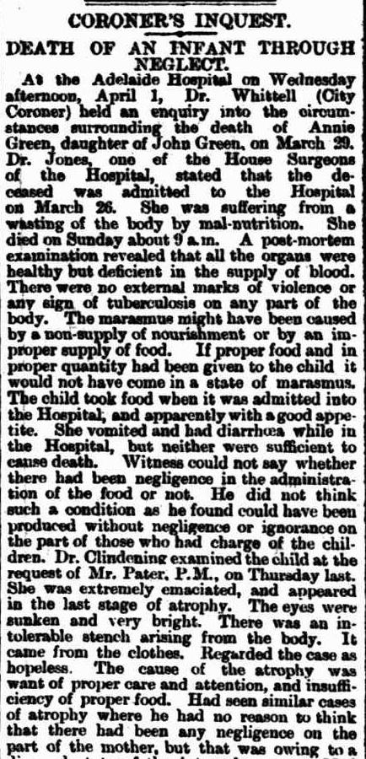 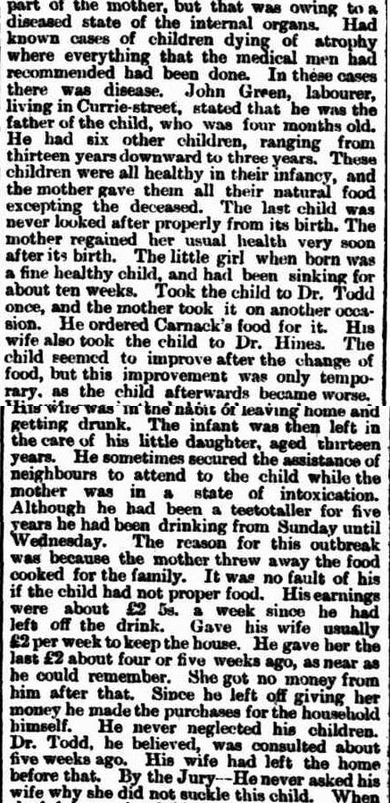

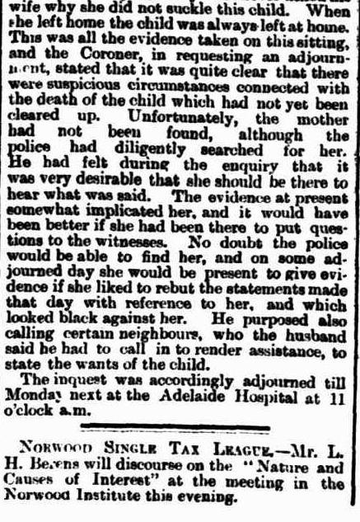

***South Australian Register, SA, dated Tuesday 7th April, 1891***

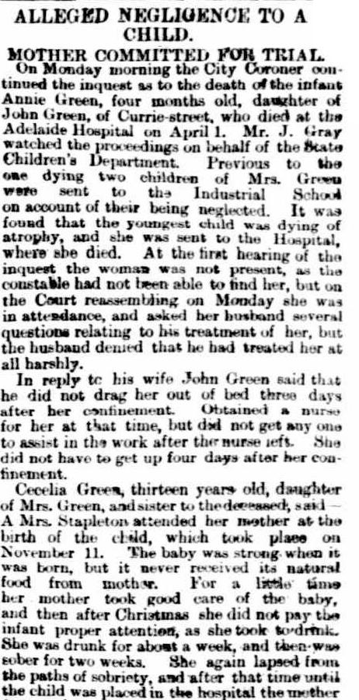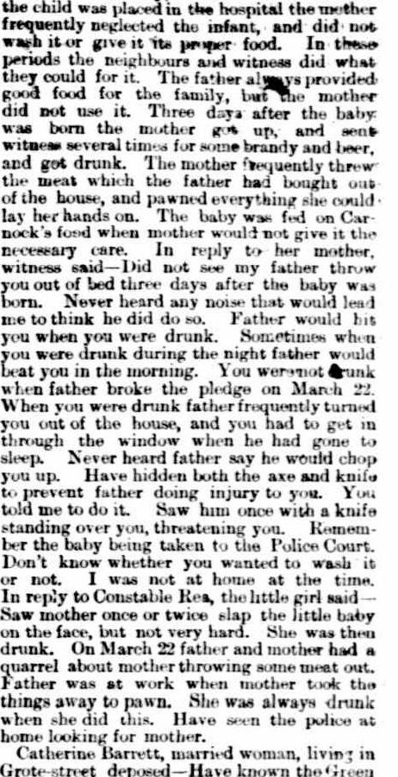

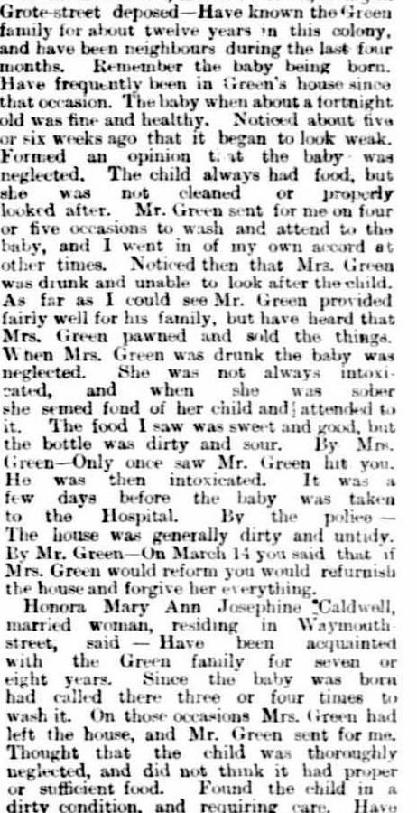 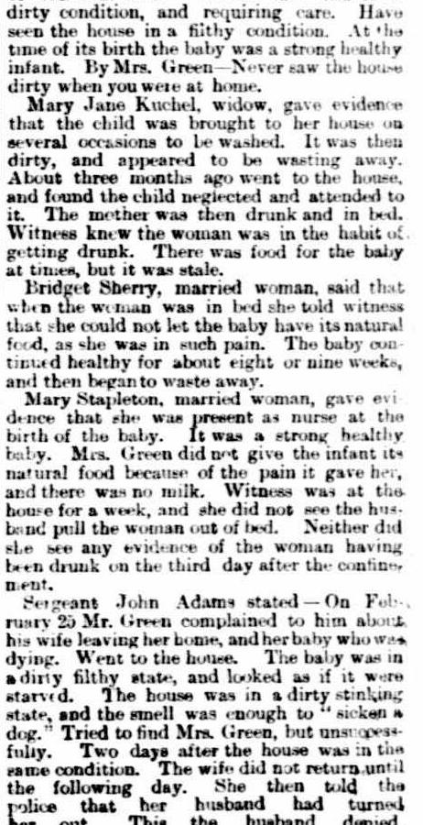

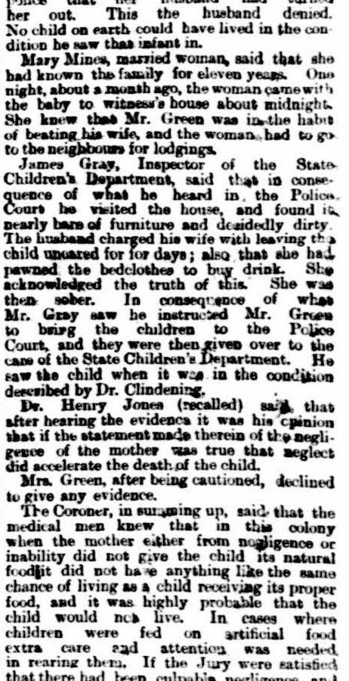 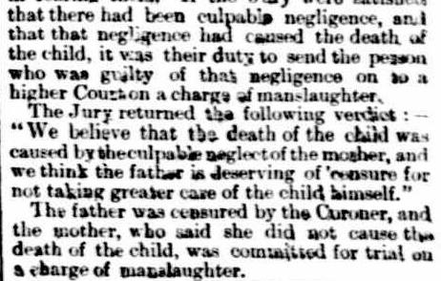

***The Advertiser, SA, dated Saturday 11th April, 1891***

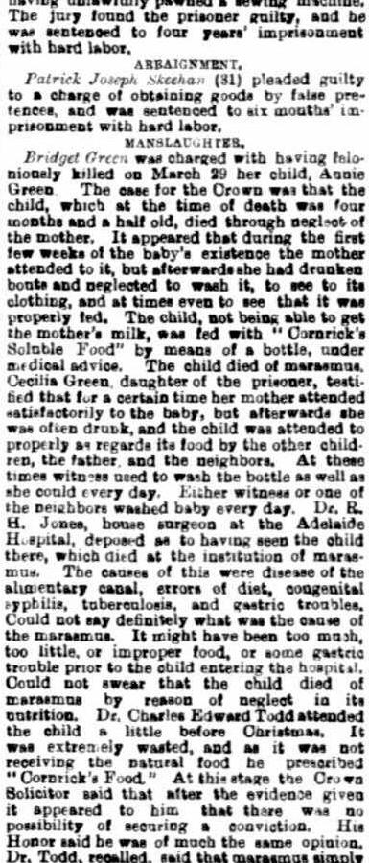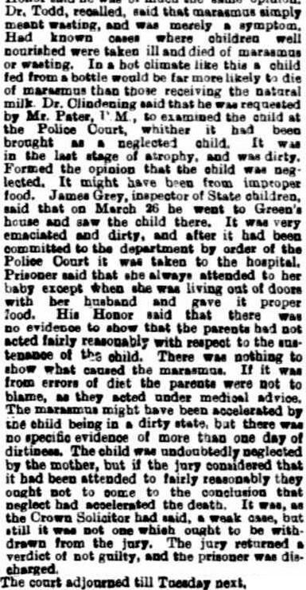

***The Advertiser, SA, dated Saturday 25th December, 1909***

**DEATH**

**GREEN** – On the 24th December, John, beloved husband of Bridget Green, and loving father of Cecelia, John, Thomas, and Mrs Harrold Keightley, of Booleroo Centre, aged 51. RIP.

***South Australian Police Gazettes, 1891***

At Adelaide, on the 1st and 6th instant, on the body of Annie Green (age 4 ½ months), who died at the Adelaide Hospital, on the 29th ultimo. Verdict – “Believe that death was caused by the culpable neglect of the mother, Bridget Green,” who was committed for trial by the coroner.

***Children of John and Bridget Green are:***

1. Cecelia Green

Born – 1878, South Australia (can’t find birth registered)

Abode - Fitzroy

1. Thomas Green

Born – c. 1880, South Australia (can’t find birth registered)

Died – by 1909

1. Mary Teresa Green

Born – 1880, South Australia (can’t find birth registered)

Died – 15th October, 1942, Truro, South Australia (bk656/pg5731)

Aged – 63 years

Buried – Truro Cemetery

Married – 22nd March, 1906, Congregational Church, Truro, South Australia (bk226/pg1180)

(groom – 27, single, father – John Keightley) (bride – 25, single, father – John Green)

Harrold James Keightley

Born – 19th February, 1879, Bowden, South Australia (bk216/pg11)

Died – 12th June, 1943, Angaston, South Australia (bk664/pg2767)

Aged – 64 years

Buried – Truro Cemetery

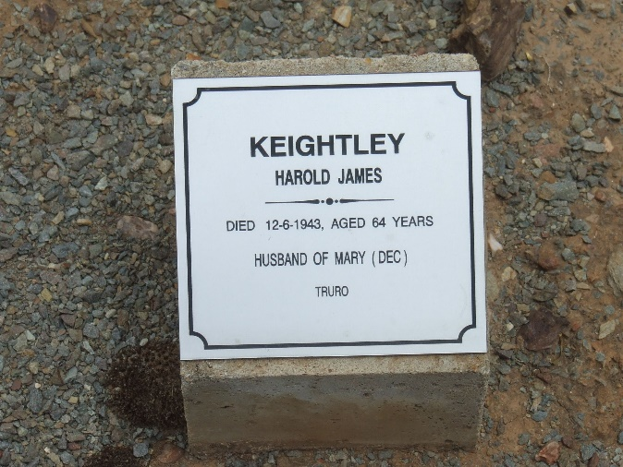 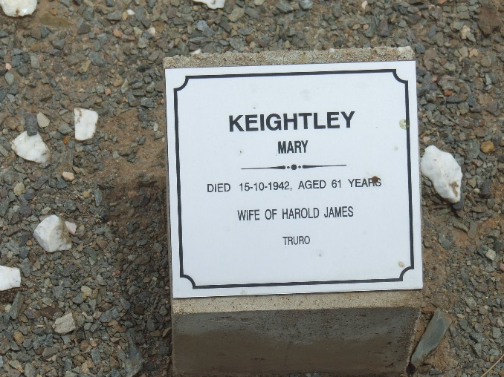

1. Maude Wilson Keightley

Born – 31st January, 1907, Truro, South Australia (bk778/pg282)

Died – 10th October, 1988, Adelaide, South Australia

Aged – 81 years

Married –

Leonard Charles Kimber

Born – 4th June, 1909, Clare, South Australia (bk823/pg461)

Died – 15th May, 1975, North Plympton, South Australia

Aged – 65 years

Occupation – Clerk

Abode - Brinkworth

***Military Service***

***Service – WW2, Australian Army***

***Service No. – SX16903***

Date and locality of enlistment – 29th January, 1942, Brinkworth, South Australia

Place of enlistment – Wayville, SA

Next of Kin – Maude Kimber

Date of discharge – 26th February, 1943

Rank - Private

1. Samuel Clifford Keightley

Born – 24th March, 1908, Truro, South Australia (bk800/pg242)

Died – 23rd October, 1981, Willaston, South Australia

Aged – 73 years

Buried – Enfield Memorial Park Cemetery, cremated

Married – 23rd November, 1935, Congregational Church, Truro, South Australia (bk362/pg4171)

(groom – 27, single) (bride – 23, single, father – Harry Gerling Bradshaw)

Marjorie Ada Bradshaw

Born - 1910

1. Thomas “Reg” Reginald Keightley

Born – 6th December, 1909, Truro, South Australia (bk834/pg18)

Died – 23rd November, 1987, Adelaide, South Australia

Aged – 77 years

Buried – Enfield Memorial Park Cemetery

Married – 20th June, 1932, Christ Church, Kapunda, South Australia (bk332/pg343)

(groom – 22, single) (bride – 21, single, father – Alexander Frederick Banks)

Dorothy Caroline Banks

Born – 19th February, 1911, Kapunda, South Australia (bk858/pg435)

Died – 24th August, 1990, Adelaide, South Australia

Aged – 79 years

Buried – Enfield Memorial Park Cemetery

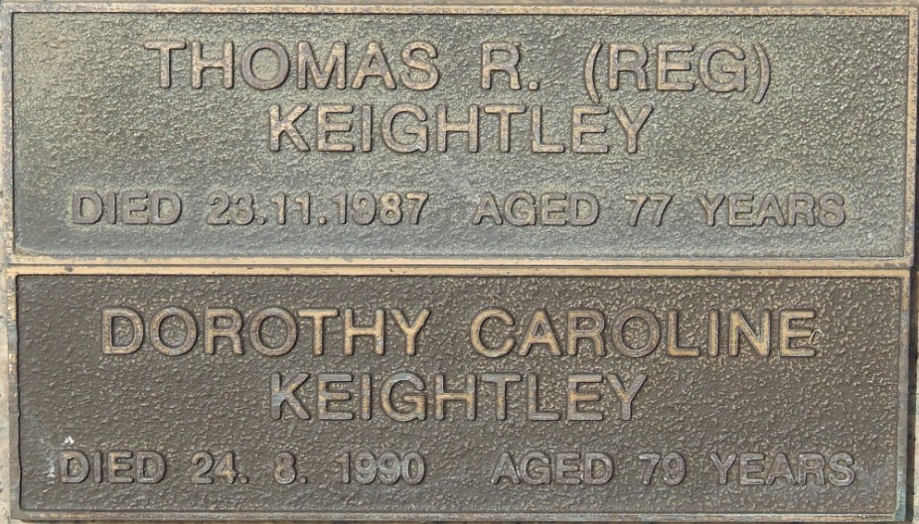

1. Un-named Green

Born – c. 1883, South Australia (can’t find birth registered)

Died – by 1909

1. Elizabeth Green

Born – c. 1886, South Australia (can’t find birth registered)

Died – by 1909

1. Martin Francis Green

Born – 22nd August, 1888, Adelaide, South Australia (bk422/pg491)

Died – 20th October, 1918, Israel and Palestine (including Gaza)

Aged – 28 years

Buried – Gaza War Cemetery, location – XXVII. D. 9

***Military Service***

***Service – WW1, AIF***

***Service No. – 2319***

Unit – 16/3rd Light Horse

Joined on 23rd December, 1915

Next of kin – sister, Miss Elizabeth Green, Alexander Avenue, Rose Park, SA, then changed to 19 Robe terrace, Medindie, SA

Religious denomination – Church of England

Height – 5 feet, 6 ½ inches; Weight – 146 lbs; Complexion – Fresh; Eyes – Blue; Hair – Brown

Cause of death – disease – Pneumonia Malaria – 47th State Hosp. Gaza

1. Annie Green

Born – 12th November, 1890, Adelaide, South Australia (bk469/pg242)

Died – 29th March, 1891, Adelaide, South Australia (bk192/pg341)

Aged – 4 ½ months

Cause of death – Mal-nutrition