The Ant build script for this project creates and defines eight commands as below.

1. Init (usage : $ ant init)

Sets up some directories that are used to store class files which are created by compiling source files and Javadoc files.

1. Compile (usage : $ ant compile)

Compiles source files and store class files to ‘bin’ (directory for compiled files) directory.

1. Doc (usage : $ ant doc)

Creates Javadoc files of source files to ‘doc’ (directory for compiled files) directory.

1. Clean (usage : $ ant clean)

Removes bin, doc, report directory and jacoco.exec file.

1. Build (usage : $ ant build)

Compile java source files and store class files to ‘bin’ directory.

1. Test (usage : $ ant test)

Runs tests from the Junit testing framework. This runs tests from the JUnit testing framework. Definition of path of build directory, junit.jar file, hamcrest-core.jar file is done. And this defines a single test class whose name is ‘MDParserTest’.

1. Cov-test (usage : $ ant cov-test)

Adds code coverage recording to Test task.

1. Cov-report (usage : $ ant cov-report)

Creates report of coverage test in ‘report’ directory. The status before and after the cov-report command is executed is shown in the following figure.

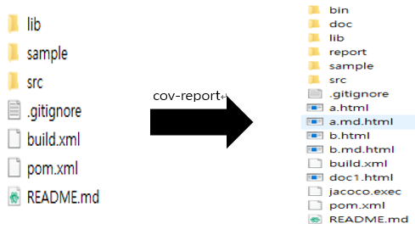

Each instruction has a dependency relation. Since cov-report relies on cov-test, cov-test depends on build, and build depends on init, the dependencies are executed first when cov-report is executed.

The relationship of each command is shown in follwing figure.

<relationship diagram>

Depends

compile

init

doc

cov-test

test

cov-report

clean

build

Depends

Depends

Depends

Depends

Depends