**Test Coverage**

In this part, we will look at the process of our softwate testing. The main purpose of the test is to get the maximum branch coverage possible, and in order to do this we have to make sure that all the branches in the conditional statement are working correctly.

**● Test requirement**

The goal is to set a maximum of 100% and achieve the maximum branch coverage as possible.

**● Coverage metrics**

1. Use Junit test to achieve the maximum branch coverage.

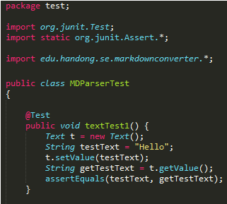

Figure 1. Test file using Junit.test

2. Use an Ant build script to unit-test project

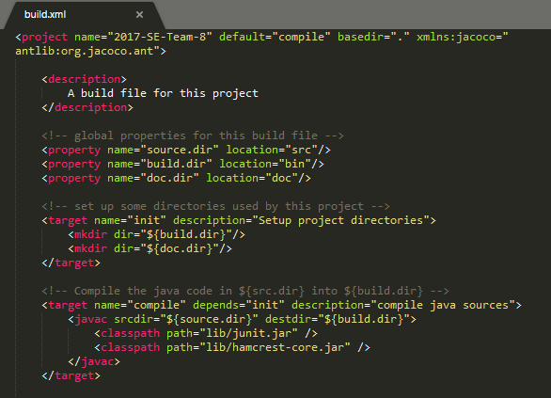

Figure 2. build.xml file

3. Use Jacoco to measure the branch coverage of the Junit test

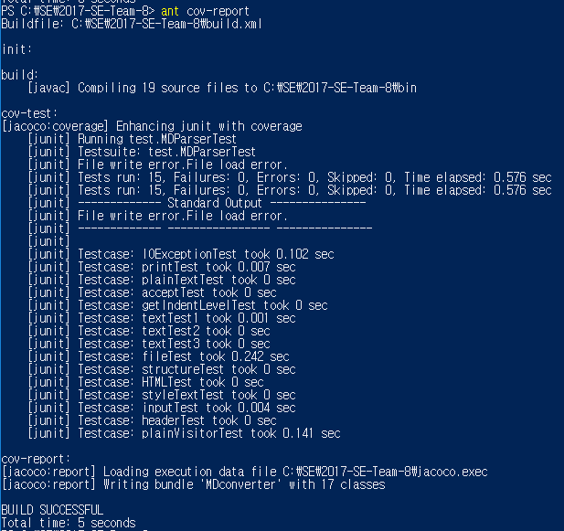

Figure 3. Execute JaCoCO test and get report.

**● Coverage**

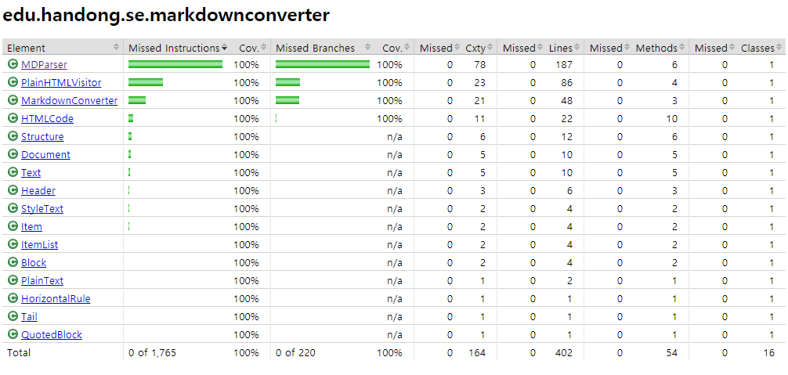

Figure 4. JaCoCo code coverage report

As we can see, the total number of branches in our source code is 220. Most of them are MarkdownConverter, which is the main class of code, MDParser, which provides parsing, and PlainHTMLVisitor, which acts as a visitor.

**● Coverage criterion**

We can ignore false branches of assertion statements.

**● Example test cases**

1. An user input a wrong command.

John wants to convert the MD file to HTML. However, when he first ran the program, he did not know how to use the program, so he entered the wrong command. In this case, the program determines whether the command entered by the user is a command for proper operation, and outputs a help message if it is not.

1. Wrong file name input

Jane created the MD file to be converted and entered the filename into the program. However, she made the mistake of typing the name of a file that did not exist, unlike the MD file she created. In this case, the program checks whether a file matching the input file name exists in the path, and if there is no file, it catches IOException and prints an error message.

1. Normal case

Mary entered the MD file normally into the program, and the program added the link and heading from the existing file contents to the new HTML file according to the procedure. And eventually she got the converted HTML file successfully.