BBeacons

Indoor navigation based on bluetooth beacons

Wouter Vande Velde & Thomas van raemdonck

2018

# Preface

The project was a challenge for both of us. We both were new to working with Bluetooth in general and with BLE signals from beacons. Indoor navigation is also something that isn’t around for that long yet, about 3 years, but there are already plenty of tutorials and libraries that offer help. We also both weren’t really familiar with Android programming either, luckily Google offers a lot of extended tutorials.

But the biggest problem was buying the beacons. We chose the buy our beacons in China since the quality should not be that much worse and the price is more than half compared to beacons from companies like Estimote or Kontakt. This also meant the delivery time of the beacons was around 20 to 40 days.

The first time we ordered beacons was around the tenth of October. These beacons arrived in the airport in Porto on the 17th of October but were not cleared by the customs. They requested the passport of the buyer, but we both only have an identity card. We couldn’t get them cleared so the beacons where eventually sent back on the 21th of October.

This meant we had to order new beacons, which we did on the 25th of October. These ones we finally got at the end of November. This means we had lost around 2 months’ time before we could start working with the beacons.

When the second set of beacons was on the way, we also ordered a new set from a different manufacturer in case the other beacons were sent back again. These beacons were also “nRF51822 Bluetooth beacons” but from the company Skylab. We ordered 2 sets of 3 beacons because we needed at least 4 beacons. When these ones arrived, we noticed they only sent one set of 3 beacons which meant we couldn’t really use them for our project. When we sent them, they said it was an accident and we could get 6 new ones for the price of 3…

But in the end, we got our beacons, and everything worked out well. We are proud to present you our project about indoor navigation with the help Bluetooth beacons.

We would also like to thank our mentor of our project, Carlos Ferreira who helped and guided us throughout the project.

Contents

Preface 1

1. Introduction 3

2. Indoor navigation using Bluetooth 3

2.1 communication 3

3. Used beacons 4

3.1 NRF51822 Wellcore Beacon 4

4 Communication 5

5 Indoor Navigation Methods 5

Triangulation 5

6 Similar projects 6

6.1 Project 1 6

6.2 Project 2 7

6.3 Project 3 7

6.4 Project 4 8

# Introduction

The project is about geolocation inside a room. Using 4 Bluetooth beacons, a room will be covered by Bluetooth signals. The challenge is to see the location of a smartphone as accurate as possible inside that room

A few examples where this idea can be possible in real life are

* the locations of clients inside a store and their pathing
* the location of babies inside a nursery
* the location of patients with for example Alzheimer's
* …

The use-case of our project is navigation/location inside a home to see where your smartphone is located within your house. To achieve this, we add a couple of rooms in the database (e.g. in the app), alongside some information about that room. This is followed by adding beacons to the database too.

When all of this is done, it will be possible to select a room and see data gathered from the beacons posted in that specific room. This data will be processed and available in the app or on the website, such as the strength of the signals sent from the beacons or a heatmap. The final product will be that can see where a person has been inside the rooms of a house.

# Indoor navigation using Bluetooth

Bluetooth communicates over small distances on the 2.4 GHz ISM frequency band. It uses 79 channels to transmit data, starting with the first channel at a frequency of 2402 MHz and continuing up to the last one at a frequency of 2480 MHz in 1 MHz increments. [1]

In order to transmit data, Bluetooth devices must first stablish a connection. One single device is capable of connecting to up to 7 devices and communicating with each one of them simultaneously. This is done by using a connection model known as “master-slave”, in which the device that initiates the connection takes the role of master over the other devices. Whenever a master and a slave establish a connection, a bond is created, enabling them to transmit and receive data. [1]

## 2.1 communication

In the case of this project, a connection is not necessary, because there is no data exchange between the beacons and the smartphone. This means there is only a one-way communication between the two. The beacons will send out packets which are picked up by the smartphone containing all the necessary information. The most important fields found in a single packet are the name, battery percentage, temperature, rssi, txPower (= transmission power), mac-address and uuid. We will mainly use the rssi and txPower in our project to calculate distances using these values. A screenshot of one package is shown in figure 1, this screenshot is taken in Android Studio during debugging.

On how the communication is realized, will be discussed further on in the report.

A screenshot of a cell phone

Description generated with high confidence

Figure 1: screenshot of the values of a single package from a Bluetooth beacon

# Used beacons

## NRF51822 Wellcore Beacon

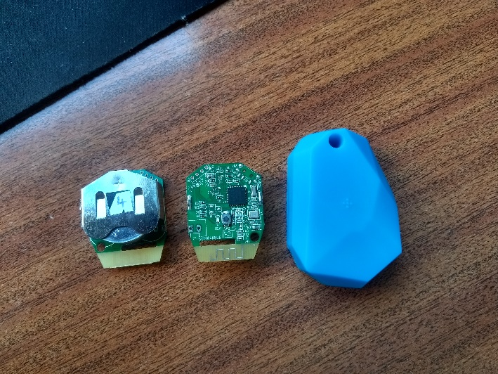The beacons used in this project are “NRF51822 Bluetooth beacons” by the company Wellcore. They were bought on the following [link](https://www.aliexpress.com/item/5pcs-lot-NRF51822-ibeacon-Module-BLE-4-0-bluetooth-beacon-eddystone-beacons/32795069285.html). [2]

Figure 2: image of the back, the front and a cover of a beacon

The beacons are little CPU’s from ARM® Cortex™ M0 with a build in NRF51822 SoC. The NRF51822 chip is made for Bluetooth low energy and 2.4GHz ultra low-power wireless applications. [3]

On figure 2, there are 3 beacons shown. The first beacon shows the backside, exposing the battery which is a CR2477. The second shows the frontside of the beacon. The third item is the cover that was found around each beacon.

From the results that were gathered, it seemed like the cover had a little impact on the strength of the signal, so they were removed leaving the beacons a little more exposed.

As was mentioned in the preface, the beacons are bought in China. This means the quality of the beacons were not guaranteed beforehand since items bought in Chinese can either be good or bad, in our experience. In this case, the beacons are decent, but not that well suited for indoor location. This is caused by the fact that the RSSI signals can be unstable which leads to some inaccurate results. The main reason for buying the beacons in China was the price. In table 1, //TODO you can see a comparison of Estimote beacons and the ones used in the project, Wellcore Beacons.

Table1:

|  |  |
| --- | --- |
| Estimote | Wellcore |
| 16/piece (bought per 3) | 10/piece (bought per 5) |
|  |  |
|  |  |
|  |  |

## accuracy

As an example, to show how accurate the beacons really are, the program ran for a little time to record 300 values on different distances. The distances on which the rssi signals were recorded are 1, 2 //TODO meter. As seen in the graph on figure //TODONumber , it is shown that the signals overlap already on one and two meters. These values should be the most accurate because the closer the beacons are, the stronger thus the more stable the signal should be. Although it is also shown that the average of the values still shows a significant difference.

//TODO 3 and 5? meters

# Communication

As said earlier in the report, the communication between the beacons and the smartphones is only in one direction. The beacons broadcast a signal and the smartphones catch that signal using their Bluetooth connection. It is not recommended to catch and use signals from the beacons with a smartphone with only native Android functions. Therefore, we use the library AltBeacon to retrieve the data from the beacons. [4] [5]

## Altbeacon

Altbeacon is a library created for the purpose of detecting beacons on Android. Altbeacon allows Android devices to use beacons much like iOS devices do. An app can request to get notifications when one or more beacons appear or disappear. An app can also request to get a ranging update from one or more beacons at a frequency of approximately 1Hz.

The library makes the communication really easy, the first thing to do is to implement the *BeaconConsumer* interface. This is followed by the abstract methods that are added, one of those methods is *didRangeBeaconsInRegion.* This method creates a collection of Beacon objects of all the beacons that are in range. The only thing that is left to do is to iterate trough these beacons, filter out the correct ones, and use the values the objects contain.

# Trilateration

Trilateration is a method to define a location in between 3 different points with the use of circles. It is not to be confused with triangulation which has the same goal but is reached using the measurement of angles. In this project, trilateration is used to locate a point in between 3 different Bluetooth beacons meaning there are 3 distances given. These distances are calculated trough the strength of each signal, the RSSI, of each beacon.

# Database

The database is a MySQL database and is hosted locally on a Wamp-server. It consists of 5 tables being devices, rooms, values, houses and users.

The table Devices contains all the beacons, this contains the name and the room in which the beacon can be found.

In the table Rooms are all the room saved alongside some information about each room such as the width and length and a small description.

In the table values are the values being saved that are taken on a certain moment in a certain room.

Each room is part of a house, as shown in the table Houses.

Finally, the table Users which contains all the users, it is linked to houses and therefor each user is limited on which rooms it can see in the app and on the website. This means that a user can’t check rooms of houses where has no access to.

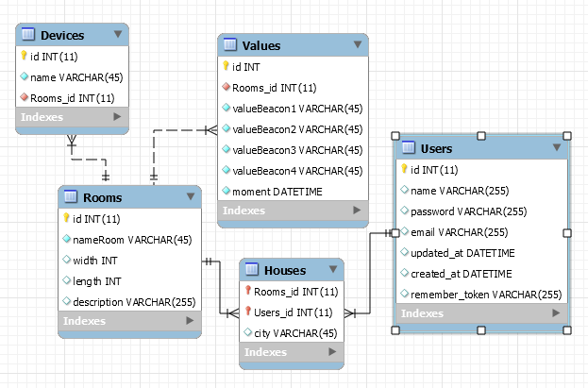

## 6.1 Database connection from Android application

// TODO

## 6.2 database connection from the website

The connection with the database is done by the Laravel package called Eloquent ORM, this is talked about in 7.1.

# Website

The website is created in the PHP web framework Laravel. Laravel is intended for the development of web applications following the model-view-controller pattern. Following features are integrated in the website: Restful controllers, Blade, Form request and Eloquent ORM.

The website contains of 3 pages, the homepage which shows //TODO. Then there is also a page which shows a list of all the rooms in the house. When you select one of the rooms from that list, you are directed to the third page. This is a detailed page of the rooms with all the data such as width and length and the beacons in the room.

## Eloquent ORM

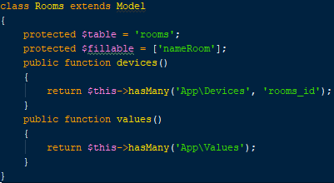Eloquent ORM is a package provided by Laravel and helps with the connection to the database. ORM stands for Object Relational Mapper, this means that Objects are linked to each other just as tables in a database are linked to each other. To achieve this, there is a PHP-file made for each table in the database. These files are then linked to each other by methods such as oneToMany or belongsTo. An example of the table rooms is shown in figure 3.

After that the classes are correctly linked to each other, the relations can be queried to get the data out easily. In figure 4, the first line shows a query that gets out all the rooms. Thanks to Eloquent ORM it is possible to just reference the table devices to the resultset from the first query to create a simple inner join. This means *$room* contains the room with the id *$id* and *$devices* contains all the beacons that can be found inside that room.

Figure 3: Rooms table programmed as an object class

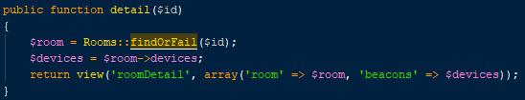

Figure 4: query to get out a room and its containing beacons out of the database

# Similar projects

## Project 1

[INDOOR NAVIGATION USING BLUETOOTH LOW ENERGY (BLE) BEACONS](http://www.theseus.fi/bitstream/handle/10024/105619/Herrera%20Vargas_Milan.pdf?sequence=1&isAllowed=y)

The project is created in 2016 by Milan Herrera Vargas. It shows the concept of indoor navigation with the help of Bluetooth beacons. The difference between our project and the described project is that the described project measures the locations in a building while our project only goes in one room. Since walls don’t really affect Bluetooth, the project is very similar.

Milan measures the distance using the average RSSI measurements at predefined distances he collected himself seen in following table:

A screenshot of a cell phone

Description generated with very high confidence

Figure 5: Average RSSI measurements at predefined distances

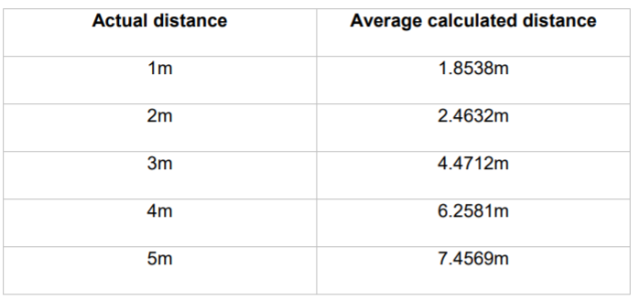He then used these values to calculate the distance from the beacon to a device, the beacon sends out a signal every 30 seconds. After a test of 300 recorded values comparing the actual and the measured distances, he could conclude the results were fairly accurate. The results were quite good at distances closer than 3m and got less accurate at longer distances. He also notes that if there is no clear line of sight between the beacon and the device, the results might get affected.

Figure 6: Comparison between calculated and actual distances

## Project 2

[How to do accurate indoor positioning with Bluetooth beacons?](https://proximi.io/accurate-indoor-positioning-bluetooth-beacons/)

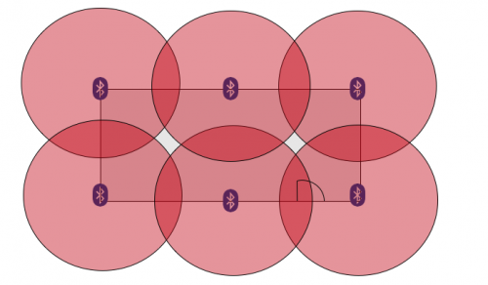The project talks about how beacons cannot measure distances but that they are merely like ‘lighthouses’ that send out signals. That why trilateration is used, the project talks about how you need 3 or more beacons to get an accurate location. The RSSI values of each of them will help you to calculate the distance between the device and the beacons as is shown in following image.

Figure 7: beacon positions in square shaped room

The best location in a room to place the beacons are on a regular and evenly basis in the environment, as shown in the picture above. It is also optimal to hang them on walls, preferably on 2m height. The article also suggests it is important to pay attention to the transmission power and interval and the maximum beacon range, it is best to adjust these values according to the environment the beacons are used in.

## Project 3

[Wayfinder: indoors routing guided by Beacons](https://www.onyxbeacon.com/wayfinder-indoors-routing-guided-by-beacons/)

This project is less relevant since it talks more about the pathing inside a building with the use of beacons. In our project we will mainly focus on the location and less on the pathing. The app created in the project is called Onyx Beacon’s Wayfinder. It shows the most optimal route in a building according to the points of interest principle and it will offer step by step indication for indoors navigation. The user will get an overview of the route and individual instruction on next steps to reach the destination. The distances between the beacons are 25 to 40 meters.

## Project 4

[Indoor positioning with beacons and mobile devices](http://bits.citrusbyte.com/indoor-positioning-with-beacons/http:/bits.citrusbyte.com/indoor-positioning-with-beacons/)

The method used in the project for estimation position using distance is trilateration.

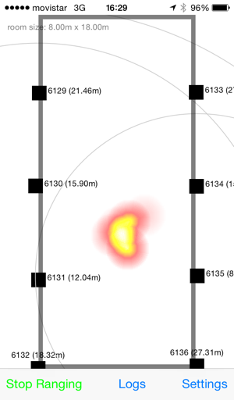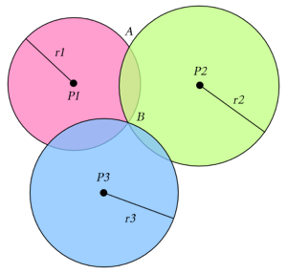In a N dimensional world, there are N+1 reference points needed: in a 2D area there are 3 beacons needed to get an accurate position as is shown in following image:

Figure 8: heatmap of a room

Figure 9: trilateration

The experiment that was conducted in the project shows that is hard to find a satisfactory solution. Therefore, they made use of heatmaps and a large set of data to get a probability area that tells where the device may be found. This is shown in following image:

The room that is used is a big hall of 8m x 18m and the beacons were placed around 2.5m high on the walls.

The article suggests using a signal as strong as possible to get the most accurate signals, it also says to put the beacons as high as possible and the more beacons the better.