Systems/Subsystem Design Specification (SSDD)

author

Today

# Scope

## Identification

Document identificator: Architecture

## Main document

You can add text what you like and and import tree’s of confluence pages with

### [Architecture](https://proactionsc.ent.cgi.com/confluence/pages/viewpage.action?pageId=262826365)

main page of architecture

#### [Context](https://proactionsc.ent.cgi.com/confluence/pages/viewpage.action?pageId=262826374)

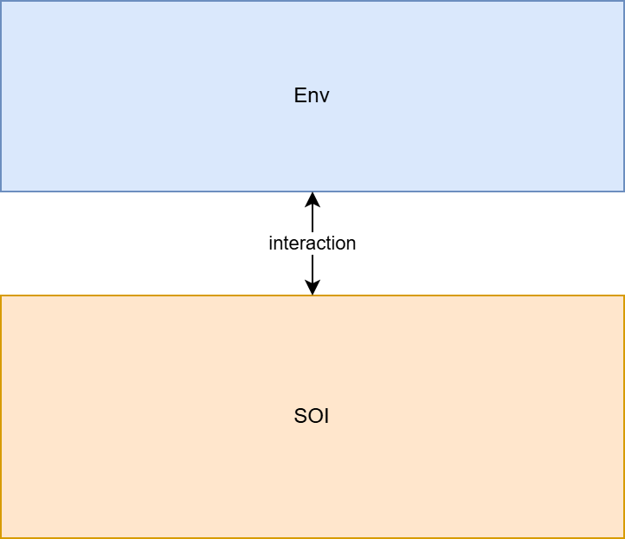

example architecture

In the context figure the following entities are shown (using a table with different column width)

| ref | summary | description |
| --- | --- | --- |
| SOI | System of Interest | The system of interest implements the requirments, both functional and non-functional |
| ENV | Environment | The environment behaves conform the environment model |

note that in the comment, the title is not used (yet).

the comment layout i

doc_constructor:include:confluence <page_id> <level> <title>

level = 3 means that the import starts with a h3 heading