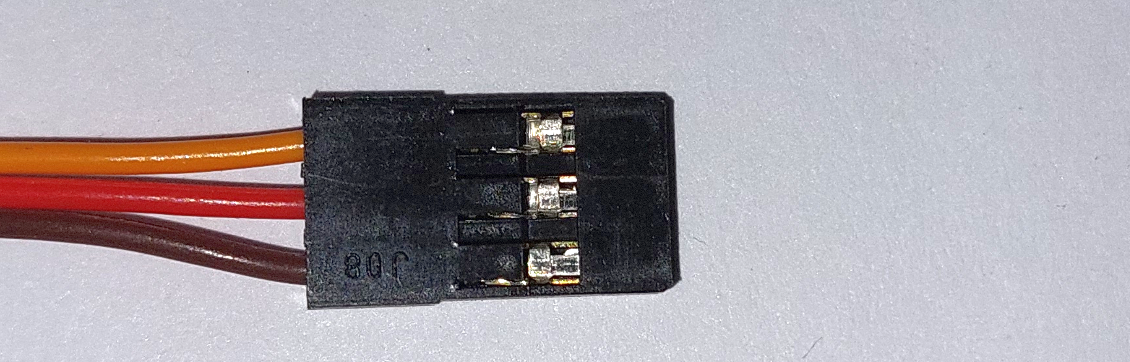

signal

ground

+5V power

Interval ~ 20 ms

5V

gnd

Pulse 1.0 .. 2.0 ms

Typical servo horn angle for 1.0, 1.5 and 2.0 ms pulses