4.1 0,0 is the state that C is in the first stage of its lifetime and is not being inspected.   
State 0,1 is the state that C is in the first stage of its lifetime and is being inspected.   
State 1,0 is the state that C is in the second stage of its lifetime and is not being inspected.   
State 1,1 is the state that C is in the second stage of its lifetime and is being inspected.  
State 1,2 is the state that C is in the second stage of its lifetime and is being repaired.  
State 2 means a C is broken and needs to be repaired.

2. $P_{0,0}*(-τ-λ1)+ P_{0,1}*C+ P_{1,2}*(κ*μ)+ P_{2}*μ=0$

$$P_{0,0}*τ+ P_{0,1}*-C=0$$

$$P_{0,0}*λ1+P_{1,0}*(-τ-λ2)=0$$

$$P_{1,0}*τ+ P_{1,1}*-C=0$$

$$P_{1,1}*C+ P_{1,2}*(-κ*μ)=0$$

$$P_{1,0}*λ+2P_{2}*-μ=0$$

$$P_{0,0}*\left(τ+λ1\right)= P_{0,1}*C+ P_{1,2}*(κ*μ)+ P_{2}*μ$$

$$P_{0,0}*τ= P_{0,1}*C$$

$$P_{0,0}*λ1=P_{1,0}*(τ+λ2)$$

$$P_{1,0}*τ= P_{1,1}*C$$

$$P_{1,1}*C= P_{1,2}*(κ*μ)$$

$$P_{1,0}*λ2=P_{2}*μ$$

$$P_{0,0}+P_{0,1}+P_{1,0}+P_{1,1}+P_{1,2}+P_{2}=1$$

$$P_{0,0}+\frac{P_{0,0}*τ}{C}+\frac{P_{0,0}*λ1}{τ+λ2}+(\frac{P_{0,0}*λ1}{τ+λ2}*\frac{τ}{C})+((\frac{P_{0,0}*λ1}{τ+λ2}*\frac{τ}{C})*\frac{C}{κ*μ})+(\frac{P_{0,0}*λ1}{τ+λ2}*\frac{λ2}{μ})=1$$

$$P_{0,0}+\frac{P_{0,0}*τ}{C}+((\frac{P_{0,0}*λ1}{τ+λ2}*\frac{τ}{C})*(\frac{C}{κ*μ}+1))+(\frac{P_{0,0}*λ1}{τ+λ2}*(\frac{λ2}{μ}+1))=1$$

$$\frac{1}{\frac{τ+C}{C}+\left(\left(\frac{λ1}{τ+λ2}*\frac{τ}{C}\right)*\left(\frac{C}{κ*μ}+1\right)\right)+\left(\frac{λ1}{τ+λ2}*\left(\frac{λ2}{μ}+1\right)\right)}=P_{0,0}$$

$$P_{1,0}+\frac{P_{1,0}*(τ+λ2)}{λ1}+\frac{P_{1,0}*(τ+λ2)}{λ1}*\frac{τ}{C}+\frac{P_{1,0}*τ}{C}+\frac{P_{1,0}*τ}{C}*\frac{C}{\left(κ*μ\right)}+\frac{P_{1,0}*λ2}{μ}=1$$

$$P_{1,0}+\frac{P_{1,0}*(τ+λ2)}{λ1}*(\frac{τ}{C}+1)+\frac{P_{1,0}*τ}{C}*(\frac{C}{\left(κ*μ\right)}+1)+\frac{P_{1,0}*λ2}{μ}=1$$

$$\frac{1}{\frac{λ1+(τ+λ2)}{λ1}*(\frac{τ}{C}+1)+\frac{τ}{C}*(\frac{C}{\left(κ*μ\right)}+1)+\frac{λ2}{μ}}=P_{1,0}$$

3.

$$P_{0,0}=\frac{1}{\frac{0.002+10}{10}+\left(\left(\frac{0.0001}{0.002+0.0005}*\frac{0.002}{10}\right)*\left(\frac{10}{5*0.1}+1\right)\right)+\left(\frac{0.0001}{0.002+0.0005}*\left(\frac{0.0005}{0.1}+1\right)\right)}$$

P0,0 = 96.1%

4. Red = P0,0  
 Green = P1,0

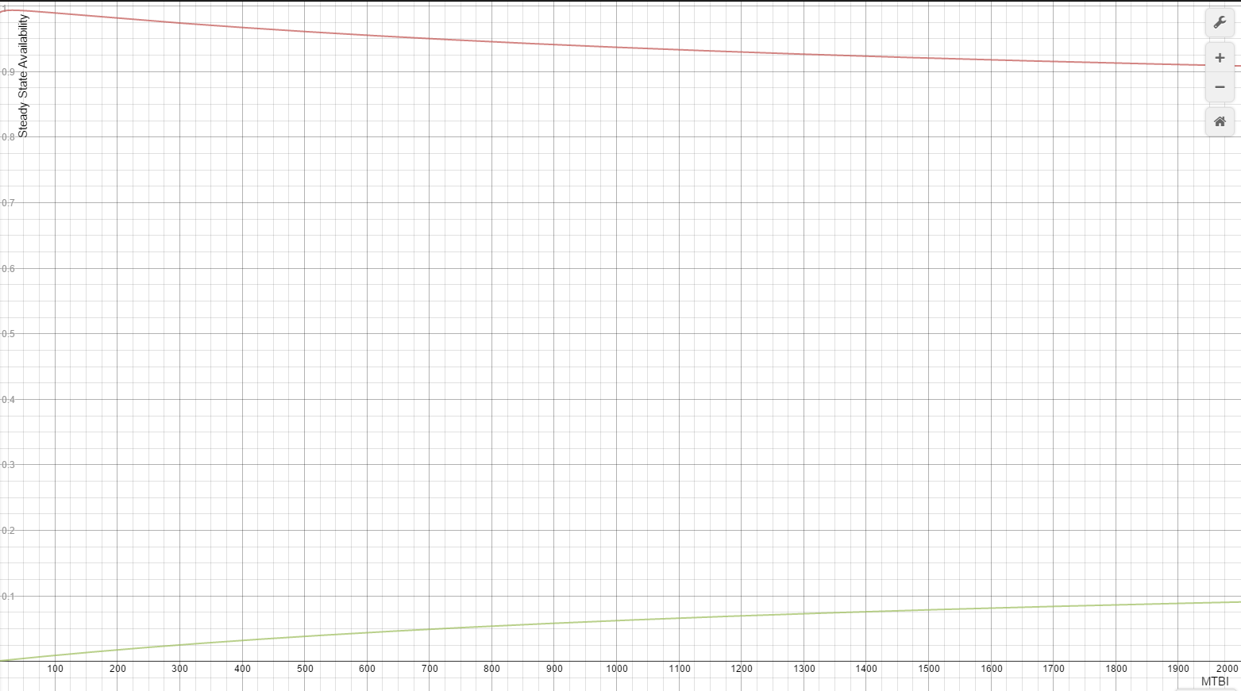

As can be seen in the graph P0,0 keeps becoming lower while P1,0 keeps becoming higher. This is logical because inspections are executed less often so when the component reaches the second stage of its life if will take longer for it to be fixed. Resulting in being longer in the second stage of its life and shorter in the first stage.

5. c=1

5.1 The last row is completely zero because the system is in the failure state and there are no transitions going from the failure state to another state so all of the rates are 0.

2.