How Much Does Machine Learning Really Improve Diabetes Risk Prediction from Population Health Indicators? An Honest, Interpretable, and Transparent Benchmark on BRFSS 2015

¿Cuánto Mejora Realmente el Aprendizaje Automático la Predicción del Riesgo de Diabetes a partir de Indicadores de Salud Poblacional? Un Benchmark Honesto, Interpretable y Transparente sobre BRFSS 2015

Álvarez-Sánchez, Guillermoª, Peredo-Valderrama, Iván^{b*}, Moya-Moya, José Javier^{c} and Pacindo-Piña, Jairo^{d}

ª  Universidad Politécnica de Querétaro,  QXJ-0529-2026, 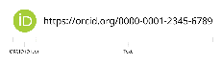 0009-0005-6254-143X, CVU CONAHCYT 2044833
^{b} Universidad Politécnica de Querétaro, QXI-7175-2026, 0000-0002-2484-9557, SNI-SECIHTI 167230
^{c} Universidad Politécnica de Querétaro, QXJ-0392-2026, 0009-0007-3628-5000, CVU SNP 1292895
^{d} Universidad Politécnica de Querétaro, QXJ-0480-2026, 0009-0008-4895-378X, CVU SNP 2089135

SECIHTI classification:
Classification reference: MARVID research areas
Area: Information Technology
Field: Artificial intelligence
Discipline: Machine Learning
Subdiscipline: Interpretable clinical prediction
DOI: Pending assignment by ECORFAN
Article History:

Received: [Use Only ECORFAN]
Accepted: [Use Only ECORFAN]

Key Handbooks
Provides a transparent comparison of nine diabetes risk models and demonstrates that calibration, interpretability, and admissible variables matter more than marginal gains in ROC-AUC.

Citation: Álvarez-Sánchez, Guillermo, Peredo-Valderrama, Iván, Moya-Moya, José Javier, Pacindo-Piña, Jairo. How Much Does Machine Learning Really Improve Diabetes Risk Prediction from Population Health Indicators? An Honest, Interpretable, and Transparent Benchmark on BRFSS 2015. ECORFAN Journal-Mexico. 2026. V-N: Pages.

* Corresponding author: ivan.peredo@upq.mx

 | ISSN XXXX-XXXX/© 2009 The Author[s]. Published by ECORFAN-Mexico, S.C. for its Holding X on behalf of Journal X. This is an open access article under the CC BY-NC-ND license [http://creativecommons.org/licenses/by-nc-nd/4.0/]  Peer Review under the responsibility of the Scientific Committee MARVID®- in contribution to the scientific, technological and innovation Peer Review Process by training Human Resources for the continuity in the Critical Analysis of International Research. | 

Abstract
Machine learning (ML) is increasingly used for population-level diabetes risk prediction, often under the premise that it substantially outperforms classical statistical models. This study rigorously evaluates the incremental benefit of different ML algorithms over logistic regression in a pre-laboratory screening setting designed to avoid direct diagnostic-label leakage from laboratory criteria. We used the CDC Diabetes Health Indicators dataset (BRFSS 2015; n = 253,680; prevalence 13.9%), which contains only self-reported survey indicators. Nine estimators were evaluated under a uniform protocol with a stratified 60/20/20 split, randomized hyperparameter search, preprocessing fitted only within training folds, and ROC-AUC assessment on a held-out test set. Uncertainty was estimated with 1,000 bootstrap resamples. Calibration, risk stratification, and interpretability were also examined. Histogram gradient boosting and XGBoost achieved ROC-AUC = 0.827 (95% CI: 0.822-0.832 and 0.822-0.831, respectively), compared with 0.820 (0.815-0.824) for L2-regularized logistic regression. The paired difference was small (ΔAUC = 0.007; bootstrap 95% CI: 0.006-0.009), statistically detectable because of the large sample but of limited practical importance. The leading boosting models were mutually indistinguishable. Seven of the nine estimators clustered between ROC-AUC 0.819 and 0.827, whereas KNN and SVM performed below that range. Accuracy (0.866) was minimally informative relative to the majority-class baseline (0.861). Isotonic calibration achieved an expected calibration error of 0.0029, and four risk levels separated observed prevalence from 2.9% to 48.0% (odds ratio 30.7; 95% CI: 28.0-33.6). Algorithm selection therefore provides only marginal gains when the variables constrain predictive information. Leakage control, calibration, interpretability, and transparent reporting are more important than maximizing small AUC differences. These models may support population screening and triage, but they do not replace clinical diagnosis.
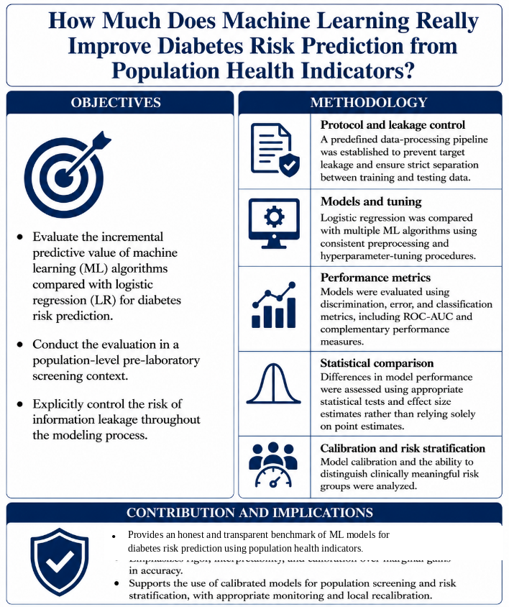
Graphical abstract. Study objective, leakage-control methodology, and clinical contribution.
Keywords
Diabetes risk prediction; machine learning; BRFSS; calibration; explainable artificial intelligence; information leakage; transparent reporting.
Resumen
El aprendizaje automático se utiliza cada vez más para predecir el riesgo poblacional de diabetes, con frecuencia bajo la premisa de que supera ampliamente a los modelos estadísticos clásicos. Este estudio evalúa rigurosamente el beneficio incremental de distintos algoritmos frente a la regresión logística en un escenario de cribado prelaboratorio diseñado para evitar la fuga directa de la etiqueta diagnóstica desde criterios de laboratorio. Se utilizó el conjunto Diabetes Health Indicators de los CDC (BRFSS 2015; n = 253,680; prevalencia 13.9%), compuesto únicamente por indicadores de encuesta autorreportados. Nueve estimadores fueron evaluados con una partición estratificada 60/20/20, búsqueda aleatorizada de hiperparámetros, preprocesamiento ajustado solo dentro de los pliegues de entrenamiento y evaluación ROC-AUC en una prueba retenida. La incertidumbre se estimó con 1,000 remuestreos bootstrap. Histogram gradient boosting y XGBoost alcanzaron ROC-AUC = 0.827 (IC 95%: 0.822-0.832 y 0.822-0.831, respectivamente), frente a 0.820 (0.815-0.824) de la regresión logística regularizada. La diferencia emparejada fue pequeña (ΔAUC = 0.007; IC bootstrap: 0.006-0.009) y de relevancia práctica limitada. Los principales modelos de boosting fueron mutuamente indistinguibles. Siete de los nueve estimadores se agruparon entre ROC-AUC 0.819 y 0.827, mientras que KNN y SVM rindieron por debajo de ese intervalo. La exactitud de 0.866 fue poco informativa frente a la línea base de la clase mayoritaria de 0.861. La calibración isotónica alcanzó ECE = 0.0029 y cuatro bandas de riesgo separaron la prevalencia observada de 2.9% a 48.0% (razón de momios 30.7; IC 95%: 28.0-33.6). Controlar la fuga, calibrar, interpretar y reportar con transparencia aporta más valor que maximizar diferencias pequeñas de AUC. El modelo apoya el cribado y el triaje, pero no sustituye el diagnóstico clínico.
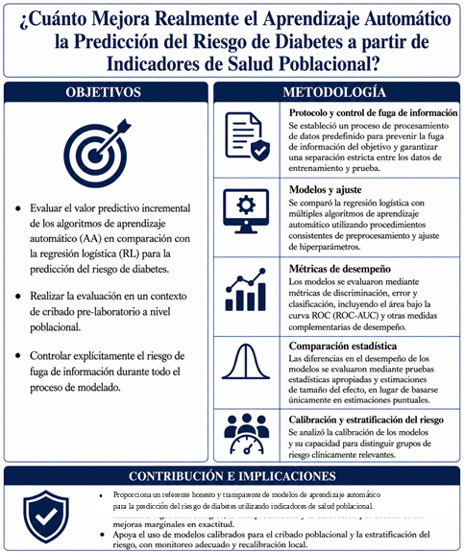
Resumen gráfico. Objetivo, metodología con control de fuga y contribución clínica.
Palabras clave
Predicción de riesgo de diabetes; aprendizaje automático; BRFSS; calibración; inteligencia artificial explicable; fuga de información; transparencia metodológica.
Introduction
Type 2 diabetes is one of the most prevalent chronic diseases worldwide, and identifying people at risk before complications appear is a public-health priority [1], [2]. Population health surveys provide low-cost information about demographic, behavioral, and cardiometabolic factors, while modern gradient-boosted trees and neural models offer flexible ways to exploit those variables. This combination has produced extensive literature reporting useful ML performance for diabetes prediction [3]-[5].
A recurring claim is that nonlinear algorithms substantially outperform logistic regression. Yet a systematic review of clinical prediction studies found no consistent ML advantage when comparisons were conducted fairly [7]. Reported improvements may instead reflect richer variables, optimistic validation, information leakage, or weak baselines. In high-stakes settings, a small gain in discrimination cannot compensate for poor calibration, opaque behavior, or invalid data provenance.
We ask how much modern ML actually improves diabetes prediction when the inputs are ordinary, self-reported population health indicators. Four hypotheses guide the analysis: (H1) complex models will not materially outperform a well-regularized linear baseline; (H2) the available variables impose an observable performance plateau; (H3) calibration and interpretability offer greater clinical value than small gains in ROC-AUC; and (H4) explicit control of information leakage changes the honest interpretation of diabetes models.
BRFSS contains no diagnostic laboratory measurements such as HbA1c or fasting glucose. It therefore represents genuine pre-laboratory screening and avoids the common error of using diagnostic criteria as predictors [8], [9]. The contribution is a uniform benchmark of nine estimators, uncertainty quantified with paired bootstrap resampling, probability calibration, clinically interpretable risk bands, and a transparent evaluation protocol. The goal is screening support, not automated diagnosis.
Related Work
A. Survey-based diabetes prediction
Previous studies using population-health and questionnaire-derived predictors generally report useful but imperfect discrimination [3]-[5]. Neural networks and ensembles sometimes lead point estimates, but their gains over simpler models are often modest. Laboratory-rich datasets, including those in [6] and [34], address a different prediction setting and should not be compared directly with pre-laboratory survey screening.
B. Machine learning versus regression
The comparative literature cautions against treating algorithmic complexity as evidence of clinical benefit. Christodoulou et al. found no systematic performance advantage of ML over logistic regression [7], while Steyerberg emphasizes validation, calibration, and transportability over discrimination alone [10]. A fair benchmark must therefore include a strong regularized linear baseline and paired uncertainty estimates.
C. Calibration, imbalance, and interpretability
Reliable probabilities are essential when predictions define triage thresholds [11]-[13]. Because diabetes prevalence is imbalanced, PR-AUC and MCC complement ROC-AUC and raw accuracy [20]-[22]. SHAP, permutation importance, and interpretable models can expose the factors driving risk [14]-[18], but post-hoc explanations should not be treated as causal or automatically trustworthy [19]. These concerns motivate the combined evaluation used here.
Dataset
A. Source and cohort
We used the public Diabetes Health Indicators dataset derived from the 2015 Behavioral Risk Factor Surveillance System [23], [24]. The binary file contains 253,680 respondents, 21 predictors, and the target Diabetes_binary. The positive prevalence is 13.9%, yielding a negative-to-positive ratio of 6.18:1. The dataset has no missing values. Exact duplicate response vectors were retained because categorical survey profiles can legitimately recur across different respondents; removing them without survey identifiers would alter prevalence and population structure.
Table I. Principal characteristics of the BRFSS 2015 binary cohort.
Property | Value
Respondents | 253,680
Predictors | 21
Target | Diabetes_binary
Positive prevalence | 13.9%
Imbalance ratio | 6.18:1
Missing values | 0
Exact duplicate rows | 24,206 (9.5%), retained
Diagnostic laboratory variables | None

B. Predictors and signal
The variables span cardiometabolic status (high blood pressure, high cholesterol, body-mass index, stroke, and heart disease), behavior (smoking, physical activity, fruit and vegetable intake, heavy alcohol use), functional health (general health, mental and physical health days, difficulty walking), access and socioeconomic conditions (healthcare access, cost barriers, education, and income), and demographics (sex and age). The strongest univariate associations are general health, hypertension, difficulty walking, BMI, high cholesterol, and age, but no single survey item provides diagnostic-level separation.
C. Bias and measurement constraints
BRFSS is cross-sectional and self-reported. It is vulnerable to recall, social-desirability, nonresponse, and telephone-coverage bias. The outcome represents previously diagnosed diabetes rather than biochemical confirmation, so undiagnosed cases may be labeled negative. Variables are coarsely quantized, and the unweighted public extract may not reproduce nationally representative estimates. These characteristics bound attainable performance and require cautious interpretation.
Methodology
A. Protocol and leakage control
All models followed one protocol. Data were divided using a stratified 60% training, 20% validation, and 20% test split, preserving prevalence and reserving 50,736 respondents for final evaluation. Numerical and ordinal features were standardized where required, binary features passed through unchanged, and all preprocessing transformers were fitted only within training folds. The test set was not used for hyperparameter selection, calibration fitting, or threshold design.
B. Models and tuning
Nine estimators covered linear, instance-based, kernel, tree, boosting, and neural families: logistic regression [25], random forest [26], extra trees, histogram gradient boosting [27], XGBoost [28], LightGBM [29], multilayer perceptron, k-nearest neighbors [30], and support-vector machine [31]. Randomized hyperparameter search used three-fold stratified cross-validation on the training partition with ROC-AUC as the objective. KNN and SVM were tuned on stratified subsamples for computational tractability and then evaluated on the complete test set.
C. Metrics and statistical comparison
Models were ranked by held-out ROC-AUC. We also report PR-AUC, MCC, balanced accuracy, F1, precision, sensitivity, specificity, accuracy, and Brier score. For each model, a 95% confidence interval for test ROC-AUC was estimated with 1,000 nonparametric bootstrap resamples [32]. Pairwise AUC differences used the same method in a paired implementation written in Python: each replicate sampled respondent indices once with replacement and applied the same indices to both prediction vectors, preserving pairing. Practical relevance was judged by effect magnitude rather than statistical significance alone.
D. Calibration, risk bands, and explanation
XGBoost was selected before test evaluation because it achieved the highest validation ROC-AUC (0.8283). It was assessed in its original form and after Platt and isotonic calibration. Brier score and expected calibration error (ECE, ten bins) quantified probabilistic quality. Four candidate thresholding strategies were compared on the validation partition, including population percentiles, quartiles, sensitivity-oriented ROC criteria, and validation-set operating points. The final 0.09/0.20/0.40 cut points were then evaluated once on the untouched test set. SHAP and permutation importance characterized global signal without assigning causal meaning.
Results
A. Model comparison
Histogram gradient boosting and XGBoost tied for the highest test discrimination (ROC-AUC 0.8268), followed closely by LightGBM (0.8265), random forest (0.8237), and MLP (0.8232). Regularized logistic regression reached 0.8197, only 0.007 below the leaders. KNN achieved 0.7947 and SVM 0.6834. The best PR-AUC was 0.4237, about three times the random baseline equal to prevalence (0.139), showing useful but still modest absolute signal.
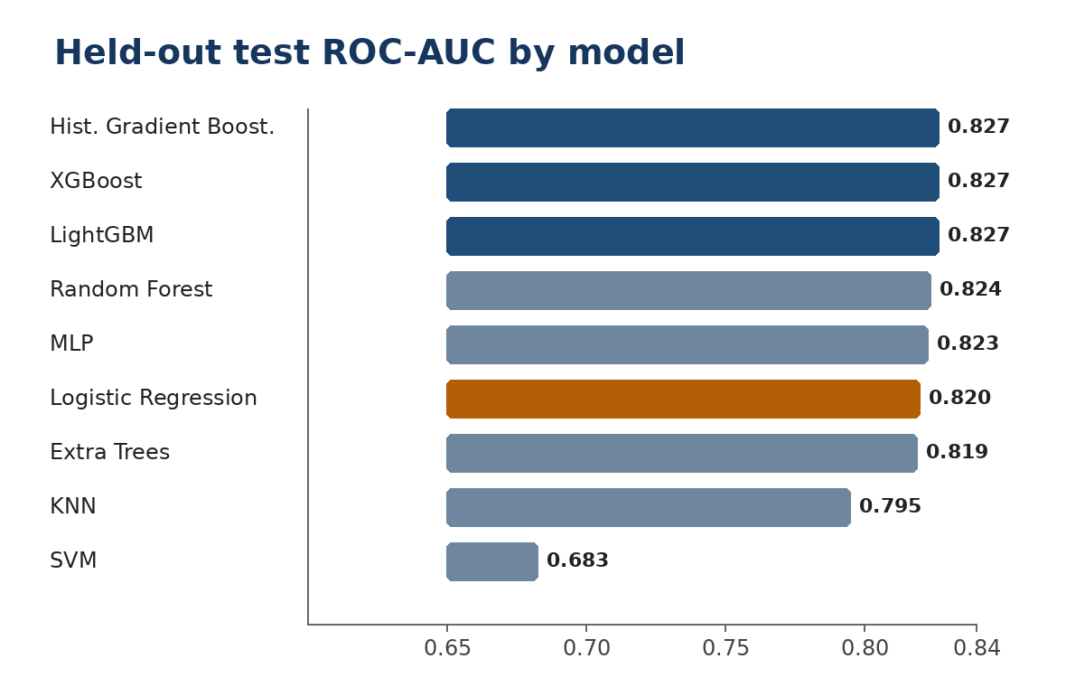
Figure 1. Held-out ROC-AUC for the nine estimators. Values come from the untouched test partition.
Table II. Held-out test performance ranked by ROC-AUC; CI values use 1,000 bootstrap resamples.
Model | ROC-AUC | 95% CI | PR-AUC | MCC | Brier
Hist. Gradient Boost. | 0.827 | 0.822-0.832 | 0.423 | 0.246 | 0.097
XGBoost | 0.827 | 0.822-0.831 | 0.423 | 0.236 | 0.097
LightGBM | 0.827 | 0.822-0.831 | 0.424 | 0.247 | 0.097
Random Forest | 0.824 | 0.819-0.829 | 0.418 | 0.213 | 0.098
MLP | 0.823 | 0.819-0.828 | 0.412 | 0.224 | 0.098
Logistic Regression | 0.820 | 0.815-0.824 | 0.393 | 0.356 | 0.177
Extra Trees | 0.819 | 0.814-0.824 | 0.409 | 0.186 | 0.099
KNN | 0.795 | 0.790-0.800 | 0.359 | 0.149 | 0.102
SVM | 0.683 | 0.675-0.691 | 0.322 | 0.123 | 0.114

The paired difference between the best model and logistic regression was ΔAUC = 0.007 (bootstrap 95% CI: 0.006-0.009). The interval excludes zero because the test set is large, but a seven-thousandth AUC gain is unlikely to change clinical decisions by itself. The leading boosting models were mutually indistinguishable. This supports H1 in its clinically relevant form: there is a statistically detectable difference, but it is too small to justify complexity on discrimination alone.
Raw accuracy was especially misleading. Tree-based models reported approximately 0.866 accuracy, barely above the majority-class baseline of 0.861, while detecting only 4%-16% of positive cases at a 0.5 cutoff. Class-weighted logistic regression achieved the highest MCC (0.356), balanced accuracy (0.744), F1 (0.441), and sensitivity (0.760). Threshold choice and calibration therefore matter more than the default classifier label.
B. Probability calibration
The original boosted model was already well calibrated (test ECE 0.0044; Brier 0.0974). Isotonic calibration reduced ECE to 0.0029 while retaining a comparable Brier score of 0.0975. Platt scaling degraded calibration in this large sample (ECE 0.0285). Isotonic probabilities were therefore used for risk stratification.
Table III. Calibration of the selected XGBoost model. Lower values are better.
Variant | Brier val. | ECE val. | Brier test | ECE test
Original | 0.0968 | 0.0040 | 0.0974 | 0.0044
Platt | 0.0985 | 0.0257 | 0.0995 | 0.0285
Isotonic | 0.0965 | 0.0000 | 0.0975 | 0.0029

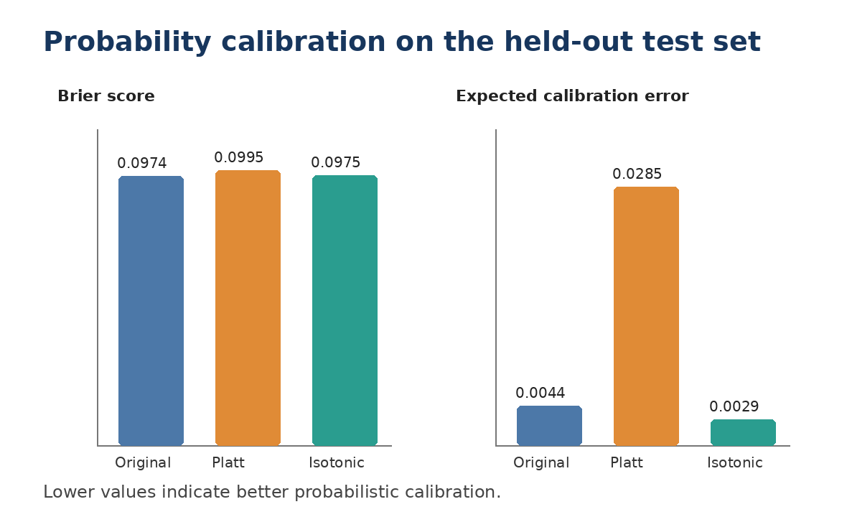
Figure 2. Held-out Brier score and expected calibration error before and after calibration.
C. Risk stratification and held-out assessment
The validation-selected cut points produced monotonic separation on the held-out test set. Observed prevalence increased from 2.9% in the Low band to 14.2% in Moderate, 29.1% in High, and 48.0% in Very high. Relative to Low risk, the odds ratios were 5.5, 13.7, and 30.7 with narrow confidence intervals. This sixteen-fold prevalence gradient suggests potential utility for population triage while requiring prospective external validation before clinical use.
Table IV. Observed outcomes by calibrated risk band in the held-out test set (n = 50,736).
Band | n | Prev. | OR (95% CI) | RR
Low | 26,149 | 2.9% | 1.0 (ref) | 1.0
Moderate | 11,877 | 14.2% | 5.5 (5.0-6.0) | 4.9
High | 7,844 | 29.1% | 13.7 (12.5-14.9) | 10.0
Very high | 4,866 | 48.0% | 30.7 (28.0-33.6) | 16.4

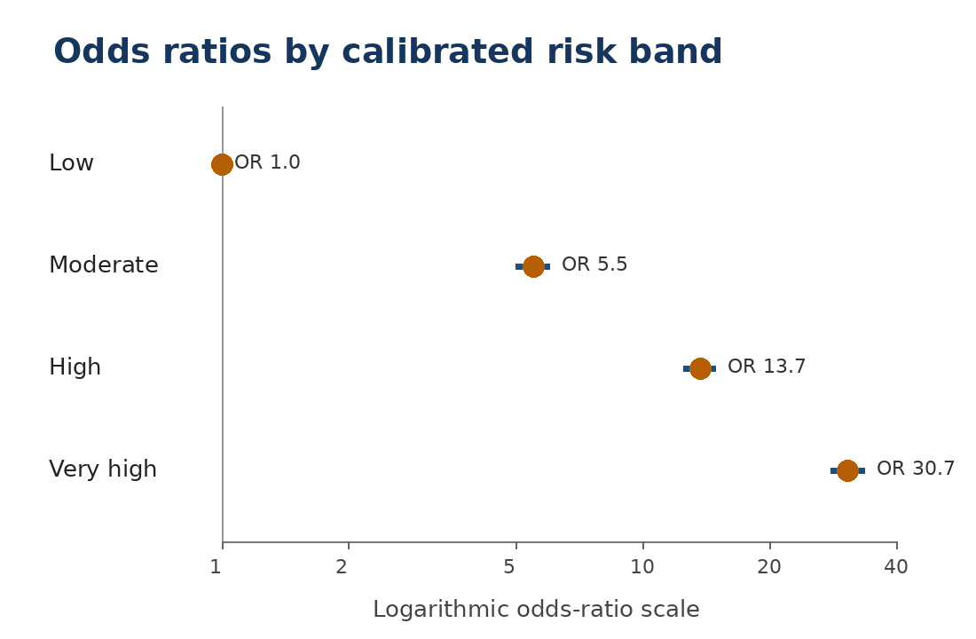
Figure 3. Odds ratios and 95% confidence intervals by calibrated risk band on a logarithmic scale.
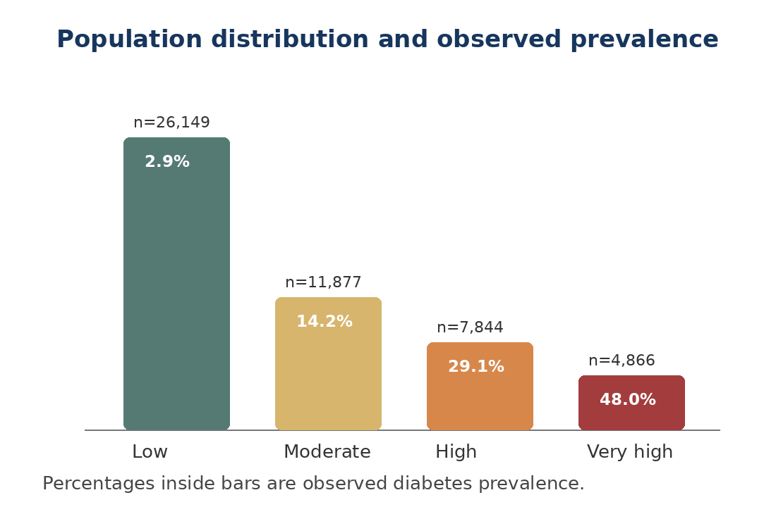
Figure 4. Population size and observed diabetes prevalence across the four risk bands.
D. Interpretability
SHAP attributions and permutation importance agreed on the dominant signal. General health, hypertension, BMI, age, and high cholesterol increased predicted risk, while higher income, physical activity, and fruit and vegetable intake were associated with lower risk. These patterns are clinically plausible and consistent with established cardiometabolic and socioeconomic risk, but they remain associations within the fitted model rather than causal effects.
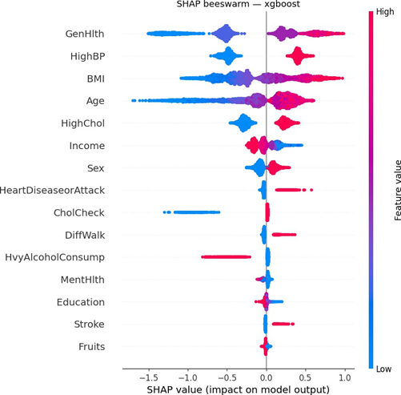
Figure 5. SHAP summary for the selected model. Color represents feature value and horizontal position represents contribution to predicted risk.
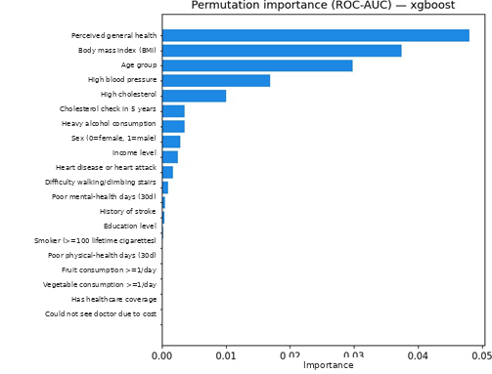
Figure 6. Permutation importance measured as the decrease in ROC-AUC. The ranking corroborates the SHAP signal.
Discussion
A. Why complex models provide little additional discrimination
The five strongest estimators differ by less than 0.004 ROC-AUC, and the best nonlinear model exceeds logistic regression by only 0.007. This near-equivalence suggests that much of the BRFSS signal is captured by low-order structure. Once the main effects of general health, hypertension, BMI, age, and cholesterol are represented, the evaluated flexible models obtain little additional discrimination.
B. The observed performance plateau
Seven of the nine estimators clustered between ROC-AUC 0.819 and 0.827, while KNN and SVM performed below that range. The clustering among the leading models is consistent with an information ceiling imposed by coarse self-reported predictors, not universal impossibility. Biomarkers, longitudinal trajectories, medication history, genetics, or more precise behavior measurements could shift that ceiling. The conclusion is comparative and limited to the present variables, models, and population.
C. Clinical and public-health meaning
An AUC near 0.83 is insufficient for individual diagnosis but useful for population triage. The Very high band represents about 10% of the cohort and concentrates an observed prevalence of 48%, a 3.4-fold enrichment over the base rate. A questionnaire-based pre-screen could prioritize confirmatory HbA1c or glucose testing when resources are limited. Diagnosis still requires biochemical confirmation under clinical standards [33].
The actionable output is not a binary label but a calibrated probability, risk band, uncertainty statement, and explanation. Presenting the 0.5 default prediction would omit most cases for several models and encourage automation bias. Safe deployment requires local recalibration, monitoring for population drift, documentation of the intended screening use, and interfaces that clearly state that the result is not a diagnosis.
D. Leakage and data governance
The feature set avoids direct diagnostic-label leakage from laboratory diagnostic criteria. Adding HbA1c or fasting glucose would change the task from pre-laboratory screening toward a diagnostic-adjacent setting and could improve discrimination, but the magnitude of that improvement was not estimated in this study. Variable admissibility is therefore at least as consequential as choosing among the leading estimators [8], [9], [33].
E. Interpretability and reporting
Agreement between SHAP and permutation importance increases confidence that the model uses recognizable epidemiological structure. It does not prove causality or fairness. Income and healthcare access may encode structural inequities, and explanations can appear plausible even when validation is inadequate [19]. Reporting should follow transparent guidance such as TRIPOD+AI, including data provenance, missingness, sample flow, calibration, thresholds, and external validation [35].
Lessons for Clinical Machine Learning
First, strong baselines are mandatory: complex models should be compared against regularized logistic regression under the same preprocessing and splits. Second, leakage control begins with a clinical definition of what information is available at prediction time. Third, probability calibration is not optional when outputs drive thresholds. Fourth, interpretability must connect to decisions rather than decorative plots. Fifth, a model that supports screening must be governed, recalibrated, monitored, and prevented from replacing professional judgment.
Limitations and Threats to Validity
The study is observational and cross-sectional. BRFSS supports association, not causation, and SHAP values or odds ratios must not be interpreted as intervention effects. Predictors and outcome are self-reported by telephone, which introduces recall and desirability bias. Previously undiagnosed diabetes is labeled negative, attenuating measured associations and potentially underestimating attainable signal.
Selection and coverage bias may underrepresent people without stable telephone access and nonrespondents. The public extract does not apply survey weights, so descriptive estimates should not be interpreted as nationally representative. Socioeconomic variables may reflect access disparities rather than biology, creating equity concerns if the score is used to ration care.
The dataset lacks HbA1c, glucose, lipids, detailed family history, medication, genetics, and longitudinal measurements. The observed plateau is conditional on this restricted feature space. Results also concern United States adults surveyed in 2015; transport to other countries, health systems, or current populations requires external validation and recalibration.
Exact duplicate response vectors can cross random partitions and may inflate absolute discrimination. They were retained because respondent identifiers are unavailable and removing repeated categorical profiles would change prevalence. The magnitude and model-specific effect of this contamination are unknown; a grouped sensitivity analysis should be added when identifiers or defensible grouping keys become available.
SVM and KNN were tuned on subsamples, which may underestimate their performance. Threshold-dependent metrics use a 0.5 cutoff and should not be confused with the calibrated risk-band policy. Finally, the study uses one stratified split with bootstrap uncertainty. Repeated cross-validation, multiple seeds, prospective validation, and decision-curve analysis remain important extensions.
Future Work
Future work should validate the model prospectively in Mexican and local clinical populations, monitor calibration over time, and evaluate fairness across sex, age, income, and access groups. Longitudinal PREDIA records could support trajectory models that distinguish stable risk from rapid deterioration. Patient-level explanations should be tested with clinicians for comprehension and actionability. Model and dataset versioning, automated metric gates, drift monitoring, and audit logs are needed before operational use.
Conclusions
Across nine estimators, available information limited performance more than algorithm choice. Seven models clustered between ROC-AUC 0.819 and 0.827, and the best nonlinear approach improved over regularized logistic regression by only ΔAUC = 0.007. This difference was statistically detectable but practically small. Raw accuracy obscured poor sensitivity at the default threshold, while calibration and validation-selected risk bands produced a clinically clearer output.
Isotonic calibration achieved test ECE = 0.0029, and the four risk bands separated observed prevalence from 2.9% to 48.0%. SHAP and permutation importance recovered plausible cardiometabolic and socioeconomic patterns. The model is therefore best understood as a transparent population-screening aid that prioritizes confirmatory evaluation, not as a diagnostic system. Methodological rigor, admissible variables, calibration, interpretability, transparent reporting, and local monitoring offer more value than marginal gains in discrimination.
Declarations
Conflict of interest
The authors declare that they have no known competing financial interests or personal relationships that could have influenced the work reported in this article.
Author contributions
Guillermo Álvarez Sánchez: conceptualization, methodology, software, data curation, formal analysis, model implementation, visualization, original draft, and review and editing.
Iván Peredo Valderrama: scientific supervision, methodological guidance, validation, correspondence, and review and editing.
José Javier Moya Moya: academic and scientific supervision, methodological review, validation, and review and editing.
Jairo Pacindo Piña: validation of results, critical review of scientific content, and review and editing.
Data and materials availability
The BRFSS-derived data used in this study are publicly available [23], [24]. Additional derived materials are available from the corresponding author upon reasonable request.
Funding
This research received no specific external funding from a public, commercial, or not-for-profit funding agency.
Acknowledgements
The authors thank the Universidad Politécnica de Querétaro for the facilities and institutional support provided during this research.
References
[1] International Diabetes Federation, "IDF diabetes atlas, 11th ed." International Diabetes Federation, Brussels, Belgium, 2025, ISBN: 978-2-930229-96-6.
[2] American Diabetes Association Professional Practice Committee for Diabetes, "1. Improving care and promoting health in populations: Standards of care in diabetes - 2026," Diabetes Care, vol. 49, no. Supplement 1, pp. S13-S26, 2026, doi: 10.2337/dc26-S001.
[3] Z. Xie, O. Nikolayeva, J. Luo, and D. Li, "Building risk prediction models for type 2 diabetes using machine learning techniques," Preventing Chronic Disease, vol. 16, p. E130, 2019, doi: 10.5888/pcd16.190109.
[4] A. Dinh, S. Miertschin, A. Young, and S. D. Mohanty, "A data-driven approach to predicting diabetes and cardiovascular disease with machine learning," BMC Medical Informatics and Decision Making, vol. 19, no. 1, p. 211, 2019, doi: 10.1186/s12911-019-0918-5.
[5] N. P. Tigga and S. Garg, "Prediction of type 2 diabetes using machine learning classification methods," Procedia Computer Science, vol. 167, pp. 706-716, 2020, doi: 10.1016/j.procs.2020.03.336.
[6] A. Rashid, "Diabetes dataset," Mendeley Data, V1, 2020, doi: 10.17632/wj9rwkp9c2.1.
[7] E. Christodoulou, J. Ma, G. S. Collins, E. W. Steyerberg, J. Y. Verbakel, and B. Van Calster, "A systematic review shows no performance benefit of machine learning over logistic regression for clinical prediction models," Journal of Clinical Epidemiology, vol. 110, pp. 12-22, 2019, doi: 10.1016/j.jclinepi.2019.02.004.
[8] S. Kaufman, S. Rosset, C. Perlich, and O. Stitelman, "Leakage in data mining: Formulation, detection, and avoidance," ACM Transactions on Knowledge Discovery from Data (TKDD), vol. 6, no. 4, pp. 1-21, 2012, doi: 10.1145/2382577.2382579.
[9] S. Kapoor and A. Narayanan, "Leakage and the reproducibility crisis in machine-learning-based science," Patterns, vol. 4, no. 9, p. 100804, 2023, doi: 10.1016/j.patter.2023.100804.
[10] E. W. Steyerberg, Clinical Prediction Models: A Practical Approach to Development, Validation, and Updating, 2nd ed., ser. Statistics for Biology and Health. Cham, Switzerland: Springer, 2019, doi: 10.1007/978-3-030-16399-0.
[11] B. Van Calster, D. J. McLernon, M. van Smeden, L. Wynants, and E. W. Steyerberg, "Calibration: The Achilles heel of predictive analytics," BMC Medicine, vol. 17, no. 1, p. 230, 2019, doi: 10.1186/s12916-019-1466-7.
[12] A. Niculescu-Mizil and R. Caruana, "Predicting good probabilities with supervised learning," in Proc. 22nd Int. Conf. on Machine Learning (ICML), 2005, pp. 625-632, doi: 10.1145/1102351.1102430.
[13] C. Guo, G. Pleiss, Y. Sun, and K. Q. Weinberger, "On calibration of modern neural networks," in Proc. 34th Int. Conf. on Machine Learning (ICML), ser. PMLR, vol. 70, 2017, pp. 1321-1330.
[14] S. M. Lundberg and S.-I. Lee, "A unified approach to interpreting model predictions," in Advances in Neural Information Processing Systems (NeurIPS), vol. 30, 2017, pp. 4765-4774.
[15] S. M. Lundberg, G. Erion, H. Chen, A. DeGrave, J. M. Prutkin, B. Nair, R. Katz, J. Himmelfarb, N. Bansal, and S.-I. Lee, "From local explanations to global understanding with explainable AI for trees," Nature Machine Intelligence, vol. 2, no. 1, pp. 56-67, 2020, doi: 10.1038/s42256-019-0138-9.
[16] M. T. Ribeiro, S. Singh, and C. Guestrin, ""why should I trust you?": Explaining the predictions of any classifier," in Proc. 22nd ACM SIGKDD Int. Conf. on Knowledge Discovery and Data Mining, 2016, pp. 1135-1144, doi: 10.1145/2939672.2939778.
[17] C. Rudin, "Stop explaining black box machine learning models for high stakes decisions and use interpretable models instead," Nature Machine Intelligence, vol. 1, no. 5, pp. 206-215, 2019, doi: 10.1038/s42256-019-0048-x.
[18] R. Caruana, Y. Lou, J. Gehrke, P. Koch, M. Sturm, and N. Elhadad, "Intelligible models for healthcare: Predicting pneumonia risk and hospital 30-day readmission," in Proc. 21st ACM SIGKDD Int. Conf. on Knowledge Discovery and Data Mining, 2015, pp. 1721-1730, doi: 10.1145/2783258.2788613.
[19] M. Ghassemi, L. Oakden-Rayner, and A. L. Beam, "The false hope of current approaches to explainable artificial intelligence in health care," The Lancet Digital Health, vol. 3, no. 11, pp. e745-e750, 2021, doi: 10.1016/S2589-7500(21)00208-9.
[20] T. Saito and M. Rehmsmeier, "The precision-recall plot is more informative than the ROC plot when evaluating binary classifiers on imbalanced datasets," PLoS ONE, vol. 10, no. 3, p. e0118432, 2015, doi: 10.1371/journal.pone.0118432.
[21] H. He and E. A. Garcia, "Learning from imbalanced data," IEEE Transactions on Knowledge and Data Engineering, vol. 21, no. 9, pp. 1263-1284, 2009, doi: 10.1109/TKDE.2008.239.
[22] D. Chicco and G. Jurman, "The advantages of the Matthews correlation coefficient (MCC) over F1 score and accuracy in binary classification evaluation," BMC Genomics, vol. 21, no. 1, p. 6, 2020, doi: 10.1186/s12864-019-6413-7.
[23] A. Teboul, "Diabetes health indicators dataset," Kaggle, 2021, derived from the CDC Behavioral Risk Factor Surveillance System (BRFSS) 2015. [Online]. Available: https://www.kaggle.com/datasets/alexteboul/diabetes-health-indicators-dataset.
[24] Centers for Disease Control and Prevention, "Behavioral risk factor surveillance system (brfss) 2015 survey data and documentation," U.S. Department of Health and Human Services, CDC, Tech. Rep., 2016.
[25] F. Pedregosa, G. Varoquaux, A. Gramfort, V. Michel, B. Thirion, O. Grisel, M. Blondel, P. Prettenhofer, R. Weiss, V. Dubourg, J. Vanderplas, A. Passos, D. Cournapeau, M. Brucher, M. Perrot, and É. Duchesnay, "Scikit-learn: Machine learning in Python," Journal of Machine Learning Research, vol. 12, pp. 2825-2830, 2011.
[26] L. Breiman, "Random forests," Machine Learning, vol. 45, no. 1, pp. 5-32, 2001, doi: 10.1023/A:1010933404324.
[27] J. H. Friedman, "Greedy function approximation: A gradient boosting machine," Annals of Statistics, vol. 29, no. 5, pp. 1189-1232, 2001, doi: 10.1214/aos/1013203451.
[28] T. Chen and C. Guestrin, "XGBoost: A scalable tree boosting system," in Proc. 22nd ACM SIGKDD Int. Conf. on Knowledge Discovery and Data Mining (KDD), 2016, pp. 785-794, doi: 10.1145/2939672.2939785.
[29] G. Ke, Q. Meng, T. Finley, T. Wang, W. Chen, W. Ma, Q. Ye, and T.-Y. Liu, "LightGBM: A highly efficient gradient boosting decision tree," in Advances in Neural Information Processing Systems (NeurIPS), vol. 30, 2017, pp. 3146-3154.
[30] T. Cover and P. Hart, "Nearest neighbor pattern classification," IEEE Transactions on Information Theory, vol. 13, no. 1, pp. 21-27, 1967, doi: 10.1109/TIT.1967.1053964.
[31] C. Cortes and V. Vapnik, "Support-vector networks," Machine Learning, vol. 20, no. 3, pp. 273-297, 1995, doi: 10.1007/BF00994018.
[32] B. Efron, "Bootstrap methods: Another look at the jackknife," The Annals of Statistics, vol. 7, no. 1, pp. 1-26, 1979, doi: 10.1214/aos/1176344552.
[33] American Diabetes Association Professional Practice Committee for Diabetes, "2. Diagnosis and classification of diabetes: Standards of care in diabetes - 2026," Diabetes Care, vol. 49, no. Supplement 1, pp. S27-S49, 2026, doi: 10.2337/dc26-S002.
[34] I. Tasin, T. U. Nabil, S. Islam, and R. Khan, "Diabetes prediction using machine learning and explainable AI techniques," Healthcare Technology Letters, vol. 10, no. 1-2, pp. 1-10, 2023, doi: 10.1049/htl2.12039.
[35] G. S. Collins et al., "TRIPOD+AI statement: Updated guidance for reporting clinical prediction models that use regression or machine learning methods," BMJ, vol. 385, p. e078378, 2024, doi: 10.1136/bmj-2023-078378.

