**MyFavBands**

**Code in Yellow you need to copy/paste**

**Code in Red Delete**

1. Create a Master/Detail iPhone App
2. Mimic Below Screen (Except Organization Name)

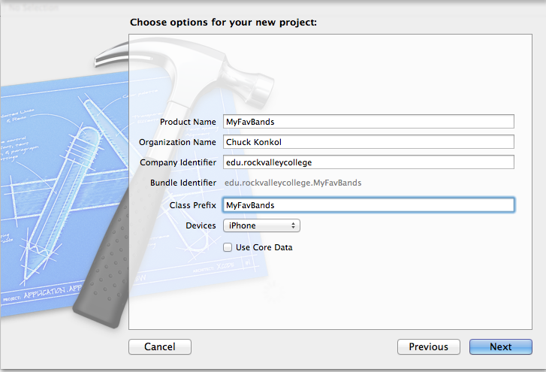

1. Delete label from Detail View Controller
2. Add UIImage to Detail View Controller  
     
   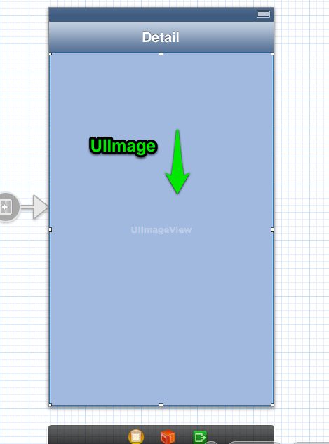
3. Edit // MyFavBandsMasterViewController.h

// MyFavBandsMasterViewController.h

// MyFavBands

//

// Created by Charles Konkol on 9/25/13.

// Copyright (c) 2013 RVC Student. All rights reserved.

//

#import <UIKit/UIKit.h>

@interface MyFavBandsMasterViewController : UITableViewController

{

NSArray *list;

}

@property (strong, nonatomic) NSArray *list;

@end

1. Edit …..MasterViewController.m

// MyBan1MasterViewController.m

// MyBan1

//

// Created by Charles Konkol on 9/27/13.

// Copyright (c) 2013 RVC Student. All rights reserved.

//

#import "MyBan1MasterViewController.h"

#import "MyBan1DetailViewController.h"

@interface MyBan1MasterViewController () {

NSMutableArray *_objects;

}

@end

@implementation MyBan1MasterViewController

//1) Add Synthesize

@synthesize list;

- (void)awakeFromNib

{

[super awakeFromNib];

}

- (void)viewDidLoad

{

[super viewDidLoad];

//2) Replace ALL existing code with below array load

self.title = @"My Favorite Bands";

NSArray *listArray = [[NSArray alloc] initWithObjects:@"Joe Cocker", @"Leonard Skynard", @"Eagles",@"Journey",@"38 Special", @"Miranda Lambert",@"Little Big Town",@"Band Perry",nil];

self.list = listArray;

}

- (void)didReceiveMemoryWarning

{

[super didReceiveMemoryWarning];

// Dispose of any resources that can be recreated.

}

- (void)insertNewObject:(id)sender

{

if (!_objects) {

_objects = [[NSMutableArray alloc] init];

}

[_objects insertObject:[NSDate date] atIndex:0];

NSIndexPath *indexPath = [NSIndexPath indexPathForRow:0 inSection:0];

[self.tableView insertRowsAtIndexPaths:@[indexPath] withRowAnimation:UITableViewRowAnimationAutomatic];

}

#pragma mark - Table View

- (NSInteger)numberOfSectionsInTableView:(UITableView *)tableView

{

return 1;

}

- (NSInteger)tableView:(UITableView *)tableView numberOfRowsInSection:(NSInteger)section

{

//3 Modify Return for menu array

return [list count];

//return _objects.count;

}

- (UITableViewCell *)tableView:(UITableView *)tableView cellForRowAtIndexPath:(NSIndexPath *)indexPath

{

//4) Replace existing code with below code

static NSString *CellIdentifier = @"Cell";

UITableViewCell *cell = [tableView dequeueReusableCellWithIdentifier:CellIdentifier];

cell.textLabel.text = [list objectAtIndex:[indexPath row]];

return cell;

}

- (BOOL)tableView:(UITableView *)tableView canEditRowAtIndexPath:(NSIndexPath *)indexPath

{

// Return NO if you do not want the specified item to be editable.

return YES;

}

- (void)tableView:(UITableView *)tableView commitEditingStyle:(UITableViewCellEditingStyle)editingStyle forRowAtIndexPath:(NSIndexPath *)indexPath

{

if (editingStyle == UITableViewCellEditingStyleDelete) {

[_objects removeObjectAtIndex:indexPath.row];

[tableView deleteRowsAtIndexPaths:@[indexPath] withRowAnimation:UITableViewRowAnimationFade];

} else if (editingStyle == UITableViewCellEditingStyleInsert) {

// Create a new instance of the appropriate class, insert it into the array, and add a new row to the table view.

}

}

/*

// Override to support rearranging the table view.

- (void)tableView:(UITableView *)tableView moveRowAtIndexPath:(NSIndexPath *)fromIndexPath toIndexPath:(NSIndexPath *)toIndexPath

{

}

*/

/*

// Override to support conditional rearranging of the table view.

- (BOOL)tableView:(UITableView *)tableView canMoveRowAtIndexPath:(NSIndexPath *)indexPath

{

// Return NO if you do not want the item to be re-orderable.

return YES;

}

*/

- (void)prepareForSegue:(UIStoryboardSegue *)segue sender:(id)sender

{

//5 Replace existing code with below to setproductname and send //to seque object item user clicked on menu

// Error will go away soon...keep going

[segue.destinationViewController setProductName:[list objectAtIndex:[self.tableView.indexPathForSelectedRow row]]];

}

@end

1. Edit …DetailViewController.h

//MyBan1DetailViewController.h

// Created by Charles Konkol on 9/27/13.

// Copyright (c) 2013 RVC Student. All rights reserved.

//

#import <UIKit/UIKit.h>

@interface MyBan1DetailViewController : UIViewController

{

//1) Add Default initializers

NSString *productName;

CGFloat previousScale;

CGFloat previousRotation;

CGFloat beginX;

CGFloat beginY;

}

//2) Modify.

//This will get rid of error on MasterViewConrtoller:

//(void)prepareForSegue:

@property (strong, nonatomic) IBOutlet UIImageView *productImageView;

@property (strong, nonatomic) NSString *productName;

3 Delete Below lines

@property (strong, nonatomic) id detailItem;

@property (weak, nonatomic) IBOutlet UILabel *detailDescriptionLabel;

@end

1. Edit …DetailViewController.m  
     
   //

// MyBan1DetailViewController.m

// MyBan1

//

// Created by Charles Konkol on 9/27/13.

// Copyright (c) 2013 RVC Student. All rights reserved.

//

#import "MyBan1DetailViewController.h"

//1) Delete or comment out next three line

//@interface MyBan1DetailViewController ()

//- (void)configureView;

//@end

@implementation MyBan1DetailViewController

//2) Add sythesize

@synthesize productName;

#pragma mark - Managing the detail item

//3) Delete or Comment Out - (void)setDetailItem Section

//- (void)setDetailItem:(id)newDetailItem

//{

//...

// }

//}

//4) Delete or Comment Out - (void)configureView Section

//- (void)configureView

//{

//...

// }

//}

- (void)viewDidLoad

{

[super viewDidLoad];

// Do any additional setup after loading the view, typically from a nib.

//5) Modify/Delete ViewDidLoad

self.title = productName;

NSString *imageName = [NSString stringWithFormat:@"%@.jpg", productName];

self.productImageView.image = [UIImage imageNamed:imageName];

//[self configureView];

}

- (void)didReceiveMemoryWarning

{

[super didReceiveMemoryWarning];

// Dispose of any resources that can be recreated.

}

@end

1. CTRL + DRAG from ViewController (Left Bottom Object) to UiIMage and Select **ProductImageView (I will show alternative in class)**

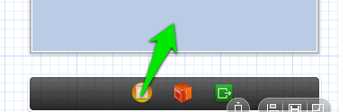

1. Add Images
   1. Right-Click on Project Name > Select **New Group**  and name **Photos**

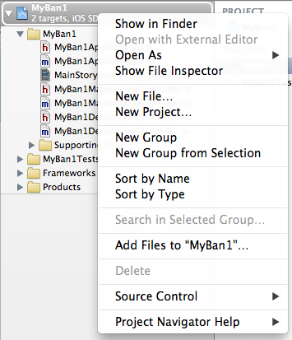

* 1. Right-Click on new Group **Photos** and select **Add File to …** add .needed .jpg images. **These images MUST match the same name as your menu array and MUST end in .jpg**. You can find these photos from the web.
  2. Here is how your screen should look:  
     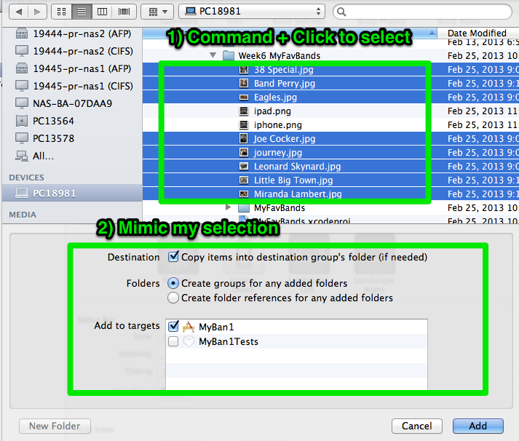

1. Add icons. I suggest using pixlr.com

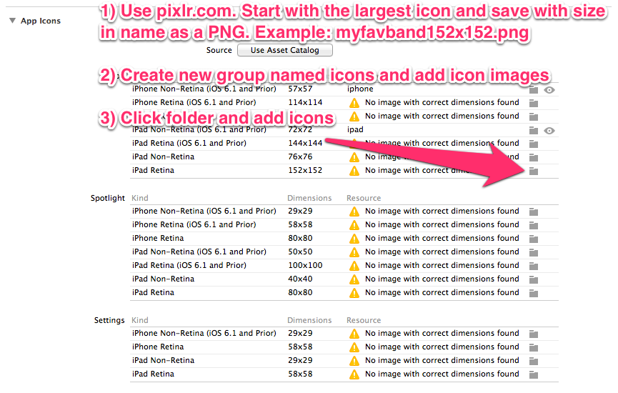

NEW iOS7

In iOS 7, app icons for high-resolution iPhone and iPod touch are 120 x 120 pixels; for high-resolution iPad, app icons are 152 x 152 pixels.

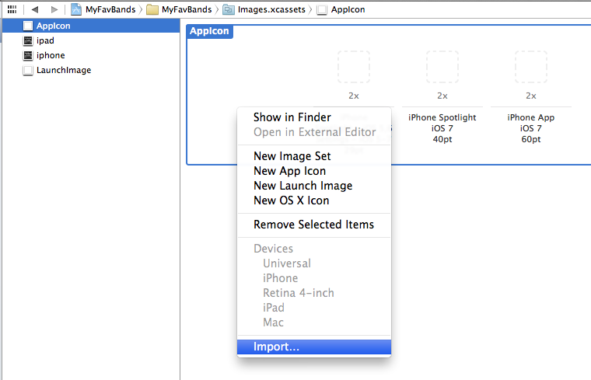

1. Make project Universal
   1. Click Project Name in Navigator
   2. Click General tab in middle of xcode screen
   3. Deployment target 7.0, Device Universal
   4. If prompted to Copy storyboard for iPad accept it.
2. Go to StoryBoard > “Detail” >File Inspector > Uncheck “AutoLayout”  
   This will allow objects to fill for iPad or iPhone

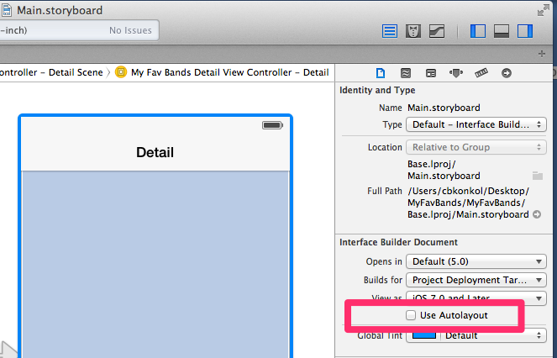

1. Click on UIImage > Size Inspector (Copy Below for AutoSizing). This will allow image to resize for iPhone or iPad devices.

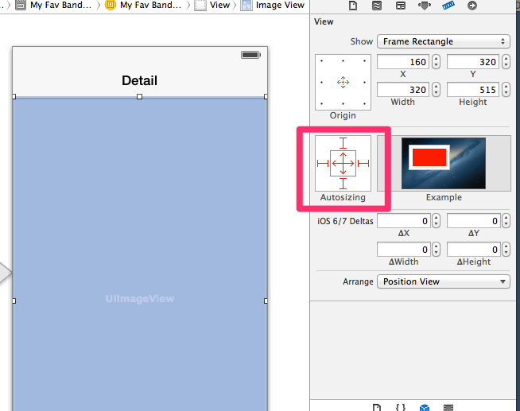

1. Run (Command + R) and Test for iPhone 4 Retina and iPad Retina
   1. Test
   2. Go to Device > Rotate Left > Test
   3. Keep going Device Rotate Left until back to portrait > Test
2. That’s IT!