Unit 2 Lesson 1
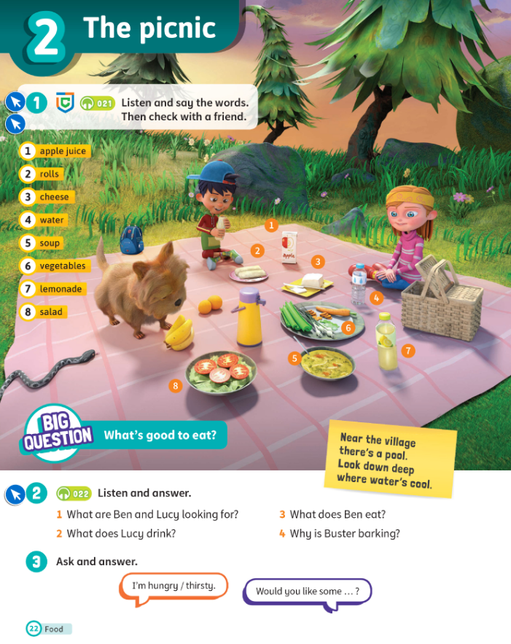

Topic: The picnic
Aims:
- Find out about the new topic
- Learn new words

Stage | Time | Tasks | Alternative
Warm-up | 3-5 | - Ask students about their mood, if they have anything new, anything interesting, etc. | - Baamboozle - name 3 https://www.baamboozle.com/game/202322  - Hangman  - “Simon says…”
Revision\HW check | 5 | Start of the unit - no homework.
PlAN of the lesson |  | - Find out about the new topic  - Learn new words  - Play and have fun
LEAD in | 2-5 | - Watch a video and ask kids to guess the topic (start watching from 0:28): https://www.youtube.com/watch?v=ckfy0BYB8lU you can use the link or you can find the video " Peppa Pig - Picnic " in the folder | Any other video related to the topic.
Presentation | 10-15 | - Textbook p. 22 - ask to repeat the words, then ask to read one by one  - Say a word and ask students to circle. | - Flashcards: https://wordwall.net/resource/35566542
Controlled Practice | 10-15 | - Do the exercise: https://wordwall.net/resource/35566552  - Ex. 2 p. 22 (SB) | - Do the listening exercise: https://www.liveworksheets.com/worksheets/en/English_as_a_Second_Language_(ESL)/Food_and_drinks/Let's_go_on_a_picnic,_listen_and_choose_fo2641949ts
Freer Practice | 10-15 | - Speaking:  - P. 22 ex. 3  - OR  - Show a picture of a fridge and a table full of food, ask one student to say “I’m hungry” and another student to say “Would you like some…”, the second student has to choose the option from what he/she can see on the table/in the fridge.
Cooler | 5 | Play a game - matching pairs: https://wordwall.net/resource/35566703 | Play a game: https://www.baamboozle.com/game/16916
PlAN of the lesson CHECK |  | Ask kids to remember the goals and ask whether you have completed everything (you can write it on the white board and ask students to tick).
Feedback\HW | 5 | - Class Dojo https://www.classdojo.com/  - Give students feedback and give them start/points. ALWAYS tell them what that point is for - for hard work, for correct answers, for behavior, for homework. Tell what they need to improve.  - Ask students for the feedback: what activities they liked, what was easy or difficult. You may spend 1-2 mins for this and perform this in Russian | - Ask to send a reaction  - Goodbye song https://www.youtube.com/watch?v=UQfvAlmr5g0 you can use the link or you can find the video "See You Later Alligator Goodbye Songs" in the folder.

HOMEWORK:
Домашнее задание на платформе Взнания. Название: SM3 Unit 2 Homework 1 (1) + SM3 Unit 2 Homework 1 (2)
Зайдите на платформу Взнания, добавьте урок, войдите в Мой класс и впишите домашнее задание.

