Unit 1 Lesson 2
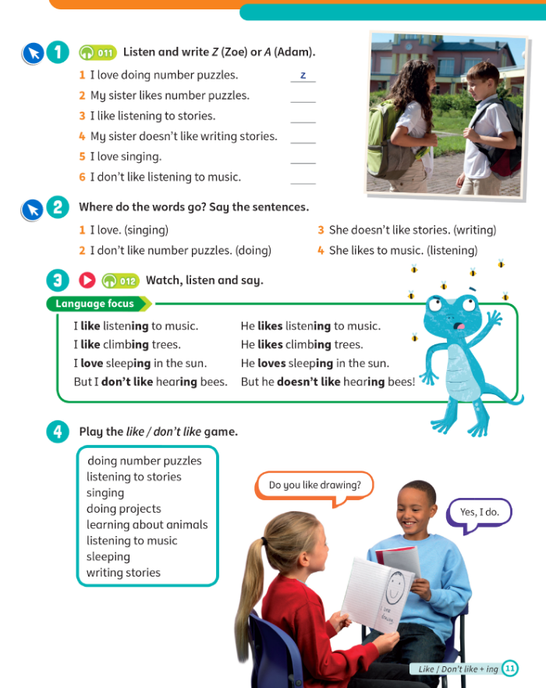
Topic: love, like, hate + Ving
Aims:
- Revise vocabulary
- Find out about the new topic
- Learn new grammar

Stage | Time | Tasks | Alternative
Warm-up | 3-5 | - Ask students about their mood, if they have anything new, anything interesting, etc. | - Baamboozle - name 3 https://www.baamboozle.com/game/202322  - Hangman  - “Simon says…”
Revision\HW check | 5 | Give a little feedback on the students' homework. Check the tasks that the Ss have difficulties with. If the student is not ready with the homework, remind him to complete it.  Do the exercise: https://wordwall.net/resource/96893318/csm3-u1-our-school-school-subjects-anagram
PlAN of the lesson |  | - Find out about the new topic  - Learn new grammar  - Practice new grammar  - Play and have fun
LEAD in | 2-5 | - Watch this video : https://www.youtube.com/watch?v=GFUgzLvdwYg you can use the link or you can find the video " Love hate like + verb + ing " in the folder  Ask kids to read and repeat after you. | - Any other video related to the topic;  - Use realia - talk about things you think are fun, boring, difficult, etc.
Presentation | 10-15 | - Textbook p.11 ex. 1 – listen, ask to read and match names.  - Provide more examples using realia.
Controlled Practice | 10-15 | - Do an exercise: https://wordwall.net/resource/96893333/likelove | https://www.liveworksheets.com/worksheets/en/English_as_a_Second_Language_(ESL)/Likes_and_dislikes/like-love-hate_doing_something_cz3492oj
Freer Practice | 10-15 | - Textbook p.11 ex.3  - You can use this link to help students make up sentences: https://wordwall.net/resource/96893345/like-dont-like-love-hate-doing  - If you want to upgrade the task, create your own set of pictures with funny ideas.  - Don’t forget to explain the rules and set an example.
Cooler | 5 | Play a game - https://www.baamboozle.com/game/9999 | For more advanced students – ask to make sentences about themselves with what they see in those pictures.
PlAN of the lesson CHECK |  | Ask kids to remember the goals and ask whether you have completed everything (you can write it on the white board and ask students to tick).
Feedback\HW | 5 | Give students feedback and give them start/points. ALWAYS tell them what that point is for - for hard work, for correct answers, for behavior, for homework. Tell what they need to improve. | - Ask to send a reaction  - Goodbye song https://www.youtube.com/watch?v=UQfvAlmr5g0  you can use the link or you can find the video "See You Later Alligator Goodbye Songs" in the folder.

HOMEWORK:
Домашнее задание на платформе Взнания. Название: SM3 Unit 1 Homework 2
Зайдите на платформу Взнания, добавьте урок, войдите в Мой класс и впишите домашнее задание.

