Unit 6 Lesson 5
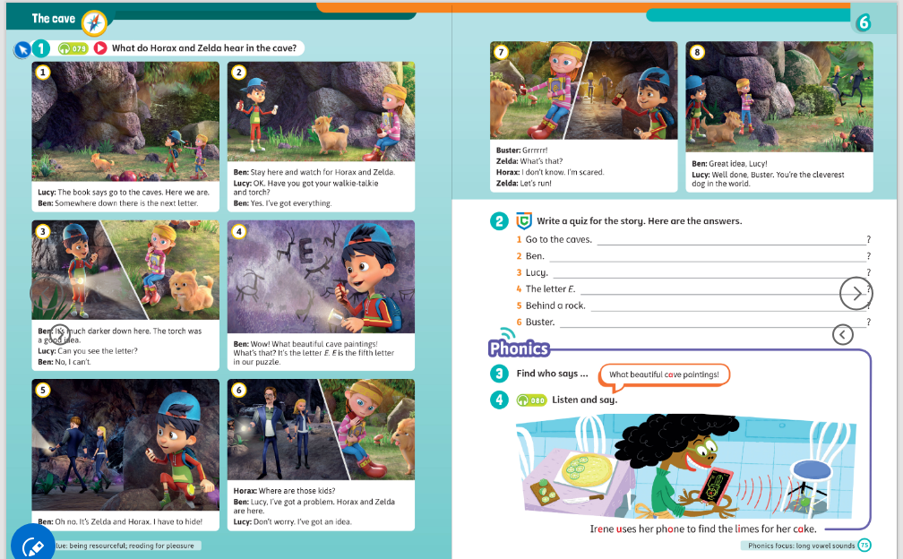
Topic: Gadgets
Aims:
- Revision of grammar
- Reading
- Listening to the story
- Phonics
Stage | Time | Tasks | Extra activities
Warm-up | 3-5 | Ask students How are you? Are you good/great/wonderful? Make them answer with full sentences (I’m great!)  Game: Name 5  It is a good way to revise all vocabulary that was learnt before.  You can also play “Snowball” (students repeat the words that was said earlier and add their own word until someone falls out of step) | https://wordwall.net/resource/97608029/warm-up-random-cards
Revision\HW check | 5 | Give a little feedback on the students' homework. Check the tasks that the Ss have difficulties with. If the student is not ready with the homework, remind him to complete it.  Revision of grammar:  Show this picture to the SS, ask them to describe people using comparative forms of adjectives  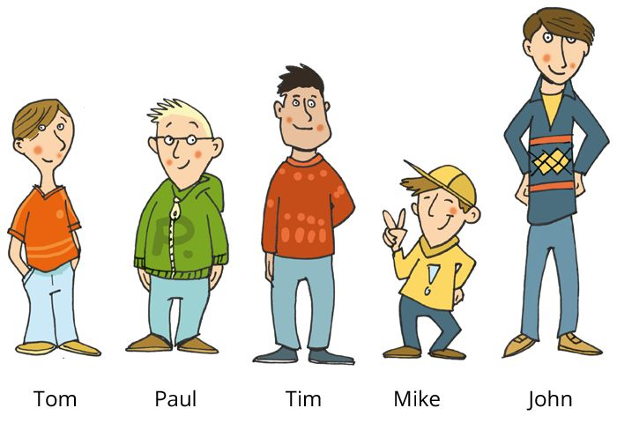
PlAN of the lesson |  | Today we are going to talk about…
Reading | 10-15 | SB p.74-75 – look at the text; ask SS to read it by roles. You can also ask questions after reading. Ask them to find comparative adjectives.
Listening | 10-15 | P.74  Watch the story. Ask SS to remember it as much as they can  SB p. 75 – ex. 2  You can also ask SS to retell the story in English to practice grammar and vocabulary  If you want to work with this story more, do exercises in WB p.74
Phonics focus | 10-15 | Ask what letter found characters in the story. Practice its pronunciation (SB p.75)  You can also take and practice some tongue twisters:  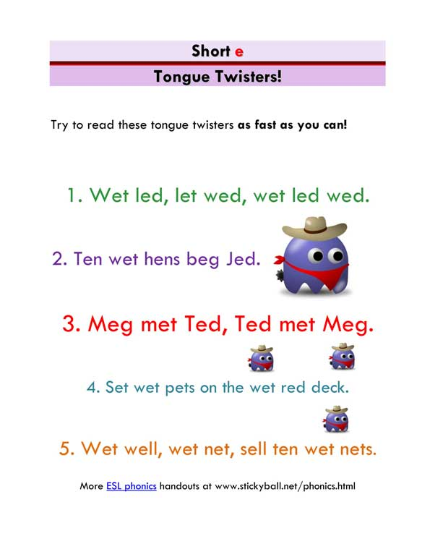
PlAN of the lesson CHECK |  | Show the lesson plan one more time and ask students to tick which items are done
Feedback\  HW | 5 | Class Dojo  https://www.classdojo.com/  Give students feedback and give them start/points. ALWAYS tell them what that point is for - for hard work, for correct answers, for behavior, for homework. Tell what they need to improve.  Ask students for the feedback: what activities they liked, what was easy or difficult. You may spend 1-2 mins for this and perform this in Russian
Cooler | 5 | Feedback  ask students to share their opinions on what was easy/difficult/interesting/boring in the lesson.  https://wallpapers.com/images/hd/emotion-pictures-1645-x-1225-xq7vly7gf0f49lku.jpg  They can circle their emotions after the lesson  Play a little game: now I can  (Students tick what they have learnt today)

HOMEWORK:
Домашнее задание на платформе Взнания. Название: SM3 Unit 6 Homework 5
Зайдите на платформу Взнания, добавьте урок, войдите в Мой класс и впишите домашнее задание.

