Unit 1 Lesson 4
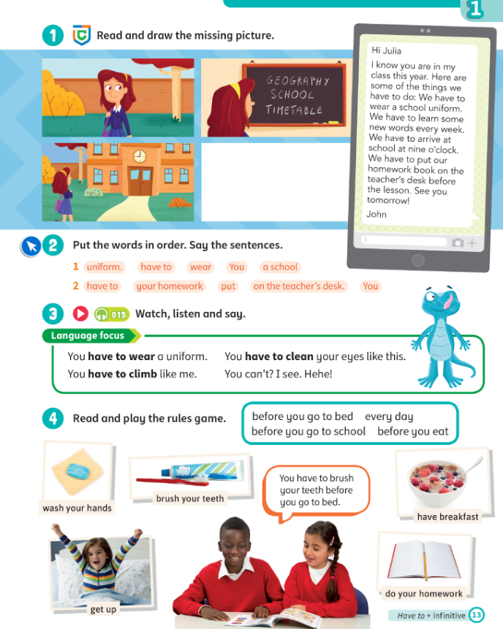
Topic: Our school
Aims:
- Learn new grammar Have to
- Practice listening, reading and comprehension skills
Stage | Time | Tasks | Extra activities
Warm-up | 3-5 | - Ask students about their mood, if they have anything new, anything interesting, etc. | - Baamboozle - name 3 https://www.baamboozle.com/game/202322  - Hangman  - “Simon says…”
Revision\HW check | 5 | Give a little feedback on the students' homework. Check the tasks that the Ss have difficulties with. If the student is not ready with the homework, remind him to complete it.
PlAN of the lesson |  | - Learn new grammar  - Practice new grammar  - Have fun
LEAD in | 2-5 | Look at the picture:  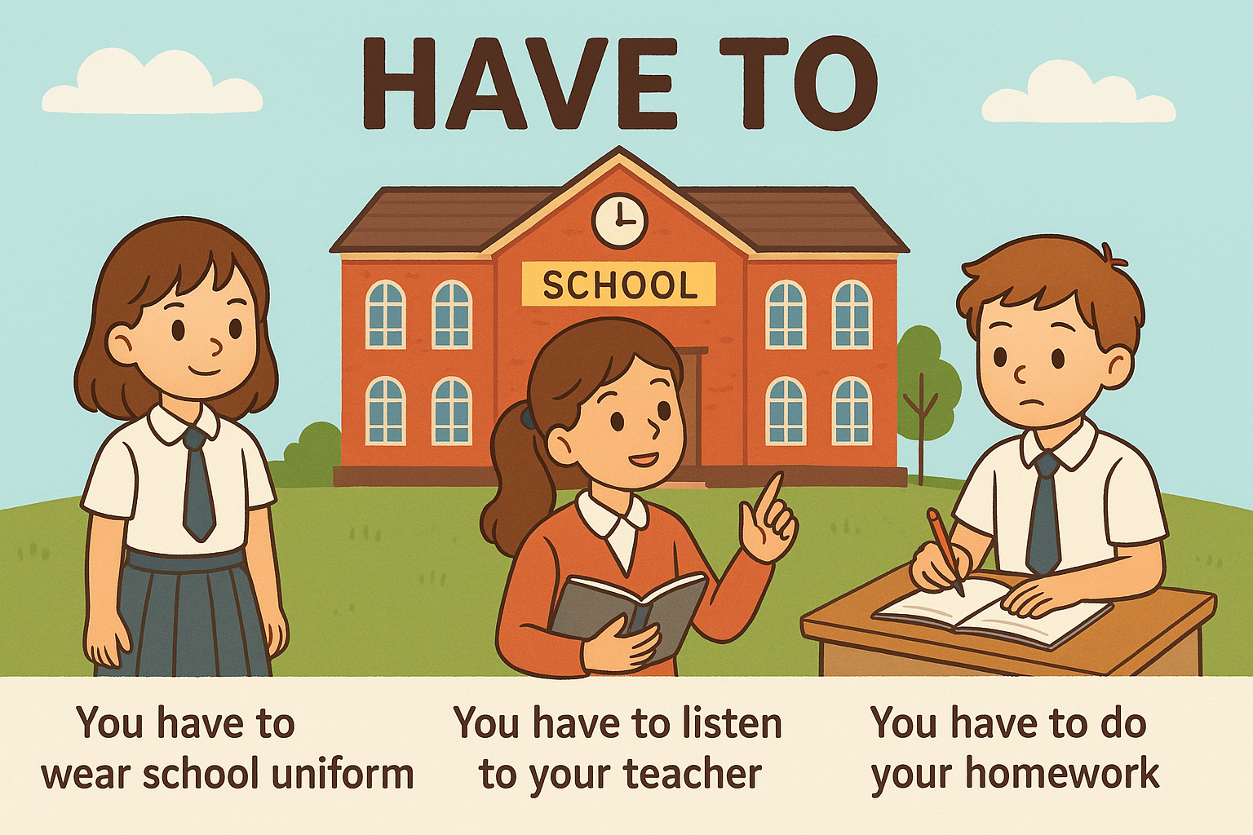  Ask Can you choose to do these things? (No). Provide/Elicit more sentences with have to and write them on the board.
Presentation | 10-15 | - SB p. 13 ex. 1 listen and tick  - SB p. 13 ex. 2 read and study grammar
Controlled Practice | 10-15 | - Sort the pictures https://wordwall.net/resource/96893398/sm3have-tohas-to | For more advanced students: https://wordwall.net/resource/96893440/spotlight-4-have-to
Freer Practice | 10-15 | - Do speaking https://wordwall.net/resource/35258233  - Ask students to ask each other questions and answer | - Play a guessing game. One student shows and action and others have to guess what he or she has to do.
Cooler | 5 | Play a game https://www.baamboozle.com/game/3614
PlAN of the lesson CHECK |  | Ask kids to remember the goals and ask whether you have completed everything (you can write it on the white board and ask students to tick).
Feedback\HW | 5 | Give students feedback and give them start/points. ALWAYS tell them what that point is for - for hard work, for correct answers, for behavior, for homework. Tell what they need to improve. | - Ask to send a reaction  - Goodbye song https://www.youtube.com/watch?v=UQfvAlmr5g0 you can use the link or you can find the video "See You Later Alligator Goodbye Songs" in the folder.

HOMEWORK:
Домашнее задание на платформе Взнания. Название: SM3 Unit 1 Homework 4
Зайдите на платформу Взнания, добавьте урок, войдите в Мой класс и впишите домашнее задание.

