Page 1

Paradox, a statement that contradicts itself.

“This statement is false.”



https://thebiomedicalscientist.net/resources/reality-paradox

Page 2

About

“From the Greek para, against or counter to, and doxa, opinion or belief, a paradox is an idea that contradicts a more generally accepted idea, on purpose.”

— The Paradox of Knowledge and Power, Keenan (1987)

You will be introduced some famous paradoxes here.

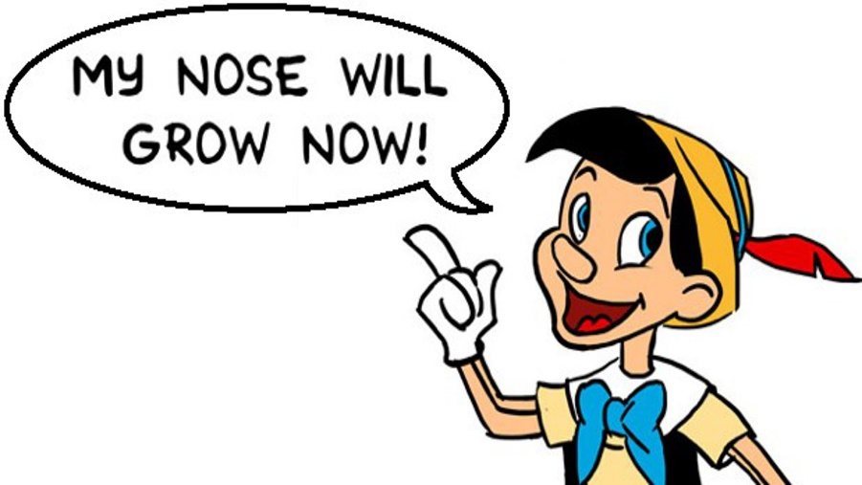

https://www.youtube.com/watch?v=b3239YOOEiw

Page 3

Barber paradox

The barber is the "one who shaves all those, and those only, who do not shave themselves." The question is, does the barber shave himself?

( Bertrand Russell: *The Philosophy of Logical Atomism*, 1918, in: *The Collected Papers of Bertrand Russell*, 1914-19, Vol 8., p. 228.)

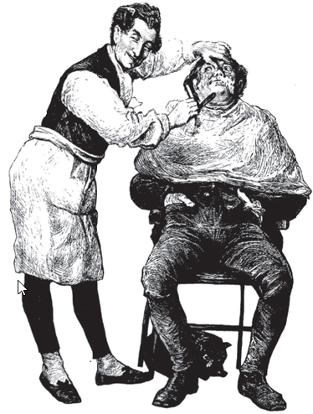

https://zipfjunk.wordpress.com/2016/08/30/paradoxes-1-the-barber-paradox/

Dichotomy paradox

One can never reach his destination. Because if he want to reach there, he must get halfway there. If he want to get halfway there, he should reach one forth there, and so on. Then he can never reach the end.

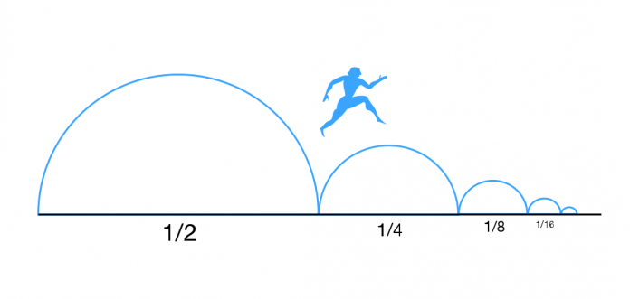

https://itotd.com/files/2018/05/Zeno_Dichotomy_Paradox-696x331.png

Ship of Theseus paradox

The wooden parts of the ship of Theseus are gradually replaced by new ones. After a long period of time, all the wooden parts have been replaced. Is this ship still the origin one?

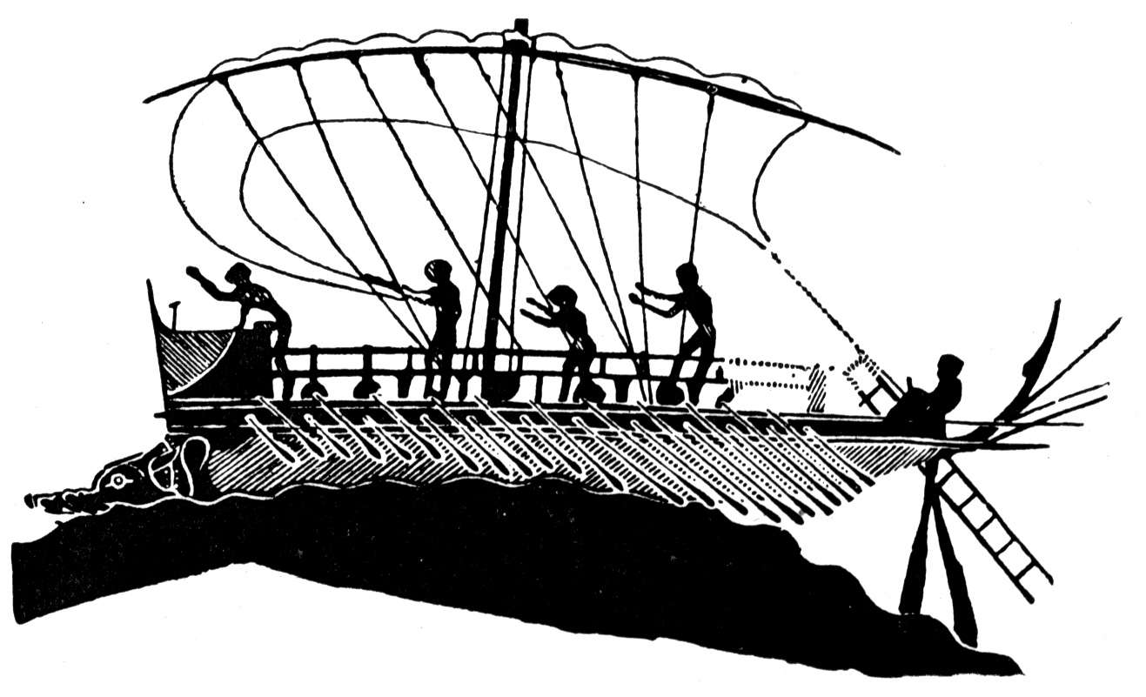

http://trek.kehsblogs.net/files/2014/01/greekboat.jpg

Grandfather paradox

One can prevent his birth by doing time traveling to kill his grandfather in the past.

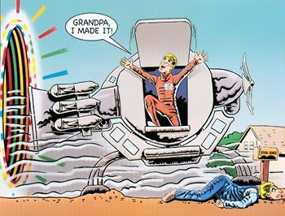

https://static.tvtropes.org/pmwiki/pub/images/grandfather_paradox.jpg

Chicken or the egg

Which came first, the chicken or the egg?

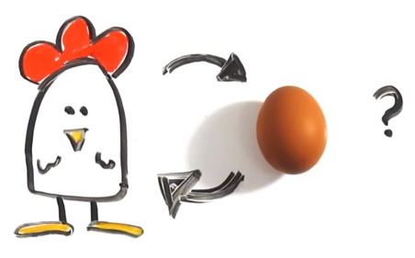

http://media1.iterated-reality.com/2015/03/ChickenOrEgg.jpg

Arrow paradox

If everything when it occupies an equal space is at rest, and if that which is in locomotion is always occupying such a space at any moment, the flying arrow is therefore motionless.[14]

— as recounted by Aristotle, Physics VI:9, 239b5

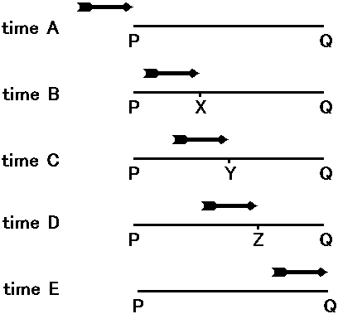

https://www.google.com/url?sa=i&rct=j&q=&esrc=s&source=images&cd=&cad=rja&uact=8&ved=2ahUKEwiE15v2267dAhUL54MKHQx4CyMQjRx6BAgBEAU&url=https%3A%2F%2Fkazuhikokotani.wordpress.com%2F2013%2F04%2F07%2Fthe-solution-of-the-arrow-paradox%2F&psig=AOvVaw1njxfYuFfnAKg3Z9VBoNNC&ust=1536609854464229

Page 4

Contact

If you have anything about paradox want to share, feel free to contact me!

Your name:

Email address:

Write your message here:

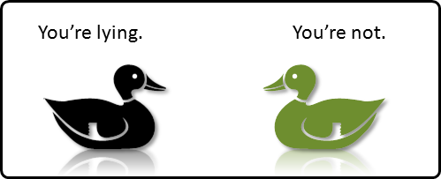

https://www.google.com/url?sa=i&rct=j&q=&esrc=s&source=images&cd=&cad=rja&uact=8&ved=2ahUKEwiC6-W43a7dAhVj5YMKHSfnCDsQjRx6BAgBEAU&url=https%3A%2F%2Fnargaque.com%2F2010%2F05%2F24%2Fpair-of-ducks%2F&psig=AOvVaw1RS75DGWk4Wfu4pKAkg1B1&ust=1536610203662735