Oxford English for Electronics, Eric H. Glendinning, John McEwan

Telecommunications
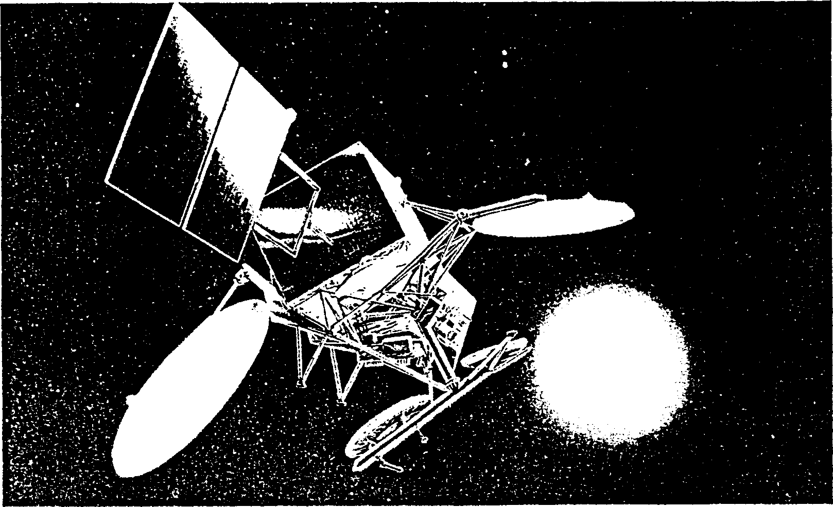

Tuning-in
Task 1
Put these developments in telecommunications in the order in which they were invented. Compare your answer with your partner.
a telex
b communication satellites
c modems
d telegraphy
e television

Now check your answers with Fig. 1 below.
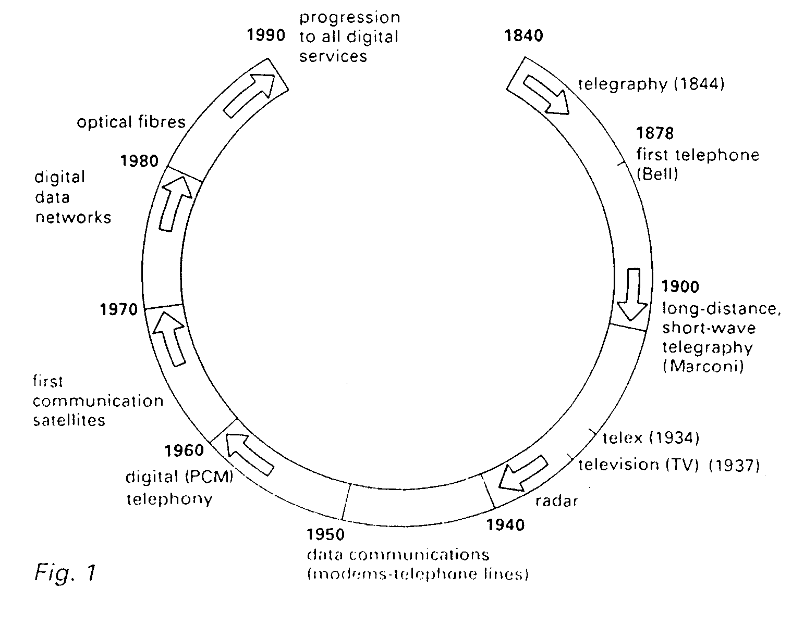
Task 2 Answer these questions with the help of Fig. 1.

1 Who invented the telephone?
2 What important development in telecommunications took place in the 1960s?
3 What prediction is made about developments in the 1990s?
4 When was telex introduced?
5 What form of telecommunications uses PCM?

Reading Reading and note-taking
Taking notes is a good way of remembering the important points in your reading, for either your study or work. When you take notes, you must:

1 identify the main points
2 record them in note form
3 organize your notes so that you can understand them easily when you read them again

A table is one way of organizing notes for easy access.

Task 3
Take brief notes from the text on the significance of the development in telecommunications during one of the periods listed below. Your teacher will tell you which period to read about.
Write your notes in the correct section of the table on page 4.

1 Nineteenth century
2 1901-1945
3 1946-1980
4 1980s on

Telecommunications: a brief historical review

The first true telecommunications system using electrical signals to carry messages started in the 1840s with machine telegraphy. Samuel Morse first developed the telegraph in 1832 but it was not until the mid-1840s that the system was put into practical use- sending coded electrical messages (Morse Code) along the wires. The telegraph became a rapid success, its speed quickly outdating the Pony Express for long-distance communications.
The next major step forward came in 1878 with the invention of the telephone by Bell. This enabled speech to be transported as electrical signals along wires and revolutionized personal communications.
In 1886, Hertz verified experimentally that electrical energy could be radiated and thus proved the existence of electromagnetic waves. This opened the way for the free-space transmission of information without wires. This provided the basis for all radio and TV broadcasting.
In 1901, Marconi established long-distance telegraph communication by transmitting between England and Canada. Although he did not realize it at the time, he achieved 4communication by transmitting between England and CanadaAlthough he did not realize it at the time, he achieved such long distances by reflecting radio waves in the ionosphere (layers of ionized gases and electrons existing in the earth's upper atmosphere at heights of 50-500 km). This overcame the problem of transmitting round the earth from one side of the Atlantic to the other.

With the discoveries of the diode and thermionic valve in the early part of this century, advances were made in both receiver and transmitter design with an associated impact in telegraphy, telephony, and civil and military communications. Radio broadcasting soon followed, with powerful transmitters serving to communicate over wide areas. Television (TV) was first established in 1937. Radar (radio detection and ranging) was also developed from the 1930s and played a vital role in aircraft detection and navigation in World War II.
As further advances in technology took place (e.g. the invention of the transistor in 1947 and the subsequent development of microelectronic integrated circuit technology), new applications became feasible, and new systems were developed.
Data communications-the transmission of coded data (e.g. text, graphics, financial information) between 'intelligent' terminals and computers-was first established in the early 1950s using modems, equipment which enables the telephone network to convey data as well as speech. Other improvements in materials and devices also led to the transmission of information via cables. Much of today's long-distance telephone traffic is by submarine cable.
The space race led to yet another means of long-distance communication, via fixed and mobile earth stations to satellites.Today, several hundred satellites orbit the earth, and satellite links provide all forms of communication and related services such as telephony, data, TV, navigation, meteorology, and surveillance.
One of the very latest developments is the optical fibre cable-a tiny glass fibre which can be used to convey signal information by light pulses. Optical fibre cable with extremely low loss at low cost has now been developed with very high data-carrying capacity. Several thousands of telephone messages can be carried down a single fibre.
Perhaps the greatest change which has occurred in the last twenty years is that from analogue to digital methods of information transmission. The very first commercially employed telecommunication system, telegraphy, was and still is a digital system. However, telephony, radio, and TV all started as analogue systems. Today, the general trend is strongly towards the digital, and within the next ten years the vast majority of telecommunications systems will be digital. Problems of noise and interference can be combated much more successfully in a digital system.
The advances in microelectronics and the merging of communications with computers have led naturally to the digital transmission mode with its advantages of computer control, automatic error checking of signals, excellent memory storage facilities for data, and intelligent terminals. The market need for vast quantities of information transmission and processing at very high speed can only be reliably catered for by using digital techniques. In fact the most rapidly growing field is almost certainly in data communications employing high-speed digital techniques.
Development Significance

Nineteenth century
telegraphy (Morse) ________________________
telephone (Bell) ________________________
existence of electromagnetic waves
proved (Hertz) ________________________

1901-1945
long-distance telegraphy via ionosphere ________________________
valves ________________________
radar ________________________

1946-1980
transistor ________________________
data communications ________________________
communications satellites ________________________

1980s on
optical fibre cable ________________________
change to digital systems ________________________
digital transmission mode ________________________

Task 4
Exchange information with the others in your group to complete all sections of the table. Check with the text if there are any points you do not understand.

Language study Simple Past versus Present Perfect
Look at paragraph 1 of the text on page 2. Which tense is used most often? Why?

Now look through the text for examples of the Present Perfect. In which paragraphs do you find them? Why is this tense used here?

Study these sentences.
1 Engineers developed optical fibre cables in the 1980s.
2 Optical fibre cables have improved the telephone system immensely.
3 Morse first developed the telegraph, a digital system, in 1832.
4 Digital systems of information transmission have replaced analogue systems in the last 20 years.

Why is the Simple Past used in 1 and 3 and the Present Perfect in 2 and 4?

We use the Simple Past for events which took place in the past and are complete. Sometimes a day, date or time is given, e.g. in 1832, on Tuesday.

We use the Present Perfect for past events which have present results. This tense links the past with the present. Sometimes we use expressions such as in the last twenty years, since the war, now to show the link. Using the Present Perfect shows that we think the past events are of current relevance.

Task 5
Put each verb in brackets in the correct tense and form.
Alexander Graham Bell ____________ (invent) the telephone in 1878. He ____________ (be) a Canadian whose family ____________ (come) from Scotland. Since then, telephone systems ____________ (grow) dramatically; in the UK alone there ____________ (be) now over 24 million lines. Formerly, the UK system ____________ (be) analogue.
Many changes ____________ (take place) in recent years. Almost the entire UK network ___________ (be) now digital. Fibre optic cables ____________ (replace) the old copper lines. Previously, telephone exchanges ____________ (use) banks of electromagnetic relays for switching. Today, they ____________ (have) computer-controlled units. The new network ____________ (be) fast and reliable, allowing users access to many other communications services.

Task 6
Study these diagrams of old and new phones. Make a list of any differences. Compare your list with your partner.

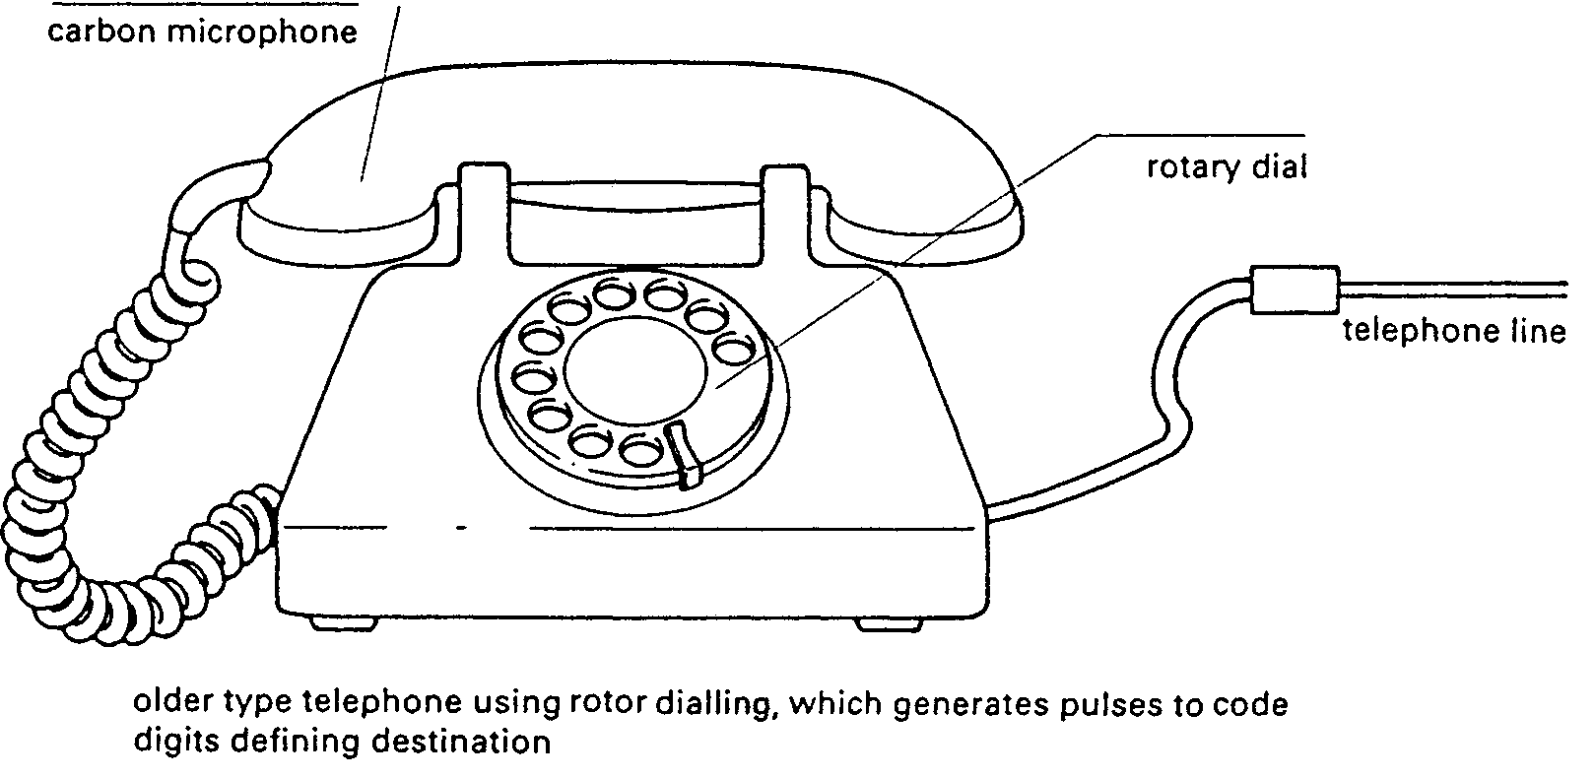
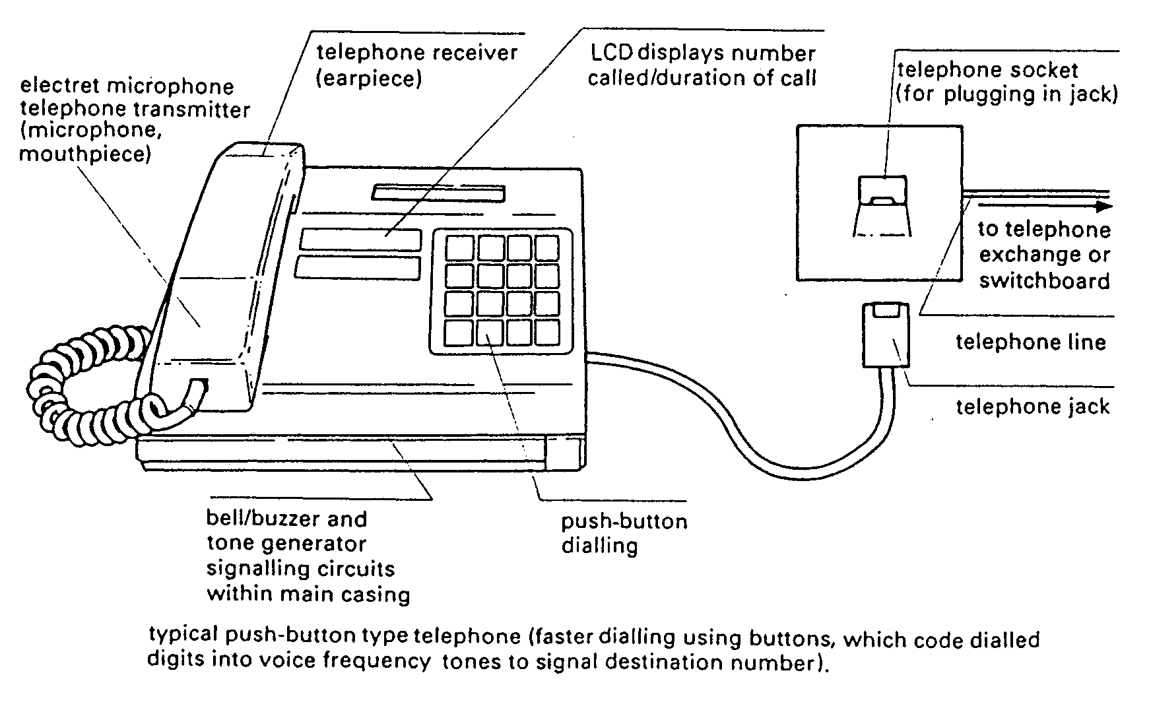
Task 7
In this description of the changes which have taken place in telephone design, put each verb in brackets in the correct tense and form.
Many changes _______________ (take place) in telephone design in recent years. Formerly, telephones _______________ (have) rotary dials. A pulse _______________ (signal) each dialled number. Now, push-buttons _______________ (replace) dials. Each button _______________ (trigger) a different audio-frequency tone. This _______________ (know) as multi-frequency dialling.
Also, the handset _______________ (change). Old models _______________ (contain) carbon microphones, which _______________ (be) inexpensive and robust but noisy. Today, moving-coil and electret devices _______________ (replace) the old microphones.
Advances in technology _______________ (allow) additional features to be added to phones. Most now _______________ (contain) memories to store frequently-used numbers. Some telephone manufacturers _______________ (add) LCDs which _______________ (display) dialled numbers and (indicate) the duration of calls.

Word study Short forms
Some technical words have common short forms. In some cases the short form is used much more frequently than the full form. For example:
Full form Short form
a facsimile message a fax

Task 8 What are the short forms for these terms?
1 amplifier
2 video recorder
3 television
4 potentiometer
5 coaxial cable

Task 9 What terms are represented by these short forms?
1 puff
2 phones
3 mike
4 CRT
5 phone

LANGUAGE FOCUS H

The passive
Passives are very common in technical writing where we are more interested in facts, processes, and events than in people. We form the passive by using the appropriate tenses of the verb to be followed by the past participle of the verb we are using.

Examples:
Active
1 We sell computers. (simple present)
2 Babbage invented 'The Analytical Engine'. (simple past)

Passive
1 Computers are sold. (simple present)
2 The Analytical Engine was invented in 1830. (simple past)

Facts and processes
When we write or talk about facts or processes that occur regularly, we use the present passive.

Examples:
1 Data is transferred from the internal memory to the arithmetic-logical unit along channels known as buses.
2 The other users are automatically denied access to that record.
3 Distributed systems are built using networked computers.

Exercise 1
Read the text below, which describes the insurance company's procedure for dealing with PC-users' problems. Fill in the gaps using the correct form of the verb in brackets.
All calls _______________ (register) by the Help Desk staff. Each call _______________ (evaluate) and then _______________ (allocate) to the relevant support group. If a visit _______________ (require), the user _______________ (contact) by telephone, and an appointment _______________ (arrange). Most calls _______________ (deal with) within one working day. In the event of a major problem requiring the removal of a user's PC, a replacement can usually _______________ (supply).

Exercise 2
Fill in the gaps in the following sentences using the appropriate form of the verb in brackets.
1 The part of the processor which controls data transfers between the various input and output devices _______________ (call) the control unit.
2 The address bus _______________ (use) to send address details between the memory and the address register.
3 The pixel positions _______________ (pass on) to the computer's pattern recognition software.
4 An operating system _______________ (store) on disk.
5 Instructions written in a high-level language _______________ (transform) into machine code.
6 In the star configuration, all processing and control functions _______________ (perform) by the central computer.
7 When a document arrives in the mail room, the envelope _______________ (open) by a machine.
8 Once the index _______________ (store), a temporary key number ______________ (generate) and _______________ (write) on the document.

Events
When we write or talk about past events, we use the past passive. Let us look at some examples.

Examples:
1 COBOL was first introduced in 1959.
2 Microsoft was founded on the basis of the development of MS-DOS.
3 The organization was created to promote the use of computers in education.

Exercise 3
Fill in the gaps in the following sentences using the appropriate form of the verb in brackets.
1 Microsoft _______________ (found) by Bill Gates.
2 C language _______________ (develop) in the 19 70s.
3 During that period, enormous advances _______________ (make) in computer technology.
4 The following year, twice as many PCs _______________ (sell).
5 In the 1980s, at least 100,000 LANs _______________ (set up) in laboratories and offices around the world.
6 The first digital computer _______________ (build) by the University of Pennsylvania in 1946.
7 Last y ear, more software companies _______________ (launch) than ever before.
8 IBM's decision not to continue manufacturing mainframes ______________ (reverse) the year after it _______________ (take).

