Small, Reviewable Corrections for Adapting a Pretrained Dexterous Grasp Planner
Haoze Lan  School of Intelligent Manufacturing  (Pen-Tung Sah Institute of Micro-Nano  Science and Technology), Xiamen University  Xiamen 361100, China | Yongbin Yuan  Fuzhou University  Fuzhou, China  yuanyongbin@fzu.edu.cn  Corresponding author

Abstract—When a robot hand develops a fault, a pretrained grasp planner must be adapted without giving up normal grasping, and the engineers who integrate the update must be able to review it. We adapt the one-step DemoGrasp planner under eight simulated shift conditions on Shadow and Allegro hands, comparing full-weight fine-tuning with residual corrections on the frozen planner, each trained with PPO or GRPO on about 19,000 grasp attempts. At the reference little-finger lock, residual updates reach 64–65% success against about 32% for full-weight updates and still lead by 28.0 percentage points after full-weight learning-rate refinement; in the other seven conditions full-weight means are slightly higher. The residual gain needs almost no capacity: one constant 24-dimensional output offset, trained with 48 parameters, reaches 67.1% success at 4.1 points of nominal loss. Across 51 training runs of every update family, lock success rank-correlates at 0.97 with a single quantity, the change in the ring-finger RFJ3 target, and σ₀-scaled output coordinates reach that edit at lower nominal cost than raw ones. At a 75% lock posture recovery no longer runs through RFJ3, and all procedures converge to 41–43%. We report each update as a record that keeps recovery, retention, evaluation reference and correction size together for review between model developers and cell integrators.
Keywords—dexterous grasping, fault adaptation, residual policy, reinforcement learning, retention, update documentation

I. INTRODUCTION
A grasping cell must often keep using a pretrained policy after an actuator or sensor changes. Pretrained dexterous policies handle diverse objects [1], [2], and DemoGrasp produces an open-loop grasp from one planning decision [3]. Adapting such a planner involves two roles: a model developer who trains the update and a cell integrator who deploys it against a retention requirement on normal grasps [4]. The integrator needs to know what the update recovers, what it costs on nominal grasps and what it changes in the planner’s output.
Two update families are available. Full-weight fine-tuning changes the pretrained network [5]; residual learning adds a correction to a frozen planner [6], [7], [8]. A recovery difference between them mixes the update family with the nominal-loss operating point that tuning selects and with run-to-run variation [9], [10], [11]. We therefore compare them on a common recovery–retention axis, under one selection rule, with training runs as the statistical units.
The comparison gives a sharp answer. At the reference little-finger lock, residual updates double full-weight recovery. The correction behind this gain is nearly constant: a 24-dimensional output offset matches the residual network, and across all update families lock success follows one joint edit, the ring-finger RFJ3 target. Output coordinates decide how much nominal performance that edit costs. When the lock posture changes, the edit and the advantage disappear.
Our contributions are: (1) a run-level recovery–retention comparison of full-weight and residual updates, each with PPO and GRPO, across eight shift conditions on two hands; (2) evidence that reference-lock recovery needs only a constant output correction and is governed by one joint edit whose nominal cost depends on update coordinates; and (3) an update record that carries recovery, retention, evaluation reference and correction size from developer to integrator.

II. RELATED WORK
Dexterous grasping. UniDexGrasp and UniDexGrasp++ learn broad grasping behaviors [1], [2]. Dexterous Grasp Transformer predicts grasp configurations from point clouds [12], and CrossDex learns across hands [13]. DemoGrasp edits a demonstration with a one-step policy [3] and provides the planner studied here.
Policy adaptation. Residual policy learning adds a learned correction to an existing controller [14], [15]. RESPRECT and ResDex apply this idea to dexterous grasping [6], [7]; Policy Decorator refines pretrained policies online [8]. DPPO updates policy weights [5], while DSRL and RFS steer frozen generative policies in latent coordinates [16], [17]. LoRA and task-specific adapters are other compact update families [18], [19]. Robot damage adaptation has searched simulated behavior repertoires [20], and RMA combines a base policy with an adaptation module [21]. Residual Fault Adaptation infers recurrent corrections from proprioceptive and command-response history under runtime joint faults, trains across randomized fault modes, joints, severities and onset times, and includes physical-hand experiments [22]. Training across faults is the alternative to adapting after a shift; we instead post-train released one-step, open-loop grasp checkpoints under a fixed interaction budget.
Retention during fine-tuning. EWC protects weights important to previous tasks [23]. LP-FT studies feature distortion during adaptation [24]; WiSE-FT combines pretrained and fine-tuned weights to preserve robustness [25]. Forgetting mitigation and calibrated offline-to-online learning also address the cost of updating pretrained behavior [26], [27]. We measure that cost directly, as nominal loss beside fault recovery, with independent training runs for inference [9], [10], [11].
Update documentation. Model cards report intended use, evaluation conditions and performance to model stakeholders [28]. Amershi et al. describe how machine-learning components move between development and integration teams [4]. We extend this reporting to policy updates, where the record must also state the frozen reference and the size of the correction.

III. ADAPTATION DESIGN

A. Planner, observations and shifts
We use released Shadow and Allegro DemoGrasp checkpoints in Isaac Gym [3], [29]. The observation contains the initial end-effector pose, object pose and point cloud; joint state and fault labels are absent. A policy selects one grasp edit, which executes open loop and receives a binary lift outcome, so each decision is a one-step contextual bandit. Shadow actions have 24 dimensions: three wrist translations, three wrist rotations and 18 hand-pose edits. The Gaussian planner samples a pre-squashing action u and executes a = tanh(u):
u = m₀(s) + σ₀ ⊙ ε, ε ∼ N(0, I). (1)
Here m₀ and σ₀ are the pretrained mean and sampling scale, and ⊙ denotes elementwise multiplication. Reference locks hold joint targets from the first demonstration frame; alternative locks use 25% or 75% of each joint’s range. Each shift-trained checkpoint serves both nominal and shifted grasps without per-grasp routing, as when a fault is intermittent or undiagnosed; nominal loss measures what this costs. Ideal health-aware routing is tested separately (H5).
The six Shadow conditions are little-finger lock (LF), thumb lock (TH), 1 cm Gaussian noise per point-cloud coordinate (PCL), a vertical offset U(−3, 3) cm (ZR), a fixed 2 cm offset plus PCL (Z2+PCL), and TH+PCL. PCL changes the point cloud but not the separate object-pose observation. Allegro uses TH and Z2. Training uses 768 objects. A grasp fails if a palm or fingertip keypoint crosses below the tabletop. The primary setting keeps the released collision filter, which disables robot–table contact in half the environments; a separate check enables all robot–table collisions and adds a ground plane.

B. Four update procedures
Full-weight PPO [30] updates the planner and scale; its value loss (coefficient 2.0) also updates the shared PointNet backbone. Full-weight GRPO [31] updates the backbone and mean head, fixes the scale to max(σ₀, 0.05), and normalizes rewards within groups of eight actions. Residual procedures freeze the planner and sample
u = m₀(s) + σ₀ ⊙ [δ_{ϕ}(s) + e^{ρ} ⊙ ε]. (2)
The correction network is a layer-normalized MLP with two 256-unit hidden layers and more than 70,000 parameters. Its input concatenates the non-point-cloud observation and the frozen PointNet embedding. Zero initialization of its output layer and of the scale vector ρ reproduces the pretrained policy. Residual PPO optimizes its correction and value networks with one Adam optimizer and gradient clipping (value-loss coefficient 0.5); residual GRPO uses the same 64-state × eight-action grouping as full-weight GRPO. Table I lists optimizer calls and interactions.
TABLE I. UPDATE CONFIGURATIONS
Procedure | Scale | Epochs | Adam  steps | Attempts
Full-weight PPO | Learned | 5 | 770 | 19,712
Full-weight GRPO | Fixed | 2 | 304 | 19,456
Residual PPO | Learned | 5 | 740 | 18,944
Residual GRPO | Learned | 5 | 740 | 18,944
Fixed scale: max(σ₀, 0.05). A phase uses a fixed object list and passes its checkpoint forward. Full-weight PPO uses three phases/77 iterations; full-weight GRPO uses 12/38; residual procedures use 12/37. Adam calls = iterations × epochs × minibatches (two for full-weight PPO, four otherwise).

C. Selection, evaluation and uncertainty
The development set has 64 objects disjoint from training and test instances. Each procedure uses one learning rate for LF and PCL, chosen from {10⁻⁵, 3×10⁻⁵, 10⁻⁴} for full-weight and {10⁻⁴, 3×10⁻⁴, 10⁻³, 3×10⁻³, 10⁻²} for residual updates. A rate is feasible if mean nominal loss is at most five percentage points (pp) in both conditions; the feasible rate with the highest average fault success wins, with ties broken by smaller worst loss and then smaller rate. Groups start with three runs and expand to five when a development condition lies within one point of the limit. Development scores use 512 fault and 2,048 nominal attempts per model. The selected rates are 10⁻⁵ for both full-weight procedures, 3×10⁻³ for residual PPO and 10⁻³ for residual GRPO; the other conditions reuse them with separately trained models.
Test evaluation uses the policy mean and seed 4242. A run’s score averages seen-category success (141 instances, 1,128 attempts) and unseen-category success (78 instances in the 100 slots of the released list, 800 attempts). Nominal loss is frozen nominal success minus adapted nominal success in the same evaluation batch.
Training runs are the statistical units. Contrasts use two-sided 95% Welch intervals, with PPO and GRPO weighted equally in residual-minus-full-weight effects; operating-point intervals use Student t across runs. The nine directional tests in Table IV use one-sided p-values with Holm correction. Curve comparisons interpolate test means linearly over the nominal-loss range shared by all procedures, with a 10,000-draw percentile bootstrap (seed 110205) that resamples runs within each rate.

IV. RECOVERY AND RETENTION

A. Observed operating points
Reference LF gives the strongest separation. The frozen planner achieves 16.9% success; full-weight procedures reach about 32% and residual procedures 64–65% (Table II). Full-weight means are slightly higher in the other seven conditions. Six of eight adapted Allegro means exceed five points of nominal loss. PPO–GRPO contrasts range from −0.3 to +1.8 pp. The GRPO pair shows the large LF gap without any value network, 32.1% for full-weight and 64.2% for residual updates, so critic sharing does not cause it.
TABLE II. INITIAL OPERATING POINTS
Shift | Frozen | Full  PPO | Full  GRPO | Residual  PPO | Residual  GRPO
LF | 16.9 | 31.9  (1.2) | 32.1  (1.0) | 65.2  (5.4) | 64.2  (4.9)
PCL | 74.5 | 81.2  (1.5) | 82.9  (2.2) | 79.7  (1.5) | 79.8  (1.0)
TH | 71.5 | 74.6  (1.7) | 76.0  (2.7) | 72.8  (1.8) | 74.2  (1.9)
ZR | 78.9 | 78.1  (1.4) | 79.8  (2.1) | 77.7  (1.0) | 78.0  (0.4)
Z2+PCL | 70.7 | 78.8  (0.7) | 78.9  (0.5) | 76.0  (0.7) | 76.2  (1.1)
TH+PCL | 68.9 | 74.0  (2.0) | 75.4  (1.6) | 72.5  (1.8) | 72.2  (1.2)
A: TH | 42.5 | 54.0  (2.8) | 56.5  (6.9) | 52.7  (5.7) | 53.7  (3.6)
A: Z2 | 68.5 | 82.2  (6.0) | 83.5  (7.8) | 80.8  (6.0) | 80.8  (6.4)
Success (%) with nominal loss (pp) in parentheses. A: Allegro; otherwise Shadow. Frozen nominal success is 91.0%/86.8% for Shadow/Allegro. n = 3, except residual PPO LF/PCL (n = 5).
Fig. 1 places recovery on a common nominal-cost axis. Over the 2.3–5.4 pp loss range shared by all four curves, residual curves lie 17.7 pp above full-weight curves (95% bootstrap interval [14.9, 20.0]). Observed points show the same gap at matched cost: full-weight PPO reaches 50.2% success at 5.1 pp loss, residual PPO 65.2% at 5.4 pp.
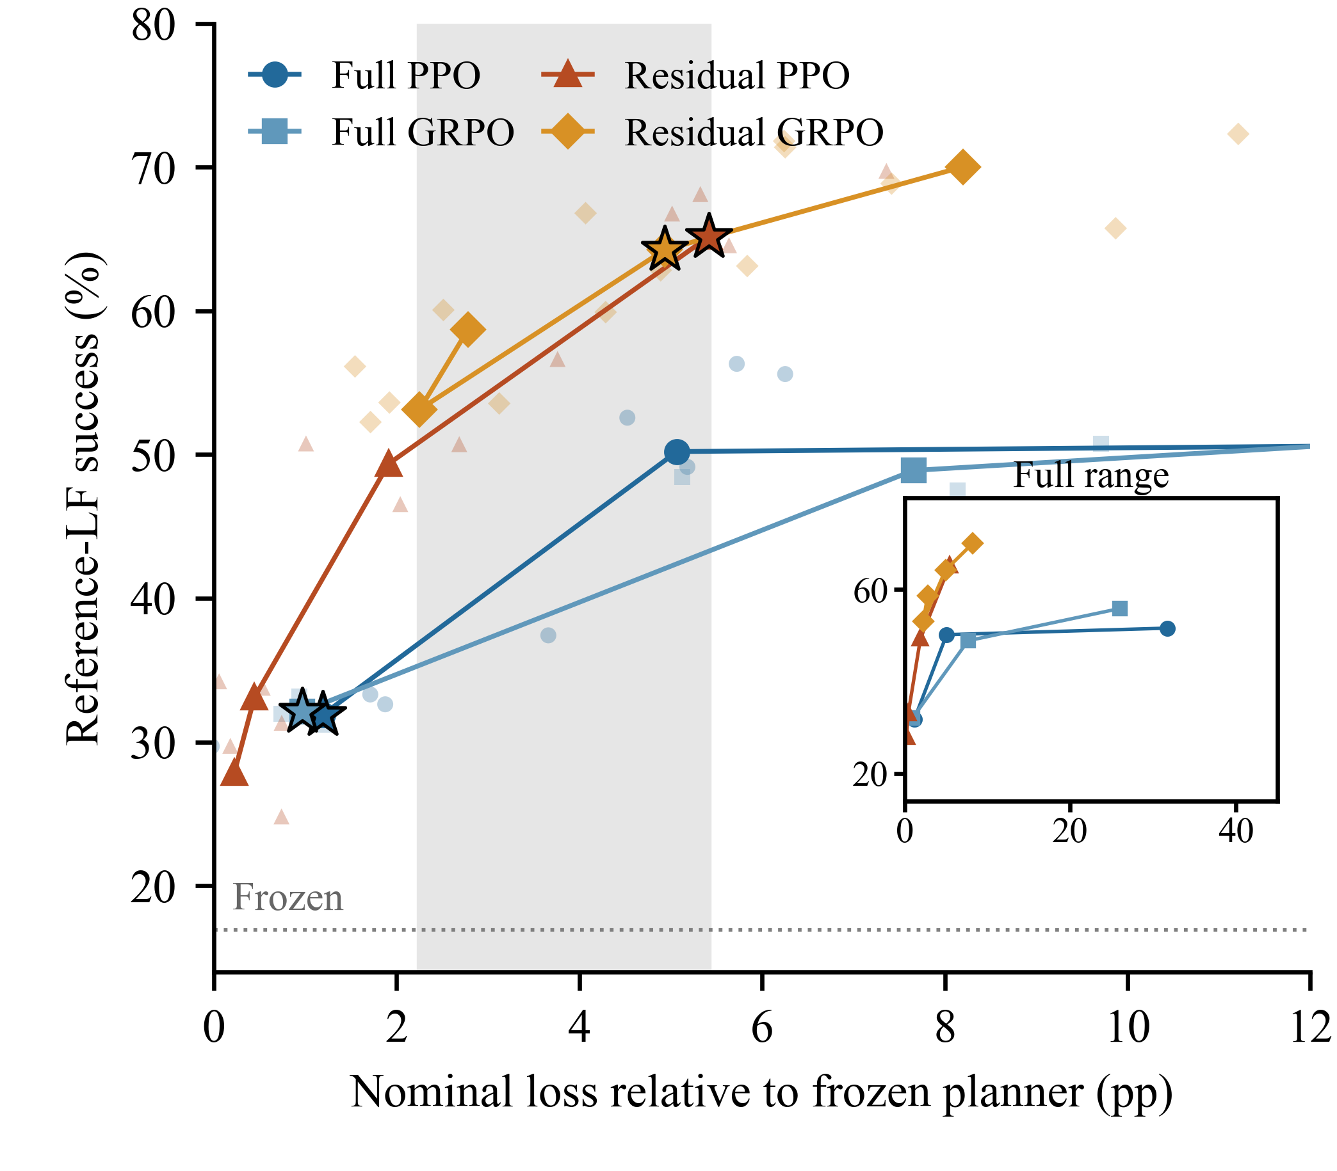
Fig. 1. Reference-LF recovery–retention curves over the initial learning-rate grids. Small markers: training runs; lines: candidate means; stars: development choices. Shading marks the loss range shared by all four curves; the inset shows the full range. Residual 10⁻² candidates are not shown.

B. Grid refinement
The initial grids leave full-weight procedures near 1 pp nominal loss and residual procedures near 5 pp, so the selected contrast, 32.7 [29.4, 36.1] pp, comes with 4.1 pp more nominal loss. Full-weight PPO at 3×10⁻⁵ missed the development limit by 0.20 pp. We therefore added 2×10⁻⁵ to both full-weight grids (22 runs, same rule) and re-evaluated the frozen planner and all selected checkpoints in one simulator runtime, the repeat batch (Table III). Full-weight PPO moves to 2×10⁻⁵; full-weight GRPO keeps 10⁻⁵.
TABLE III. REFINED-GRID OPERATING POINTS
Procedure (n) | LF  success | LF loss  [95% CI] | PCL success  (loss)
Full PPO (3) | 41.0 | 3.4 [-0.1, 6.9] | 81.8 (3.5)
Full GRPO (3) | 32.2 | 1.4 [0.3, 2.4] | 82.8 (2.4)
Residual PPO (5) | 65.1 | 5.7 [4.0, 7.5] | 79.6 (2.3)
Residual GRPO (3) | 64.2 | 5.2 [3.6, 6.8] | 79.5 (1.6)
Repeat batch; success in %, loss in pp; frozen nominal success 91.3%. Rates: 2×10⁻⁵, 10⁻⁵, 3×10⁻³ and 10⁻³, in row order. Intervals span training runs. The five-point limit applies to development loss.
Residual updates still lead by 28.0 [23.1, 33.0] pp at reference LF, with 3.1 pp more nominal loss; the PPO pair alone differs by 24.1 [14.2, 33.9] pp. Under PCL, full-weight updates lead by 2.7 [0.4, 5.1] pp. Matching full-weight GRPO’s fixed scale and two epochs does not remove the residual advantage: this residual GRPO control reaches 68.0% LF success at 3×10⁻⁴, although its 7.8 pp development loss fails the rule.

C. Lock posture decides the advantage
Reference-trained models keep their advantage at the 25% lock, but at the 75% lock the contrast falls to 0.4 [−2.7, 3.5] pp (Fig. 2), although frozen success stays at 16–19% across postures. Retraining at 75% lifts all four procedures to 41–43%, with an averaged contrast of −1.5 [−4.8, 1.8] pp. With ring and little fingers locked together, residual updates lead by 7.4 [2.5, 12.4] pp (five runs).
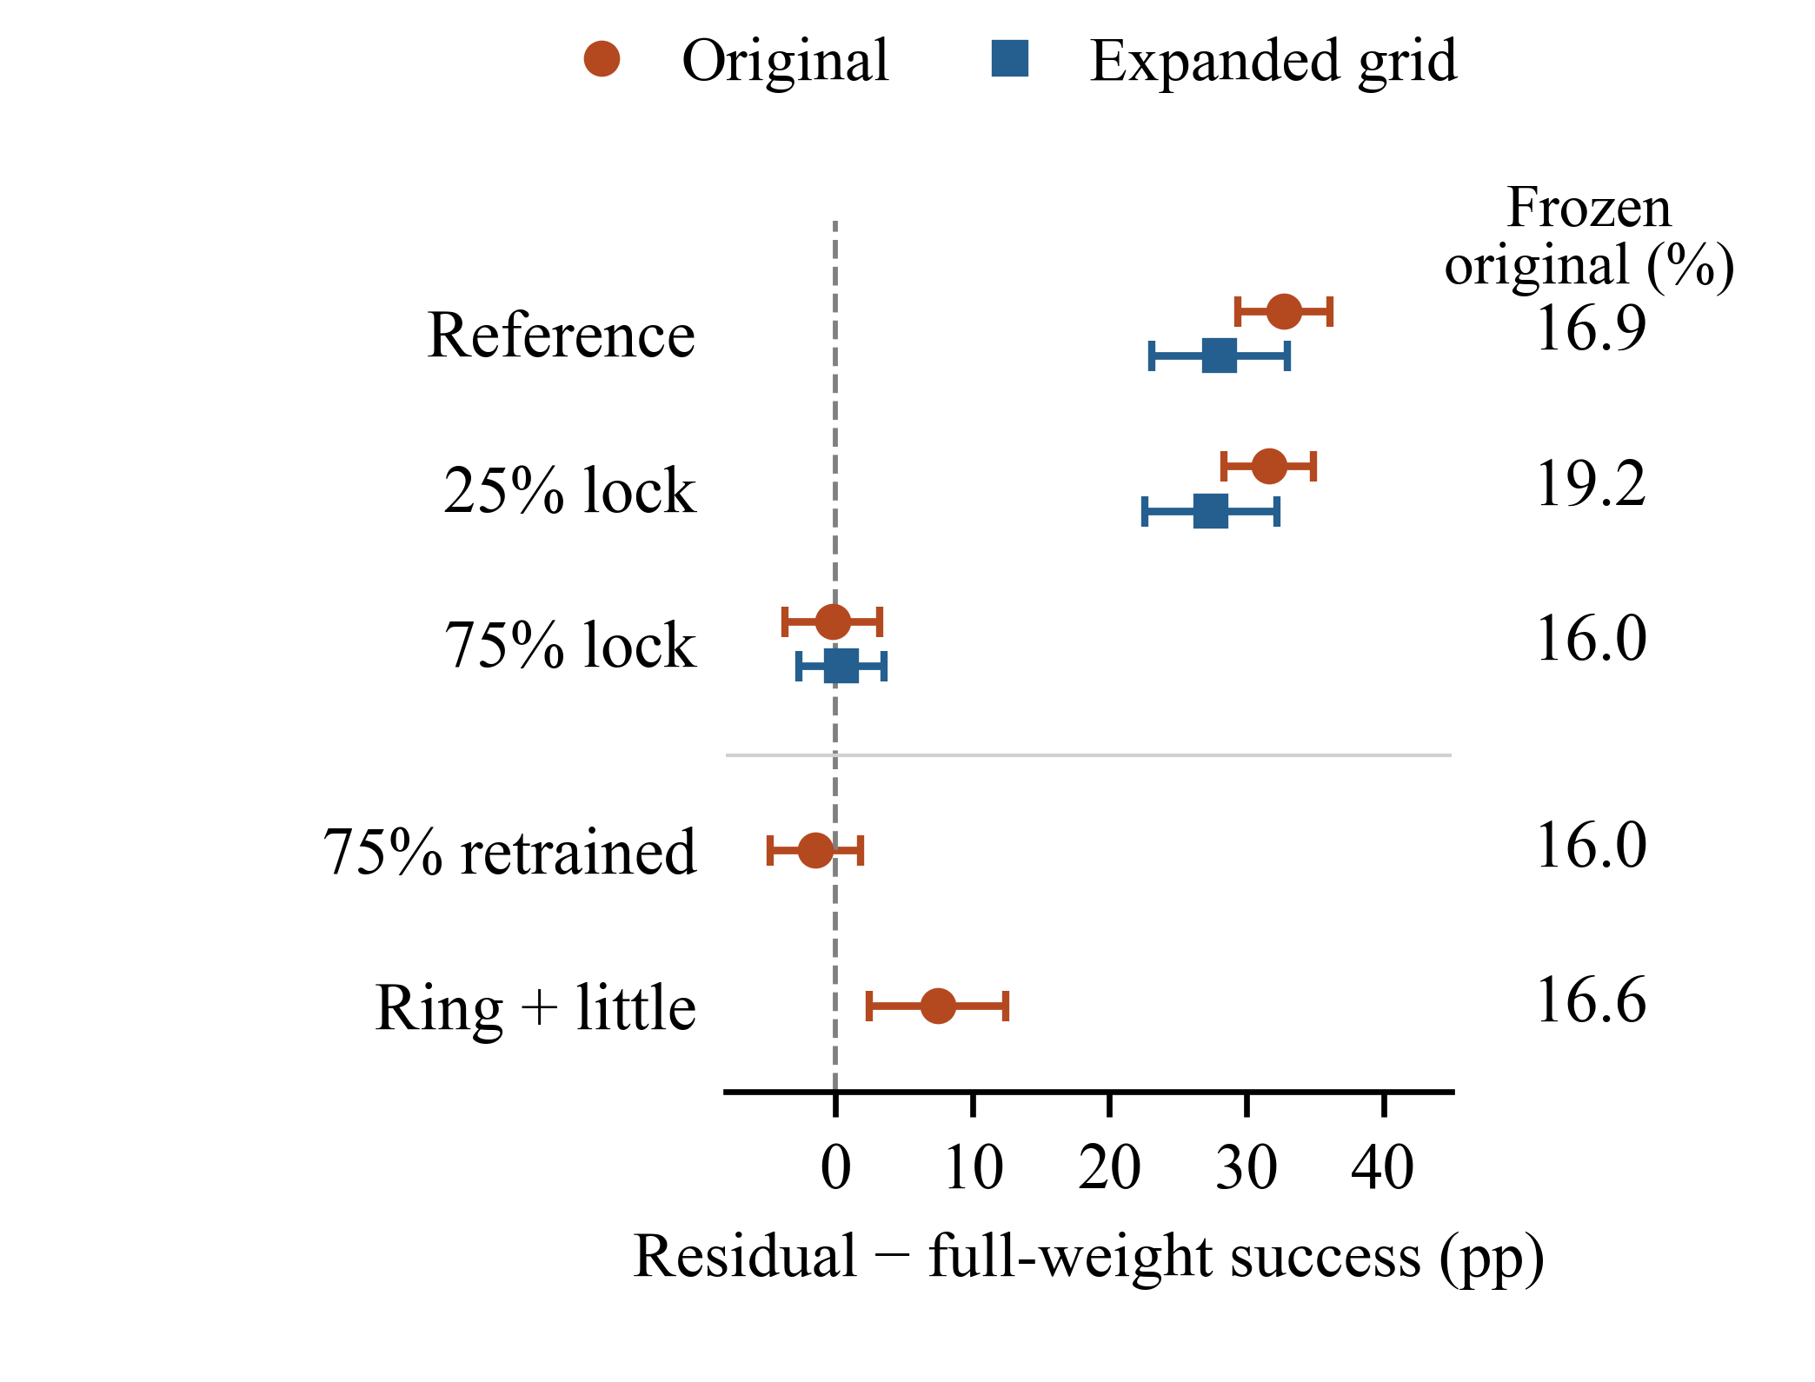
Fig. 2. Residual-minus-full-weight success with two-sided 95% intervals. Original: initial selection and batch. Expanded grid: refined full-weight selection with the original residual choices, repeat batch. The top three rows evaluate reference-trained models at each posture; lower rows use models retrained there. Right: frozen success, initial batch.

D. Retention controls and directional tests
KL regularization does not close the gap. KL-regularized full-weight GRPO, with rate 3×10⁻⁵ and coefficient 0.00528 selected jointly on development LF/PCL from {0.1, 1}/K̄ (K̄: mean Gaussian mean-shift KL of six selected residual-GRPO checkpoints on common nominal states), reaches 36.8% LF success at 2.4 pp loss; at that cost the residual curves give 51.5% (PPO) and 54.6% (GRPO). Ideal routing, which sends nominal grasps to the frozen planner and selects fault models without the retention limit, leaves a 14.5 [2.2, 26.9] pp residual advantage (H5). Enabling all robot–table collisions with a ground plane changes the LF contrast by 0.2 [−0.9, 1.4] pp.
TABLE IV. NINE DIRECTIONAL TESTS
Test | Setting / gain | Effect [95% CI] | Holm p
H1 | Reference LF | 32.7 [29.4, 36.1] | <0.001
H2 | LF versus PCL | 35.0 [31.6, 38.5] | <0.001
H3a | 25% lock | 31.6 [28.4, 34.9] | <0.001
H3b | 75% lock | -0.2 [-3.7, 3.2] | 1.000
H4a | LF → LF+PCL  31.4 → 19.7 | 11.7 [10.1, 13.3] | <0.001
H4b | PCL → LF+PCL  6.4 → 2.9 | 3.4 [2.2, 4.7] | <0.001
H4c | TH → TH+ZR  2.9 → 1.5 | 1.4 [0.6, 2.1] | 0.013
H4d | ZR → TH+ZR  -0.5 → -0.2 | -0.3 [-1.8, 1.2] | 1.000
H5 | Ideal routing | 14.5 [2.2, 26.9] | 0.048
Effects and unadjusted two-sided 95% Welch intervals in pp; one-sided p-values use Holm correction. H1: residual-minus-full-weight LF effect; H2: LF effect minus PCL effect; H3: residual-minus-full-weight effects at alternative locks. H4 reuses single-shift models: gains over frozen before → after, with effects measuring the reduction. H5: residual-minus-full-weight under ideal routing.

V. WHAT THE CORRECTION CHANGES

A. A constant correction suffices at the reference lock
The residual advantage needs almost no capacity. Replacing the residual network by one learnable offset c, so that the deployed mean is m₀(s) + σ₀ ⊙ c, and training c with its 24 log-scales (48 parameters) reaches 67.1% LF success at 4.1 [3.8, 4.4] pp nominal loss (Table V). This matches both residual networks (64.2–65.2%) at lower loss. A 24-parameter offset with fixed sampling scale reaches 67.6%, and averaging an already-trained residual head over nominal states gives 66.7% with no further training. The planner still adapts each grasp to the object; only the correction is constant (Fig. 3).
TABLE V. REFERENCE-LF CORRECTIONS
Correction | Success  [95% CI] | Nominal loss  [95% CI]
Residual network | 64.2 [58.7, 69.7] | 4.9 [2.7, 7.1]
Post-training mean | 66.7 [63.4, 69.9] | 4.2 [2.4, 6.0]
Constant + scale (48) | 67.1 [65.1, 69.1] | 4.1 [3.8, 4.4]
σ₀-scaled shift (24) | 67.6 [66.5, 68.7] | 4.5 [2.9, 6.2]
Raw shift (24) | 27.1 [26.4, 27.9] | 3.3 [0.8, 5.8]
Initial batch (frozen nominal 91.0%); n = 3 per row; success in %, loss in pp. Network and post-training mean share source models (paired success difference 2.4 [−6.2, 11.1] pp). Constant + scale selects its rate on LF; the 24-parameter offsets select jointly on LF/PCL.
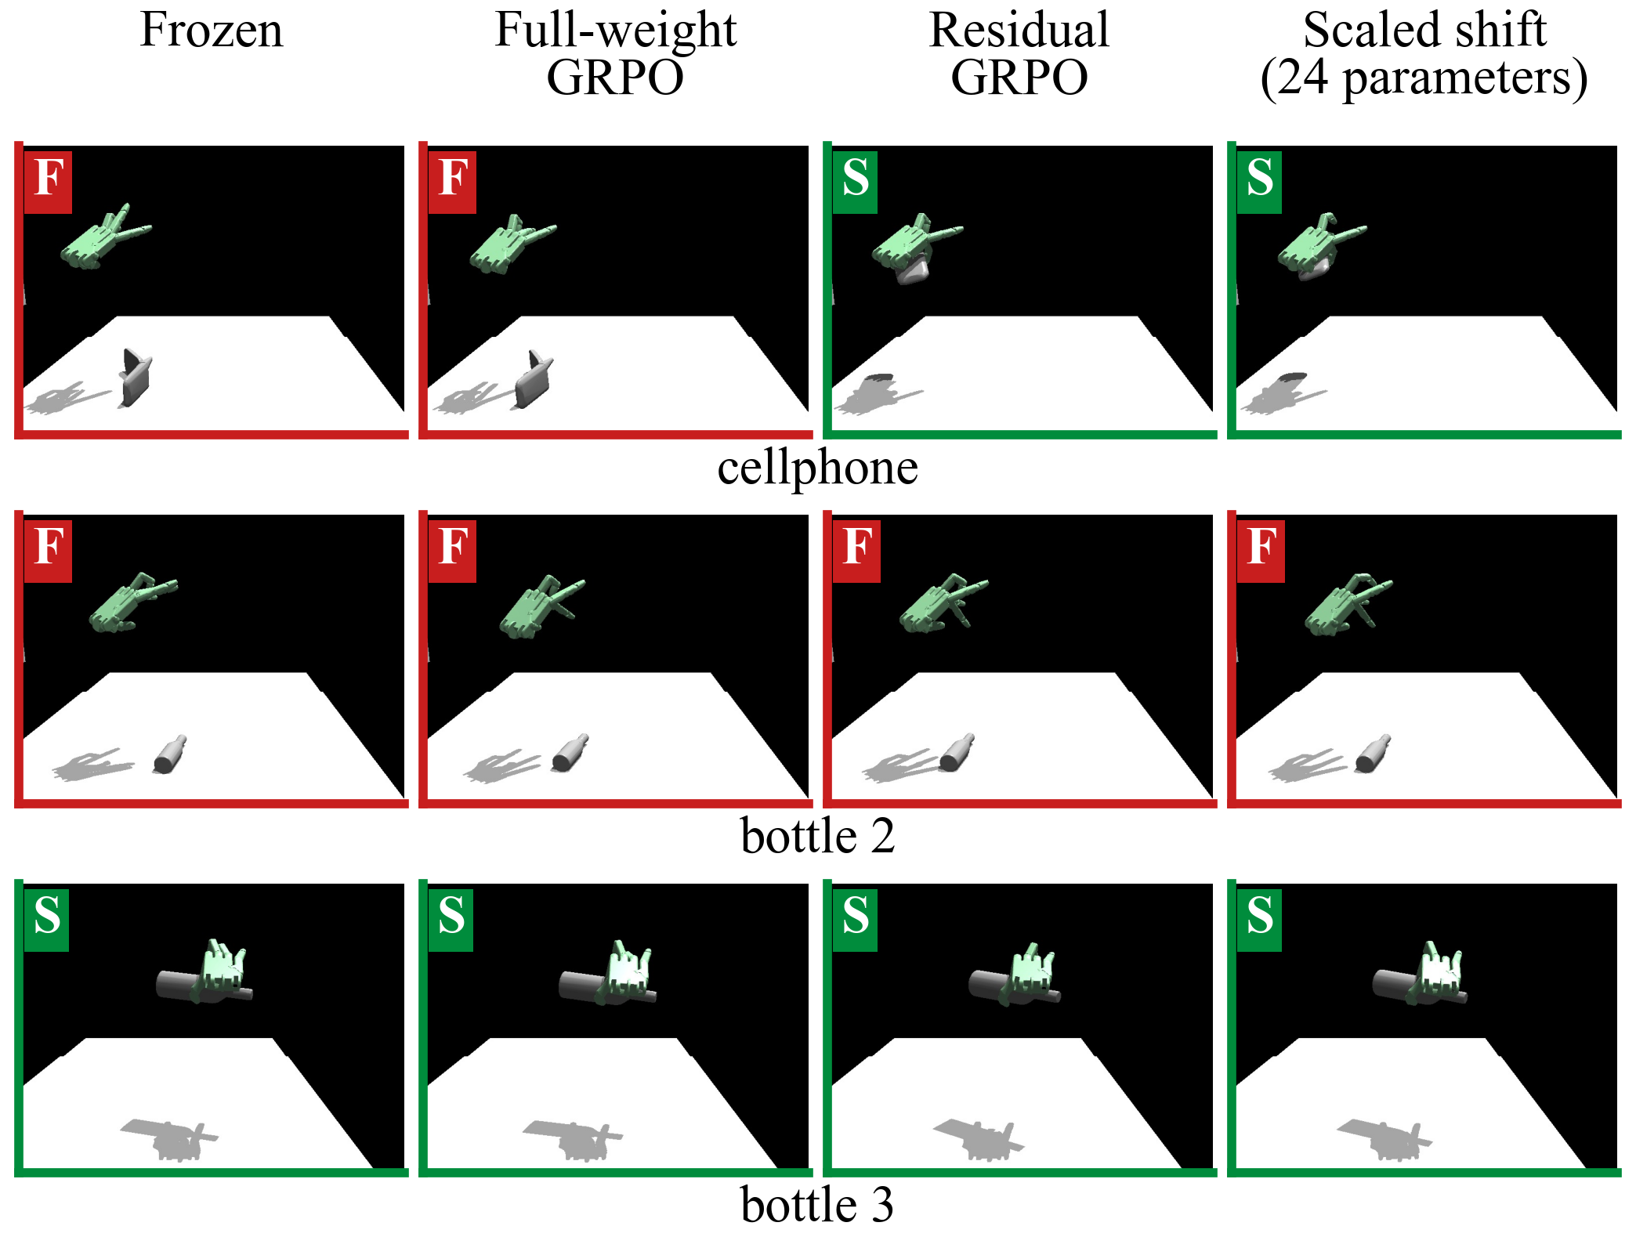
Fig. 3. Final frames of three selected reference-LF test episodes (seen-category objects, first training run of each procedure). S/F: recorded success flag. Scaled shift: the 24-parameter σ₀-scaled constant offset.
The constant is enough only at the reference lock. At the retrained 75% posture, replacing the network by its mean lowers success from 41.1% to 36.7%; under the two-finger lock, network, mean and directly trained constant reach 36.5%, 32.5% and 26.8%. These faults need state-dependent corrections.

B. One joint edit, priced by output coordinates
Fig. 4 shows what the correction does. Across all 51 reference-lock training runs, from every update family and rate, lock success rank-correlates with the mean change in the RFJ3 control target (third ring-finger joint, after tanh and joint limits) at ρ = 0.97, against 0.41 for the size of the whole σ₀-normalized mean shift. Recovery from the little-finger lock is carried by the neighboring ring finger.
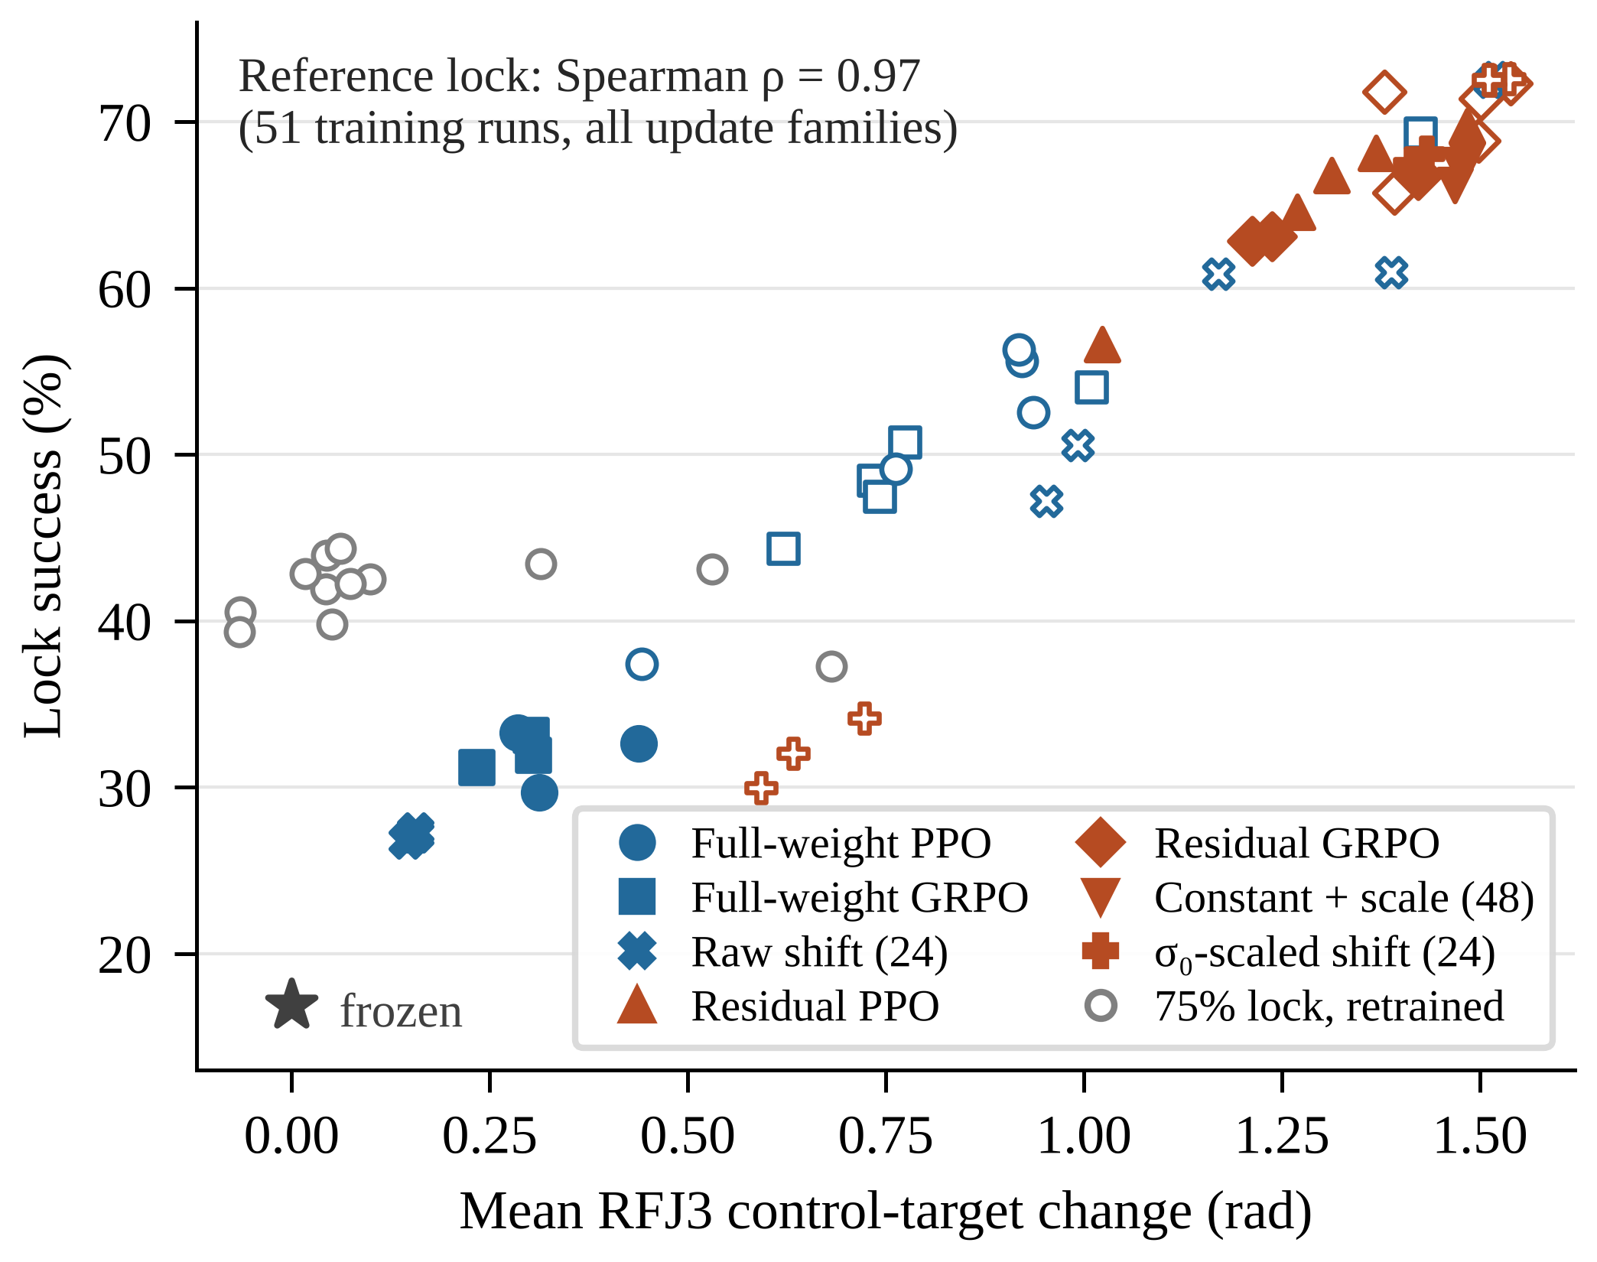
Fig. 4. Lock success against the mean RFJ3 control-target change on 2,048 common nominal states, one marker per training run. Blue: raw output coordinates (full-weight updates, raw offset); orange: σ₀-scaled coordinates (residual networks, constant offsets). Filled: selected rates; hollow: other rates. Gray: models retrained and evaluated at the 75% lock.
Update coordinates set the nominal price of this edit. For a frozen linear mean head m₀(s) = Wh₀(s) + b, a scaled offset d = σ₀ ⊙ c is exactly an output-bias change:
m₀(s) + d = Wh₀(s) + (b + d). (3)
Raw and σ₀-scaled offsets therefore span the same corrections. Yet the selected raw offset moves RFJ3 by 0.15 rad and reaches 27.1% success, close to the full-weight updates, whereas the selected scaled offset moves it by 1.42 rad and reaches 67.6%. A larger raw rate does reach 1.47 rad and 68.7%, but at 8.5 pp nominal loss instead of 4.5 pp. With Adam, scaling by σ₀ multiplies each output coordinate’s effective step by its sampling scale, and RFJ3 is among the 12 largest-scale dimensions (σ₀ = 0.56). Residual GRPO accordingly puts 87% of its absolute mean change on those 12 dimensions, against 62% for full-weight GRPO, and moves RFJ3 by 1.29 rad against 0.28 rad. Full-weight updates reach the same edit only at higher rates and higher cost (Fig. 4), up to 26.0 pp nominal loss for full-weight GRPO at 10⁻⁴. At reference LF, the residual advantage is an advantage of output coordinates, not of capacity.
At the 75% lock this route closes. Models retrained there move RFJ3 by −0.07 to 0.68 rad yet reach 37–44% success (Fig. 4, gray), and residual GRPO’s correction has only a 0.46 cosine with its reference-lock correction. Recovery runs through a different edit, and all four procedures find it equally well.

C. An update record for developer–integrator review
The developer who trains an update and the integrator who deploys it need the same evidence. Following model cards [28], Table VI records for each candidate the update family and size, recovery and nominal loss with run-level intervals, and the evaluation batch whose frozen planner defines the loss. Two fields change the decision. The frozen reference does: residual GRPO loses 4.9 pp against 91.0% frozen nominal success and 5.2 pp against 91.3% in the repeat batch, so a five-point mean-loss rule accepts it once and rejects it once, while its intervals show that it sits on the limit. Correction size does too: the 48-parameter correction clears the limit with its whole interval and deploys as 24 offsets that the integrator can read joint by joint; two-thirds of its joint-target change is the RFJ3 edit of Fig. 4. Without these fields, evaluation noise becomes an acceptance decision and the integrator cannot see what the update changes.
TABLE VI. LF UPDATE RECORD
Batch | Update (trainable size) | LF  success | Nominal loss  [95% CI]
Initial | Residual GRPO (>70k) | 64.2 | 4.9 [2.7, 7.1]
Repeat | Residual GRPO (>70k) | 64.2 | 5.2 [3.6, 6.8]
Initial | Constant + scale (48) | 67.1 | 4.1 [3.8, 4.4]
Initial | σ₀-scaled shift (24) | 67.6 | 4.5 [2.9, 6.2]
Repeat | Full-weight GRPO (all) | 32.2 | 1.4 [0.3, 2.4]
Success in %, loss in pp; n = 3. Loss is relative to the frozen planner of the same batch (initial 91.0%, repeat 91.3%).

D. Limitations
All results are simulated, with one open-loop planner family at the stated budgets. Locked joints hold their targets; limp or torque-limited joints may behave differently. Three-run groups and sparse rate grids limit the curve estimates. Test objects were used in exploratory runs before the protocol was fixed. A full-weight update with σ₀-scaled output coordinates is the direct test of the coordinate account, and the update record has not yet been used by practitioners.

VI. CONCLUSION
At the reference little-finger lock, residual corrections on a frozen DemoGrasp planner recover 64–65% of grasps against 32–41% for full-weight fine-tuning, and the gain survives learning-rate refinement. The gain is one joint edit that σ₀-scaled output coordinates reach cheaply, and a 48-parameter constant correction captures it at 67.1% success and 4.1 pp nominal loss. When the lock posture changes, the edit and the advantage disappear. Compact corrections are therefore the first update to try and the easiest to review: their recovery, cost and content fit in a record that an integrator can check.

ACKNOWLEDGMENT
Claude (Anthropic) and ChatGPT/Codex (OpenAI) assisted with drafting, editing, analysis and plotting code. The authors reviewed the text, code and results.
Data and code: https://github.com/woxihuanni99/Adapting-Pretrained-Dexterous-Grasping-Policies-to-Deployment-Shifts

REFERENCES
[1] Y. Xu et al., “UniDexGrasp: Universal robotic dexterous grasping via learning diverse proposal generation and goal-conditioned policy,” in Proc. IEEE/CVF CVPR, 2023, pp. 4737–4746, doi: 10.1109/CVPR52729.2023.00459.
[2] W. Wan et al., “UniDexGrasp++: Improving dexterous grasping policy learning via geometry-aware curriculum and iterative generalist-specialist learning,” in Proc. IEEE/CVF ICCV, 2023, pp. 3868–3879, doi: 10.1109/ICCV51070.2023.00360.
[3] H. Yuan, Z. Huang, Y. Wang, C. Mao, C. Xu, and Z. Lu, “DemoGrasp: Universal dexterous grasping from a single demonstration,” in Proc. ICLR, 2026, arXiv:2509.22149.
[4] S. Amershi et al., “Software engineering for machine learning: A case study,” in Proc. IEEE/ACM ICSE-SEIP, 2019, pp. 291–300, doi: 10.1109/ICSE-SEIP.2019.00042.
[5] A. Z. Ren et al., “Diffusion policy policy optimization,” in Proc. ICLR, 2025, arXiv:2409.00588.
[6] F. Ceola, L. Rosasco, and L. Natale, “RESPRECT: Speeding-up multi-fingered grasping with residual reinforcement learning,” IEEE Robot. Autom. Lett., vol. 9, no. 4, pp. 3045–3052, 2024, doi: 10.1109/LRA.2024.3363532.
[7] Z. Huang, H. Yuan, Y. Fu, and Z. Lu, “Efficient residual learning with mixture-of-experts for universal dexterous grasping,” in Proc. ICLR, 2025, arXiv:2410.02475.
[8] X. Yuan, T. Mu, S. Tao, Y. Fang, M. Zhang, and H. Su, “Policy Decorator: Model-agnostic online refinement for large policy model,” in Proc. ICLR, 2025, arXiv:2412.13630.
[9] R. Agarwal, M. Schwarzer, P. S. Castro, A. C. Courville, and M. Bellemare, “Deep reinforcement learning at the edge of the statistical precipice,” in Advances in Neural Information Processing Systems, vol. 34, 2021, pp. 29304–29320.
[10] T. Eimer, M. Lindauer, and R. Raileanu, “Hyperparameters in reinforcement learning and how to tune them,” in Proc. ICML, PMLR, vol. 202, 2023, pp. 9104–9149.
[11] A. Patterson, S. Neumann, M. White, and A. White, “Empirical design in reinforcement learning,” J. Mach. Learn. Res., vol. 25, no. 318, pp. 1–63, 2024.
[12] G.-H. Xu, Y.-L. Wei, D. Zheng, X.-M. Wu, and W.-S. Zheng, “Dexterous Grasp Transformer,” in Proc. IEEE/CVF CVPR, 2024, pp. 17933–17942, doi: 10.1109/CVPR52733.2024.01698.
[13] H. Yuan, B. Zhou, Y. Fu, and Z. Lu, “Cross-embodiment dexterous grasping with reinforcement learning,” in Proc. ICLR, 2025, pp. 81413–81434.
[14] T. Silver, K. Allen, J. Tenenbaum, and L. Kaelbling, “Residual policy learning,” arXiv preprint arXiv:1812.06298, 2018.
[15] T. Johannink et al., “Residual reinforcement learning for robot control,” in Proc. IEEE ICRA, 2019, pp. 6023–6029, doi: 10.1109/ICRA.2019.8794127.
[16] A. Wagenmaker et al., “Steering your diffusion policy with latent space reinforcement learning,” in Proc. CoRL, PMLR, vol. 305, 2025, pp. 258–282.
[17] E. Su, T. Westenbroek, A. Nagabandi, and A. Gupta, “RFS: Reinforcement learning with residual flow steering for dexterous manipulation,” in Proc. ICLR, 2026, arXiv:2602.01789.
[18] E. J. Hu et al., “LoRA: Low-rank adaptation of large language models,” in Proc. ICLR, 2022, arXiv:2106.09685.
[19] Z. Liu et al., “TAIL: Task-specific adapters for imitation learning with large pretrained models,” in Proc. ICLR, 2024, pp. 16330–16353.
[20] A. Cully, J. Clune, D. Tarapore, and J.-B. Mouret, “Robots that can adapt like animals,” Nature, vol. 521, pp. 503–507, 2015, doi: 10.1038/nature14422.
[21] A. Kumar, Z. Fu, D. Pathak, and J. Malik, “RMA: Rapid motor adaptation for legged robots,” in Proc. Robotics: Science and Systems, 2021, doi: 10.15607/RSS.2021.XVII.011.

[22] L. Deng et al., “Residual fault adaptation for dexterous in-hand manipulation under runtime joint faults,” arXiv preprint arXiv:2609.17404, 2026.
[23] J. Kirkpatrick et al., “Overcoming catastrophic forgetting in neural networks,” Proc. Natl. Acad. Sci. USA, vol. 114, no. 13, pp. 3521–3526, 2017, doi: 10.1073/pnas.1611835114.
[24] A. Kumar, A. Raghunathan, R. Jones, T. Ma, and P. Liang, “Fine-tuning can distort pretrained features and underperform out-of-distribution,” in Proc. ICLR, 2022, arXiv:2202.10054.
[25] M. Wortsman et al., “Robust fine-tuning of zero-shot models,” in Proc. IEEE/CVF CVPR, 2022, pp. 7959–7971.
[26] M. Wolczyk et al., “Fine-tuning reinforcement learning models is secretly a forgetting mitigation problem,” in Proc. ICML, PMLR, vol. 235, 2024, pp. 53039–53078.
[27] M. Nakamoto et al., “Cal-QL: Calibrated offline RL pre-training for efficient online fine-tuning,” in Advances in Neural Information Processing Systems, vol. 36, 2023, pp. 62244–62269.
[28] M. Mitchell et al., “Model cards for model reporting,” in Proc. ACM Conf. Fairness, Accountability, and Transparency (FAT*), 2019, pp. 220–229, doi: 10.1145/3287560.3287596.
[29] V. Makoviychuk et al., “Isaac Gym: High performance GPU-based physics simulation for robot learning,” in Proc. NeurIPS Datasets and Benchmarks Track, 2021, arXiv:2108.10470.
[30] J. Schulman, F. Wolski, P. Dhariwal, A. Radford, and O. Klimov, “Proximal policy optimization algorithms,” arXiv preprint arXiv:1707.06347, 2017.
[31] Z. Shao et al., “DeepSeekMath: Pushing the limits of mathematical reasoning in open language models,” arXiv preprint arXiv:2402.03300, 2024.

