1.02-install-and-opencode.md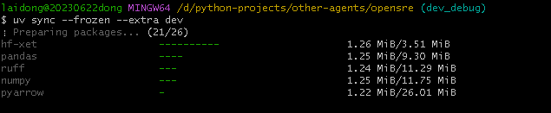
2.

