User interface
Our main goal was to create simple and intuitive, yet powerful user interface. We tried to achieve this by minimization of the number of control elements down to 2 panels, one for graph building purposes and another one for algorithm control.

Creating a simple graph
Left panel of application's main window serves for graph creation. Users are able to add or remove nodes from pop-up menu, that shows up after right click of the mouse on the desired location. Nodes are represented as black circles with its id displayed inside. Right next to them, there's an indicator of current height of the node, which plays role in algorithm itself.
Right clicking on the node invokes the same pop-up menu, but with more options enabled, such as deletion of selected node, starting edge from that node, selection of this node as source or sink of the graph.
Edges are displayed as lines, with an arrow in the middle pointing in the direction of that edge, as relabel-to-front algorithm works with oriented graphs. Next to this arrow, there are two numbers separated by slash, indicating current flow and capacity of the edge. Edges are created from pop-up menu mentioned above, after right clicking on desired start node and then selection of the destination node (this is done again by clicking with any mouse button on desired node). Loops are not allowed.
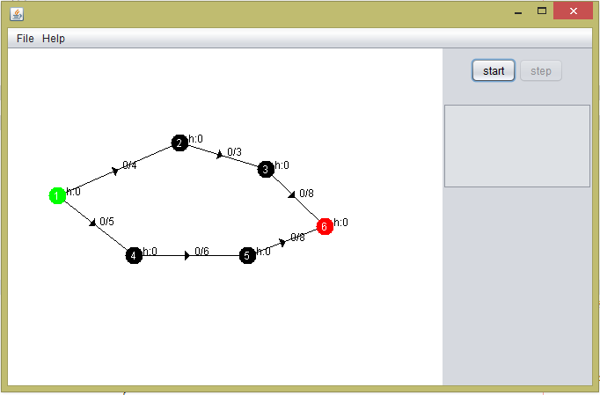Illustration 1: Simple graph created in our application. Node 1 is selected as source, node 6 as sink.

Saving and loading graphs
Application allows to store and load graphs in GraphML format. This is a widely-used xml format for graph representation. More info about this format can be found here: http://graphml.graphdrawing.org/. The application can load GraphML files created by an application itself, other files must contain definition of additional attributes such as x_position, y_position and height for nodes, and capacity for edges. For more details, look at the saved file itself, the structure is, thanks to xml format, easily readable.

Running an algorithm
To run relabel-to-front algorithm, one must select source and sink nodes first. Source node will be colored green and sink node red. After that, users can run algorithm simply by clicking on the start button in the panel on the right. This will initialize all variables necessary for the algorithm. Then, algorithm continues by simple steps after clicking on the step button. Changes to the graph are highlighted:
- node, which turns yellow, had its height changed in the last step (height number turns to red)
- edge, which flow has changed, is highlighted by yellow border, and its flow and capacity marking is written in red
There are steps of the algorithm, when relabel-to-front works with virtual edges, which are not visible to the user. Information about these changes (and also about all visible changes) can be found in text area below the control buttons. Final flow is displayed here too.
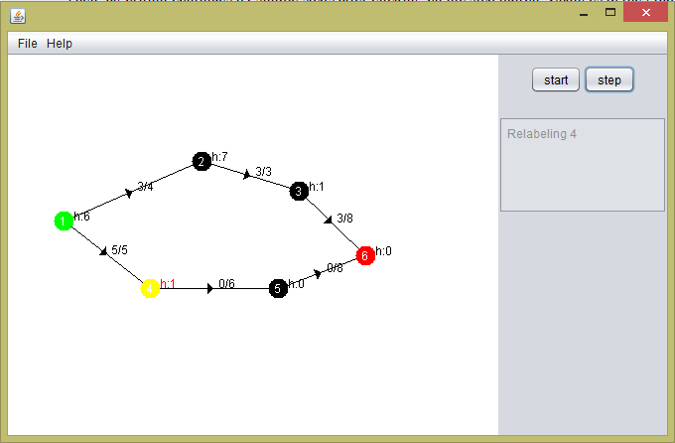Illustration 2: Running an algorithm. Node 4 is being relabeled, so it is painted in yellow.

