Estimated Aileron / Roll transfer functions :

with delay

Roll Rate 1 + 30.328 * s
------------ = -0.33204 * ---------------------------------------------- * exp(-0.13494 * s) (FIT = 53.9%)
Ailerons (1 + 5.2366 * s) * ( 1 + 0.087719 * s)

Without delay

Roll Rate 1 + 22.314 * s
------------ = -0.39977 * ---------------------------------------------- (FIT = 47.9%)
Ailerons (1 + 4.4472 * s) * ( 1 + 0.21548 * s)

Adding integrator term results in the Aileron / Roll continuous time transfer functions, with delay:

1 + 30.328 * s
Gars_d = -0.33204 * -------------------------------------------------- * exp(-0.13494 * s)
s * (1 + 5.2366 * s) * ( 1 + 0.087719 * s)

and without delay

1 + 22.314 * s -8.92 s - 0.3998
Gars = -0.39977 * ------------------------------------------------- = ---------------------------------
s * (1 + 4.4472 * s) * ( 1 + 0.21548 * s) 0.9583 s^3 + 4.663 s^2 + s

Converting to discrete time with a sampling period Ts = 0.02 seconds, the transfer function with delay results in a State-space model that is stable:

x(t + Ts) = A x(t) + B u(t) + K e(t)
y(t) = C x(t) + D u(t) + e(t)

A = x1 x2 x3
x1 0.79272 -0.038856 0.012933
x2 0.017848 0.9996 0.00017283
x3 0 0 0

B = u1
x1 0.0049154
x2 1.256e-005
x3 1

C = x1 x2 x3
y1 -21.922 -0.72284 0

D = u1
y1 0

K = y1
x1 0
x2 0
x3 0

x(0) =
x1 0
x2 0
x3 0:

whereas the transfer function without delay results in following unstable system:

-0.001803 z^2 + 5.542e-005 z + 0.001745
Garz = ----------------------------------------------------
z^3 - 2.907 z^2 + 2.814 z - 0.9073

PID tuning is unable to stabilize the Garz transfer function but only the state space model, with an proportional gain of :

Kp = -0.2827

and following step response:
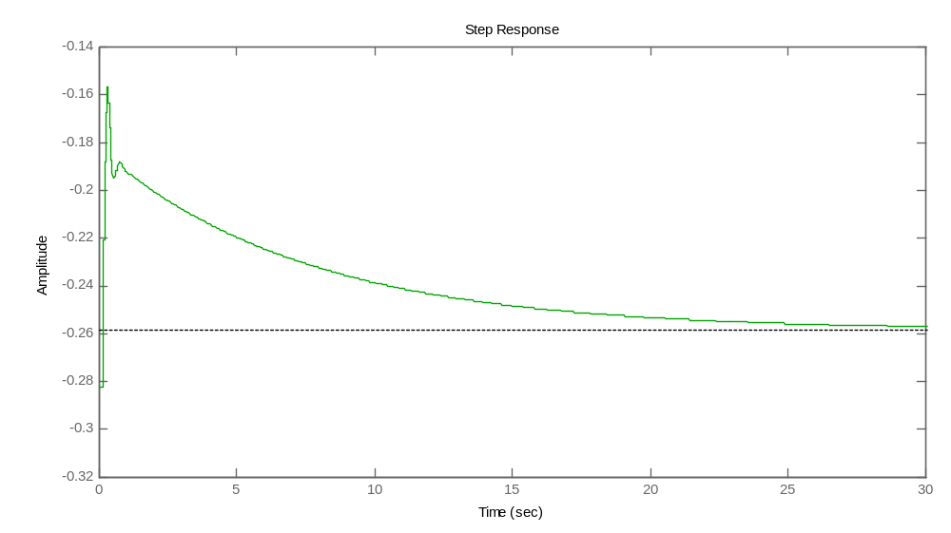
Interestingly, sisotool can’t stabilize the system with either PI or PID controllers, but only with P controller.

ELEVATOR

Controller :
