Estimate transfer functions

Steps are:

- collect aileron / elevator position and gyroscope output data at 50 Hz sampling frequency
- convert aileron / elevator position data from [ms] to [-1 ; +1]
- convert gyroscope raw data to [dps]
- identify aileron/roll and elevator/pitch transfer functions with Matlab System identification toolbox (n42s state space model from Linear Parametric Models was chosen)
- convert state space model into discrete time transfer function with Matlab tf()
- convert transfer function from discrete time to continuous time with Matlab d2c()
- add integrator term multiplying transfer function by 1/s
- convert back transfer function to discrete time with Matlab c2d()

Roll Controller

Proportional-only controller computed with singular frequency based PID tuning. Kp = - 2389.8
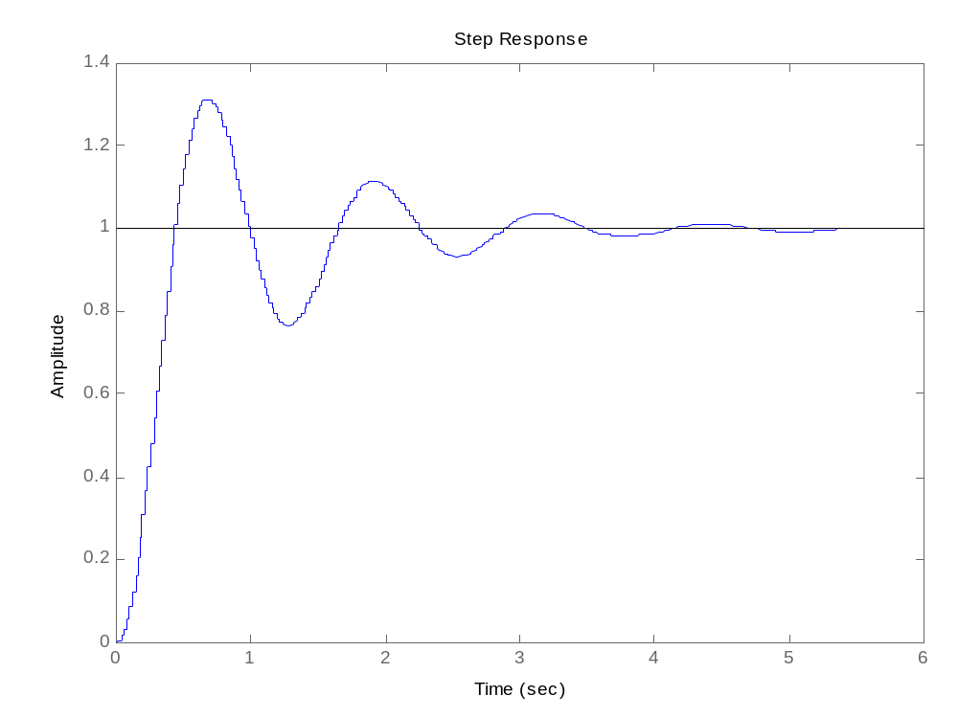

Pitch controller

Proportional and Integrative controller computed with Ziegler-Nichols open loop PID tuning;

3.6045 (1 + w) / w

where

w = (z – 1) / Ts and Ts = 0.02

resulting in

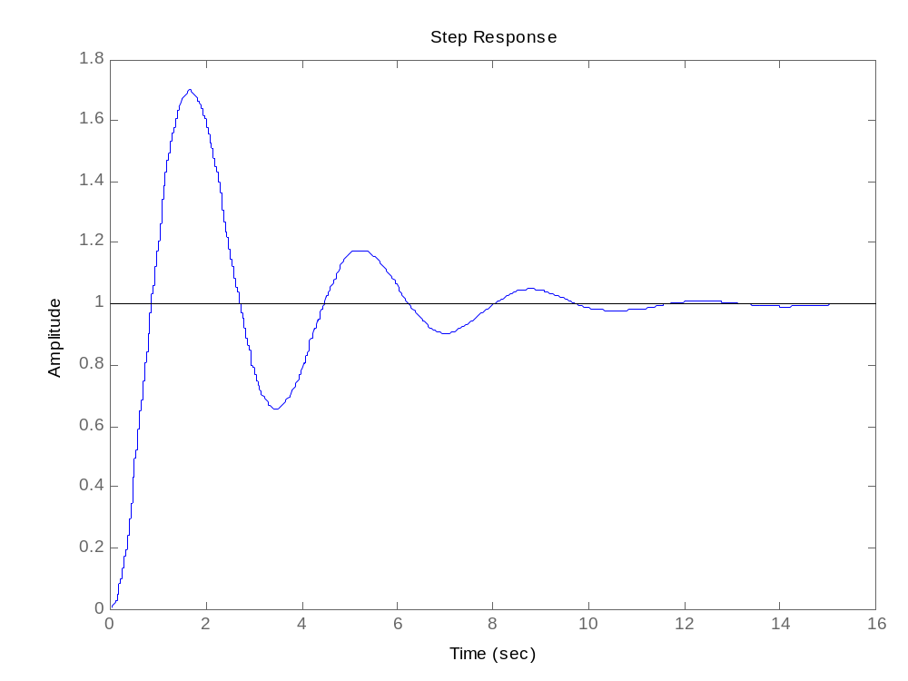
3.6045 (z – 0.98) / (z - 1)

From the PI transfer function the Kp and Ki gains need to be calculated:

Kp = 3.6045 * 0.98 = 3.53241
Ki = 3.6045 * (1 – 0.98) = 0,07209

The coefficients are valid as long as values are expressed in the correct units, i.e.:

actual pitch and roll angles (“plant” output) = [rad]
setpoint = [rad]
controller output = [us]

Since DCM matrix contains cosines, pitch and roll angles result form following conversion :

Pitch = arccosf(DCM_Matrix[2][0])
Roll = arccosf(DCM_Matrix[2][1])

