Estimate transfer functions

Steps are:

- collect aileron / elevator position and gyroscope output data at 50 Hz sampling frequency
- convert aileron / elevator position data from [ms] to [-1 ; +1]
- convert gyroscope raw data to [dps]
- identify aileron/roll and elevator/pitch transfer functions with Matlab System identification toolbox (n42s state space model from Linear Parametric Models was chosen)
- convert state space model into discrete time transfer function with Matlab tf()
- convert transfer function from discrete time to continuous time with Matlab d2c()
- add integrator term multiplying transfer function by 1/s
- convert back transfer function to discrete time with Matlab c2d()

Aileron / Roll rate transfer function:

61.22 s - 1892
----------------------------- [dps / %]
s^2 + 11.88 s + 52.05

Adding integrator term results in the Aileron / Roll continuous time transfer function:

61.22 s - 1892
---------------------------------- [deg / %]
s^3 + 11.88 s^2 + 52.05 s

Converting to discrete time with a sampling period Ts = 0.02 seconds:

0.008933 z^2 - 0.009822 z - 0.01256
------------------------------------------------- [deg / %]
z^3 - 2.77 z^2 + 2.559 z - 0.7885

Elevator / Pitch Rate transfer function:

23.13 s + 1.799
--------------------------- [dps / %]
s^2 + 2.77 s + 0.257

Adding integrator term results in the Elevator / Pitch continuous time transfer function:

23.13 s + 1.799
-------------------------------- [deg / %]
s^3 + 2.77 s^2 + 0.257 s

Converting to discrete time with a sampling period Ts = 0.02 seconds:

0.004544 z^2 - 7.377e-005 z - 0.004456
----------------------------------------------------- [deg / %]
z^3 - 2.946 z^2 + 2.892 z - 0.9461

Roll Controller

Proportional-only controller computed with singular frequency based PID tuning. Kp = -0.047831

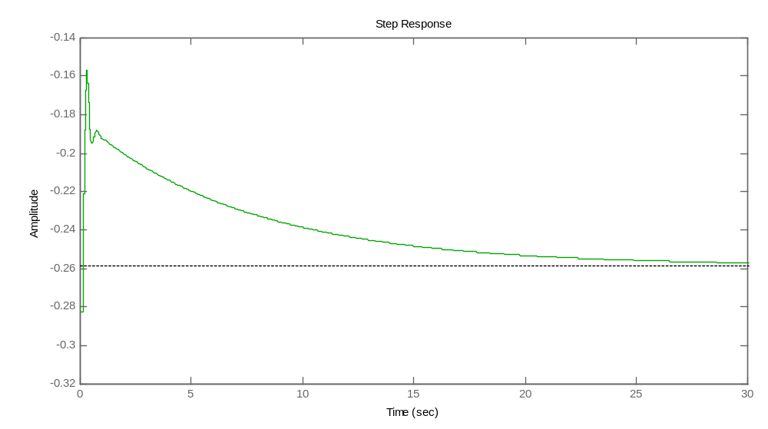

Pitch controller

Proportional and Integrative controller computed with Ziegler-Nichols open loop PID tuning

(1 + 32 * w) z - 1 z – 0.9993
0.00013085 * ----------------- , where w = --------, thus : 0.0041872 * -----------------
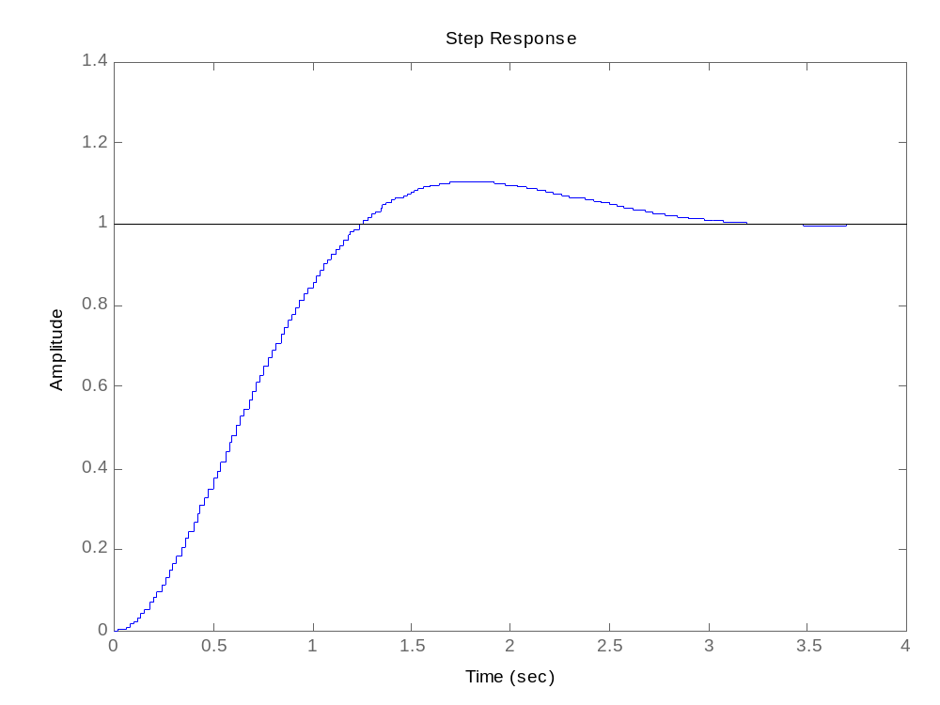
w Ts z – 1

From the PI transfer function the Kp and Ki gains need to be calculated:

Kp = 0.0041872 * 0.9993 = 0.0041842
Ki = 0.0041872 * (1 – 0.9993) = 0.0000029

The coefficients are valid as long as values are expressed in the correct units, i.e.:

actual pitch and roll angles (“plant” output) [deg]
setpoint [deg]
controller output [%]

Since DCM matrix contains cosines, pitch and roll angles result form following conversion :

Pitch = arccosf(DCM_Matrix[2][0]) * 180) / PI
Roll = arccosf(DCM_Matrix[2][1]) * 180) / PI

Conversion radians - degrees can be made with controller's gain.

Controller output must be converted in microseconds for controlling servos:

position = controller output * 500 + 1500

