# 1. How To Install Plugin

upload and install .zip under Plugins >> Add New > Upload, and activate the HB Audio Gallery plugin.

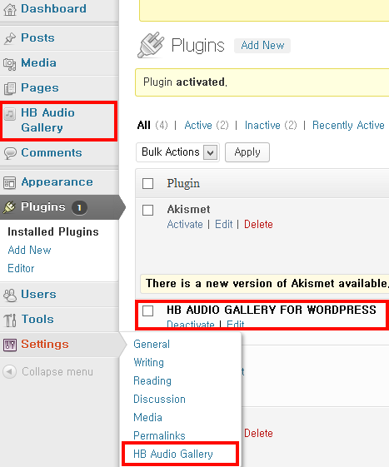

# 2. How To Add New Gallery

First, Click HB Audio Gallery >> Add New menu.

Second, enter gallery name and auther name, and click publish button.

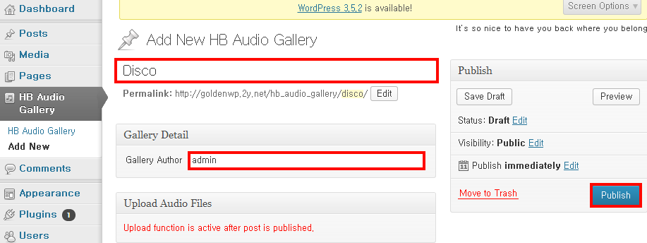

If you click publish button, Select Files and Scan Files button will appear in Upload Audio Files section.

# 3. How to Upload Audios via Admin Section

First, click Select Files button and then select your songs in file dialog window. If you do so, selected songs are uploaded to wp-content/hb-audio-gallery/(gallery name) directory and appear in Audio List section.

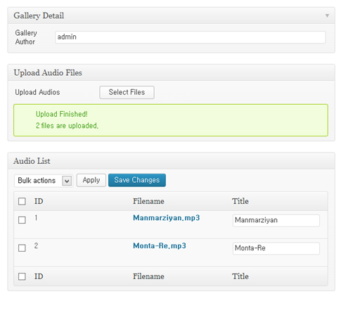

# 4. Available Shortcodes And Settings.

# If you click Settings >> HB Audio Gallery menu, abailable shortcode is showed.

- Single Audio shortcode

• Shortcode : [hb-single-audio aid="(audio_id)"]

• How to get audio_id?

