OneSportEvent WordPress PlugIn

Plugin Name: OneSportEvent
Plugin URL: www.OneSportEvent.com/plugins/wordpress
Author: sporty - sport@onesportevent.com
Author URL www.OneSportEvent.com/AboutUs.aspx
Description

The OneSportEvent plug-in allows you to easily get event listings for sporting events and race (e.g. half marathons, swimming, orienteering, kayaking etc) onto your own website. It can also be used for club-only race calendars so your members know information about your events.
Events come from a free shared database which you can add and edit, and the plug-in gives you full control over the styling, branding and functionality using css and administration options. This includes the ability to show certain event types by default or enable/disable different user filtering functionality.
When adding events at www.onesportevent.com you also have a lot of flexibility including a full editor allowing you to use bolding, tables, layout, colours and pictures or maps in your event descriptions - or even edit the raw HTML.

Getting Authority to use the PlugIn

Simply email sport@onesportevent.com and ask for "webkey". Your webkey is simply the website you are hosting the events on. Please provide your full name, contact details the website(s) you wish to add the events too.

At a future date we may add functionality to automate this process, you could also check www.onesportevent.com/plugins

Terms and Conditions For Use of the API/plugin Services

Obviously you should read this entire agreement but if you read nothing else, make sure you read paragraph #2 and #3 otherwise you risk being shutdown, prosecuted, electrocuted, or in generally other bad things may happen. Ok, maybe not electrocuted.

Access to the information on OneSportEvent.com, the "Site", including the website, database, plugins, modules and others API's are subject to the following terms and conditions. If you do not agree to these terms and conditions, do not use this site or services.
You must provide an indexable link back to www.onesportevent.com thanking or at least acknowledging us for your free access to this service. nb we do accept donations for running costs.
You may not extract, copy or reproduce the data from the shared database and store it in anywhere or reproduce it electronically without our prior consent. It is there for everyone to use not for you to rip-off. We may however give consent, just ask. Most likely we will alter the API if necessary so you can get data however you want it, even if it is just raw data.
OneSportEvent.com is a shared database of events primarily provided by third parties including event organisers, race directors and fellow multisporters. We cannot take direct responsibility for the accuracy of the information and so users are advised to always make contact with event organisers to confirm specific event details, just in case the information changes or was entered incorrectly.
You agree that OneSportEvent.com, its related entities and their directors, staff, consultants or volunteers are in no way liable to you, or to any third party claiming through you, for any loss or damage including without limitation, indirect or consequential damages, arising out of your use of this web site or in respect of any of your actions or omissions taken in reliance on any information contained on this web site or any web site to which this web site is linked. You further agree to indemnify these parties from and against all claims and demands in relation your use of the website.

Protecting Yourself Incase They Turn up to the Wrong Event!

It would be prudent for you to put a disclaimer on your website to indicate that the data is from a shared database of events primarily provided by third parties including event organisers, race directors and fellow multisporters. We cannot take direct responsibility for the accuracy of the information and so users are advised to always make contact with event organisers to confirm specific event details, just in case the information changes or was entered incorrectly.

Plugin Options

The plug-in parameters are all described in the administration screen for the plug-in. They are also described in the API documentation www.onesportevent.com/plugins/API.

Finding Your Country, Region or City ID
If you specify a default view level of Country, Region or City you must supply a specific ID of the area you wish to view. The easiest way to find the area ID is go browse www.onesportevent.com, navigate to the area you want and look at the ID passed in the URL. e.g.
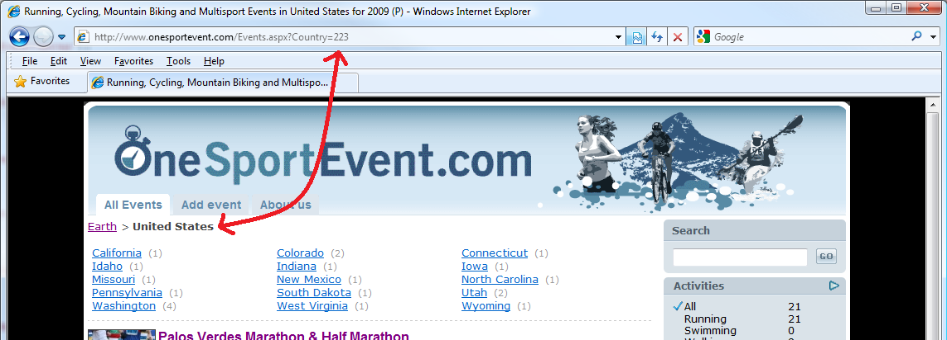
Event Type Codes

1 5 Km
2 10 Km
3 Half Marathon
4 Marathon
7 Ultra Marathon

Activity Type Codes

1 Running
2 Swimming
3 Walking
4 Mountain Biking
5 Kayaking
6 Rowing
7 Orienteering
8 Cycling

Style Codes

1 Onroad
2 Offroad
3 Mountain
Wordpress Plugin - Administration Configuration Screen

