Restricted Page plugin
/*
Plugin Name: Restricted Page
Plugin URI:
Description: Plugin hides page content from not logged-in users
Version: 1.0.0
Author: Leonid N. Malyshev
Author URI: http://mln.sk
*/

Description
"Restricted Page" plugin was created to prevent unauthorized users from viewing particular pages. The plugin must be placed on the destination page.
For logged-in users the plugin can show (in addition to the content of the page) predefined text and “Log out” button.
For not logged in users plugin shows a predefined texts, login form and sign in button instead the page content.

Settings
In plugin settings (Admins menu “Settings”->”Restricted Page Options”) you can set:
For not logged in users:
- Text to publish before login form
- Text to publish after login form
- Show "Sign In" button?
- Sign In Button text
- Text to publish before Sign in form
- Text to publish after Sign in form
For logged in users:
- Show "Disconnect" button?
- Disconnect Button text
All options allow entering text with html tags (eg <h1>, <div>…)
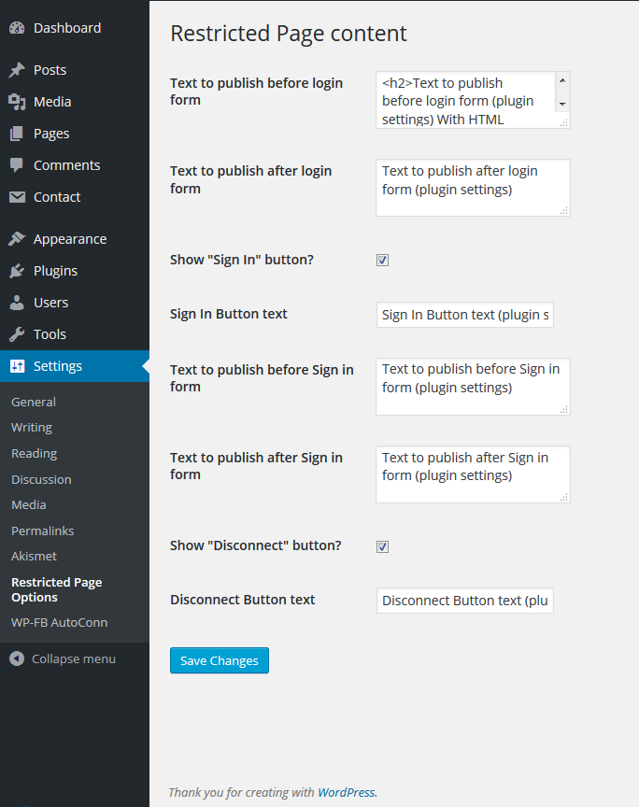

Usage
You can insert plugin’s shortcode in any place of you page. You can place:
- [RP_registered_only]
- [RP_registered_only]Text to show[/RP_registered_only] – For registered users “Text to show” would be printed in the place of the shortcode before “Sign out” button (if shown).
- You can place shortcodes more than 1 time. WARNING. In this case all "[RP_registered_only]" must be closed by "[/RP_registered_only]"

Results of using the plugin for not logged in users:
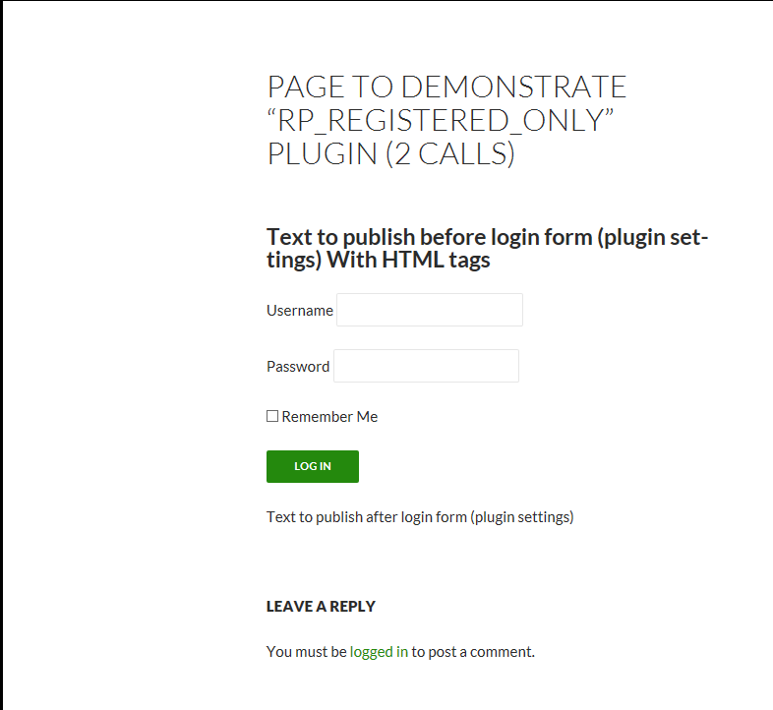
Same but with “Show “SignIn” button” option on.
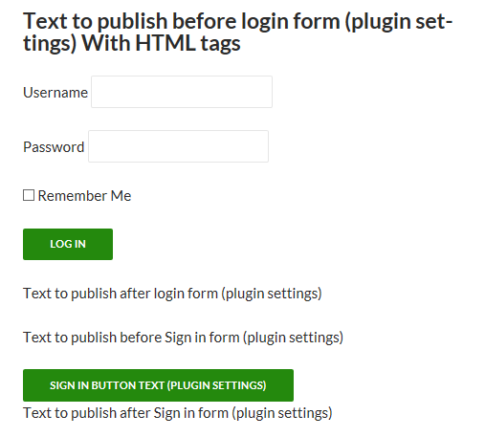

Results of the plugin usage for logged in users:

