**Algorithms**

# Sorting:

**01: Bubble Sort**

* Run two loops
* If **a[ j ] > a[ j+1 ]** then replace that

**02: Selection**

* Run Two Loops
* Store value of first loop each time
* Each time the second loop will be like that
  + // j=1->len // j=2->len // j=3->len
* If a[ j ] < a[ mainElement ] then mainElement = j
* When the second loop completed check that condition
  + If mainElement != i then swap them like arr[mainElement]⬄ arr[i]

**03: Insertion**

Picking One value and set it into its exact position

* Two Loops
* **Second loop is a reverse loop**

04: Merge

* Two Functions
* Recursion

05: Quick

06: Counting Sort

07: Radix Sort

# Stack And Queues:

01: Stack => LIFO

02: Queues => FIFO

# Searching:

01: Linear

02: Binary

# Recursion:

I think there are two types of recursions

1. Reverse
2. Forward
3. We can use multiple recursion inside a function

01: Factorial

02: Fibonacci

03: Memorization

04: Tail Recursion

# Graphs:

01: Breadth-First Search (BFS)

02: Depth-First Search (DFS)

03 Flood Fill

# Dynamic Programming:

01: Knapsack Problem

02: Longest Common Subsequence

# Linked list:

01: Single

02: Double

# Hash Table:

01: With collision

02 Without collision

# Tree Traversal:

01: BFS

02: DFS

03: Binary Search

# Two Pointers:

01: Simple two pointer

# Backtracking:

01: General purpose

02: Simple Example

# Binary Heaps:

# Union Find

# Ad hoc / String manipulation:

# Greedy Algorithm:

# Trie:

# Segment Tree:

# Fenwick Trees:

# Bitmask:

# Time Complexity:

// --- Important Resources

All the Algorithms which we should know before apply to Google

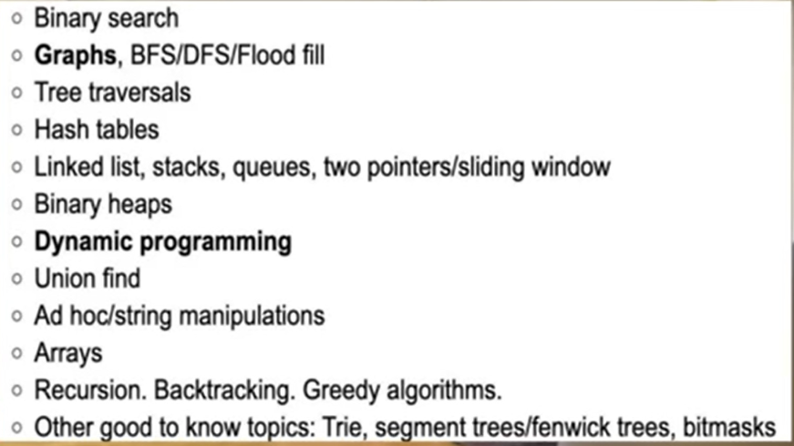

All Algorithms are present there with Animation:

~ <https://www.w3schools.com/dsa/index.php>

GPT Chat link:

~ <https://chatgpt.com/share/01b0c8ed-2a3d-448b-8e38-7f91c28cc1aa>