William Pabst

Eastern Connecticut State University

Computer Algorithms

Assignment #5

**Brute force method**

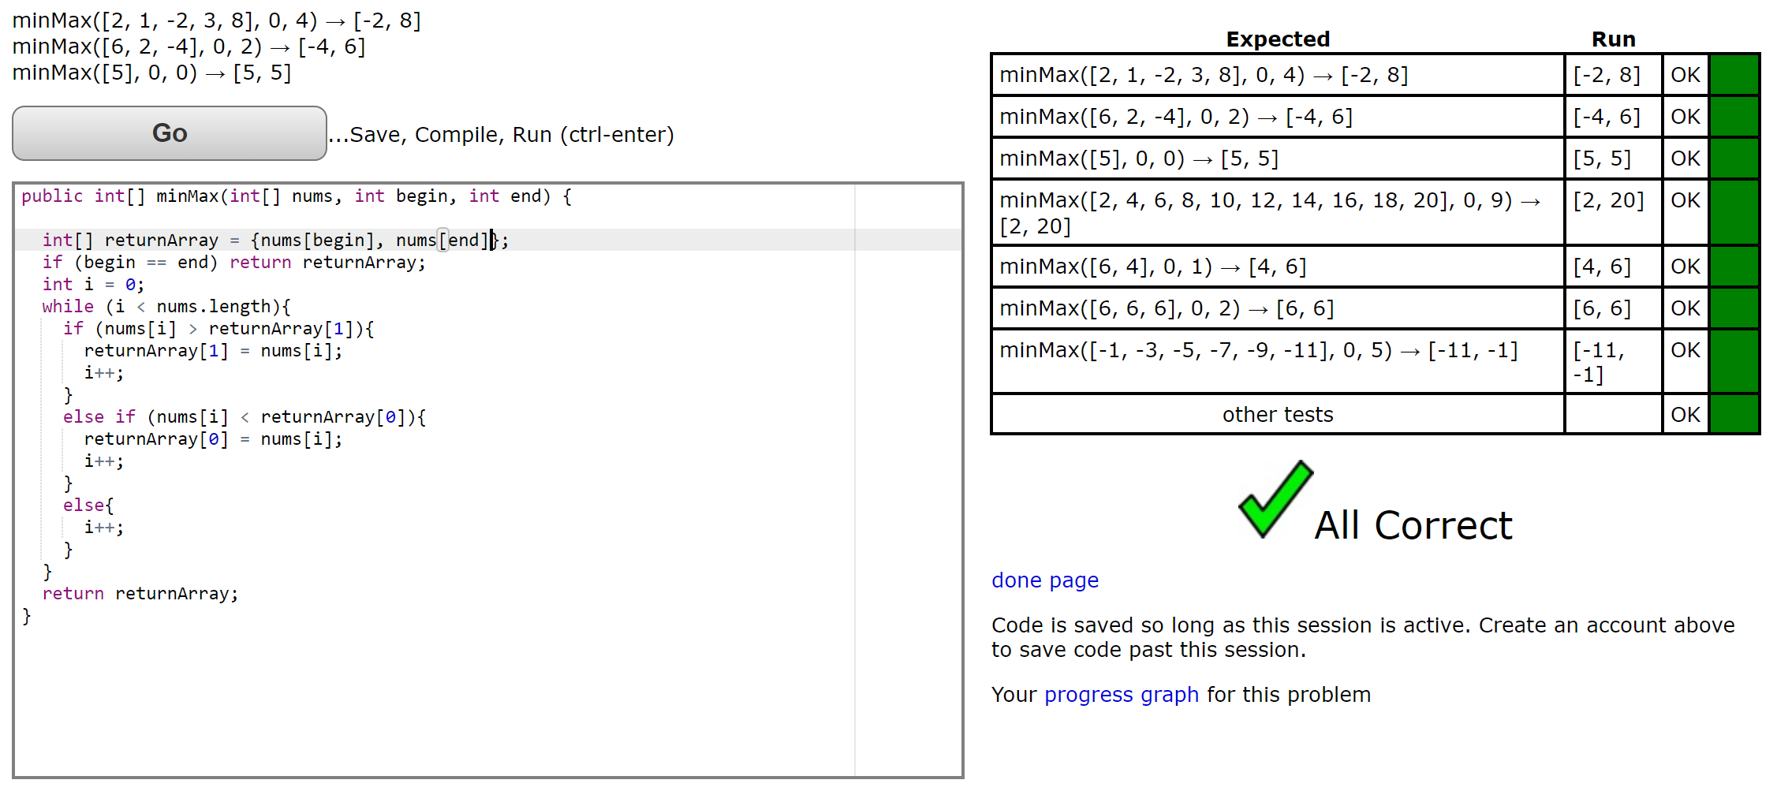

**Key Idea:** For each element, check if it is bigger than the largest KNOWN element. If it’s not, check to see if it is smaller than the smallest KNOWN element.

**Number of comparisons:** For an array with one element, there is one comparison (begin == end)If the element is larger, there is one comparison, but if the element is smaller, there are 2 comparisons. There is a ~50/50 chance that the element is larger, so the average number of comparisons per element is 1.5. Every element must be checked against the next, which translates to N-1 times through the while loop. **1.5(N-1)+1 number of comparisons.**

**Divide and Conquer (Recursive)**

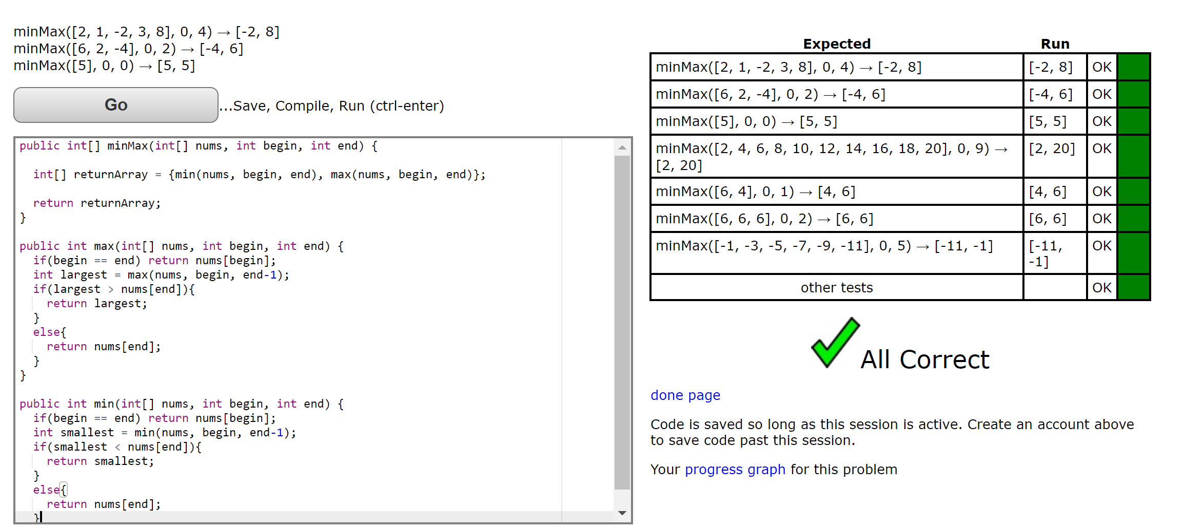

**Key Idea:**  I have created a method to find the smallest element, and a method that returns the largest element. The program returns an array containing {//recursive call to the min() method , //recursive call to the max() method}.

**Recurrence relation:**

N = length of the array

min method = N-1 comparisons

max method = N-1 comparisons

Recurrence relation = f(N) = 2f(N-1)

Seed Values : f(0) = undefined ; f(1) = 1

f(1) = 1 comparison

f(2) = 2f(1) = 2(1) 2 comparisons

f(3) = 2f(2) = 2(2(f(1))) = 2(2(1)) = 4 comparisons

f(4) = 2f(3) = 2(2(f(2))) = 2(2(2(f(1)))) = 2(2(2(1))) = 6 comparisons