**ECE 4370 Project Report:**

**Bending Loss in Waveguides**

**Ling-Wei Lee**

**Warren Parad**

**Paul Rademacher**

**Kevin Tang**

**Goal**

The goal of our project is to measure bending loss in waveguides. The function of a bend is to route an optical signal in a different direction, so that information can be transmitted from place to place. The device we are analyzing is an optical structure with varying bends, and the parameter we are investigating is the relationship between bending radius and power loss. To do this, we have created an optical structure with varying bend radii, and we plan to measure the power loss through each of these bends. The radius of a bend is defined as the inside curvature, and is measured as the radius of the inside surface of a bend, as seen in Figure 1.

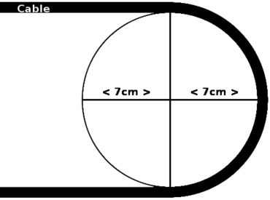

Figure 1. Bend radius

We chose this device for our project because we thought it would be interesting to try to understand how bends affect power loss. Bends are powerful tools for directing optical signals, and a solid understanding would be useful knowledge to have. In addition, we derived theoretical equations in class for modeling bending loss, and we thought it would be interesting to see how well these models actually translate in real life. Also, the equations for circular waveguides are often used as an approximation for rectangular waveguides, which is what we deal with. It would also be interesting to see how well the equations account for this.

**Background**

Bending loss in waveguides has been studied by researchers for over 40 years. Beginning with the first paper in 1969 by Marcatili titled “Bends in optical dielectric guides”, researchers have since expanded upon his original ideas. The span of time that has been dedicated to research in bends is a clear indication of the importance of bends.

Of particular interest to us was the study of bends in rectangular waveguides, since that is what we are actually measuring. Although the equations for circular waveguides are used to approximate rectangular waveguides, we were still interested in methods used to calculate bending loss in rectangular waveguides. Towards this end, the paper “Optical characteristics of bent dielectric rectangular waveguides” provided us with insight into this area. In this paper, the authors describe an approach to measuring bending loss in rectangular waveguides through the use of a conformal transformation, which allows us to transform a bent rectangular waveguide into a straight one. Using this method, the resulting physical model is clear and easily analyzed. However, the process involved in calculating the conformal transformation is complicated, and so we decided to stay with the circular waveguide bending loss approximation.

A fairly recent paper on bending loss that features new advances is the paper “Experimental Demonstration of Guiding and Bending of Electromagnetic Waves in a Photonic Crystal”, which was published in the prestigious journal *Science*. In this paper, the authors show that a photonic crystal waveguide is able to achieve near 100 percent transmission in sharp 90 degree corners. This is extremely amazing, as the results help take additional steps towards making low bending loss in sharp corners possible.

In terms of technologies involving waveguide bends, the most obvious one that comes to mind is the photonic integrated circuit (PIC). PIC’s are analogous to electronic integrated circuits, with the major difference between the two being that a PIC provides functionality for information signals imposed on optical wavelengths typically in the visible spectrum or near infrared. An ongoing problem in integrated circuit design is circuit size. Trying to shrink the PIC down as much as possible is important, and to achieve this goal, optical interconnects must be made to save space. Because of this, we cannot have optical interconnects with large bend radii, because these bends are large, and waste valuable space on a chip. Thus, we would like to have optical interconnects with small bend radii to save space. The importance of the study and understanding of bends is clearly seen through its use in reducing size in PICs.

There are many recent advances in PICs, with a particular interesting one being pioneered by David Welch in 2007. Welch created a PIC that has a complete edge over wavelength division multiplexing, which is the technique used for transmission since the early 1990s. The PIC contains an amazing total of 240 patterned optical components on it. The latest development by Welch’s company is capable of sending and receiving at a rate of 1.6 terabits of information per second.

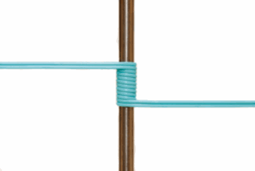

Figure 2. Fiber wound around a pencil

Another advance in fiber optic technology unrelated to PICs, but directly related to our project on bending loss is the Corning ClearCurve Optical Fiber. This optical fiber is able to withstand sharp 90 degree bends, and is even able to be wound around a pencil and still achieve negligible loss, as shown in Figure 2. Invented by three scientists at Corning, the optical fiber works by infusing the cladding that surrounds the fiber’s core with microscopic guard rails called nanostructures. These nanostructures help keep light from seeping out of the fiber. This technology is a major breakthrough, as it will now allow companies to bring fiber optic communications into everyday uses without having to worry about drilling holes through walls to ensure optical fibers stay unbent.

**Theoretical Predictions**

**Bending loss equation**

In the waveguide, a wave front perpendicular to the direction of travel must be maintained. The outer part of the mode field at the bend must travel faster than the inner part to maintain the wave front, and thus, the outer part of the mode field is force to travel faster than the velocity of in the material. Since this is not possible, the energy in the outer part of the mode field is lost through radiation. We have used the bending loss equation for circular waveguide to model the expected bending loss.  The equation is the following:

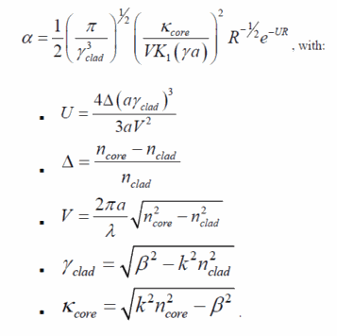

Where alpha is the loss of power per unit length. Since our wave guide is actually rectangular instead of circular, we substituted the radius term, a, with half of the width of the rectangular waveguide, which is 1.5 um.   Beta for the mode that propagates in the waveguide is calculated using the effective index method, and the result is 6.021*106 rad/m. We have also assumed that our waveguide is symmetric with core index 1.537 and cladding index 1.48.  Figure1 and table 1 show the expected bending loss per unit length using the bending loss equation and the parameter described above.

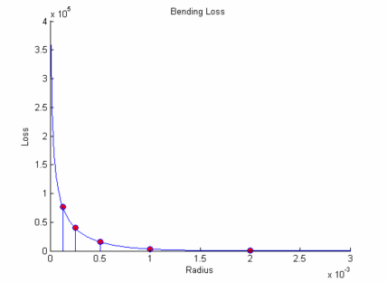

Figure 3, bending loss versus radii

|  |  |  |  |  |  |
| --- | --- | --- | --- | --- | --- |
|  | 0.125 mm | 0.25 mm | 0.5 mm | 1 mm | 2 mm |
| α (db/m) | 76828 | 39683 | 14972 | 3014.2 | 172.77 |

Table 1, expected bending loss by bending loss equation

Bending loss equation models the loss per unit length for a single mode waveguide given the core radius, bend radius, core index, cladding index, and β. It is obvious that the losses increase exponentially as the radius is reduced as shown in Figure 3.

**BPM Simulation**

Beam propagation method is also used to simulate the bending loss in our wave guide. In order to apply BPM to simulate the bent waveguides, 2 dimensional index profiles are created to account for the bent regions. Furthermore, to account for the modes that does not propagate in the waveguides, we have let the wave propagate through a 16mm region of straight waveguide before entering the bent region in the BPM simulation so that only the mode that does propagate in the waveguides is accounted for the calculation later. The relation of the initial power, power in the end and the bending loss per unit length is following:

where Pin is the power after the 16mm region; Pout is the power in the end;  α is the bending loss per unit length and L is the length over the bent regions. Therefore, we can calculate the bending loss per unit length from the BPM simulation by

and the result is shown in Figure 4 and Table 2.

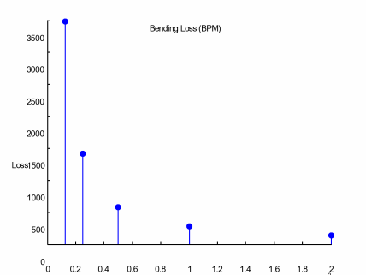

Figure 4, loss per unit length simulated by BPM

|  |  |  |  |  |  |
| --- | --- | --- | --- | --- | --- |
|  | 0.125 mm | 0.25 mm | 0.5 mm | 1 mm | 2 mm |
| α (db/m) | 3482.2 | 1422.1 | 574.20 | 277.40 | 138.29 |

Table 2, loss per unit length simulated by BPM

In Figure 4, we can still see that as the radius decreases, the bending loss increases dramatically. However, BPM simulates waves propagate through the waveguides that we are going to do the real measurement, and therefore, the layout of the waveguide will affect the result of the simulation. The number of the results differs from that modeled by the bending loss equation by some factor because in both cases, the bending loss are per unit length, and a single bend of short radius, such as the ones in our waveguides, does not have significant length for significant bending loss. Therefore, we expect to see that the result from the real measurement for our waveguides is going to be closer than that simulated by BPM than that modeled by the bending loss equation.

**Experimental**

To experimentally measure the effect of bending radii, multiple different length bends were considered.  Looking at the theoretical predictions, the bending loss is hyperbolic in relation to the radius of the bend, and therefore bends with smaller radii, thus higher degree of bend, should have more loss.  For instance, a 900 bend has a radius of 0.0m, and a 00 bend has a radius of infinity.  To perpetuate the theoretical results specific bend radii were chosen.  Because the bending loss equation α is hyperbolic in R, radius, radii that have constant proportional value, have a constant multiplicative factor in power.  For this reason, the following radii are used: [2.00mm, 1.00mm 0.500mm, 0.250mm, and 0.125mm].  The separation of these distances makes sure that each significant part of the bending loss curve is exemplified.

Once the theoretical part of the waveguide has been built, the specifications for the remainder of the experimental part could be considered.  Since some light that is to be coupled into the waveguide at the entrance side passes through the SiO2 layer and does not enter the SiON core layer it can be detected at the output.  As a result the output of the waveguide is separated horizontally by at least 3.0mm; in each case the distance is much greater.  Normally this distance is much more than needed to discern the difference between the input wave and output wave, however due to Huygens-Fresnel’s principle; the output wave undergoes diffraction and thus has a large spread angle which means that it must be focused to detect the total output intensity.

The next consideration for the specification of the experiment is the fact that light can be coupled from one waveguide to another one if it is in close proximity to the waveguide of concern.  Coupled waveguides can exist because the E-M field that solves Laplace’s equation within the waveguide causes there is to be exponential decaying tails in the cladding of the waveguide.  If the nearest waveguide can “see” the evanescent wave from the first waveguide, the exponential tail can excite a similar mode in the second waveguide.  The only reason that this is of concern is the fact that this excitation of another mode causes a transfer of power from the first waveguide to the second one.  This could be a place of loss that is not relevant to the experimental hypothesis.  Thus the design accounts for this by ensuring that at any point waveguides are at least 250.00µm apart.  At this distance the coupling coefficient K goes to zero, which prevents this kind of loss in the experiment.

The final specifications of the waveguide are as follows: there are three layers on top of the bottom substrate layer, the first is SiO2 has an index of refraction nc = 1.48 and is 5.0µm thick, then a SiON core layer which a nf= 1.537 and is only 600.00nm thick by 3.00µm wide, the final layer which also surrounds the core on both sides is also an SiO2 cladding which is 3.00µm thick.  Each waveguide is then replicated on the integrated silicon so that any manufacturing errors that might have occurred can be accounted.  There is only a single replication, thus two in total of each bent waveguide; however in measuring the waveguides no such extreme manufacturing errors were detected that prevented the waveguides from operating in their suspected operating zones.

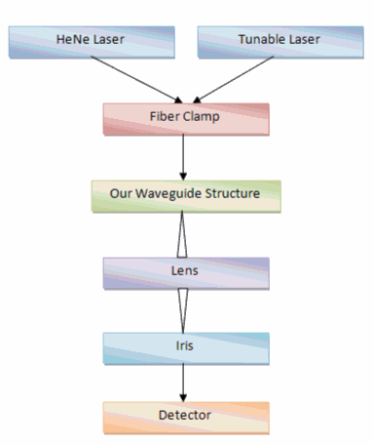

Figure 5. Lab Schematic

The experimental lab setup is depicted in Figure 5.   First the HeNe laser is connected across the waveguide to simulate if there is output from the particular waveguide.  Since the HeNe has one wavelength in the visible spectrum, 628 nm, it is easily seen coupled into the waveguide.  The laser output is coupled into a fiber and then at a fiber clamp the waveguide is aligned to allow for maximum coupling.  The output of the waveguide is focus by a lens on the detector.  Since the output of the waveguide had multiple output peaks an iris had to be used to prevent non relevant power from being focused into the detector.  The fact that there are multiple output peaks will be discussed in the conclusions section.

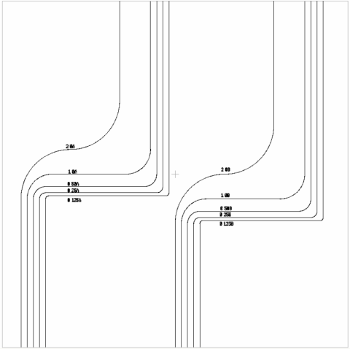

Figure 6. CAD File

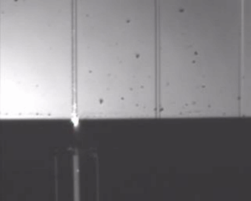

The HeNe light is focused onto the waveguide.  The fiber is visible on the bottom while the scattering light can be seen on the waveguide(black).

       Figure 7. Fiber Incident on waveguide

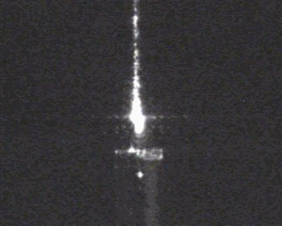

                                                                                                                                                              Without the microscope light present, the coupled laser light visibly follows the path of the waveguide seen in figures 8 and 9.  The fact that the intensity of the light decreases over distance, acknowledge difference between figures 8 and 9, shows that this experiment has some merit.

     Figure 8. HeNe Laser Light Propagation

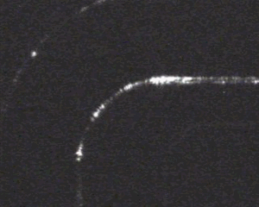

Figure 9. Bend Visualization

When the light passes around the bend radius some of the scattering/ loss from bending excites the modes of waveguides that are in close proximity.  Here the 1.00mm radius waveguide is coupled and yet the 2.00mm waveguide has non-coupled light excitation, and although dim, the .500mm waveguide has coupled light also visible.  Theoretically this means that there might actually be loss due to coupling in adjacent waveguides, or it couple mean that the evanescent fields are still strong enough at 250µm; however that latter is very improbable.

**Results**

To get our experimental results we used the LabView software to record received power as we swept the infared laser from 1520nm to 1570nm. Below is a logarithmic plot of the detected power versus wavelength for each of our five bending radii:

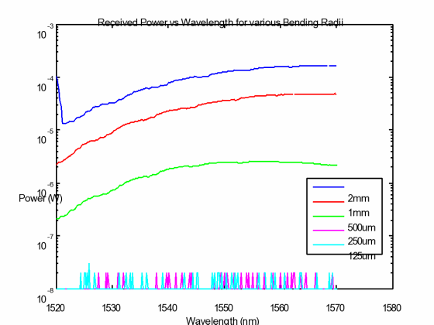

Figure 10. Bending loss Experimental Values

As expected we observe much more received power for the waveguides with larger radii due to less bending loss. However, due to large bending losses the power for the waveguides with radii of 250 microns and 125 microns is too small to be resolved by the detector. Because the detector rounds to tens of nanoWatts, the plot shows spikes from 10 nW up to 20 nW. To compare these results for the two smallest bending radii, we used a moving average window of length 200 (about 35nm):

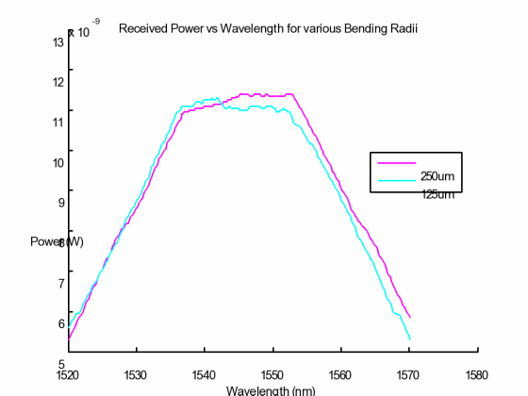

Figure 11. Moving Average Separation for Low Powers.

We chose to use a large window size to create smoother plots, even though the large window creates large tails from the convolution. The averaged results agree with our expectations: the larger radius of 250um experiences less bending loss, yet both have sufficiently small radii to lose almost the entire transmitted power.

To remove the spectral shaping of the laser from our plots, we recorded baseline power for the same range of wavelengths. There are two notable behaviors from our baseline plot below. First, the power for the center wavelengths (around 1540 nm) is greater than the power for the beginning and end wavelengths. Second, the curve shows some periodicity. Both of these observations can be attributed to the operation of the tunable laser. The greater power around 1540 nm is a result of photon emission due to energy level transitions. There are many possible transitions and thus many possible wavelengths, but the emissions that produce the center wavelengths occur with much higher probability. As such, more photons can be emitted for these wavelengths and we see higher power output.  The periodic behavior is also a result of the energy level transitions. Because there are discrete energy levels, there is a discrete set of wavelengths that the laser can produce. Wavelengths in between these discrete values cannot be exactly produced thus in trying to focus the wavelength between the discrete ones results in non-maximal laser output at that wavelength.

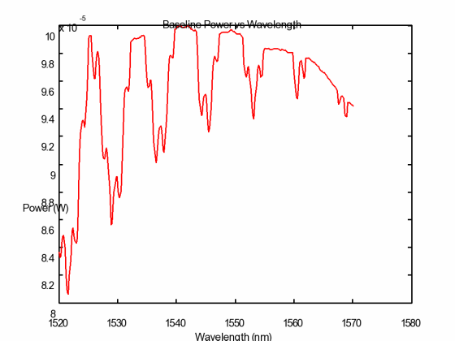

Figure 12.  Baseline laser Correction

After recording the baseline data with LabView, we normalized the data for each of the five bending radii. Although the shape of the baseline spectrum did not greatly affect our observations, comparison of the received power before and after normalization shows a removal of the periodicity from our results. The normalized curves are shown below.

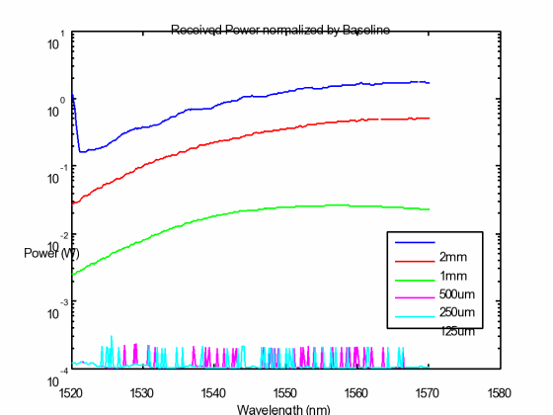

Figure 13. Normalized Waveguide Output Power

………..BPM results…….

|  |  |  |  |
| --- | --- | --- | --- |
| **Bending Radius** | **Theoretical Loss** | **BPM Loss** | **Acutal Loss (mW)** |
| 2mm |  |  | 2.50486 |
| 1mm |  |  | 2.59428 |
| 500um |  |  | 2.62782 |
| 250um |  |  | 2.63025 |
| 125um |  |  | 2.63026 |

Table 3. Comparisons

**Conclusions**