1、拆整体过程图，image process

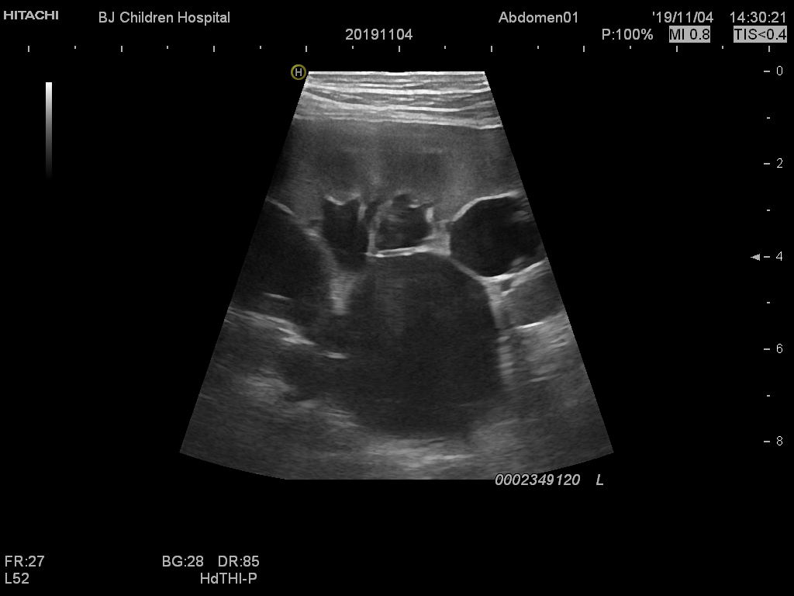

Semantic segmentation

&

Image processing

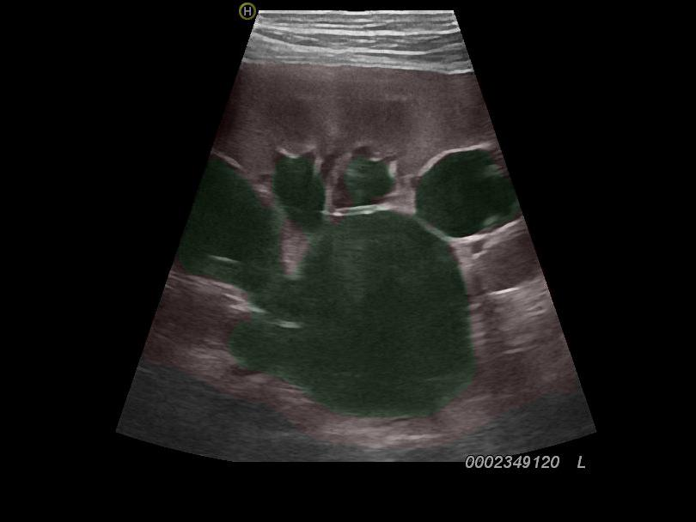

Classifier

The pathological grade

改图，箭头指示不明确，金字塔扁，



[3,473,473]



**.**

**.**

**.**

[2048,30,30]

a

b

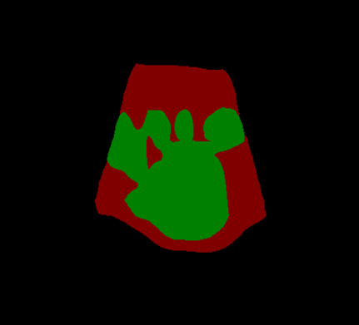

[5,5]

[10,10]

[15,15]

[30,30]

concatenate

Resize

c

2、具象化一点，

Features

（4096,30,30）

Bottleneck

（512,30,30）

Conv

BatchNorm

ReLU

Dropout

Conv

(3,30,30)

Resize

(3,473,473)

Predict&Color

（3,473,473）

3、公式引用：加ref

1. a,b字母该位置去掉歧义

concatenate

AvgPool

FC

Output

(num_classes)



Conv => (64,112,112)

BN&ReLU

DWT



concatenate

(3,224,224)

a

b

1. BasicBlock 扩充解释

Conv

BN&ReLU

Conv

BN

Features

Conv

BN

identity

ReLU

Output

1. precision拼错，in_norm=>SFU_0-2

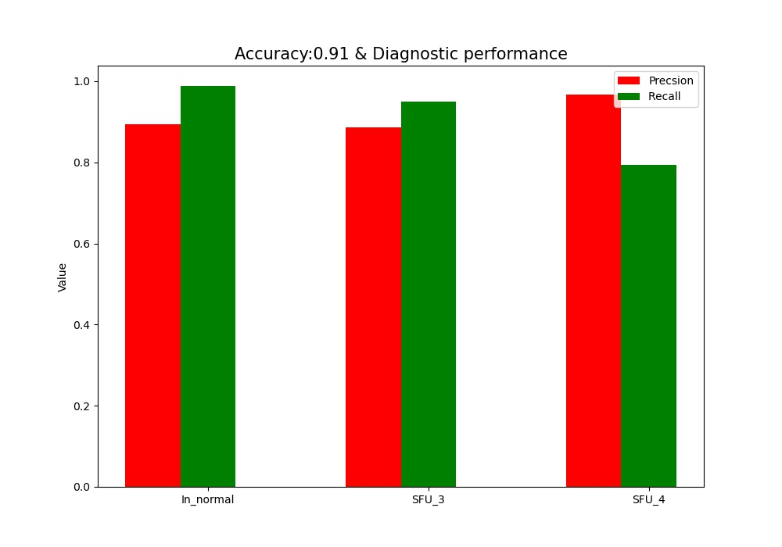

1. CID 加下标，区分
2. 视频添加加用户的加解密过程
3. **实验添加上链与不上链的对比试验结果，AUC之类的，多点图。**
4. 实验最低优先级：添加实验结果>添加实验
5. 添加ResNet Wave_resnet对比，解释为什么没改VGG

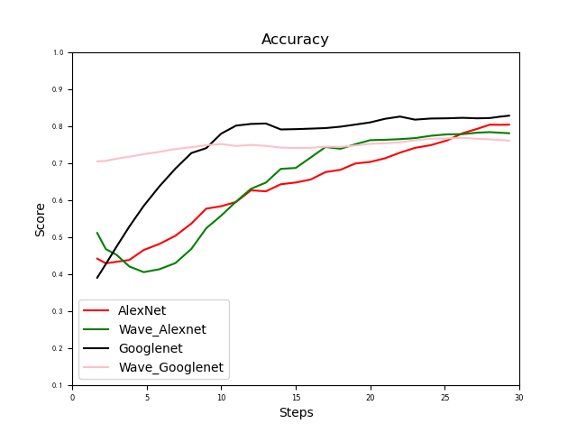

1. TableI 加列数
2. 拆成两图，并添加一些Measures

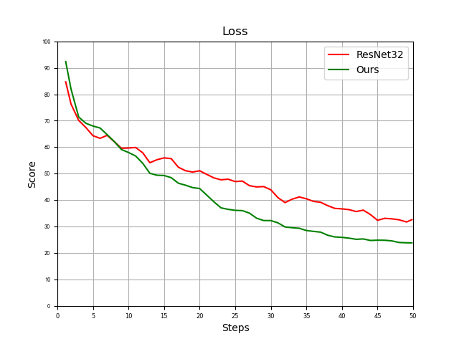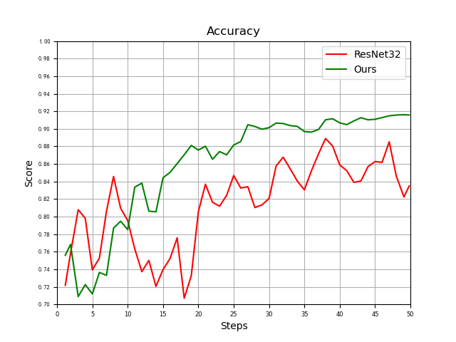

ComboLoss、 Ref

Xu L, Xiang J. ComboLoss for Facial Attractiveness Analysis with Squeeze-and-Excitation Networks[J]. arXiv preprint arXiv:2010.10721, 2020.

ResNet、 Ref

He K, Zhang X, Ren S, et al. Deep residual learning for image recognition[C]//Proceedings of the IEEE conference on computer vision and pattern recognition. 2016: 770-778.