[Accessory](E:/%E6%9C%89%E9%81%93/Dict/8.7.0.0/resultui/html/index.html" \l "/javascript:;) of 《AlN film-based Fabry-Perot cavity resonance enhanced absorption》

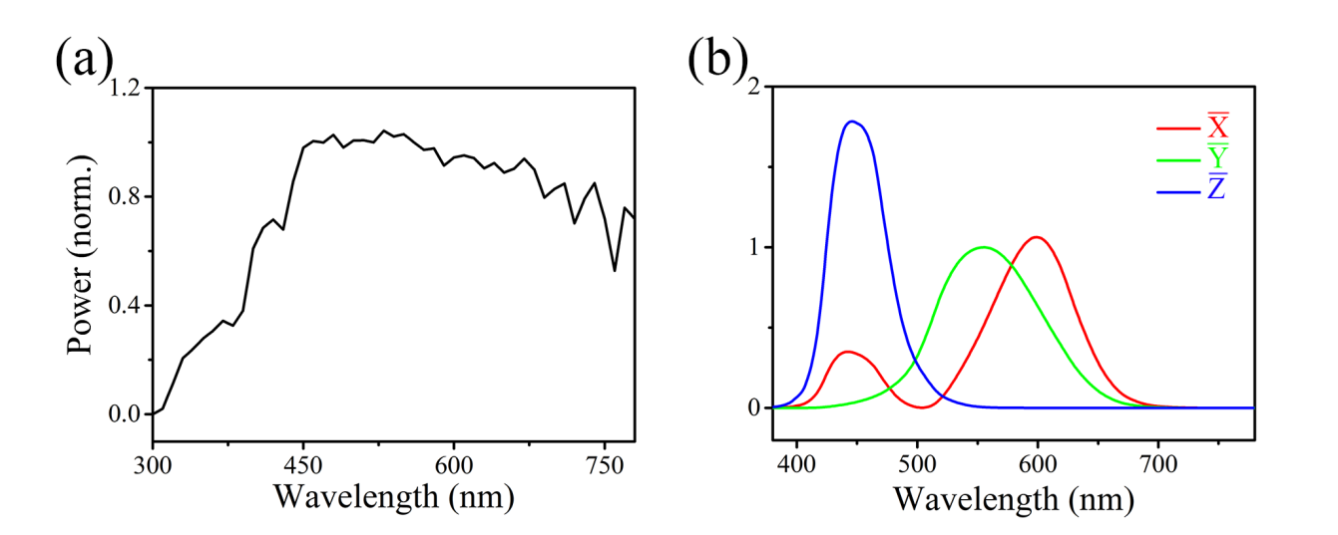

Fig. S1  (a) The spectrum of standard D50 light source. (b) The color matching functions of CIE1931.

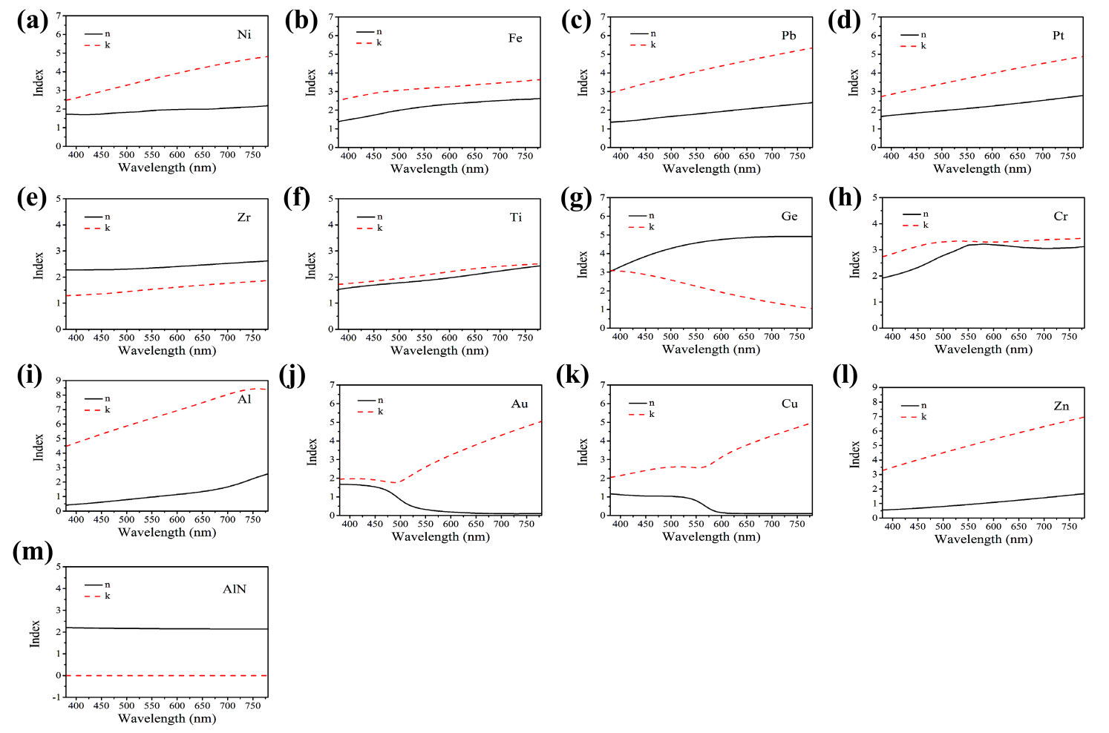

Fig. S2 The refractive index(n) and extinction coefficient(k) of 12 metals and AlN.

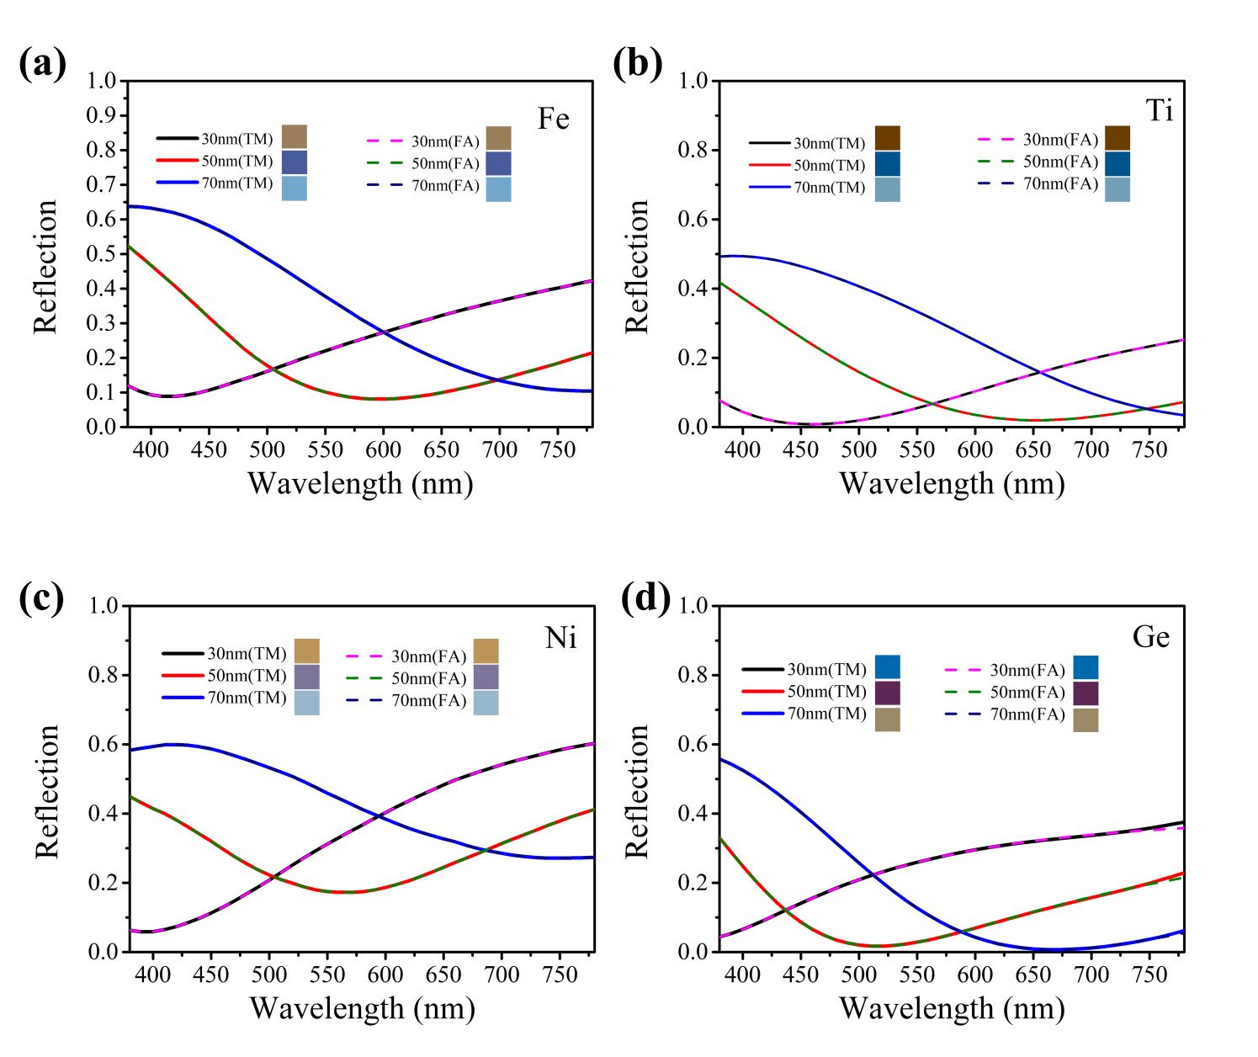

Fig. S3 The reflectivity of 4 kinds of metals as substrates of AlN/Metal, is mapped as function curves of thickness and wavelength, calculated by Transfer-Matrix theory and Fresnel-Airy [equation](E:/youdao/Dict/8.8.1.0/resultui/html/index.html" \l "/javascript:;), respectively.